**Micro-scale Imaging of Electrical Activity of Yield Killer Defects in 4H-SiC with Charge Assisted KFM and UV-Photoluminescence**

# M. Wilson1, D. Greenock2, D. Marinskiy1, A. Savtchouk1, A. Ross1, C. Almeida1, B. Schrayer1, J. D’Amico1 and J. Lagowski1

1Semilab SDI, 10770 N. 46th St., Ste. E700, Tampa, FL 33617 USA; [mwilson@semilabsdi.com](mailto:mwilson@semilabsdi.com)

2X-Fab, 2301 N. University Ave., Lubbock, TX 79415 USA; [david.greenock@xfab.com](mailto:david.greenock@xfab.com)

## **Keywords: SiC, UV, Photoluminescence, micro, KFM, killer defects**

**Abstract**

**In this work we compare non-contact charge-voltage imaging and UV-photoluminescence (UV-PL) imaging of yield killer defects in epitaxial 4H-SiC wafers. Two significant findings are based on macro- and micro-scale imaging, respectively. 1- Whole wafer images demonstrate that only a fraction of the UV-PL defects in triangular, downfall and carrot categories are electrically active. 2- Micro-scale images reveal similarities and differences between PL and electrical defect images. Presented for the first time, micrometer resolution leakage patterns within triangular defects are consistent with the microstructure modeling in reference 1. The results imply that the depletion layer leakage within killer defects corresponds to exposed 3C-SiC polytypes. This leakage may be a consequence of the lower 2.2eV energy gap of 3C-SiC compared to 3.3eV in 4H-SiC.**

introduction

Silicon carbide high voltage power devices have reached a stage of high-volume manufacturing. This requires improvement in yield and reliability that depends critically on elimination of the detrimental effects of structural defects [1,2]. Wafer pre-screening for various yield killer and non-killer SiC epitaxial defects is currently performed with UV-PL combined with optical topographic images [2]. Corresponding UV-PL and optical imaging categorize different defects with triangular, downfall or carrot defects being among the most important causes of electrical failures and yield losses. Other defects seen in UV-PL may be non-killer in nature. However, UV-PL does not provide information on electrical leakage defect activity and must be supplemented with electrical characterization performed on final devices or fabricated test structures, such as p-n junctions, or Schottky barrier diodes. There is a cost associated with fabricating test structures and the feedback can take weeks.

Only recently a non-contact, preparation-free electrical metrology became available with multiparameter characterization of wide bandgap semiconductors [3] that eliminates the need for any test structures for electrical characterization. In the present work it is important that this charge based non-contact C-V (CnCV) metrology incorporates the “QUAD” (Quality, Uniformity and Defect) method for whole wafer surface voltage mapping of electrically active defects. As already demonstrated, QUAD mapping is capable of resolving the electrical activity of defects in epitaxial SiC, supplementing microwave detected photoconductance, µPCD, mapping and photoluminescence defect mapping. By measuring defects within the surface depletion barrier, QUAD is effective even in very thin epitaxial layers, without the restrictions of µPCD and PL imposed by surface recombination. Standard whole-wafer QUAD mapping is performed with a 2mm diameter Kelvin voltage probe. Simultaneous multiprobe high throughput measurements (2 minutes per wafer) are used for high speed, high density whole wafer voltage images. Micro-scale QUAD imaging uses a 10µm diameter probe and Kelvin Force Microscopy measurement of the surface voltage [4].

EXPERIMENTAL RESULTS AND DISCUSSION

In QUAD, the defect visualization is enhanced by charge-biasing of the surface that increases the surface depletion barrier. The biasing is an important factor in identification of electrical activity of defects. In CnCV metrology, unlike in conventional electrical measurements, the biasing does not require fabrication of any test structures or Schottky diodes.

For n-type SiC wafers used in this study, biasing to depletion is performed by deposition of negative surface charge on the wafer. As discussed in ref. [5], charging of SiC surface is non-invasive and fully reversible. The deposited charge can be neutralized by capturing of photogenerated minority carriers and is conveniently removed by wafer illumination.

Similarly, the defects in the depletion barrier can cause localized charge neutralization. A corresponding decrease of the depletion voltage makes the defect visible in the surface voltage images as spots with reduced voltage magnitude.

In this work, the QUAD measurements were combined with UV-PL and optical topography measurements on the same 150mm, n-type epitaxial 4H-SiC wafers. The high and low defect density wafer A and wafer B, respectively, had similar epi thickness and doping of 13µm and 1 x 1015 cm-3. The UV-PL measurements were performed at X-Fab using a Lasertec SICA88 tool with a 313nm UV excitation lamp. The PL images were captured using a near ultraviolet (NUV) band pass filter. The DIC (Differential Interference Contrast) optical images in this work were also captured using the SICA88. In addition to whole wafer defect imaging, the micro-scale measurements were performed on selected individual defect sites. The micrometer resolution QUAD was performed using a corona-Kelvin micro-metrology system that incorporates a Kelvin Force Microscopy probe with a machine vision system for exact location of the sites of interest [4]. All QUAD related measurements were performed at Semilab SDI using a commercially available CnCV series tool.

Whole Wafer Results

Near-UV photoluminescence defect maps and QUAD surface voltage maps are presented on the next page in the left and the right columns, respectively. Fig. 1 and Fig. 2 on the top of the page are for wafer A with a high PL total defect count of 3200. The maps below, shown in Fig. 3 and Fig. 4 are for wafer B with a lower total PL defect count of 680. In the QUAD maps, the color scale is used to represent the surface voltage value. Yellow to red spots demonstrate electrically active defect sites with total counts of about 100 for wafer A and 23 for wafer B. The strongest depletion voltage decrease corresponds to the red color. Therefore, the red spots are defects with the largest electrical activity. Corresponding strong electrical activity defect numbers are about 30 for wafer A and 7 for wafer B. Comparing the UV-PL and QUAD images leads to the following observations: 1. Both PL and QUAD reveal significantly higher defect numbers in wafer A than in wafer B; 2. QUAD defect numbers are much lower (about 30 times) than PL defect counts, indicating that only a fraction of UV-PL defects are electrically active in the depletion layer. One may note that this is qualitatively consistent with UV-PL defects acting as killer and non-killer centers [2] ; 3. The defect number ratios wafer A/B for UV-PL and for QUAD are 4.7 and 4.3, respectively. This similarity is quite remarkable, considering the different physical phenomena involved in photoluminescence and depletion leakage.

Micro-scale Defect Images

Micro-meter resolution measurements were performed on selected defect sites on wafer B that are marked in Fig. 5 and Fig. 6, and also on some selected sites on wafer A. SICA88 micro-imaging included DIC optical defect images and NUV-PL images presented with identical spatial resolutions as the KFM surface voltage images. Micro-scale images of three representative defects are presented (Fig. 7 to Fig. 10 for defects from wafer B and Fig. 11 for a defect from wafer A). The images in Fig. 7 show optical and UV-PL images of defect 1 categorized as a triangular defect. The optical image indicates a downfall defect at the apex of the triangle and a stripe at the triangle base. The corresponding KFM QUAD surface voltage images are shown in Fig. 8. The strongest electrical activity is observed at the triangle base and it is manifested by a depletion voltage magnitude of -2.5V compared to -5.5V in the area surrounding the defect. The electrical activity at the apex is less pronounced, but it is still manifested by -3.8V, i.e., 1.7V lower than the background. The electrical activity image of the defect is best visible in the surface voltage gradient magnitude map on the right in Fig. 8. The downfall defect spot and the sharp base stripe reveal the electrical microstructure within the triangular defect that is not resolved in the UV-PL image in Fig. 7.

A similar observation can be made based on the micro-scale imaging of defect 2, presented in Fig. 9 and Fig. 10. The highest electrical activity is, in this case, localized at the two edges of the defect visible as the white lines in the gradient magnitude image and the red pattern in the surface voltage image; once again not visible in the PL image.

An example of a more complex triangle defect microstructure is given in Fig. 11. The surface voltage image and the UV-PL image indicates a defect in the shape of two triangles, while only the lower triangle is revealed by the optical image. The QUAD image shows an electrical micro-structure containing, in this case, the base region on the lower triangle, the boundary between the triangles and the largest electrical activity in the downfall defect.

Summarizing the microscale results, one should point out a novel element of the experimental findings, namely the complex micro-structure of the electrical defect activity and the existence of regions within the defects that dominate the electrical activity.

In the presented examples, such regions included the base and edges of triangular defects and downfall defects at the apex. Speculating about the origin of high surface depletion leakage in such regions, one may consider the presence of 3C-SiC. The triangular defect micro-structure treatment by Guo et. al in Ref. 1 postulates defect formation in epitaxial growth that involves the step-flow process interrupted by a downfall defect. Within the created triangular pit, 3C-SiC crystals are formed. They are gradually overgrown by a 4H-SiC layer starting from the apex toward the base. This process may leave a stripe of lower bandgap 3C-SiC near the base not completely overgrown, causing strong electrical activity and high leakage.

CONCLUSION

Based on the present results, we believe that charge-enhanced surface voltage imaging of defects in epitaxial silicon carbide constitutes a powerful tool complementing UV-PL wafer screening. The micro-imaging version of the technique realized with KFM surface voltage measurement can be of fundamental importance providing a unique means for studying the micro-structure of killer defects and understanding of the electrical activity of defects.

The metrology can be beneficial for advancement in identification, classification and distinguishing between killer and non-killer defects.

## References

[1] J. Guo et al., Journal of Crystal Growth, 480 (2017) 119-125.

[2] H. Das et al., ECS Transactions 80, no. 7 (2017): 239-243.

[3] M. Wilson, Compound Semiconductor, 25-6 (2019), pp. 20-26.

[4] A. Findlay et al., ECS Journal of Solid State Science and Technology, 5(4) P3087 (2016).

[5] M. Wilson et al., ECS Journal of Solid State Science and Technology, 6 (11) S3129-S3140 (2017).



Fig. 1. NUV-PL Defect Map for wafer A with high 3200 defect count (Carrot, Downfall, Triangular and BPD).

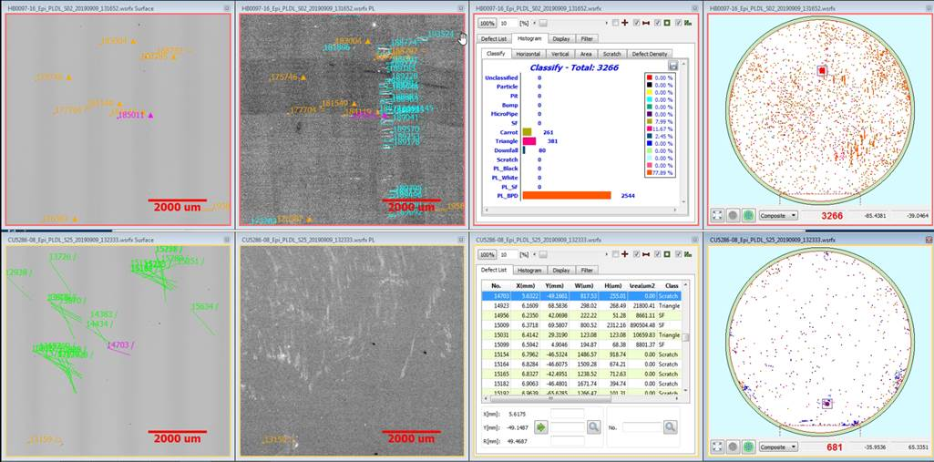

Fig. 3. NUV-PL Defect Map for wafer B with lower 680 defect count (Carrot, Downfall, Triangular and BPD).

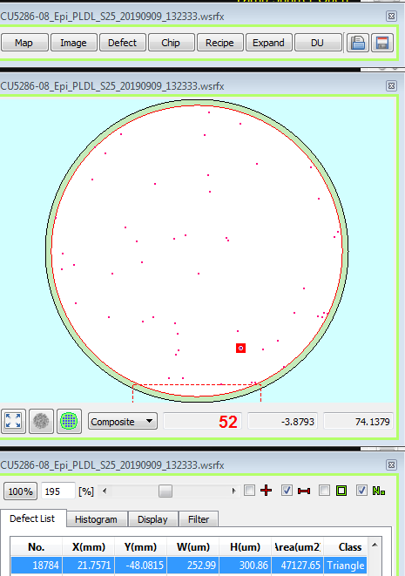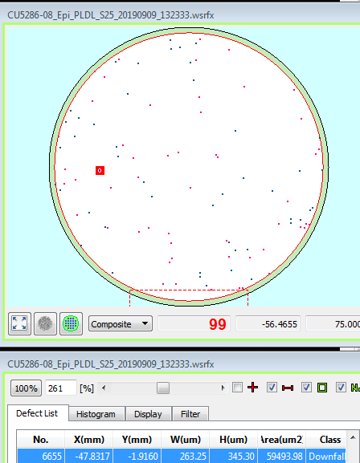

Fig. 5. NUV-PL Defect Map of wafer B (Triangular Only) with defects 1 to 4 measured in micro-scale.



Fig. 2. QUAD whole wafer macro-scale defect map on wafer A showing about 100 defects. Defects are manifested as spots with reduced depletion voltage.



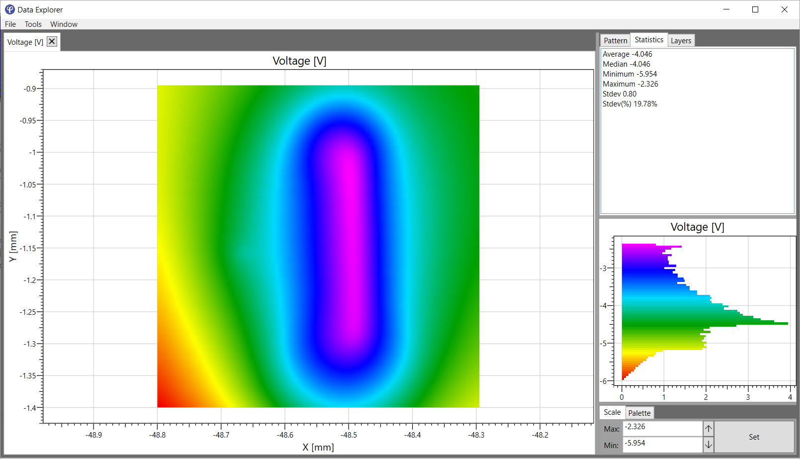

-14V

-18V

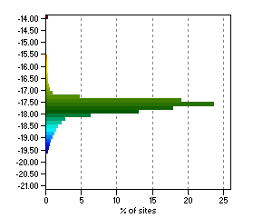

Fig. 4. QUAD whole wafer macro-scale defect map on wafer B showing 23 defects. Defects are manifested as spots with reduced depletion voltage.



1

2

3

4



-14V

-18V



Fig. 6. Wafer B QUAD whole wafer defect map highlighting certain high leakage defects. Defects 1 to 4 measured in micro-scale.

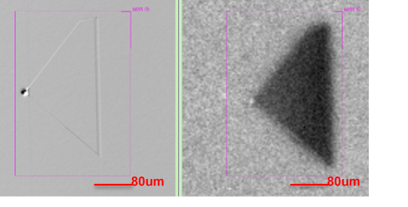

Fig. 7. Wafer B Defect 1 optical and UV-PL images.



Fig. 8. Wafer B Defect 1 charge assisted KFM surface voltage electrical images. The surface voltage gradient magnitude image on the right clearly shows the electrical activity microstructure present within the triangular defect.

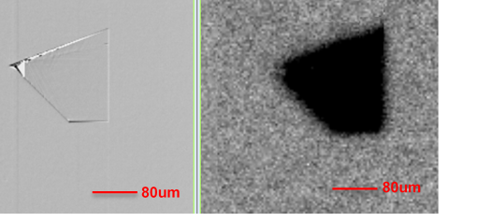

Fig. 9. Wafer B Defect 2 optical and UV-PL images.



Fig. 10. Wafer B Defect 2 charge assisted KFM surface voltage electrical images. White lines at the triangle edges represent high leakage areas.

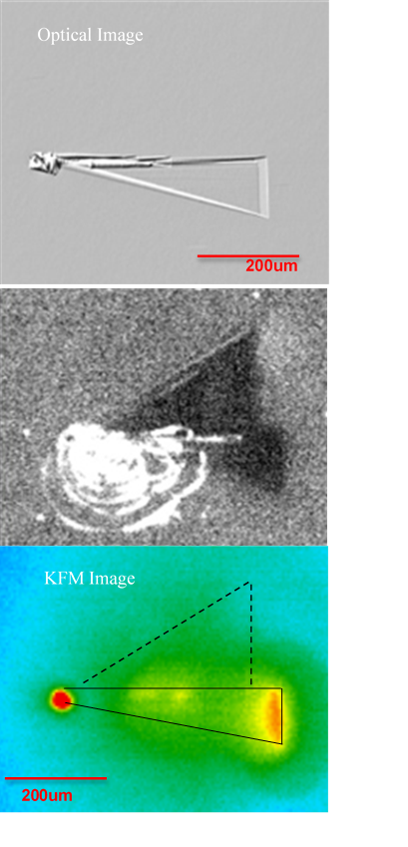

Fig. 11. Complex triangular defect in wafer A. Compared to UV-PL, the optical image shows only the lower defect with the apex and base exhibiting high leakage in the KFM surface voltage image.