Self-Aligned Refractory Metal Gate Scaling in β-Ga₂O₃ MOSFETs

Kyle J. Liddy^{1*}, Andrew J. Green², Thaddeus J. Asel³, Shin Mou⁴, Kevin D. Leedy², Don Dorsey⁴, Kelson D. Chabak²

¹KBR, Sensors Directorate, WPAFB, OH 45433
²Air Force Research Laboratory, Sensors Directorate, WPAFB, OH, 45433
³UES, Air Force Research Laboratory, Materials and Manufacturing Directorate, WPAFB, OH 45433
⁴Air Force Research Laboratory, Materials and Manufacturing Directorate, WPAFB, OH, 45433

Keywords: β-Ga₂O₃, MOSFET, Self-Aligned, Scaled, Refractory

Abstract
This work characterizes the effects of gate-length (L_{G}) scaling in a self-aligned gate (SAG) β-Ga₂O₃ MOSFET process. Additional performance gains are expected by extending the SAG process from large L_{G} to sub-micrometer dimensions. This data incorporates L_{G} scaling down to 200 nm to improve device performance in Ga₂O₃ SAG MOSFETs using a stepper lithography process to define sub-micron gate lengths.
INTRODUCTION
β-Ga₂O₃ (BGO) has recently sparked interest as a promising semiconductor for power applications. The bandgap of BGO is nearly 5 eV, and the estimated critical field strength (Ecrit) of ~8 MVcm⁻¹ are both higher than GaN and SiC [1,2]. The high E_{crit} of BGO can potentially realize advances in efficient power conversion and even RF devices. Recently, BGO was shown to possess the highest E_{crit} ever measured in a lateral transistor [3] which has sparked BGO device research towards obtaining high Baliga Figure of Merit (BFOM) [4] and low dynamic switch power losses [5]. BGO RF power devices have also been reported in the low-GHz regime [6,7].
BGO has a relatively low mobility but higher E_{crit} compared to GaN. The high E_{crit} of BGO allows devices to be scaled laterally to a fraction of GaN based ones for a given breakdown voltage. Critical to laterally scaled BGO devices is developing a self-aligned gate (SAG) feature to remove parasitic access resistance between the source and gate electrodes (R_{s}) with the use of refractory metal gate-first processing [8]. Here, we report sub-micron L_{G} scaling defined by stepper lithography and characterize the small-signal RF performance of SAG BGO devices.
DEVICE FABRICATION
A 65 nm Si-doped BGO channel layer was homoepitaxially grown on an Fe-doped (010) substrate by molecular beam epitaxy (MBE). Room temperature Hall measurements reveal a sheet charge density of 3.6x10¹² cm⁻² (estimated N_{D}= 5.5x10¹⁷ cm⁻³ and R_{sh}= 23.7 kΩ/sq based on thickness) with 73.6 cm²/V·s carrier mobility. The first step in device fabrication was mesa isolation using a high-power BCl₃ ICP/RIE (inductively coupled plasma/reactive ion etch) dry etch process. Aluminum oxide (Al₂O₃) was deposited using PEALD (plasma-enhanced atomic layer deposition) to serve as a gate dielectric as well as an implant cap. Source and drain implant regions were defined subtractively through W sputtering, followed by an SF₆ RIE W dry etch process to achieve 1.75 µm source-drain distance. Si-implant was achieved using a shallow implant design with 35 and 85 keV implant energies targeting 1.0x10²⁰ cm⁻³ Si ion concentration, followed by a rapid thermal anneal at 900ºC for 120 sec in N₂. Use of a refractive metal gate such as W is essential to a SAG process, as typical Au gates will not survive the high activation temperatures necessary for Si implantation. Ohmic contact was achieved using a
Ti/Al/Ni/Au evaporated metal stack, followed by a rapid thermal anneal at 470ºC for 60 sec in N₂. Gate scaling was accomplished using a stepper process to selectively remove W and achieving L_{G} of 1.75 µm (no drift region), 0.75 µm, 0.5 µm and 0.2 µm using an additional SF₆ RIE W dry etch. The region of removed W formed the drift region of the devices. Ti/Au interconnect metal was added via an evaporative deposition for device characterization. A cross-sectional schematic of the device is shown in Figure 1, as well as top-down SEM images showing sub-micron W gates in Figure 2.
Figure 2: Top-down SEM images of SAG Ga₂O₃ MOSFETs with A) L_{G} = 1.75 µm, B) L_{G} = 0.75 µm, C) L_{G} = 0.50 µm, and D) L_{G} = 0.20 µm

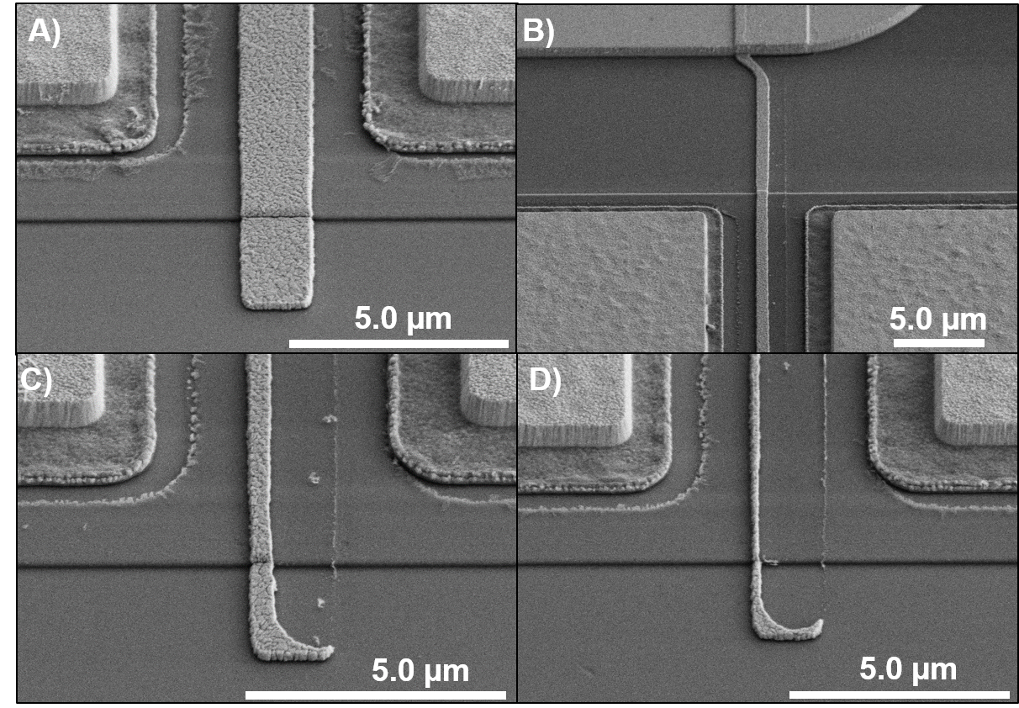
Figure 1: Self-Aligned BGO MOSFET schematic

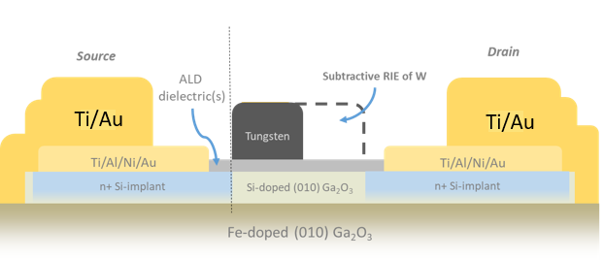
DEVICE CHARACTERIZATION
Standard DC I-V device characterization was performed and is shown in Figure 3(A-C). Figure 3A shows transconductance (g_{m}) as a function of V_{GS} at V_{DS} = +15V for four gate lengths. A clear improvement in g_{m} is demonstrated as L_{G} decreases. The L_{G} = 0.20 µm SAG MOSFET achieved a g_{m} of 42 mS/mm, representing a record-high for β-Ga₂O₃ MOSFETs. Figure 3B shows Log transfer characteristics for four L_{G}, showing loss of channel control as L_{G} decreases. This can be improved by optimizing the Ga₂O₃ channel doping and thickness on future devices. Figure 3C shows the output family of curves for a scaled SAG MOSFET with L_{G} = 0.75 µm from V_{GS} = -6V to +6V and V_{DS} = 0 to +14V, achieving a drain current density (I_{DS}) of 315 mA/mm and on resistance (R_{ON}) of 32 Ω∙mm.
Small signal RF performance is shown in Figure 4(A-B) as a function of L_{G} and V_{DS}. The f_{t} and f_{max} were recorded at g_{m,peak} conditions over a V_{DS} range of +5V to +14V and show increasing values with smaller L_{G} as expected. The f_{t} and f_{max} likely decrease from self-heating for the smaller L_{G} devices that achieve higher current. A SAG MOSFET with L_{G}=0.20 µm achieved f_{t} and f_{max} of 7 and 11 GHz, respectively.
CONCLUSION
This study has reported the DC and RF performance as a function of L_{G} using a self-aligned gate process for BGO MOSFETs. High current density (>300 mA/mm) and g_{m} (>40 mS/mm) were obtained with laterally scaled SAG BGO MOSFETs despite higher channel sheet resistance. For short-gate SAG devices, good RF performance is reported while leaving substantial room for additional materials and device engineering improvements.

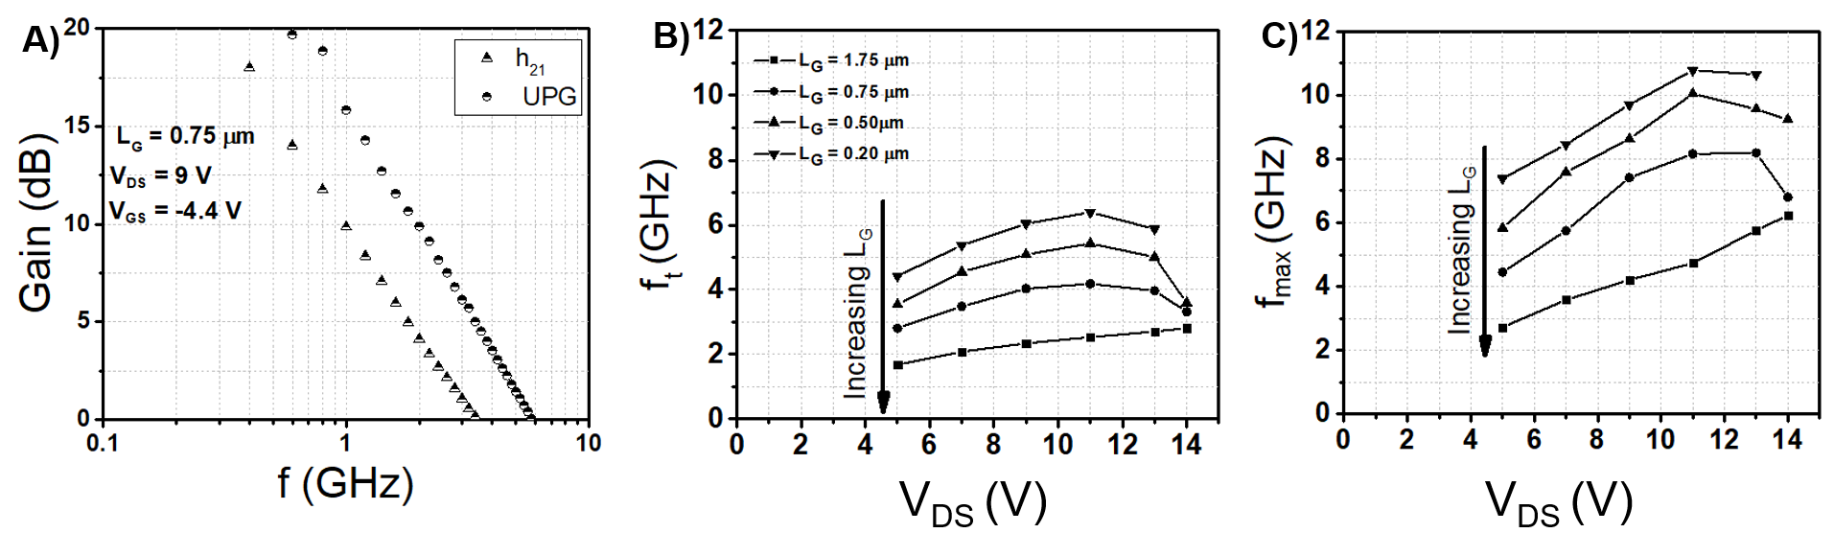
Figure 4: Small signal radio frequency performance at g_{m,peak} as a function of L_{G} and V_{DS}.

Figure 3: A) Transconductance (g_{m}) of SAG MOSFETs as a function of L_{G}, B) Log transfer curve of SAG MOSFETs as a function of L_{G}, and C) output family of curves for a SAG MOSFET with L_{G} = 0.75 µm from V_{GS} = -6V to +6V and V_{DS} = 0 to +14V.

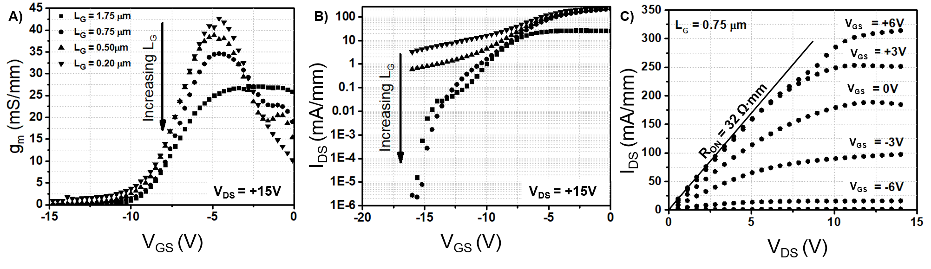

ACKNOWLEDGMENTS
The authors would like to acknowledge the Air Force Office of Scientific Research (AFOSR), who partially supported this work under grant FA9550-17-1-0279.

REFERENCES
[1] M. Higashiwaki, K. Sasaki, A. Kuramata, T. Masui, and S. Yamakoshi, "Gallium oxide (Ga2O3) metal-semiconductor field-effect transistors on single-crystal β-Ga2O3 (010) substrates," Applied Physics Letters, vol. 100, pp. 1-2, Jan 2 2012.

[2] M. Higashiwaki, K. Sasaki, T. Kamimura, M. H. Wong, D. Krishnamurthy, A. Kuramata, T. Masui, and S. Yamakoshi, "Depletion-mode Ga₂O₃ metal-oxide-semiconductor field-effect transistors on β- Ga2O3 (010) substrates and temperature dependence of their device characteristics," Applied Physics Letters, vol. 103, pp. 1-4, Sep 16 2013.
[3] A. Green, K. Chabak, E. Heller, R. Fitch, M. Baldini, A. Fiedler, K. Irmscher, G. Wagner, Z. Galazka, S. Tetlak, A. Crespo, K. Leedy, and G. Jessen, "3.8 MV/cm Breakdown Strength of MOVPE-Grown Sn-doped β-Ga₂O₃ MOSFETs," IEEE Electron Device Letters, vol. 37, pp. 902-905, Jul 2016.
[4]B. J. Baliga, "Semiconductors for High-Voltage, Vertical Channel Field- Effect Transistors," Journal of Applied Physics, vol. 53, pp. 1759-1764, Sep 1982.
[5] Kelson D. Chabak, Jonathan P. McCandless, Neil A. Moser, Andrew J. Green, Krishnamurthy Mahalingam, Antonio Crespo, Nolan Hendricks, Brandon M. Howe, Stephen E. Tetlak, Kevin Leedy, Robert C. Fitch, Daiki Wakimoto, Kohei Sasaki, Akito Kuramata, Gregg H. Jessen, “Recessed-Gate Enhancement-Mode β-Ga₂O₃ MOSFETs,” Electron Device Letters, vol. 39, pp. 67-70, JAN 2018.
[6] Andrew J. Green, Kelson D. Chabak, Michele Baldini, Neil Moser, Ryan Gilbert, Robert C. Fitch, Gunter Wagner, Zbigniew Galazka, Jonathan Mccandless, Antonio Crespo, Kevin Leedy, Gregg H. Jessen, “β-Ga₂O₃ MOSFETs for Radio Frequency Operation,” Electron Device Letters, vol. 38, pp. 790-793, JUNE 2017.
[7] Zhanbo Xia, Hao Xue, Chandan Joishi, Joe Mcglone, Nidhin Kurian Kalarickal, Shahadat H. Sohel, Mark Brenner, Aaron Arehart, Steven Ringel, Saurabh Lodha, Wu Lu, Siddharth Rajan, “β-Ga₂O₃ Delta-Doped Field-Effect Transistors With Current Gain Cutoff Frequency of 27 GHz,” Electron Device Letters, vol. 40, pp. 1052-1055, July 2019.
[8] Kyle J. Liddy et al, 2019, Appl. Phys. Express, 12, 126501

ACRONYMS
SAG: self-aligned gate
MOSFET: metal-oxide-semiconductor field-effect transistor
BGO: β-Ga₂O₃
BFOM: Baliga’s Figure of Merit
RF: radio frequency
DC: direct current
MBE: molecular beam epitaxy
ICP: inductively coupled plasma
RIE: reactive ion etch
PEALD: plasma enhanced atomic layer deposition

