SiN Films Grown in Production Scale MOCVD Reactor for Passivation of III-nitride Structures

O. Laboutin, F. Kaess, C.-K. Kao, H. Marchand

IQE MA, 200 John Hancock Rd. Taunton, MA 02780, olaboutin@iqep.com, Phone: 508-824-6696

Keywords: in-situ SiN, MOCVD, III-nitrides, HEMT

Abstract
SiN films were grown in a production scale vertical MOCVD reactor and studied for in-situ passivation of III-nitride HEMT structures. The SiN was near-stoichiometric in composition and uniform in thickness across 4-, 6- and 8-inch diameter substrates. Its surface exhibited low roughness of about 0.3nm when the films were grown using H₂ carrier gas. Contamination of the SiN with Al and Ga elements was as low as 1e16cm⁻³ and the H concentration was approximately 1at.% when optimized growth conditions were employed. It was demonstrated that the density of states at the SiN/III-nitride interface can be controlled by SiN growth conditions.

Introduction

The III-nitrides are a material system of choice for many power and RF applications. However, their device performance can be adversely affected by electrically active surface states. In order to minimize the adverse effects, a dielectric passivation of the III-nitride structures is commonly used during device fabrication. The dielectric passivation inside the reactor chamber used for the growth of III-nitride structures (in-situ passivation) can improve the dielectric-III-nitride interface and device performance of these structures [1]. In-situ SiN passivation has been demonstrated to result in low damage to the underlying material, oxide-free interface [2] and low interface state densities [3].
Despite all advantages of the in-situ passivation of III-nitride structures, there are only a few reports in the literature on studies of the SiN growth by MOCVD [4, 5]. In these studies, silane (SiH₄) and ammonia (NH₃) were used as the precursors. The SiN film thickness was limited to a few nanometers, which made it difficult to assess some material properties. For the ultra-thin SiN films in-situ deposited on Al_{0.4}Ga_{0.6}N layers, island-like crystalline structure was reported at the SiN/Al_{0.4}Ga_{0.6}N interface [4]. It was also suggested that the growth rate was controlled by the SiH₄ molar flow. A growth rate dependence on the growth temperature, pressure and SiH₄/NH₃ ratio was studied for the SiN growth on AlN [5]. High sensitivity of the growth rate was reported for all these parameters.
In this study, we investigated the growth of in-situ SiN employing disilane (Si₂H₆) and NH₃. We noted that the Si₂H₆
has been previously compared to the SiH₄ and demonstrated to be more efficient and less sensitive to the growth temperature in low pressure MOCVD of the Si doped GaAs films [6, 7] suggesting that the Si₂H₆ may be a more practical solution for production of the III-nitride structures. High growth rates of the SiN can be also beneficial in this case. For these reasons, we employed the Si₂H₆ source and growth rates in the range of 0.01 – 0.1nm/s. Wide ranges of the Si₂H₆ flow, NH₃ flow and growth temperature were examined. Thick and thin SiN films were studied to assess different material properties.

Experimental

The SiN films were grown on both Si (111) on axis substrates and III-nitride HEMT structures in a production scale vertical MOCVD reactor. Both nitrogen (N₂) and hydrogen (H₂) were employed as carrier gases. Disilane (Si₂H₆) and ammonia (NH₃) were used as the Si and N precursors, respectively. The NH₃ to Si₂H₆ molar ratio (N/Si ratio) and SiN growth temperature were varied over a wide range of conditions.
SiN films with thicknesses between 100 and 200 nm were grown on 4-, 6- and 8-inch diameter Si substrates in order to assess thickness uniformity and composition. The SiN thickness was inferred from the optical interference analysis employing Ocean Optics’s Filmetrics interferometer. The standard deviation of the thickness was found to be better than 4% for all substrate diameters. The composition of the SiN was assessed using RBS and Ellipsometer analysis of the index of refraction. The RBS analysis indicated that the films were nearly stoichiometric in composition with [N] of 57-58at.% and [Si] of 42-43%. The index of refraction was found to be about 1.96 – 2.04, confirming RBS findings.
For the process regime used in this study, it was found that the SiN growth rate was linearly proportional to the Si₂H₆ molar flow into the reactor and weakly dependent on the NH₃ molar flow and growth temperature.
The surface of the SiN was studied using AFM operating in tapping mode. Figure 1 shows the AFM images of the bare Si substrate, SiN film grown using N₂ carrier gas and SiN film grown using H₂ carrier gas. The Si substrate surface exhibited well-defined atomically smooth terraces with an RMS surface roughness of about 0.15nm (Figure 1(a)). Two drastically different surface morphologies were revealed by the SiN films grown using N₂ and H₂ carrier gases
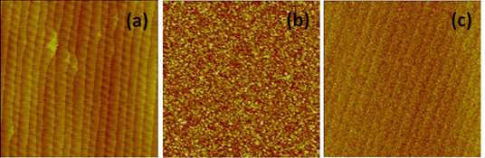
Fig. 1. (5 X 5) µm AFM images of (a) Si substrate surface, (b) SiN film grown under N₂ atmosphere and (c) SiN film grown under H₂ atmosphere. The z-contrast is 5nm.

The surface was granular and rough when the SiN was grown under the N₂ atmosphere (Figure 1(b)). The substrate terraces were no longer evident. The RMS surface roughness was about 1.0nm. In contrast, when H₂ was used as the carrier gas, the SiN surface was smoother (RMS surface roughness of approximately 0.3nm) with clear evidence of terraces and steps that mirror those on the bare Si substrate (Figure 1(c)).
Contamination of the SiN layer with MOCVD by-products was investigated using SIMS analysis. The 30-35nm thick films in-situ deposited over the III-nitride HEMT structures were prepared for this study. The SIMS analysis of Al, Ga and H elements was carried out at Eurofins Materials Science EAG Laboratory. Figure 2 shows the contaminant depth profiles in a film grown without any optimization. All three elements were found in significant concentrations. The Al, Ga and H concentrations were approximately 1e17cm⁻³, 2e18cm⁻³ and 3at.%, respectively. The reactor chamber was the most likely source of the Al and Ga. The Si₂H₆, NH₃ and products of their decomposition were likely the source of the elemental H in the SiN. An optimization of the growth conditions was subsequently carried out to reduce the concentrations of contaminants. As a result, the Al and Ga concentrations decreased to about 1e16cm⁻³ while H concentration decreased to approximately 1at.% (not shown).
High-resolution STEM studies of the SiN passivated III-nitride HEMT structures were carried out at Eurofins Materials Science EAG Laboratory on samples grown under different SiN growth conditions (temperature and N/Si ratio). For all conditions studied, the SiN film was amorphous. However, the character of the SiN/III-nitride interface depended on the growth conditions. The samples grown at low temperature and high N/Si ratio exhibited a sharp and smooth interface (Figure 3(a)). The samples grown at high temperature and low N/Si ratio exhibited a rough interface (Figure 3(b)). The magnitude of the interface roughness was estimated to be about 3 – 4 monolayers. It is reasonable to assume that the deficit of elemental N during the transition from the III-nitride to SiN
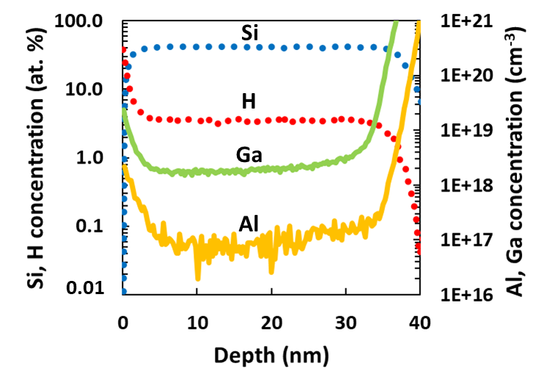
Fig. 2. SIMS depth profile of Al, Ga and H elements in SiN film in-situ grown on III-nitride structure.

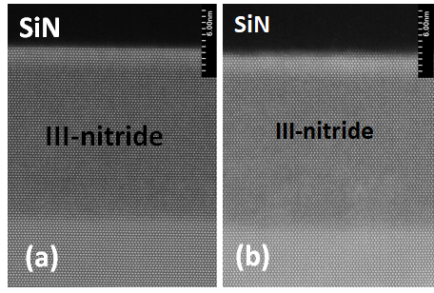
Fig. 3. STEM images of SiN passivated III-nitride HEMT structures with (a) sharp and (b) blurry SiN/III-nitride interface.

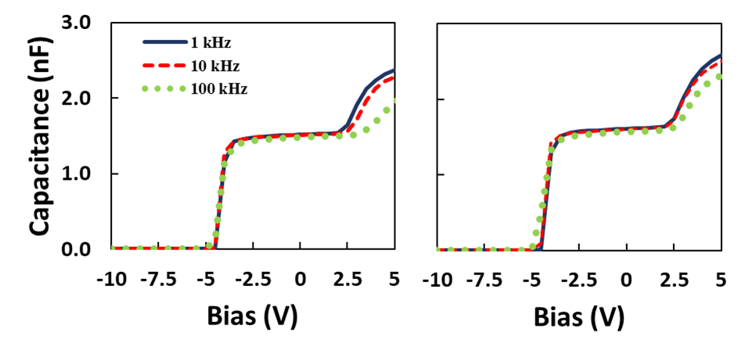
Fig. 4. C-V characteristics of III-nitride HEMT structures in-situ passivated with SiN deposited (a) without optimization and (b) under optimized conditions.
growth is a cause of the interface roughening or material intermixing.
Frequency-dispersion C-V analysis of the in-situ SiN passivated III-nitride HEMT structures was carried out to assess the SiN/III-nitride interface state density. The C-V characteristics were recorded using MDC Hg-probe station at three different frequencies - 1, 10 and 100kHz. The thickness of the SiN film was approximately 15nm. Two samples of the passivated structures were compared. One sample had the SiN grown without SiN growth optimization, while the other had the SiN grown under the optimized growth conditions. The representative characteristics are shown in Figure 4.
Two distinct steps in all C-V curves can be seen, one at a negative bias and one at a positive bias. The step at about -4.7 V can be attributed to the depletion of the 2DEG at the AlGaN/GaN interface of the III-nitride structure. The step at about 2.5V can be attributed to a charge accumulation at the SiN film. The C-V characteristic dispersion in the positive bias range is caused by electron capture on the acceptor-like states at the SiN/III-nitride interface. Following the C-V analysis reported by Y. Hori et al [8], the on-set voltage difference in the accumulation step between 1 and 100kHz was estimated to be 1.2 and 0.3V for two samples reported in Figure 4 indicating lower frequency dispersion in sample grown under optimized conditions. The data indicate that the interface state density for the optimized sample was about 4 times lower than that for the sample grown under non-optimized conditions. It is noted that the lower interface state density did not appear to correlate with either interface roughness or H concentration in the SiN. Further detailed studies are needed to elucidate an influence of the SiN growth conditions on the SiN/III-nitride interface state density.
Large-area-HEMT devices were formed on both the SiN passivated and unpassivated HEMT structures. The SiN was deposited in-situ with a thickness of 5nm. All passivated and unpassivated structures went through the same fabrication process. For the passivated samples, the SiN layer was preserved under the ohmic and gate contacts. The on-wafer DC and pulsed I-V characteristics were measured for both unpassivated and passivated devices. The passivated devices exhibited two orders of magnitude reduction in gate leakage and off-state three terminal leakage as compared to the unpassivated devices (Figure 5). Low dispersion between DC and pulsed I-V characteristics indicating high quality film and SiN/III-nitride interface will be presented.

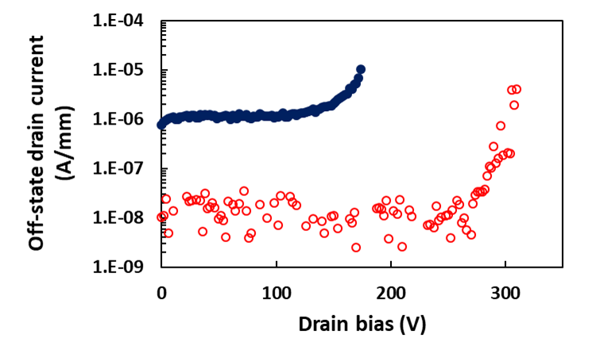

Fig. 5. Off-state I-V characteristics of unpassivated (blue dots) and in-situ SiN passivated (red circles) III-nitride HEMTs. The gate bias is -6V.

Conclusion

We have demonstrated that near-stoichiometric SiN films can be grown with uniform thickness in a commercial MOCVD reactor for in-situ passivation of III-nitride HEMT structures. The SiN was grown in a high growth rate regime where growth rate scales linearly with the molar flow of the Si₂H₆. The SiN films exhibited low surface roughness and low contamination by the MOCVD precursors when optimized deposition conditions were employed. A smooth SiN/III-nitride interface with a low density of the interface states was obtained for the SiN grown under optimized conditions. The low interface state density was confirmed by variable frequency C-V and large area HEMT I-V studies. These findings suggest that the in-situ SiN passivation can be successfully employed for high performance production scale III-nitride HEMT structures.

References

[1] J. Derluyn, S. BoeyKens, K. Cheng, R. Vandersmissen, J. Das, W. Ruythooren, S. Degroote, M. R. Leys, M. Germain and G. Bortghs, J. Appl. Phys. 98, 054501 (2005)
[2] E. Ogawa, T. Hashizume, S. Nakazawa, T. Ueda and T. Tanaka, Jap. J. Appl. Phys., 46, 24, L590 (2007)

[3] X. Lu, J. Ma, H. Jiang, C. Liu and K. M. Laua, Appl. Phys. Lett. 105, 102911 (2014)
[4] T. Takizawa, S. Nakazawa and T. Ueda, J. Electronic Materials 37, 5, 628 (2008)
[5] J. Ma, X. Lu, H. Jiang, C. Liu and K. M. Lau, Appl. Phys. Express 7, 091002 (2014)
[6] E. Veuhoff, T. F. Kuech and B. S. Meyerson, J. Electrochem. Soc.: Solid State Science and Technology 132, 8, 1958 (1985)
[7] H. K. Moffat, T. F. Kuech, K. F. Jensen, P. –J. Wang, J. Crystal Growth 93, 1-4, 594 (1988)
[8] Y. Hori, Z. Yatabe and T. Hashizume, J. Appl. Phys. 114 244503 (2013)

Acronyms

MOCVD: Metal-Organic Chemical Vapor Deposition
HEMT: High Electron Mobility Transistor
RBS: Rutherford Backscattering Spectroscopy
AFM: Atomic Force Spectroscopy
SIMS: Secondary Ion Mass Spectroscopy
STEM: Scanning Transmission Electron Microscopy
RMS: Root Mean Square

