High Performance In-situ Monitoring System for ICP Dry Etching

Tomoya Sugahara*, Atsuki Maruno, Peter Wood and Shin-ichi Motoyama

Samco Inc. 36, Waraya-cho, Takeda, Fushimi-ku, Kyoto 612-8443, JAPAN
E-mail: sugahara@samco.co.jp, TEL +81-75-623-0365

Keywords: ICP dry etching, in-situ monitoring, etching depth control, end point detection

Abstract
Laser interferometric spectra and plasma emission spectra are widely used to realize precise dry etching depth control of compound semiconductor devices. However, fixed wavelength light sources for the laser interferometric systems are limited to analyze end point detection signals. Our ICP dry etching systems such as the RIE-400iP, and RIE-800iP are equipped with a high-performance in-situ monitoring system that can analyze multiple wavelengths from the reflected light of Xe or Xe-Hg (or Halogen lamp). The system is also capable of detecting the variation of plasma emission intensity simultaneously. In this work, we present examples of applying the high-performance in-situ monitoring system to GaAs, InP, and GaN-based device structure etching, and discuss the possibility of highly accurate and stable etching depth control.

Introduction

Figure 1 shows the in-situ monitoring system equipped with Samco ICPs. A light source with broad band spectra from the lamp housing (Xe or Xe-Hg or Halogen lamp) is guided into the camera unit through an optical fiber. The light focused by a focal lens is irradiated on the etching surface. The optical fiber is a bundle of fiber, the center of which is for the light source and around it is for light receiving. Therefore, the reflected light from the etched surface can be coupled with the receiving fiber through the same optics. The receiving light is transferred into the spectrometer by the bifurcated fiber. The spectrometer can resolve reflected light from 200 to 800nm. Then we can plot the wavelength resolved reflected light intensity as a function of the etching time.

The receiving light can be a reflection from the etching surface or an interferometric signal synthesizing the reflection intensity from the etching surface and from interfaces between the layers inside the sample. The reflection intensity is determined by the refractive index (n) and the extinction coefficient (κ) of each layer, and changes with the wavelength of the light source. Then, the variation of the reflected light can be analyzed to find the end point signal during etching.

In our system, the light source can be moved either manually or automatically in order to irradiate the focused light source only at the area that will be etched.

In addition, since our in-situ monitoring system can also detect plasma emission, it is possible to have an optical emission spectroscopy (OES) function as well.
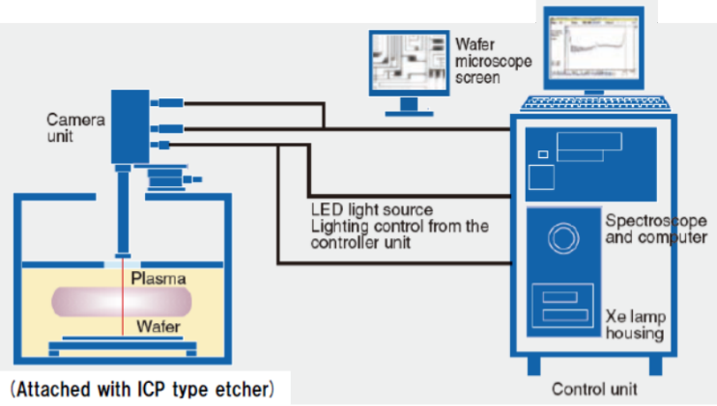

Fig.1: In-situ monitoring system

AlGaInP Cladding Layer Laser Diode Ridge Etching

Most semiconductor laser diodes need to fabricate a ridge stripe structure for current and optical confinement. The ridge formation is critical for laser characteristics such as current threshold density, FFP (Far Field Pattern), etc. [1]-[2] At present, dry etching is used for most of these ridge formations.

In order to minimize variations in laser characteristics, it is necessary to control precise etch depth. Figure 2 shows one example of the in-situ monitoring for ridge formation etching. The etch structure consists of GaInP top layer/AlGaInP cladding layer. The interferometric spectrum of 580 nm and Indium (In) OES of 451 nm are shown as a function of etching time. After the In OES signal of the GaInP contact layer decreases, the etch rate was calculated by using the interferometric spectra from the interface between AlGaInP and its underlayer.
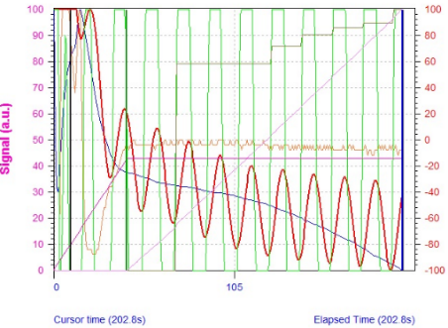
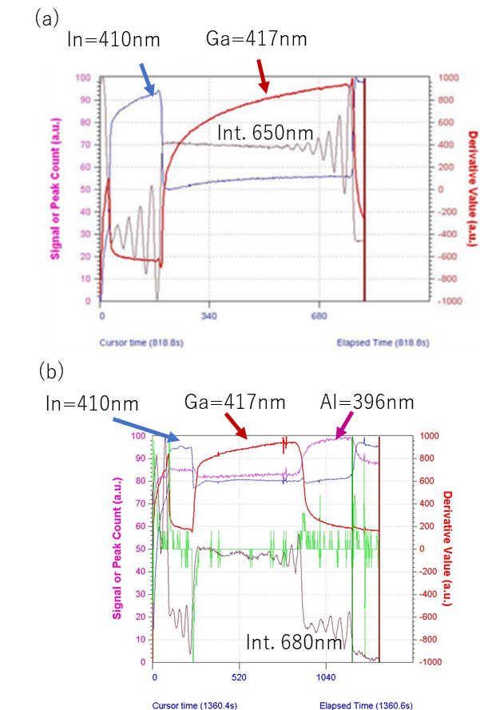
In=451nm
Int. 580nm
Fig.2: In-situ monitoring spectra during AlGaInP cladding etch

The etching depth was controlled to 950 nm and the reproducibility of a continuous six run test was proven as shown in Figure 3.
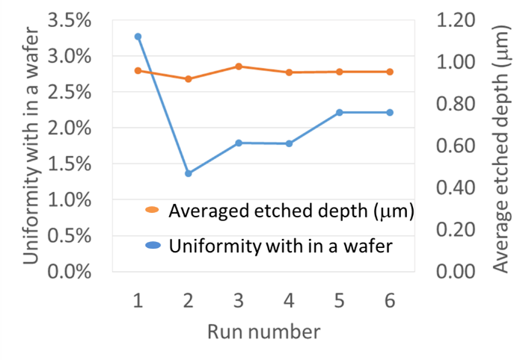

Fig.3: Continuous six run test results for both etching depth and uniformity data for 3inch wafer.

3. InP/InGaAs/InP Photo Diode Mesa Etching

Figure 4(a) shows variations of reflected light at 650 nm and OES signals at 410 nm (Indium) and 417 nm (Gallium) during the etch. Interferometric oscillations from the InP/In_{0.53}Ga_{0.47}As/InP interfaces were clearly detected. The optimum monitoring wavelength can be selected for each epi-structure.

Plasma emission signals are also useful for end point detection since the variation of indium and gallium is large enough.

More complicated epi structures including In_{0.52}Al_{0.48}As layers can be also applied for our in-situ monitoring system as shown in Figure 4(b). SEM observation reveals that the

Fig.4: (a) InP / InGaAs / InP in-situ monitoring spectra and (b)InGaAs/InP/InGaAlAs/InAlAs/InP in-situ monitoring spectra

etch depth corresponds to the target value as shown in Figure 5.
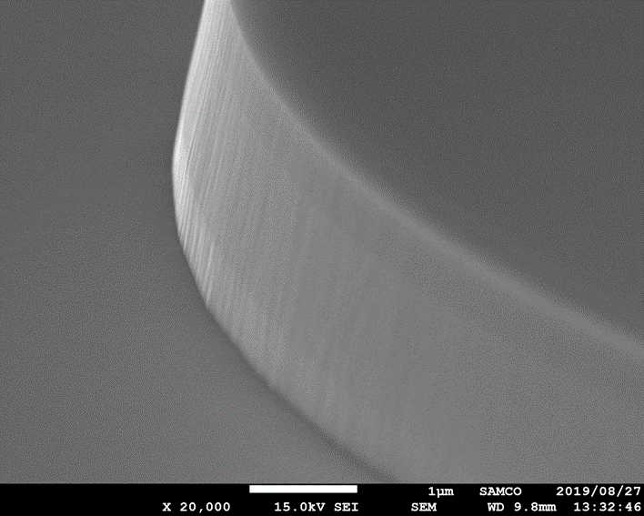

Fig.5: SEM image etched for the epi structure with In_{0.52}Al_{0.48}As layer

- AlGaN/GaN HEMT Gate Recess Etching
Recent research and development advances have brought AlGaN/GaN HEMTs to the production stage. [3] A precise shallow etch of AlGaN is necessary to fabricate the recess gate structure.[4] Interferometric oscillations at the AlGaN (28nm)/GaN interface can be detected by shorter wavelength (< 350nm) light sources as shown in Figure 6(a) and (b). The AlGaN etching rate in Figs. 6(a) and (b) are 2.6 nm/min and 0.7 nm/min, respectively. The part of the oscillation that is dependent on the wavelength of light source was observed. The flat area of the spectra indicates the GaN channel layer. The etching time of each bottom position can be used to analyze the end point detection signals.
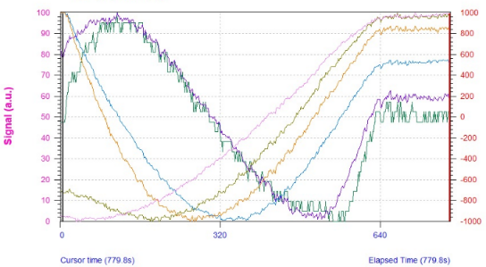
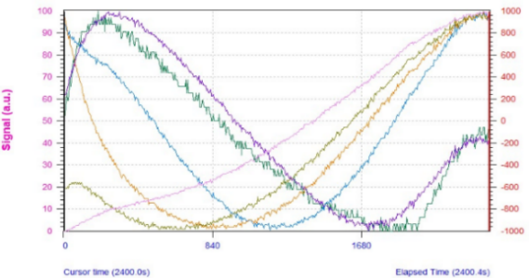
(a)
300nm
350nm
300nm
(b)
350nm

Fig. 6: In-situ monitoring spectra of AlGaN/GaN etching (a) etching rate of 2.68 nm/min, (b) etching rate of 0.78 nm/min

Conclusions

We presented ICP etching examples of compound semiconductor device using our high performance in-situ monitoring system. Multiple wavelength monitoring utilizing both interferometric signals and optical emission spectra allowed end point detection for various complex compound semiconductor epi-structures.

Acknowledgements

The authors are sincerely grateful to the following Samco staff: Matthew Alexander, Yoshi Uesugi, Henry Chan, Tobin McGee, and Atsushi Tsuchihashi for business development and technical discussions. We also would like to thank Tsukasa Kawabe (COO) and Osamu Tsuji (CEO and chairman) for supporting research and development projects.

References

[1] K. Nitta et al., Astigmatism in Ridge-Stripe InGaAlP Laser Diodes, JJAP 28, L2089 (1989).

[2] B. Ma et al., Realization of High-Power Highly Efficient GaInP/AlGaInP Ridfe Laser Diodes for Recordable/Rewritable Digital Versatile Discs, JJAP 45, 774 (2006).

[3] P. Moens et al., AlGaN/GaN Power Devices in a Si World: From R&D to Manufacturing and Reliability, 2019 CS MANTECH Digest of Papers, pp. 137-140, May 2019.

[4] Hosoi et al., Mobility enhancement in recessed-gate AlGaN/GaN MOS-HFETs using an AlON gate insulator, JJAP 58, SCCD16 (2019).

Acronyms

ICP: Inductively Coupled Plasma
SEM: Scanning Electron Microscope
EPD: End Point Detection
OES: Optical Emission Spectroscopy
HEMT: High Electron Mobility Transistor

