AlGaN/GaN Ohmic Contact Investigation

Chiao-Yi Tsai*, Szu-Ting Chen, Cheng-Ju Lin, Yi-Wei Lien, Wei-Chou Wang and Kai-Sin Cho

WIN Semiconductors Corp., No. 35, Technology 7th Rd., Hwaya Technology Park, Guishan District, Taoyuan City 333, Taiwan
E-mail:joannet@winfoundry.com
Phone: +886-3-3975999#2321

Keywords: GaN, ohmic contact, TEM, phase identification, TiN, Ti₃AlN

Abstract
To produce high performance AlGaN/GaN heterostructure field effect transistors for RF power applications, one of the critical control parameters of AlGaN/GaN system is the contact resistance (Rc) of the ohmic metal to AlGaN. In the present study, two important factors for the contact resistance, a Ti₃AlN interfacial layer and TiN islands were investigated using phase identification, and morphology as determined by Nano Beam Electron Diffraction (NBD) technique in transmission electron microscopy. Based on our study, both Ti₃AlN interfacial layer and TiN islands contribute to ohmic contact behavior in the system.

Introduction

Gallium nitride (GaN), with its wide bandgap (3.4 eV) and high breakdown voltage, is ideal for high-power applications at microwave frequencies. Especially AlGaN/GaN heterostructures, as high electron mobility transistors (HEMT) are capable of handling higher current densities than other III-V high electron mobility transistors due to higher density of two-dimensional electron gas (2DEG). These are widely investigated for the applications in 5G base stations [1]. To fabricate high performance AlGaN/GaN devices, low contact resistance is essential. However, ohmic contacts to AlGaN/GaN are effected by ohmic scheme, alloy temperature, atomosphere, and epi etc. The TiAl-based multilayer metallization is well-known to be the most suitable ohmic scheme for AlGaN/GaN heterostructures [2].

In this article, WIN Semiconductors evaluated the microstructure of ohmic contacts in detail and also verified the mechanisms of ohmic contact in AlGaN/GaN system. Two models of ohmic contact are discussed. First, nitrogen vacancies generated by interfacial reaction during annealing created a heavily n-doped in AlGaN, thus enhancing the possibility of carrier tunneling [3]. The second one is intermetallic TiN islands with lower work function (3.74 eV) [4] than that of Ti (4.33 eV) [5] providing a direct electric path for carrier between 2DEG and ohmic metal [6, 7].

experimental procedure

Ti/Al/Mo/Au ohmic multilayer was deposited on typical (0001)-oriented AlGaN/GaN structure on SiC substrate using e-beam evaporation in a vacuum of $1×{10}^{-6}$torr and then annealed above 800$℃$ with N₂ gas flow. The contact resistance (Rc) was measured by a linear Transimission-Line Modeling (TLM) Method. TLM pattern was defined by photolithography process.
TEM analysis including high resolution TEM, HADDF and Nano Beam Electron Diffraction (NBD) technique were carried out using FEI-TALOS operated at 200 kV which supports phase identification of ultra thin interfacial layers. EDX mappings were obtained from a Super-X SDD detector system to observe the ohmic metal composition after high temperature annealing. EELS analysis was conducted using JEOL ARM-200F to analyze the element binding in the interfacial layer. Ohmic metal and TiN islands were etched by nitric acid and sulfuric acid to view the distribution of TiN islands under SEM inspection. Image J software was used to analyze the coverage ratio of TiN islands under ohmic metal.

results and discussions

Ohmic contacts with low contact resistance (Rc), high thermal stability, and smooth surface morphology on AlGaN/GaN is crucial for mass production of GaN HEMTs. To control ohmic contact performance, failure analysis of samples with different contact resistance is important to the knowledge of ohmic contact mechanism. In the present study, TEM NBD technique was applied to identify the interfacial layer in the samples with low Rc (~0.35 ohm-mm) and high Rc (~0.84 ohm-mm). TEM EDX mappings of the interfacial layer in the samples with high Rc (Fig. 1(a)) found a Ti-rich layer existing on AlGaN epi. However in the sample with low Rc, a 2-nm-thick ternary phase with Ti, Al, and N was observed in the interfacial layer (Fig. 1(b)). Phase identification of Ti-Al-N ternary phase was conducted by NBD with 5 nm spot size. Diffraction pattern of the interlayer shows the overlay of ohmic Au, AlGaN, and Ti-Al-N ternary phase (Fig. 2.). After excluding the diffraction pattern of Au and AlGaN, we identified the interfacial layer as Ti₃AlN phase in point group m$\overset{¯}{3}$m with cubic crystal structure (Fig. 3.).

(a)
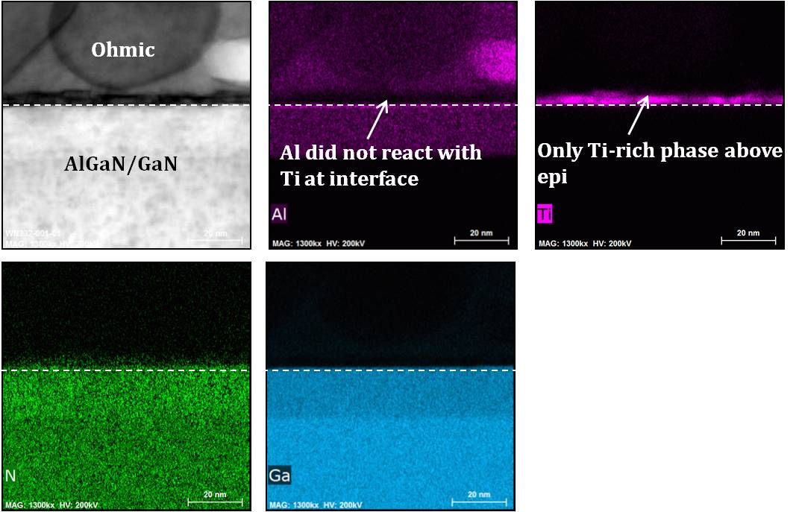

(b)
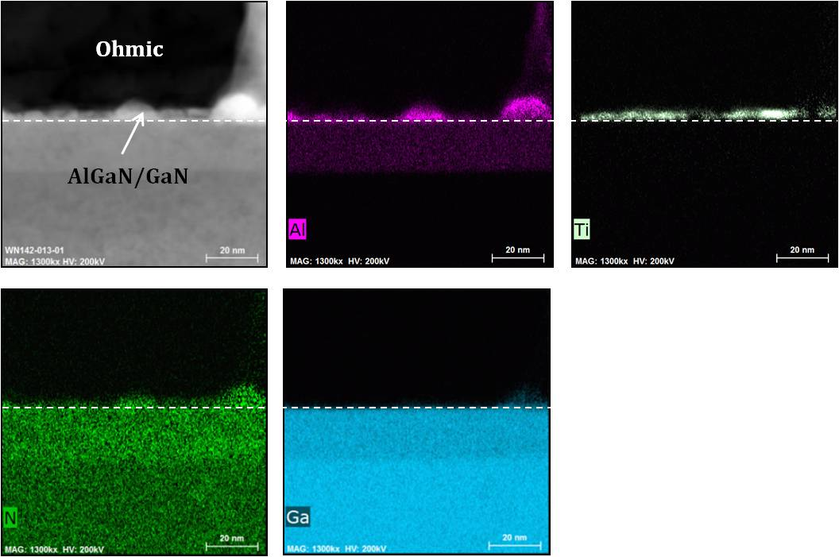
Fig. 1. TEM EDX mapping at the interface between ohmic metal and epi in the samples with (a) high Rc (0.84 ohm-mm) and (b) low Rc (0.35 ohm-mm).

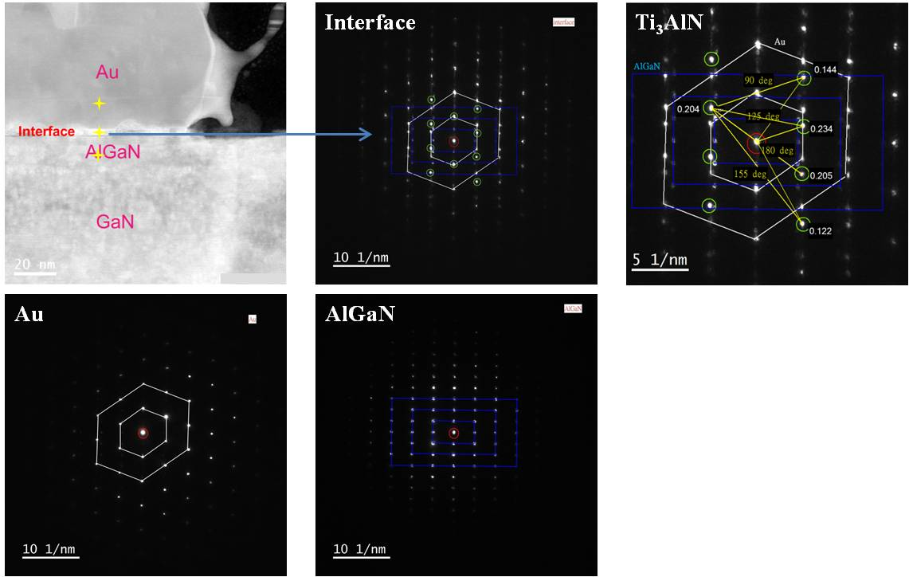
Fig. 2. Diffraction pattern of interfacial layer from NBD in the sample with low Rc (0.35 ohm-mm) which included Au, AlGaN and Ti₃AlN phase.
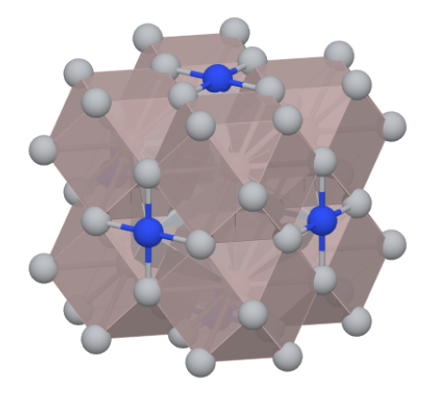
Fig. 3. Ti₃AlN crystallize in point group m$\overset{¯}{3}$m with cubic structure.

On the other hand, the diffraction pattern of the interfacial layer in high Rc sample cannot be analyzed due to poor crystallinity (Fig. 4.). In order to investigate the Ti-rich layer with poor crystallinity existing on epi in high Rc samples, EELS analysis was also conducted in an effort to characterize the composition of the Ti-rich layer. The energy loss peak of Ti-rich layer in the high Rc sample was identified as TiN at the interface (Fig. 5.).
From microstructural characterization of the samples with different ohmic contact resistance, we found distinct interfacial layers were produced owing to the process variation during annealing in high temperature. There is a solid reaction between ohmic metal Ti and Al with AlGaN in high temperature annealing to form crystallized Ti₃AlN phase at the interface in the sample with good ohmic contact. Thus N vacancies were induced during the formation of Ti₃AlN which enhances the possibility of carrier tunneling in AlGaN thus decreasing the contact resistance. As for the high Rc sample, Al has outdiffused toward the surface, and Ti-N bond was generated at the interface.

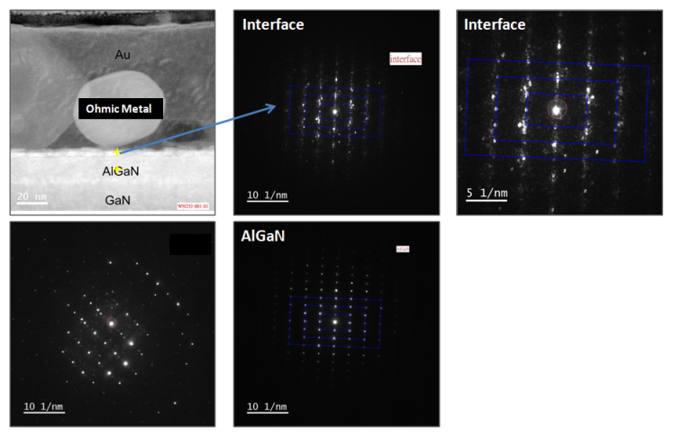
Fig. 4. Diffraction pattern of interfacial layer from NBD in the sample with high Rc (0.84 ohm-mm).

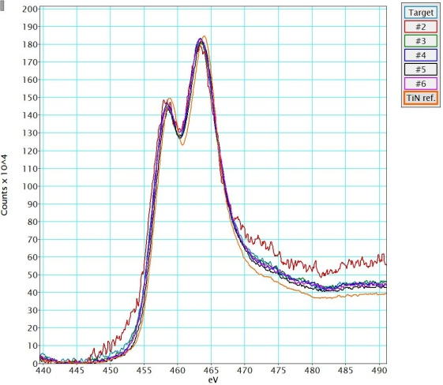
Fig. 5. Energy loss peak of Ti-rich interfacial layer in high Rc samples shows TiN at the interface.

As for the investigation of ohmic contact contribution of TiN islands, ohmic metal and TiN islands were removed after annealing by nitric acid and sulfuric acid to observe the distribution of TiN islands. Plan view SEM images showed that TiN islands were etched away and left the holes on the epi surface (Fig. 6.). From FIB cross section, the formation of TiN islands penetrated the AlGaN and contacted 2DEG near the interface of AlGaN/GaN (Fig. 7.). These islands are associated with the presence of screw dislocations and interfacial Au (Fig. 8.).

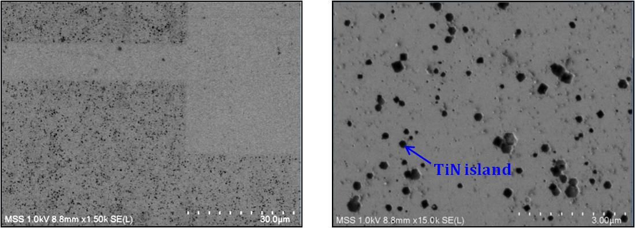
Fig. 6. SEM images with plane view after removing ohmic metal by nitric acid and sulfuric acid. The hole was left by the removal of TiN island.

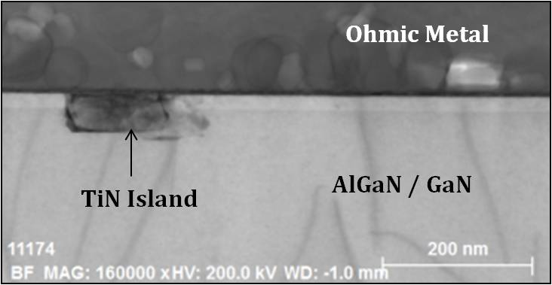
Fig. 7. SEM image of TiN island in cross section view under ohmic metal.
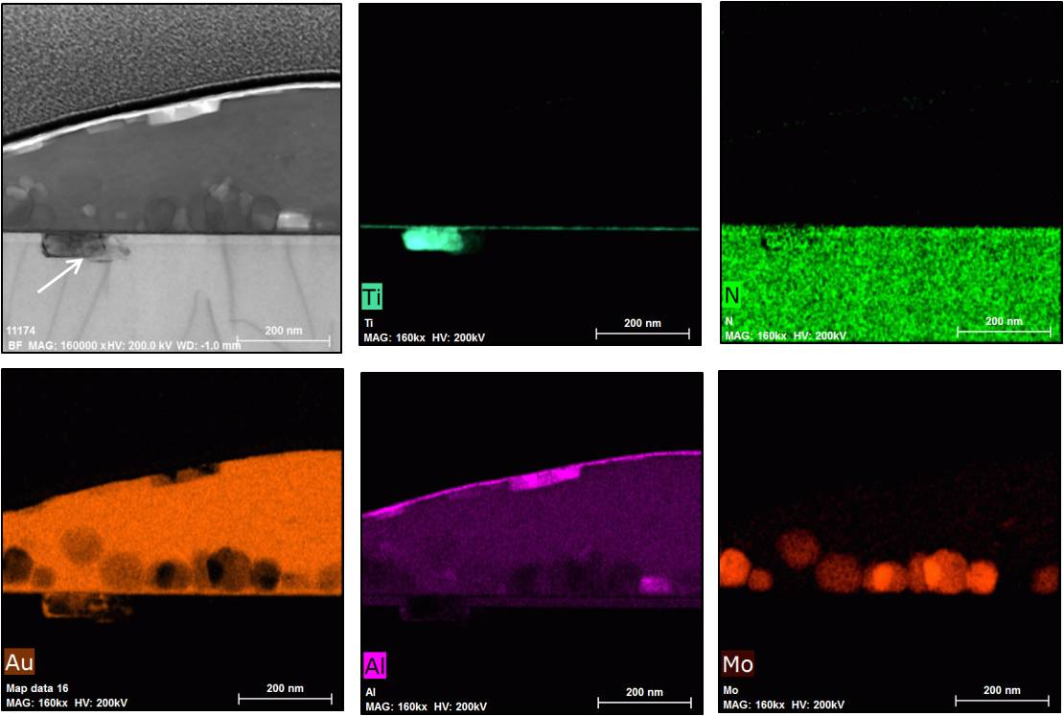
Fig. 8. TEM EDX mapping shows TiN island penetrated AlGaN/GaN which associated with interfacial Au.

For the purpose of studying the contribution of TiN island, Image J software was utilized to calculate the coverage ratio of TiN island in SEM images with plan view since SEM images with dark contrast indicated the existence of TiN islands. Average coverage ratio of TiN islands reached 4.40% in the sample with low contact resistance (Fig. 9.). On the other hand, we observed lower average coverage ratio of TiN islands in the sample with high contact resistance which is 3.42% (Fig. 9.). Furthermore the distribution of TiN islands on the epi surface is more uniform in the sample with good ohmic contact behavior.

- Low Rc sample (b) High Rc sample
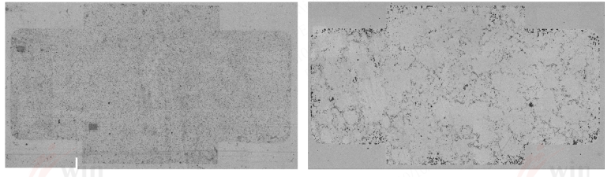
Fig. 9. SEM images with plane view after removing ohmic metal. (a) Low Rc sample, average coverage rate of TiN island was 4.40%. (b) High Rc sample, average coverage rate of TiN island was 3.42%.

Based on our current study, both Ti₃AlN interfacial layers and TiN islands contribute to good ohmic contact behavior in the system. In summary, the ohmic contact mechanism in Ti/Al/Mo/Au on AlGaN/GaN is illustrated in Fig. 10. Two dominant factors provide carrier conduction path in two different ways. One is the onset of crystallized Ti₃AlN formation and its corresponding depletion of N from the surface of AlGaN. It creates a heavily N-doped in AlGaN, thus enhancing the possibility of carrier tunneling. The other factor is TiN islands with lower work function which provide a direct electrical conduction for carrier between ohmic metal and 2DEG.
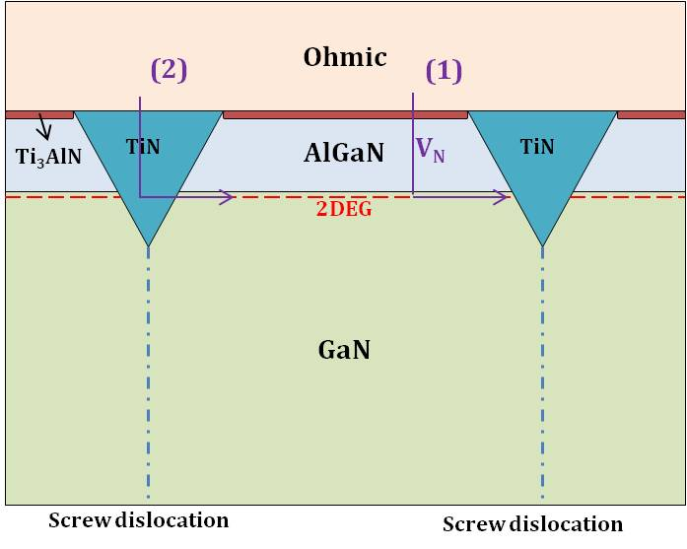
Fig. 10. Illustration of ohmic contact mechanism in Ti/Al/Mo/Au on AlGaN/GaN.

Conclusions

Two dominant factors of ohmic contact in Ti/Al/Mo/Au system were investigated in this study. Both Ti₃AlN interfacial layer and TiN islands have contribution to good ohmic contact behavior. Crystallized Ti₃AlN with cubic crystal was identified by NBD under high resolution TEM in the sample with low contact resistance (~0.35 ohm-mm). Higher TiN islands coverage ratio was also found in the sample with low contact resistance which reached 4.4%.
As for the sample with high contact resistance (~0.84 ohm-mm), ohmic metal Al was outdiffused toward the surface due to process variation during high temperature annealing instead of forming Ti-Al-N ternary phase at the interface. Lower coverage ratio and non-uniform distribution of TiN islands were also observed in high Rc sample.

Acknowledgements

This study was supported by MSS Corps. Ltd. in Hsinchu, Taiwan including delayer, TEM, and SEM analysis.

References

[1] O. Ambacher et al., J. Appl. Phys. 85, 3222 (1999).
[2] S. Ruvimov et al., Appl. Phys. Lett. 73, 2582 (1998).
[3] Z. F. Fan et al., Appl. Phys. Lett. 68, 1672 (1996).
[4] S. Miller and P. H. Holloway, J. Electron. Mater. 25, 1709 (1996).
[5] B. P. Luther, S. E. Mohney, and T. N. Jackson, Semicond. Sci. Technol. 13, 1322 (1998).
[6] R. P. Taylor et al., J. Appl. Phys. 76, 7966 (1994).
[7] R. P. Taylor et al., Superlattices Microstruct. 24, 337 (1998).

Acronyms

HEMT: High Electron Mobility Transistors
2DEG: Two-dimensional Electron Gas
Rc: Contact Resistance
TLM: Transimission-Line Modeling
NBD: Nano Beam Electron Diffraction
TEM: Transmission Electron Microscopy
EELS: Electron Energy Loss Spectroscopy

