Homoepitaxial GaN for vertical power and RF hybrid devices grown on production-scale MOCVD reactors

F. Kaess, O. Laboutin, C.-K. Kao, H. Marchand

IQE MA, 200 John Hancock Rd. Taunton, MA 02780, felixkaess@iqep.com, Phone: 508-824-6696

Keywords: GaN, MOCVD, III-nitrides, Homoepitaxy

Abstract
Homoepitaxial GaN growth was implemented, studied, and improved in a production scale MOCVD reactor. The epitaxial GaN threading dislocation density was very close to that of the different free-standing GaN substrates and uniform across large diameters. We were able to limit incorporation of impurities to the low levels required for vertical electron drift layers by using appropriate growth process conditions. Different surface analysis studies revealed near-perfect step flow growth over large areas of the wafers.

Introduction

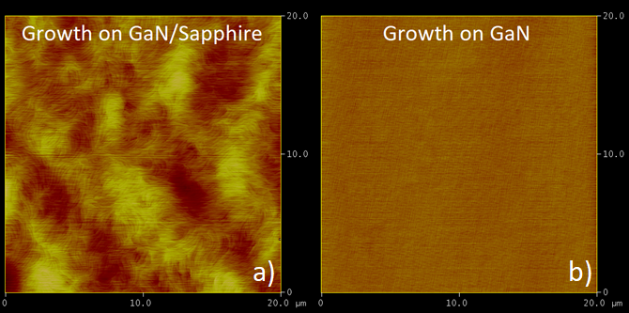
Wide-bandgap semiconductors such as SiC, GaN, and Ga₂O₃ are promising candidates for high power and high frequency electronic applications. Especially GaN with its increasing availability, quality, and acceptance in industry is an important semiconductor for new vertical electronic devices, which can have significant advantages over current lateral devices [1]. Those benefits include: 1) higher breakdown voltages, 2) much smaller chip sizes with respect to system performance, 3) better thermal management, 4) superior reliability, as the device surface does not need to endure peak electric fields. Several new vertical GaN device concepts, such as advanced MIS Schottky barrier diodes or vertical fin MOSFETs, do not require p-doping [2]. This prevents the associated technical difficulties of reduced breakdown voltage or low carrier mobilities, along with additional processes such as GaN regrowth or Mg ion implantation.
This work focuses on achieving high crystal quality of GaN for applications in vertical electronic devices through epitaxy in production scale MOCVD reactors, as it is important to find economic processes to produce and characterize GaN-on-GaN epiwafers. The GaN growth initiation, defect incorporation, electrical properties, structural quality, and surface morphologies of GaN epilayers were analyzed using different characterization techniques.

Fig. 1. (20 x 20)µm AFM images of a GaN epi layer stack grown on 100mm a) GaN/sapphire template vs. b) free-standing GaN substrate (from the same production run): Image Z range is a) 22.0nm vs. b) 2.3nm; RMS roughness is a) 0.74nm vs. b) 0.19nm, respectively.

Experimental

GaN layers between 1µm and 12µm total thickness were grown on GaN/sapphire templates and on commercially available free-standing GaN substrates of either 2- or 4-inch diameter. The GaN/sapphire templates were produced at IQE. Trimethylgallium (TMGa) and ammonia (NH₃) were used as the Ga and N precursor, respectively. Disilane (Si₂H₆) was used for intentional doping of parts of the structures. Both N₂ and H₂ were used as a carrier gas for the growth and for the in-situ surface preparation of the GaN substrates.
The surface morphology of the GaN wafers was studied using AFM in tapping mode: i) prior to epitaxy, ii) after in-situ annealing, and iii) post-epitaxy.
Figure 1 shows typical (20 x 20)µm scans of the post-epitaxy GaN surface. The RMS surface roughness of GaN on a) GaN/sapphire template and b) free-standing GaN substrate was 0.74nm and 0.19nm, respectively. The latter is close to the theoretical limit for the observed 2D step-flow growth morphology.

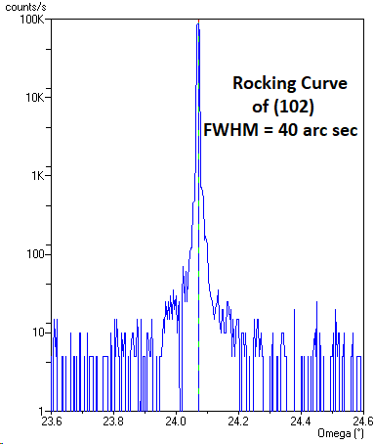
Fig. 2. Rocking curve scan of the (102) peak of a typical GaN homoepitaxial film. The high structural quality of the epi film typically matches the substrate.

The GaN epiwafers were measured using HRXRD, revealing rocking curve FWHM values around 60arcsec for the (002) and as low as 40arcsec for the (102) peak of the epitaxial GaN layers [3]. A typical example of a rocking curve scan is shown in Figure 2. This was found to be slightly narrower than the pre-epi substrate peak width in some cases. The total threading dislocation density of the GaN films can be estimated to be around 1·10⁶cm⁻², which is mostly dependent on the quality of the GaN substrate used.
The flatness of a 4-inch homoepitaxial GaN wafer was analyzed using a standard capacitance-based contactless wafer measurement tool. The wafer bow and warp were measured to be 22.7µm and 28.7µm, respectively, which is consistent with typical flatness requirements for device fabrication [4].

Since there is no substantial refractive index contrast between the GaN substrate and the epitaxial film, traditional growth rate metrology tools relying on interferometry cannot be used for thickness measurements. Instead, companion wafers grown on GaN/sapphire templates were measured using cross-sectional SEM to analyze the thickness and structural uniformity of the GaN grown under different conditions, see an example in Figure 4.
The total GaN thickness (epitaxial and template) of this sample is measured to be 16.3µm, which is in excellent agreement with a simple optical ex-situ Fabry-Perot interference measurement of the epi-stack. In the SEM scan, the GaN/GaN overgrowth interface cannot be identified, which should be at around 5µm distance from the GaN/sapphire interface of the initial template growth. This finding is expected for an optimized GaN surface preparation before initiating the GaN overgrowth.
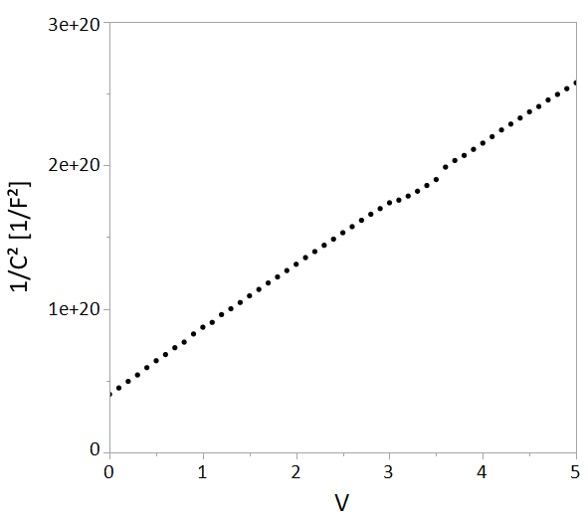
Fig. 3. Capacitance-voltage measurement of a typical epiwafer with unintentionally doped thick GaN top layer

Further, capacitance-voltage profiling was used to probe the effective carrier concentration in the electron drift layer, see Figure 3. A constant slope of 1/C² vs. V was measured over the entire range of applied voltages (0-5V), corresponding to the required low carrier concentration for drift layers of vertical GaN devices.

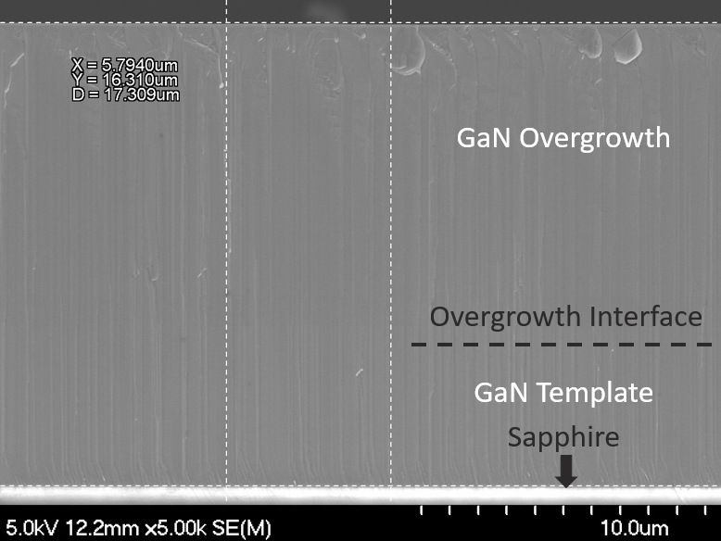
Fig. 4. Cross-sectional SEM image of a companion wafer grown on a GaN/sapphire template, total GaN epi thickness is 16.3µm (including template). This measurement determines the growth rate for different conditions during epitaxy and helps improve overall wafer uniformity.

The unintentional incorporation of point defects was investigated using high-precision SIMS analysis, carried out by Eurofins EAG Laboratory. When optimized growth conditions are used, the defect levels of unintentional C and O for the electron drift layer could be limited to concentrations in the mid 10¹⁵cm⁻³ and low 10¹⁵cm⁻³ range, respectively [5]. This is consistent with the requirements on ionized impurity background in the low 10¹⁶cm⁻³ range or below, to ensure proper control of the electric field in the drift layer. This limits the ionized impurity scattering and enables free electron mobility of 1000cm²/Vs and above for carrier transport in direction of the c-axis.
Besides analyzing the drift layer, it was shown that intentional Si-doping could be controlled in a range between low 10¹⁶cm⁻³ to low 10¹⁹cm⁻³ for specific layers of the different epi-structures.

Conclusion

In summary, homoepitaxial growth on free-standing GaN substrates was carried out using production scale MOCVD reactors. High crystalline quality and low defect incorporation into the electron drift layers were demonstrated, which are arguably the most challenging part for the growth of almost any vertical GaN device epi-structure.

References

[1] T. Oka, Jpn. J. Appl. Phys. 58 SB0805 (2019)
[2] Y. Zhang, M. Sun, J. Perozek, Z. Liu, A. Zubair, D. Piedra, N. Chowdhury, X. Gao, K. Shepard, T. Palacios, IEEE El. Dev. Lett., 40 1 (2019)
[3] H. Heinke, V. Kirchner, S. Einfeldt, and D. Hommel, Appl. Phys. Lett. 77, 2145 (2000)
[4] D. Zhu, C. McAleese, K. K. McLaughlin, M. Häberlen, C. O. Salcianu, E. J. Thrush, M. J. Kappers, W. A. Phillips, P. Lane, D. J. Wallis, T. Martin, M. Astles, S. Thomas, A. Pakes, M. Heuken, C. J. Humphreys, SPIE Proc. 7231, LED 723118 (2009)
[5] F. Kaess, S. Mita, J. Xie, P. Reddy, A. Klump, L. H. Hernandez-Balderrama, S. Washiyama, A. Franke, R. Kirste, A. Hoffmann, R. Collazo, and Z. Sitar, J. Appl. Phys. 120, 105701 (2016)

Acronyms

MOCVD: Metal-Organic Chemical Vapor Deposition
MIS: Metal Insulator Semiconductor
MOSFET: Metal Oxide Semiconductor Field Effect Transistor
HRXRD: High-Resolution X-ray Diffraction
FWHM: Full Width at Half Maximum
AFM: Atomic Force Microscopy
SIMS: Secondary Ion Mass Spectroscopy
SEM: Scanning Electron Microscopy
RMS: Root Mean Square

