**High Uniformity Etching of GaAs/AlGaAs VCSEL Mesas**

Katie Hore*, Ning Zhang, Stephanie Baclet and Ligang Deng

Oxford Instruments Plasma Technology, North End, Yatton, Bristol BS49 4AP, UK

*Email: katie.hore@oxinst.com Tel: +44 1934 837000

## **Keywords: VCSELs, lasers, gallium arsenide, uniformity**

## **Abstract**

**The etching of uniform, repeatable GaAs/AlGaAs mesas is an important step in manufacturing VCSELs. This paper presents a high uniformity, low foot etching of mesa structures on 6” wafers. The improved uniformity permits the use of production-friendly optical endpoint techniques which can be used to stop on a specific layer in the VCSEL structure.**

VCSELs are already in daily use by most of us in ‘low tech’ applications such as laser mice and laser printers [1,2]. More recently the market has increased in ‘high tech’ applications, for example, facial recognition in luxury smart phones and LiDAR (Light Detection and Ranging). The market share will continue to grow as these high-end applications become more affordable [3].

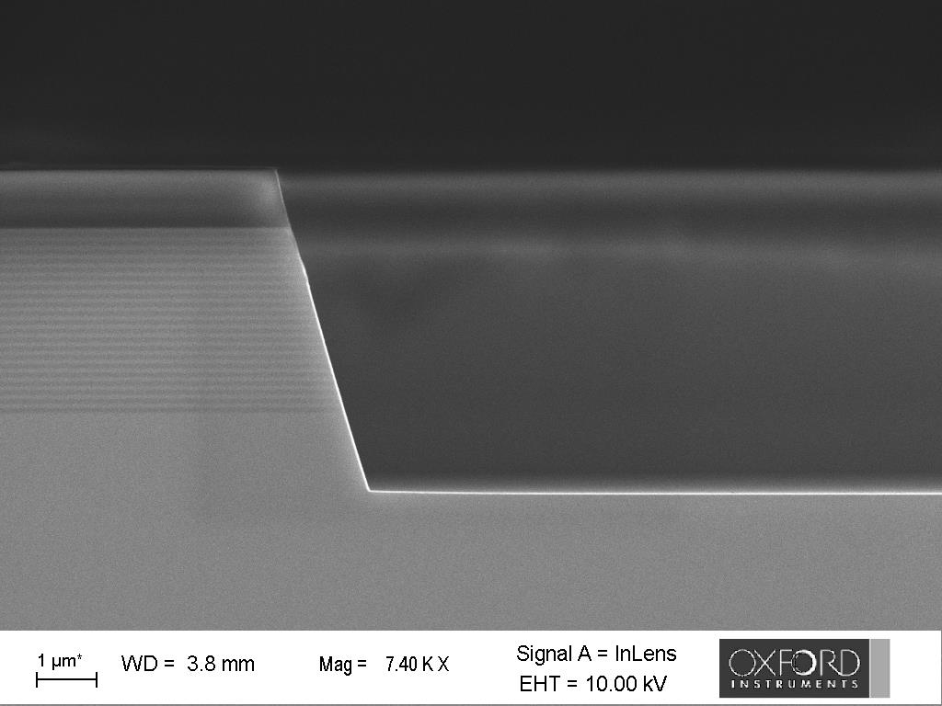

Fig. 1. SEM images of GaAs/AlGaAs mesa etched using a SiNx mask.

### VCSELs are simpler (and therefore cheaper) to manufacture than standard edge emitting lasers and they can be produced at a higher density on larger wafers. The ‘vertical’ structure allows for in-line testing, the formation of 2D arrays and high level of integration of the VCSEL with other components such as mirrors and photodetectors. VCSELs also have a lower threshold current and lower power consumption than comparable edge emitters, so they are inexpensive to run and more environmentally-friendly. The light beam they produce is circular, monochromatic, and with low divergence. There is also the possibility for effective wavelength tuning.

There are multiple steps in the formation of a VCSEL, all of which must be precisely controlled to ensure consistent performance of the final product.

Among the most important steps is etching through the epitaxial layers and the active region to form the main structure of the laser - the mesa. Examples of plasma etched VCSEL mesas are shown in Fig. 1. The geometry and the etching of the mesas must be carefully considered as the structure will affect the final performance of the device. The diameter of the mesa will affect the power conversion efficiency and the threshold current of the device. The sidewalls of the device must be smooth to ensure that there is no damage to the active region. The mesa must be etched accurately and repeatably to a defined etch depth with good uniformity, to prevent the blocking of electrons into the active region or potentially damaging the active region. All the mesas, both within a wafer and between wafers must be identical so the performance of the final product is consistent.

All the processes described in this paper were performed on an Oxford Instruments Plasma Technology Cobra plasma etcher. Depending on the requirements the process was tuned to achieve sidewall angles between 60° and 90° using either a photoresist (PR) or a SiNx mask. The etch rate for both the sloped and vertical processes was >600 nm/min and for the vertical process the selectivity of GaAs:SiNx of >10:1 and of GaAs:PR of >3:1. The sloped process has a selectivity of GaAs:SiNx of >5:1 and of GaAs:PR of >1.5:1 [4].

The process for etching GaAs and related materials is chemically driven; therefore, the etching rate tends to be slower in the centre of the wafer than at the edge. There is a higher concentration of exposed GaAs at the centre compared to the edge with a similar concentration of active species available, so the centre will be etched more slowly. The effect on uniformity will be more pronounced as production moves from 3”/4” to 6” wafers

OIPT have developed chamber furniture which is designed to improve the etch uniformity. Simulations show that this furniture increases the velocity of the molecules close to the wafer and changes the distribution of the plasma in the chamber.

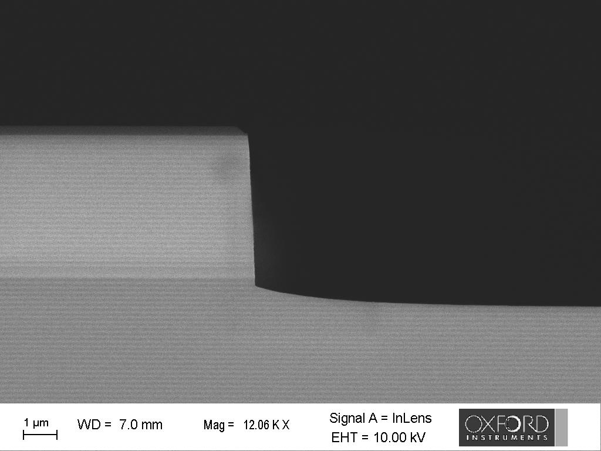

Fig. 2. SEM image of an imperfect mesa etch with large footing.

Foot

Etch depth

The effect of the distance between the wafer and the aperture in the chamber furniture and the size of the aperture has also been investigated experimentally. Without modification to the chamber the uniformity when etching sloped GaAs/AlGaAs mesas on a 6” wafer was ±4.6%[1]. With the optimal baffle configuration, the uniformity was improved to ±1.2%.

 

Fig. 4. OES trace of the ratio of gallium and aluminium signals during the etching of GaAs/AlGaAs mesas. Top: high uniformity process and Bottom: lower uniformity process.

Time (s)

Reflectance (arbitrary units)



Fig. 3. Laser interferometry trace of the etching of a GaAs/AlGaAs mesa.

Another potential issue when etching VCSEL mesas is footing, the curve between the sidewall and the base of the etch (see Fig. 2). Footing can affect the oxidation of the active region and the placement of contacts. Footing also contributes to the (non-)uniformity of the process, a large foot means several epilayers are exposed at the base of each mesa increasing the non‑uniformity across the wafer. For example, the mesa shown in Fig. 2 is 5100 nm deep and has a footing of 610 nm, this equates to a local non-uniformity in the etching of the mesa of ±6.4%. Both the sloped and vertical processes described here have very low footing. Footing of <3% is achievable as shown in Fig. 1.

The etching of the mesas aims to expose the aluminium-rich layer which will be oxidized to form the aperture of the laser. The design of a VCSEL is carefully chosen to give the required electrical and optical properties, therefore, it is important for the mesa etching to stop on the required layer. Time dependent etching is sufficient for some applications but endpointing techniques allow tighter control of the etch depth. Endpointing also reduces the wafer-to-wafer variation.

Laser interferometry (LI) uses the changes in interference trace of a laser reflected off the sample to track the layers etching. In the trace in Fig. 3 each of the oscillations corresponds to one GaAs/AlGaAs pair. It can be used to efficiently track the etching of a single point on the wafer of ~60 µm2 in size. However, it is not an ideal technique for a production environment as it gives no information on what is occurring across the wafer and cannot be used on the etching of smaller features. The laser spot must also be manually positioned on every wafer.

An alternative for the production environment is Optical Emission Spectroscopy (OES) which is a fully automated technique and monitors etching across the whole wafer. When species are excited in a plasma, each emits a characteristic spectrum of light. OES collects the light being emitted by the plasma which is analysed to determine the species present. The evolution of a single emission line from a single species or a weighted quantity which incorporates multiple lines from several species can be tracked. For a typical VCSEL structure the concentrations of gallium and aluminium in the plasma are used to ‘count’ down through the structure as the epilayers are etched. Fig. 4 shows the OES traces for the etching of high and lower uniformity VCSEL mesas. Each of the oscillations corresponds to the etching of a GaAs/AlGaAs pair in the VCSEL’s Bragg reflector. In a higher uniformity process where the same layer is being etched across most of the wafer, the concentrations of species in the plasma will be representative of the layer being etched and the OES trace will show well defined ripples throughout the etch. In a non-uniform process, due to poor cross wafer uniformity or large footing, layers of different composition will be being etched across the wafer at the same time. The concentrations of gallium and aluminium in the plasma will be an average of the layers being etched at that moment and the OES will not have a clear enough signal to define layers with the signal decaying away during the etching.

## Conclusions

In summary, a high uniformity mesa etching process is important for the production of VCSELs to ensure the laser product produces reliable and repeatable performance. High uniformity is achieved using chamber furniture and a low footing process to improve the within-wafer uniformity. Automated OES can be used to monitor the etching and endpoint when the required layer is reached, a high uniformity process allows tracking of the etching of thin epitaxial layers.

## References

[1] J. A. Tatum, *VCSEL proliferation*, Proc. SPIE 6484, 648403 (2014).

[2] F. Koyama, *Advances and new functions of VCSEL photonics*, Optical Review 21(6) pp 893 (2014)

[3] Yole Développement, *VCSELs – Market and Technology Trends 2019*, June 2019

[4] L. Deng, K. Hore, *Patent application,* “SEMICONDUCTOR ETCHING METHODS” WO2020/016578

## Acronyms

VCSEL: Vertical Cavity Surface Emitting Laser

LiDAR: Light Detection And Ranging

PR: Photoresist

LI: Laser interferometry

OES: Optical Emission Spectroscopy

1. Uniformity calculated using the formula: