Rapid Transformation of a Legacy Photonics Fab

Michael Mandracchia
The MAX Group | 180 Old Tappan Road, Bldg. 4, Old Tappan, NJ 07675
Michael_Mandracchia@maxieg.com | 201-750-7888

Keywords: Fab Transformation, Manufacturing Culture, Cycle Time Reduction, Ramping Output

Abstract

The MAX group was hired to provide transitional leadership and to improve fundamental performance of a legacy photonics fab. Over a six-month time-frame, weekly output increased by 32% and cycle time was cut by 46%. This paper will discuss the approach taken to transform the fab.

Introduction

Many compound semiconductor manufacturers live through many years of up and downs in product demand. Through the years, fabs experience personnel changes due to uncertainty, push from management to change culture, and outside factors. In our case study, a sudden turnover of the management team created a leadership gap in an advanced photonic wafer fab. All the key roles in the fab leadership team saw turnover over a very short period of time. The reason for the turnover was to change direction in fab results and drive an overall transformation of the fab. The cycle times and output were not meeting customer demands and there were other issues contributing to poor yield trends showing little improvement. Rapid change often requires changing a leadership team. It leads to resetting expectation levels, bringing in new ideas, and ultimately changing the culture.
The MAX Group was contracted to fill the Fab leadership role and to provide direction until a long-term leader was hired and then to assist in the transformation. Two people from the MAX Group were assigned to the fab. One was assigned to lead the operations and the second was assigned to implement best practices in factory floor management. The duration of the project was six months. Specific targets were given to improve the cycle time and output of the Gallium Arsenide (GaAs) line and to increase the output of the Lithium Niobate (LiNbO3) line. They were as follows:
- Increase the output on the LiNbO3 line by 60% and the GaAs line by 13% over the baseline performance.
- Reduce the cycle time of the GaAs line by 18% from the baseline.
Although these targets were limited to output and cycle time, achieving only those targets would not be sufficient. There was a tacit expectation that the MAX leadership role would extend over the full range of activities a manufacturing operation would be faced with. In that regard, we were involved in all aspects of the operation.

The Overall Resource Effectiveness ™ Study

A couple of months prior to the start of the project, MAX had conducted an Overall Resource Effectiveness ™ study of this factory. The ORE™ includes an intensive multi-observational study of the complex interactions of process tools, people, and WIP flow in the factory. It is targeted at identifying and quantifying the improvement opportunities. During the ORE™, interviews were conducted with all levels of people in the factory. A number of “deep dives” were carried out involving both detailed data analysis and direct observations to explore a topic in full. The observations, discussions, and data suggested the Fab was underperforming and had an opportunity to increase output by 40%.

The Project Challenges

With a project duration set at 6 months, the key challenge was to gain traction quickly and make progress while the key positions were filled. A major challenge was that every senior position in the fab had turned over. Table I captures the key positions to illustrate the extent of the turnover.

TABLE I: TURNOVER OF KEY POSTIONS
Position | Comments
Global Fab VP  (project sponsor) | Approximately 33% into the project the individual was replaced by an external hire.
Fab VP | The position was vacant for the first 25% of the project. It was filled by external hire.
Director Manufacturing | The position was vacant through 42% of the project. It was filled by an external hire.
Director Engineering (Process) | Outgoing Director was in place for a few weeks before leaving. Position was then filled with an internal promotion.
Director Engineering (Product/Process Integration) | Position was vacant through the first 50% of the project. It was then filled by an external hire.
Equipment Director | Outgoing Director was in place for 20% of the time. Position has been vacant since.

Some functions had capable junior level managers who helped bridge the gap until permanent replacement leaders could be identified. In a few functions, there was simply no one with enough knowledge to answer questions or to receive direction in adopting solutions. In those cases, it was necessary to work directly with each individual in the function.
Both the role of the Fab VP and the Manufacturing Manager were critical vacant positions that needed to be covered until replacements were on board. Once on board, it was necessary to work with the newly hired leaders through a transition.
The extent of leadership turnover in the organization generated a lot of concern in the surviving population of employees. Many hours were devoted to guidance and coaching individuals throughout the six months.
Metrics was another area of concern. What had been historically reported out of the operations lacked data integrity. The fab operated with two MES (manufacturing execution system) implementations from which data was extracted to create custom reports. However, the extractions excluded important operational data and, in short, were not presenting clean and accurate representations of operational KPI’s.
From the initial assessment, the findings were that the operation was running more like a LAB/R&D fab site and less like a true manufacturing oriented fab. Many of the best-in-class operational practices were either weak or missing. The fab was staffed with a very bright and talented engineering team that understood the nuances of their technology, but less so the science of manufacturing. They were shipping the highest quality parts in their market but, at the same time, the line required excessive engineering intervention to run and had high levels of scrap. Many of the engineering and manufacturing practices needed to be changed. MAX identified gaps between industry benchmark practices and how the fab was operating. From this, a roadmap for improvement was documented. These changes would ultimately touch every aspect of the operation from planning, manufacturing, and engineering. In addition to addressing methodologies, the culture also needed to be addressed.

CHANGING CULTURE

Much is written about the process of changing culture in an organization. This is not within the scope of this paper. But rest assured, major changes were underway. The corporate leadership set the mandate that change was needed through their actions. Under normal circumstances, it would be difficult for an interim outsider to be impactful on changing work cultures and ingrained practices. The natural tendency for the organization would be to go into a “holding pattern” of sorts pending changes that would come from a permanent leader. The experience level of the MAX assignees helped to build credibility with the team and to minimize organizational paralysis. In fact, just the opposite occurred. Improvement sped up over the six-month period as people were energized by the changes. Not insignificant was the fact then when the newly hired VP of the operations arrived on site, there was perfect alignment in not only the strategy MAX was rolling out, but in the chemistry and work styles between the new leader and the MAX interim leader. This made for a seamless and effective transition. For the organization, there was continuity as they were hearing the same messages from the MAX interim leader and the new VP.

The Improvement Process and Roadmap

Jointly with the client, MAX presented monthly project status, strategy, and planned actions to an executive steering committee that included the CEO, COO, as well as other important leaders within the company. By the 4th week into the project, a roadmap highlighting the issues and plans was set in place. The roadmap covered major topics by category, the observations in detail that illustrated the issues, what the best-in-class practices were, the plans to close the gap, and the current status. The document was painfully direct and far too specific to provide in this paper. In the following paragraphs, the reader will be informed on the solutions implemented.

IMPROVING THE FOCUS ON THE MANUFACTURING MISSION

In order to accelerate manufacturing performance improvement, the organization needed to balance engineering attention between long term development efforts and the needs of supporting the line and improving the existing manufacturing. The following changes were made to increase focus on line execution.
- Daily Operations Meeting: Meeting requirements were documented in a standard work document to set expectations. Meeting start time was shifted from a late morning time to an earlier start time. Mandatory attendance requirements and expected behavior of participants were set. The meeting was run by MAX until a fab manager was onboard. This was a major paradigm change for the organization.
- Supervision: Standard work requirements were implemented that addressed pass-downs, communication, scrap follow-up, and WIP management.
- Engineering: Previously, work schedules for engineering were fully flexible by individual. Steps were taken to adjust schedules to better support manufacturing and to provide some predictability in the presence of engineering in the building.

GETTING TO INDUSTRY STANDARD METRICS

Accurate metrics and performance reporting are a core requirement for manufacturing. Having accurate data is also crucial for planning. There were significant disconnects in the metrics that needed to be addressed.
- Metrics: Worked with IT to create a set of accurate reports for yields, WIP, outs, starts, moves, and cycle time.
- Targets: Implemented the methodology to calculate targets for WIP, moves, and starts to achieve outs and cycle time targets.
- Dashboards: Implemented two dashboards, one for daily performance tracking and the other for weekly executive level reporting.
- Capacity and Labor Models: Reviewed models and identified many improvements and corrections to more accurately capture needs.
- Equipment Tracking: Redefined rules to match SEMI E10 standards and standardized the use across the factory.

IMPROVING WIP MANAGEMENT

WIP Management practices were very poor in the factory. Historical WIP trends were not tracked and there was no process in place to manage WIP levels or the WIP health. There were thousands of wafers sitting in the factory with excessive aging that were not moving. There was WIP on the MES systems that could not be found, as well as large quantities of lot boxes containing wafers that were used for engineering purposes in the past. There was an overly complex priority system with six levels of priority. Actions taken to bring this under control were as follows:
- Starts: Implemented controls to linearize starts across the days of the week. Set WIP control targets to bring down WIP levels to accelerate the line.
- WIP Banks: The practice of parking WIP in the line in “banks” was eliminated. The “banks were closed” and the WIP was dispositioned.
- Lot Priority: Set rules to align with best-in-class practices. Three levels were allowed; hand carry, rush, and standard. Targets were set for each and controlled.
- Line Balance: Developed and implemented tools to manage line balance.
- Lot Dispatch: Implemented dispatch rules based on lot priority level, lateness index, and critical ratio. The MES system lacked dispatch capability so MAX wrote the SQL code to create reports for the line. This helped to tighten the distribution of lots coming out of the factory and aided supervisors in identifying lagging lots.
- WIP Staging: Improvements were made to improve visibility and reduce scrap issues.
- WIP Management: Rules were defined with strict controls on where wafers may be in the factory. The fab and office areas were purged of wafers that did not have a justifiable reason. Wafers were no longer allowed in offices.
- EPI Scheduling: Developed and implemented a scheduling model to manage complexity and minimize EPI WIP overbuilds.

IMPROVING YIELD, QUALITY, AND EFFECTIVE RESPONSE TO LINE PROBLEMS

Significant gaps were apparent in the engineering disciplines around problem solving, the use of SPC, and general disciplines in factory operations. At the corporate level, there were defined and effective approaches but somehow these were not ingrained in this factory’s operations at the correct level. Following were some of the actions taken.
- Problem Solving: Required use of structured problem-solving methodologies. MAX led many problem-solving efforts to demonstrate proper use.
- SPC Disconnects: Identified significant gaps in understanding of basic SPC. Leveraged available corporate quality training to address.
- Quality Policy: Wrote and implemented a policy that defined, in detail, expectations for every level in the fab operations towards quality. This triggered a major effort to address deficiencies in work instructions.
- Change Management: Drove compliance to the already established company process change rules.
- OCAP’s (out of control action plans): At every opportunity reinforced the need for OCAP’s in the work instructions.
- Yield: Implemented a scrap policy. Defined roles and methodologies to track scrap trends. Modified the MES to improve analysis and record keeping and worked to improve effectiveness of yield meetings.
- Rework Reduction: Through the quality policy, implementation standards were set for what was allowable rework. This cut allowable rework flows in half and eliminated all major reworks.

General & business process – knowledge transfer

Following were some general areas where MAX worked with the organization to improve.
- Project Management: Provided methodology for selection and management. Required cataloging all active projects to review the use of resources and to check for alignment with the strategy.
- Process Transfer: Provided detailed guidelines for the successful transfer of processes between manufacturing sites.
- Cycle Time: Delivered extensive training and mentored the new Manufacturing Manager on cycle time management.
- S&OP (sales and operating plan): Documented recommendations for companywide improvement in the S&OP process.
- MES (manufacturing execution system): Led in helping the operations understand and define what the “should be state” is for a modern MES system.
The Results

The following charts capture the results against the agreed metrics. The charts have been normalized to mask sensitive customer information.

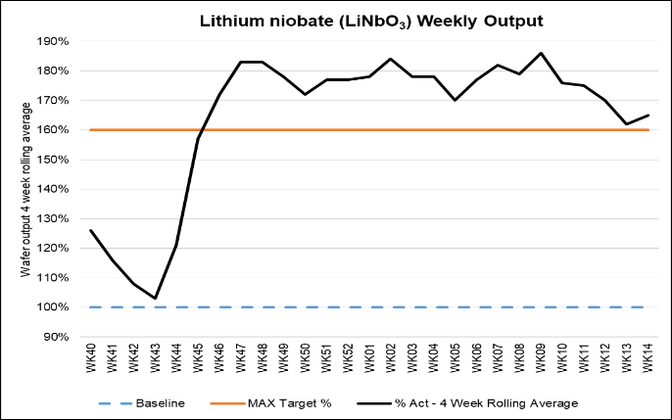
FIGURE 1: Output LiNbO3 line

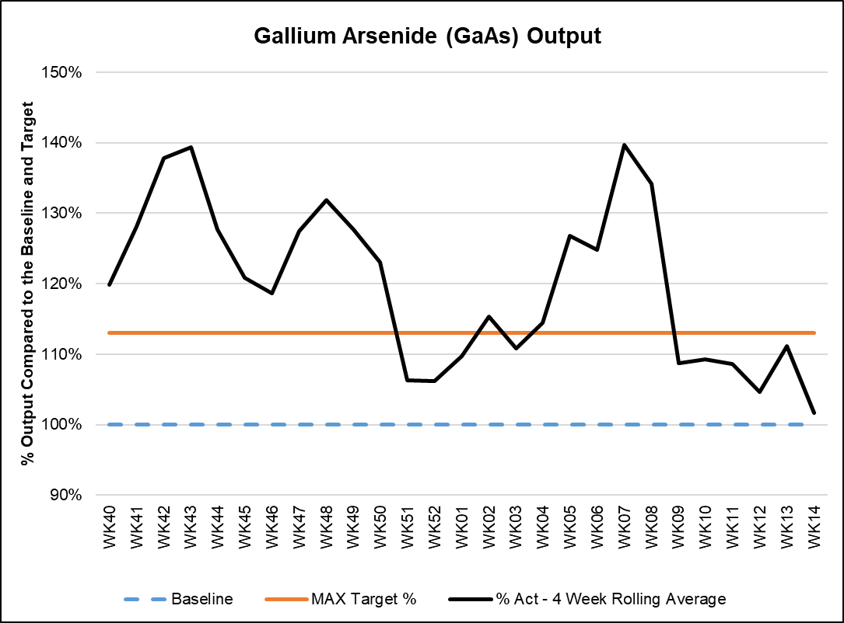
FIGURE 2: Output GaAs line.

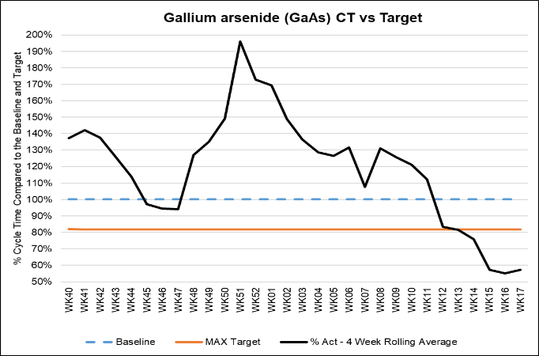
FIGURE 3. Cycle time trend of the GaAs line

FIGURE 1 shows how quickly output was exceeding the goals on the LiNbO3 line. FIGURE 2 shows a similar trend for GaAs products. The tail off in the last five weeks was a result of lowering fab demand to adjust for backend inventory. FIGURE 3 shows that it took over 3 months before the fab was able to reach the goal cycle time. Two reasons accounted for this. First, the baseline excluded lots with extreme cycle time. MAX required that all lots should be included in the metrics. Secondly, the changes in WIP management took time to implement and then time to flush aged WIP. Cycle time is now cut in half and everything is included in the metric.

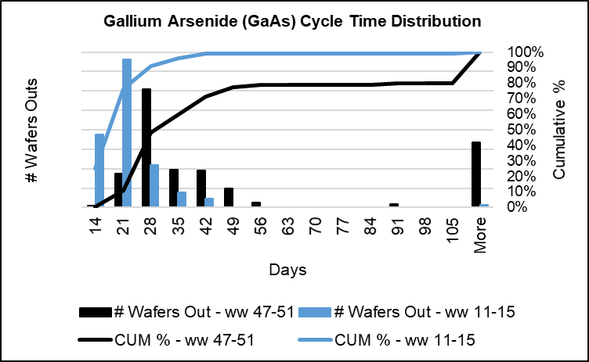
FIGURE 4. Comparison of the distribution of cycle time

FIGURE 4 shows the distribution of recent lot cycle time (WW 11-15) and what it was early in the project (WW 47-51).

Conclusions

Over six months, changes were made to all aspects of the fab operations, resulting in dramatic improvement in the operational metrics. Getting the right metrics in place, instilling a manufacturing culture, and transferring knowledge of best-in-class practices to the team enabled the fab to improve at a surprising rate. Goals were not only reached: they exceeded the company’s expectations. This was accomplished through a period of where there was a leadership transition underway.

Acknowledgements

The author would like to thank the fab staff for their support and willingness to accept many changes. The author would also like to thank his MAX colleague, Renato Masubay, who provided some very creative solutions on the project. Finally, the newly hired leaders who wholeheartedly supported the changes and made the transitions seamless. They were great to work with, together they made the hard work a pleasure!

ACRONYMS

SPC: Statistical Process Control
WIP: Work in Progress
ORE™: (Overall Resource Effectiveness) MAX business process for quantifying the effectiveness of an operation.
SQL: Structured Query Language, a programming language
SEMI E10: An industry standard for measurement of equipment availability.

