Low-Mg Out-Diffusion of a Normally Off p-GaN Gate High-Electron-Mobility Transistor by Using the Laser Activation Technique

Liann-Be Chang¹, Chia-Hao Liu¹, Hsien-Chin Chiu¹, Hsiang-Chun Wang¹, Hao-Yu Wang¹, Chong-Rong Huang¹
¹Department of Electronics Engineering, Chang Gung University, Taoyuan 333, Taiwan

TEL: +886-3-2118800 # 3645 Email: hcchiu@mail.cgu.edu.tw

Keywords: p-GaN gate HEMT, Normally off, Laser activation, Drain lag

Abstract
A low- Magnesium (Mg) out-diffusion normally off p-GaN gated AlGaN/GaN high-electron-mobility transistor (HEMT) was developed using a low-temperature laser activation technique. Conventionally, during the actual p-GaN layer activation procedure, Mg out-diffuses into the AlGaN barrier and GaN channel at high temperatures. In addition, the Al of the AlGaN barrier layer is injected into GaN to generate alloy scattering and to suppress current density. In this study, the GaN doped Mg layer (Mg:GaN)was activated using short-wavelength Nd:YAG pulse laser annealing, and a conventional thermal activation device was processed for comparison. The results demonstrated that the laser activation technique in p-GaN HEMT suppressed the Mg out-diffusion-induced leakage current and trapping effect and enhanced the current density and breakdown voltage. Therefore, using this novel technique, a high and active Mg concentration and a favorable doping confinement can be obtained in the p-GaN layer to realize a stable enhancement-mode operation.

Introduction

A GaN-based high-electron-mobility transistor (HEMT) can be favorably used for high-power and high-frequency applications because of its excellent properties, such as wide band gap, high mobility, and low ON-resistance. However, a typical AlGaN/GaN HEMT is a normally on device that displays a negative threshold voltage, high electron mobility, and high current density because of its two-dimensional electron gas (2DEG) [1]. Therefore, many approaches have been proposed to realize a normally off operation in GaN HEMTs, such as p-GaN gate [2], fluorine treatment under the gate metal [3], gate-recessed structures [4], and ultra-thin barriers [5]. The AlGaN/GaN HEMT with a p-GaN gate is used in commercial products. In the p-GaN HEMT, when the Mg:GaN layer is grown using metal organic chemical vapor deposition (MOCVD), pure NH₃ and high-quality Trimethy gallium (TMG) are used as precursor chemicals and Cp₂Mg is used as the carrier gas for organometallics. However, because of the hydrogen passivation effect, the Mg atoms combine with H atoms and form Mg–H complexes that affect the quality of the p-GaN layer. Therefore, the technique of removing hydrogen from the Mg–H complexes is a key process to activate the Mg in the p-GaN layer. Moreover, the stability of the threshold voltage (V_{TH}) and reliability of the p-GaN HEMT gate are attributed to injection and trapping of holes from the p-GaN gate or the ionization of donor defects, which exhibits a strong relationship with the distribution and activation of Mg atoms in the p-GaN layer [6]. Many studies have proposed a technique in which p-GaN is irradiated using low-energy electron beam interaction and then thermally activated in nitrogen at 700°C to obtain a superior GaN that is epitaxial and conductive [7]. This technique can effectively interrupt the formation of Mg–H complexes, and the Mg atoms can be successfully activated to become the acceptor center. According to cost and flexibility considerations, the activation of p-type GaN is performed at 700–800°C in MOCVD. Posthuma et al. used secondary-ion mass spectrometry (SIMS) to demonstrate that the diffusion distance of Mg atoms is strongly related to the doping concentration and growth temperature [8]. These results indicate that the diffusion distance of Mg atoms in the GaN layer increases in the AlGaN barrier layer with a high growth temperature, heavy doping, and a high growth time, and therefore, current density is suppressed. In this study, a short-wavelength laser activation process was used to activate the p-GaN layer at room temperature for improving serious Mg out-diffusion under a conventional high-temperature environment [9].

EXPERIMENTAL PROCEDURES
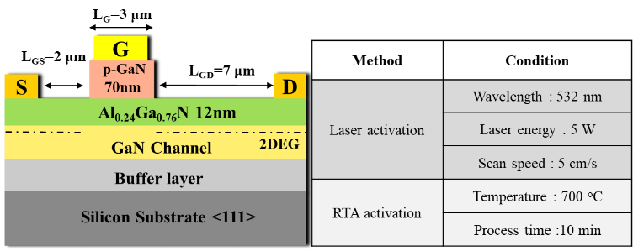

Fig. 1. Cross-sectional schematic of p-GaN gate HEMT and the conditions of laser and RTA activation techniques.

In this study, the p-GaN/AlGaN/GaN HEMT was grown on a 6-inch p-type low resistivity Si (111) substrate by using the
Table 1. Hall measurements for the laser and RTA activation techniques.

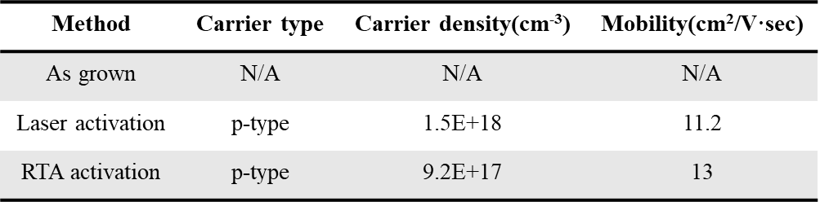

MOCVD technique. For the epitaxial structure presented in Fig. 1, an undoped GaN channel layer with a thickness of 300 nm was grown on an undoped AlGaN/GaN buffer/transition layer with a thickness of 4 μm. Subsequently, a Al_{0.24}Ga_{0.76}N barrier layer with a thickness of 12 nm and a p-type GaN layer with a thickness of 70 nm were grown. The Mg concentration in the p-GaN layer was 3 × 10¹⁹ cm⁻³; however, the in-situ MOCVD-based Mg activation procedure was avoided. Before the standard fabrication procedure, two types of samples were prepared and activated: one by using the laser process (LA-HEMT) and the other by using the RTA system (RTA-HEMT). The process conditions of laser activation and RTA activation are presented in Fig. 1. For LA-HEMT, the sample was loaded into a short-wavelength Nd:YAG pulse laser system at room temperature. The parameters of the Nd:YAG laser are as follows: a wavelength of 532 nm, pulse duration of 20 ns, pulse frequency of 50 kHz, and laser power up to 5 W. The spot size was 2150 μm × 44 μm and the scan speed was 5 cm/s. For RTA-HEMT, the sample was activated using the RTA system at 700 °C for 10 min under nitrogen-rich ambient conditions. For LA-HEMT, the hole concentration and mobility were 1.5 × 10¹⁸ cm⁻³ and 11.2 cm²/V⋅s, respectively. For RTA-HEMT, these values were 9.2 × 10¹⁷ cm⁻³ and 13 cm²/V⋅s, respectively. After laser activation, photon-assisted breaking of Mg–H bonds and/or the removal of hydrogen atoms in the presence of oxygen enhanced the activation efficiency of Mg dopants, which produced p-GaN with an increased hole concentration.
In device fabrication, a SiN_{x} hard mask was used to protect the active region, and the mesa isolation region was removed in a reactive ion etching (RIE) chamber using BCl₃ + Cl₂ mixed gas plasma. To avoid intermetallization between the Ti-gate and p-GaN layer during ohmic high-temperature annealing, the source/drain ohmic contact formation process was started by removing the p-GaN with a thickness of 80 nm. The ohmic region was defined using photolithography, and the p-GaN layer in the ohmic region was etched using low-power chlorine-based inductively coupled plasma RIE. A Ti/Al/Ni/Au (20/150/50/80 nm) metal stack was deposited and annealed at 850 °C for 30 s in an N₂ ambiance. Thereafter, Ti/Au stacked metals of 2-μm length were deposited on the gate region of 3-μm length as gate terminals. A plasma-enhanced chemical vapor deposition SiNx (50 nm) was employed as the passivation layer, followed by a device stabilization bake at 400 °C for 10 min in an N₂ ambiance. The thickness of the deposited gold interconnection metal was 2 μm. The ohmic contact resistance for LA-HEMT and RTA-HEMT was 8.2 10⁻⁵ Ω∙cm² and 9.6 10⁻⁵ Ω∙cm², respectively, as measured using the transmission-line method. For both the fabricated devices, the gate width was 100 μm, gate length was 3 μm, source–gate distance was 2 μm, and gate–drain distance was 7 μm.

RESULTS AND DISCUSSION

Fig. 2 presents the Mg concentration as a function of depth, measured using SIMS, beneath the gate metal of the LA-HEMT and the RTA-HEMT. Fig. 2 clearly suggests that compared with a device without the activation procedure, the Mg atoms diffused into the thin AlGaN barrier layer and the GaN channel, which improved the carrier density of the 2DEG for the RTA p-GaN HEMT. However, in the LA-HEMT system, the Mg out-diffusion effect was suppressed by the low-temperature laser activation process.

Fig. 2. Ga, Al, N, and Mg profiles (SIMS) of the p-GaN gate HEMT fabricated without activation by using laser activation and by using RTA activation.

Figs. 3(a) and (b) present the log-scale transfer (I_{DS}−V_{GS}) and output (I_{DS}−V_{DS}) characteristics of the LA-HEMT and RTA-HEMT. As presented in Fig. 3(a), V_{GS} = 0 V, the OFF-state current for the LA-HEMT and RTA-HEMT was 1.4 × 10⁻⁶ and 6.2 × 10⁻⁶ mA/mm, respectively. The results imply that the leakage in the device channel in the RTA-HEMT was higher, which was caused by the Mg out-diffusion-induced traps at the AlGaN/GaN interface. By contrast, low-temperature laser activation techniques achieved one order of magnitude leakage current improvement because of the slight Mg out-diffusion phenomenon. The threshold voltage (V_{TH}) for the LA-HEMT and RTA-HEMT was 2.5 and 2 V (defined by I_{DS} = 1 mA/mm), respectively. The threshold voltage in the LA-HEMT was higher because of the higher hole concentration and superior hole confinement compared with the RTA-HEMT. The drain ON/OFF current ratio (I_{ON}/I_{OFF}) of the LA-HEMT and RTA-HEMT was 1.7 × 10⁸ and 2.9 × 10⁷, respectively, and adopting the laser activation technique improved the subthreshold swing from 156 to 123 mV/decade. The corresponding maximum drain current density (I_{Dmax}) was 181 and 250 mA/mm, respectively. The I_{Dmax} value of the LA-HEMT was 38% higher than that of the RTA-HEMT because the out-diffusion of Mg and Al atoms was suppressed simultaneously. The ON-resistance (R_{on}) for the LA-HEMT and RTA-HEMT at V_{GS} = 6 V was 8.2 and 13 Ω·mm, respectively, which corresponds to a specific ON-resistance (R_{sp}) of 1.06 and 1.69 mΩ·cm² at V_{DS} = 10 V.

Fig. 3. (a) Log-scale I_{DS}−V_{GS} transfer and (b) I_{DS}−V_{DS} output characteristics of the LA-HEMT and RTA-HEMT and by using RTA activation.

To investigate the improvement in the device reliability resulting from the use of the laser process for Mg:GaN activation, the three-terminal OFF-state and two-terminal Schottky breakdown voltages are presented in Fig. 4. The inset table in Fig. 4(a) displays the values of OFF-state breakdown voltage and figure of merit (FOM = V_{B}² / R_{on}). At V_{GS} = 0 V, the OFF-state breakdown voltage of the LA-HEMT and RTA-HEMT was 466 and 393 V and FOM was 204.8 and 91.3 MW/cm², respectively. The primary cause of this result is that the laser activation technique efficiently suppresses the Mg and Al out-diffusion-induced leakage current. The Schottky breakdown voltage and FOM values are presented in the inset table in Fig 4(b). The measured Schottky breakdown voltage for the RTA-HEMT was −310 V, and this further increased to −479 V by adopting the laser activation technique. The Schottky breakdown FOM of LA-HEMT and RTA-HEMT was 216.4 and 56.8 MW/cm², respectively. Based on these measured results, the Mg out-diffusion in RTA-HEMT also lead to a major carrier traps effect at reverse gate bias conditions; thus, its two-terminal Schottky breakdown is much worse than its OFF-state breakdown.
Low-frequency-noise (LFN) spectra measured under five different bias conditions from 10 to 1000 Hz by using a

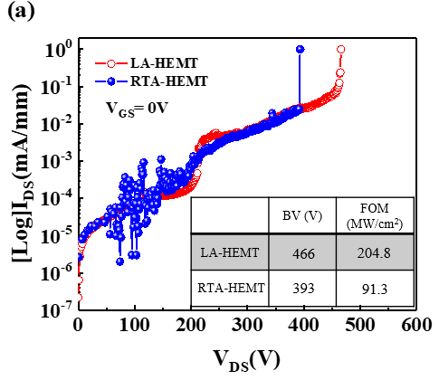

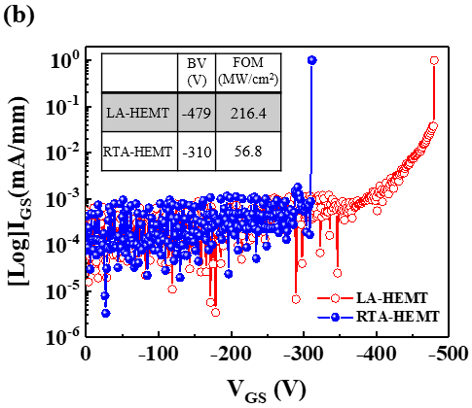

Fig. 4. OFF-state and Schottky breakdown voltages of the LA-HEMT and RTA-HEMT.

noise analyzer (Agilent 35670A) and 1/f noise measurement system software were used to further analyze the Mg and Al out-diffusion-induced traps in the channel layer for both HEMTs, as indicated in Fig 5 (a). The noise level in the LA-HEMT was lower than that in the RTA-HEMT by one order of magnitude because the Mg out-diffusion produces a trapping phenomenon in the channel, which can be expressed by (1) [10]:
$S_{ID}/I_{ D}^{2}=\frac{α_{H}q}{fWLC_{i}｜V_{GS}-V_{th}｜}$ (1)
where f is the frequency, C_{i} is the unit capacitance of the gate insulator, and q is the elementary electron charge. Fig. 5 (b) presents the Hooge’s constant with various V_{GS}−V_{TH} biases for both devices. The order of the α_{H} value of the LA-HEMT and RTA-HEMT was 10⁻³ and 10⁻², respectively. The result evidences that suppression of the Mg and Al out-diffusion-induced trap centers occurs at the p-GaN/AlGaN/GaN interface in the RTA-HEMT and that these traps result in the fluctuation of the device mobility.
To analyze the trapping/detrapping effect, the dynamic R_{on} ratio of the LA-HEMT and RTA-HEMT was measured using a pulse width of 2 μs and period of 200 μs. In this work, there are four bias conditions need to set up which are pulse voltage (V_{GS}, V_{DS}) and quiescent voltage (V_{GSQ}, V_{DSQ}). However, the carrier will be trapped when the quiescent voltage is applied. Then, the carrier has no enough time to be released when the pulse voltage is switching to the quiescent voltage immediately. As the results, the V_{DSQ} for the LA-HEMT and RTA-HEMT was swept from 0 to 100 V and from 0 to 80 V with increments of 20 V, respectively. Clearly, the LA-HEMT exhibits a superior dynamic R_{on} than the RTA-HEMT because the dynamic R_{on} ratio improved from 2.8 to 1.67 times at V_{DSQ} = 80 V, as indicated in Fig. 6. In addition, a higher V_{DSQ} was applied because of a lower trap density in the device channel layer. Therefore, using laser activation technique to suppress out-diffusion of the Mg and Al atoms, a lower dynamic R_{on} ratio can be achieved.

Fig. 5. (a) LFN spectra characteristics and (b) Hooge’s constant value for the LA-HEMT and RTA-HEMT.

Fig. 6. Dynamic R_{on} ratio of the LA-HEMT and RTA-HEMT.

CONCLUSION

In this study, short-wavelength laser energy was applied in the activation process of p-GaN/AlGaN/GaN HEMT. The low-temperature laser activation technique achieved a higher hole concentration and profile confinement in the p-GaN layer when the activation rate was 5%. In addition, SIMS measurement clearly indicated lower out-diffusion of Mg and Al atoms. The LA-HEMT exhibited a drain saturation current of up to 250 mA/mm, which was approximately 38% higher than the drain saturation current exhibited by the RTA-HEMT. In addition, the device Schottky and OFF-state breakdown voltages in the LA-HEMT improved because of its better FOM. The lower trap density and trapping/detrapping effects were analyzed and verified using LFN and pulse measurement. Therefore, the laser activation technique is a promising method to fabricate high-performance normally off p-GaN HEMTs.

REFERENCE

- D.-B. Li, “Direct observation of localized surface plasmon field enhancement by Kelvin probe force microscopy,” Light: Science & Application, vol. 6, e17038, Aug. 2017, doi:10.1038/lsa.2017.38.
- X. Hu, “Enhancement mode AlGaN/GaN HFET with selectively grown pn junction gate,” Electron. Lett., vol. 36, no. 8, pp. 753-754, Apr. 2000, doi:10.1049/el:20000557.
- Y. Cai, “High-performance enhancement-mode AlGaN/GaN HEMTs using fluoride-based plasma treatment,” IEEE Electron Device Lett., vol. 26, no. 7, pp. 435-437, Jul. 2005, doi: 10.1109/LED.2005.851122.
- W. Saito, “Recessed gate structure approach toward normally off high-voltage AlGaN/GaN HEMT for power electronics applications,” IEEE Trans. Electron Devices, vol. 53, no. 2, pp. 356-362, Feb. 2006, doi: 10.1109/TED.2005.862708.
- T. Oka, “AlGaN/GaN recessed MIS-gate HFET with high-threshold-voltage normally-off operation for power electronics applications,” IEEE Electron Device Lett., vol. 29, no. 7, pp. 668–670, Jul. 2008, doi: 10.1109/LED.2008.2000607.
- M. Ge, “Gate Reliability of p-GaN Gate AlGaN/GaN High Electron Mobility Transistors” IEEE Electron Device Lett., vol. 40, no. 3, pp. 379–382, Mar. 2019, doi: 10.1109/LED.2019.2893290.
- H. Amano, “P-Type Conduction in Mg-Doped GaN Treated with Low-Energy Electron Beam Irradiation (LEEBI)”, Appl. Phys., Part 2 28, L2112 ~ (1989).
- N.E. Posthuma, “Impact of Mg out-diffusion and activation on the p-GaN gate HEMT device performance”, ISPSD, June 12–16, 2016.
- S. R. Aid, “Carrier activation in Mg implanted GaN by short wavelength Nd:YAG laser thermal annealing”, Phys. Status Solidi A 214, No. 10, 1700225 (2017) / DOI 10.1002/pssa.201700225.
- C. Surya and T. Y. Hsiang, A thermal activation model for 1/f noise in Si-MOSFETs, Solid State Electron, pp.959–964, (1998).
Acronyms
HEMT: High Electron Mobility Transistor
SIMS: Secondary-Ion Mass Spectrometry
FOM: Figure Of Merit

