Gate Recess Etch Sensitivity of Thick and Highly-Doped GaInAs Cap Layer in InP HEMT Fabrication

Daxin Han, Diego C. Ruiz, Tamara Saranovac, Olivier Ostinelli, Colombo R. Bolognesi*

Millimeter-Wave Electronics Group (MWE)
ETH-Zürich, 8092 Zürich, Switzerland
*Email: colombo@ieee.org
*Tel: +41 44 632 87 75

Keywords: High Electron Mobility Transistor (HEMT), Gate Recess, Gate Leakage, High Cap Doping, Wet Etching

Abstract

The use of highly-doped thick cap layers is a common strategy to enhance the performance of GaInAs/AlInAs/InP High Electron Mobility Transistors (HEMTs) by reducing the Ohmic contact resistance (R_{C}). However, because of the high doping level, cap layers become very sensitive to processing steps performed before and during gate recess etching. In this paper, the sensitivity of gate recess etching on a 20 nm highly-doped GaInAs cap layer (doped 7.3 × 10¹⁹ cm⁻³) is studied with respect to Ohmic contact type (annealed/non-annealed), chip size, gate finger length, and etchant choice. The use of very high cap doping levels exacerbates device and process scaling challenges. For example, the recess finger length dependence complicates multi-project wafer runs which would simultaneously include narrow finger HEMTs used in digital ICs and longer finger HEMTs used in microwave analog circuits.

introduction
InP HEMTs are key components of Low-Noise Amplifiers (LNAs) due to their high gain, high-speed, and low noise figure at high frequencies. Further improvement of the device performance is always desirable, especially regarding their cut-off frequencies (f_{T} and f_{MAX}).
Minimizing the contact resistance (R_{C}) of the source and drain contacts in InP HEMTs results in higher f_{T} [1], where one reliable approach is increasing the doping level of the cap epitaxial layer. The cap doping level is limited by many factors, such as epitaxial growth capabilities and final crystal quality [3]. While higher doping levels improve contact resistance, challenges in the recess etching arise well before the maximum possible doping level is reached as determined by dopant solid solubility. As more dopants are introduced into the cap layer, etching becomes dopant dependent. The cap layers become vulnerable to attack by recess etchants and photoresist removers. Consequently, the etching rate of highly-doped thick caps is much more sensitive to surface conditions compared to the caps with a standard doping level (3 × 10¹⁹ cm⁻³). Surface properties are highly influenced by various aspects of the device processing before and during gate recess etching. In this paper, we report extremely sensitive GaInAs cap recess etching rates in GaInAs/AlInAs/InP HEMTs with respect to various processing aspects including Ohmic contact annealing, chip size, gate finger length, and etchant selection.

fabrication
All experiments presented in this work were carried out on the epitaxial layer stack shown in Fig. 1. HEMTs with non-annealed and annealed contacts were fabricated according to the standard ETH-MWE process flow [4, 5]. The Hall effect measurement at room temperature shows an electron mobility of 1.17 × 10⁴ cm²/V·s and a sheet carrier density of 1.80 × 10¹² /cm². Device fabrication began with the formation of the source and drain Ohmic contacts by evaporation of Ti/Pt/Au (non-annealed) or Ge/Au/Ti/Au (annealed) metal stacks. Next, device isolation was performed by wet chemical etching. Following the patterning by electron beam lithography, the gate region was recessed by selective removal of the n⁺⁺ GaInAs cap layer (doped 7.3 × 10¹⁹ cm⁻³), and the T-gate contact was formed by evaporation and lift-off of a Pt/Ti/Pt/Au metal stack. Following the gate metal deposition, chips were annealed to sink Pt through the InP etch-stop layer and into the AlInAs Schottky barrier, thus reducing the gate-to-channel distance [5]. After passivation with ALD-grown aluminum oxide, the HEMTs were characterized. The discussion in this work is focused on gate-region recess sensitivities.
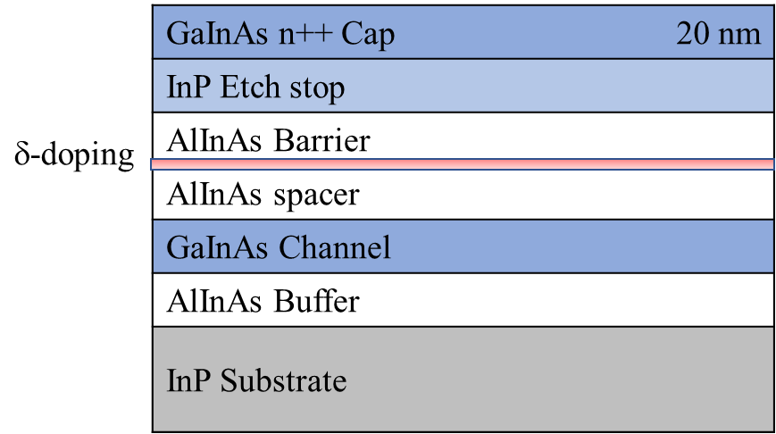
Fig. 1. Schematic cross-section of the epitaxial layer structure used in our experiments.

Experiments
Identical fabrication flows were followed for all samples except for the Ohmic metal deposition and recess etching steps. It is worth mentioning that the recess photoresist exposure and development conditions were identical, resulting in the same recess pattern widths prior to etching. In the following experiments, all recess etchings were performed with the samples held individually with a Teflon tweezer under constant agitation in a beaker filled with recess etchant, which was heated in a thermostatic water bath at 30 ºC. In order to keep comparable etching conditions, the recess etchant was freshly mixed every 20 minutes using a magnetic stirrer.
To study the influence of Ohmic contacts annealing on recess etching, two 7×6.5 mm² chips were processed in parallel. One chip used a Ti/Pt/Au layer stack to form non-annealed Ohmic contacts, whereas the second used a Ge/Au/Ti/Au layer stack thermally annealed at 278 ºC. For the gate recess, cap layers were etched in a solution of citric acid and hydrogen peroxide C₆H₈O₇:H₂O:H₂O₂ (20:20:1) at 30 ºC for both chips. After recessing and removal of the photoresist, the recess region was inspected by Scanning Electron Microscopy (SEM) and shown in Fig. 2. The effective recess etching rate was estimated by comparing the time required to reach a given recess width. For HEMTs with a 10 μm finger length on each chip, 18 seconds are needed to reach a ~200 nm recess width for the first chip, whereas 26 seconds are required for the second chip to reach the same recess opening width.
(a)
(b)
Cursor height = 207 nm
Cursor height = 191 nm
Fig. 2. SEM images of recess width for HEMTs with (a) Ti/Pt/Au non-annealed contact and (b) Ge/Au/Ti/Au annealed contact.
The recess etching rate was also studied by comparing the recess width among transistors of various gate finger lengths (10 to 75 μm) on the same chip, as shown in Fig. 3 for HEMTs with non-annealed Ohmic contacts. For longer fingers, the effective recess etch rate was increased by 43 %, and the recess edge ended up excessively rugged due to high etching rate. With annealed Ohmic contacts, the effective etch rate showed a reduced length dependence and the recess edge maintained a better acuity. The strong effect of gate finger length on the gate recess width has obvious manufacturing implications when varied gate finger lengths have to be processed simultaneously, for instance in multi-project wafer runs where small finger lengths would be used in digital circuits while longer fingers would be needed for microwave parts (for impedance matching considerations).
(b)
Cursor height = 295 nm
Cursor height = 206 nm
(a)
Fig. 3. SEM images of recess opening on HEMTs with nonannealed Ohmic contacts and gate finger length of (a) 10 μm and (b) 75 μm.
To examine the effect chip scaling effect on recess etching, full 7×6.5 mm² chip and a quarter chip of 3.5×3.75 mm² were etched under the same conditions and duration. The recess regions of identical geometry transistors on each chip are shown in Fig. 4. The etch rate was higher for the devices fabricated on the smaller chip. This effect needs to be considered when differently sized chips or wafers are processed, indicating care must be exercised in scaling an R&D process to bring it into production.

(b)
(a)
Cursor height = 263 nm
Cursor height = 206 nm
Fig. 4. SEM images of recess opening on HEMTs with device processed on (a) quarter chip and (b) whole chip.
The effect of recess etchant choice was investigated by comparing the cap etching rates achieved in a solution of citric acid and hydrogen peroxide C₆H₈O₇:H₂O:H₂O₂ (20:20:1) to that in a solution of succinic acid, hydrogen peroxide, and ammonium hydroxide C₄H₆O₄:H₂O:H₂O₂:NH₃H₂O (1 g:5:1:1), both at 30ºC. The effective recess etch rates were calculated by comparing the times required to achieve the same recess width for an identical device from each chip. The surface morphology of the InP etch stop after removal of the cap layer was inspected by Atomic Force Microscopy (AFM) images. Whereas both the citric and succinic acid etchants lead to apparently good recess morphologies when inspected by SEM (in Fig. 5a and 5b), AFM images reveal that some surface residue remain in the recess region when the citric acid etchant in used (Fig. 5d).

(b)
(a)
400 nm
400 nm
(d)
100 nm
100 nm
(c)
Fig. 5. SEM and AFM images of recess openings etched with Succinic acid (a and c); and citric acid (b and d).
The succinic acid solution etch rate also shows a finger length dependence, although weaker than for citric acid. For instance, the recess width achieved on 75 μm long fingers is only 10% wider than on 10 μm fingers, and thus the length dependence is 4× weaker than with citric acid. This reduced length sensitivity is a manufacturability advantage for succinic but we note that succinic-based etchants cannot be used to etch Aluminum-containing layers [6].
We have characterized gate diode leakage currents as a function of recess etching solution as shown in Fig. 6. Gate leakage is an order of magnitude higher with the citric based etchant. The higher gate leakage currents observed with the citric acid etch correlate well to the etch due residues observed with AFM (Fig. 5d).

Fig. 6. DC gate diode characteristic of HEMTs recess etched with C₄H₆O₄ (Succinic acid):H₂O₂:NH₃H₂O solution and C₆H₈O₇ (Citric acid):H₂O₂.

Conclusions
We studied the recess etching of highly n-doped (7.3 × 10¹⁹ cm⁻³) GaInAs cap layers in InP-based HEMTs with citric and succinic acid-based solutions. The results show variable etch depending on Ohmic contact types (annealed/non-annealed), chip size, gate finger length, and etchant selection.
We conclude that for highly-doped thick caps (higher than standard doping of, say, 3 × 10¹⁹ cm⁻³), extra attention needs to be paid to all aspects of the manufacturing process prior to gate recess step: smaller chip size, larger gate finger length and smoother surface of non-annealed contacts lead to significantly faster recess etching rate. Higher GaInAs cap layer doping levels may be desirable to minimize contact resistances but bring about scalability challenges in device manufacturing. Additionally, the etchant choice is crucial, because more reactive etchant, such as citric acid, leaves more residues on the surface. Consequently, the device gate leakage current is significantly increased.

Acknowledgments
The authors would like to thank the staff of FIRST Lab at ETH Zürich, Zürich, Switzerland for their support.

References
[1] H. Fukui, "Optimal noise figure of microwave GaAs MESFET's," IEEE Transactions on Electron Devices, vol. 26, no. 7, pp. 1032-1037, 1979.
[2] V. Rideout, "A review of the theory and technology for ohmic contacts to group III–V compound semiconductors," Solid-State Electronics, vol. 18, no. 6, pp. 541-550, 1975.
[3] H. Aldridge, et al., "N-type Doping Strategies for InGaAs," Materials Science in Semiconductor Processing, vol. 62, pp. 171-179, 2017.
[4] A. R. Alt and C. R. Bolognesi, "Temperature Dependence of Annealed and Nonannealed HEMT Ohmic Contacts Between 5 and 350 K," IEEE Transactions on Electron Devices, vol. 60, no. 2, pp. 787-792, 2013.
[5] T. Saranovac, et al., "Pt Gate Sink-In Process Details Impact on InP HEMT DC and RF Performance," IEEE Transactions on Semiconductor Manufacturing, vol. 30, no. 4, pp. 462-467, 2017.
[6] S. R. Bahl and J. Del Alamo, "Elimination of mesa-sidewall gate leakage in InAlAs/InGaAs heterostructures by selective sidewall recessing," IEEE Electron Device Letters, vol. 13, no. 4, pp. 195-197, 1992.

Acronyms

HEMT: High Electron Mobility Transistor
SEM: Scanning Electron Microscopy

