**Keywords: bi-layer, undercut, lift-off, LOR, PMGI, insulators.**

**Abstract**

**The bi-layer lift-off method has been used successfully to commercially fabricate many structures including source, drain ohmic contacts, gates and air bridges for use in Gallium Arsenide (GaAs), GaN, InP, MEMS and other semiconductor devices. It is widely adopted for common pattern metallization processes. The process utilizes LOR-PMGI (polydimethylglutarimide) plus an imaging resist to create a dual layer masking structure. Uniquely, this structure can be customized because its composition and dimensions can be tailored for a given material-deposition-application system. This is enabling for use in select process applications.**

**Deployment of VCSEL applications enabled by 5G latency advantages can benefit by using commercialized technology to comply industry development clockspeed.[1] VCSEL devices can be broadly categorized in terms of deposition material thicknesses and structures based on power output.[2] This study quantifies the most relevant bi-layer structural features for effective use with the reference metallization film, Aluminum. It builds on these findings to explore the multivariate optimization required to successfully use bi-layer processing with common metal oxide insulators (SiO2 / Al2O3) in isotropically sputter deposited thicknesses of 100nm to 250nm. A model is presented that characterizes the key variables. Also, it introduces a new high temperature bi-layer process using a negative imaging resist capable of maintaining stability during higher temperature insulator deposition. This investigation identifies the dimensional targets to fabricate successful bi-layer’s for use with sputtered insulators suitable for process optimization to facilitate evolving III-V applications.**

INTRODUCTION

There are two common methods for producing metal or oxide microstructures for semiconductors, namely; lift-off and etching. Lift-off is an additive process where a sacrificial photoresist layer is printed using an inverse mask pattern. The metallic or oxide pattern is created by blanket coating the photoresist pattern with metal or oxide and washing away the sacrificial layer. There are several different lift-off processes, which are all compatible with both e-beam and sputtering techniques. In some cases, a metal hard mask is needed to handle higher temperature deposition methods, like ICP-PECVD, if the imaging resist is thermally limited or substrate is not cooled.

The lift-off technique known as bi-layer uses a coating of LOR/PMGI, which is not photosensitive but has controlled dissolution in typical aqueous TMAH developers. LOR/PMGI is coated on the substrate first, followed by the photoresist coating. No intermixing of the two layers occurs. After imaging, the photoresist and LOR/PMGI are developed concurrently. Once the photoresist is fully developed and the dissolution of the resist stops, the developer continues dissolving the LOR/PMGI in open areas. By increasing the develop time, the LOR/PMGI undercut width can be tailored to the deposition requirements.

The image in Figure 1 depicts a bi-layer structure studied and formed with Kayaku Advanced Materials LOR 5C and positive resist Dow® MegapositTM SPR220TM1.2.

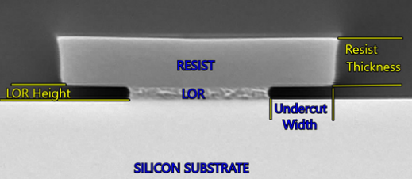

**Figure 1** – Bi-layer cross-section with identified variables

Stoney’s Formula describes the relationship of material and

dimensional factors for a cantilever beam. [3,4] Relevant factors include: beam length (*L*) determined by development time to create the undercut width, the beam thickness (*t*)resulting from the selected resist thickness and Youngs Modulus (*E*) & Poisson’s ratio ($v$) which relates to resist formulation. These customizable structural elements dictate the beam end deflection (δ) which correlates to the effective LOR height in the process under applied stress (σ) from deposition.

$$δ= \frac{3σ \left(1-v\right)}{E}*{\left(\frac{L}{t}\right)}^{2}$$

Hence, a bi-layer structure with predictable dimensional and physical properties may be tailored for different stress conditions uniquely related to the film and deposition process.

METAL FILMS

Owing to the directional properties and lack of ion bombardment with evaporation, simple structure designs can deliver robust process outcomes. Prior work on bi-layer constructionidentified that undercut amount and LOR height are the important variables.[5] This study extended that original work by demonstrating that at a fixed LOR height to deposit thickness in the range of 1.2 to 1.5, the extent of undercut beyond a minimum did not influence processing outcomes. This finding held true across a range of line spacings from 7um to 40um. The experimental construct for this utilized a 3um LOR 30C and 4um SPR220 bi-layer and deposition of Ti 250Å & Al 2um held constant; undercut was variable. Depositions were done by evaporation on a CHA Solution system with a 6 pocket E-gun and off-center resistance source.



**Table 1** – Al throw versus undercut for fixed bi-layer

In Table 1 above, the response variable Al throw is shown to be process robust to undercut (develop time). Al throw is the measured ingress of Al into the undercut width. Lift-off assessments also demonstrated universally good results. Hence, for most metallization processes reliable bi-layer structures with good physical integrity are straightforward by focusing on the LOR / deposit thickness.

SILICON OXIDE FILMS

Trends for VCSEL fabrication and use of lift-off processes is reported as an important capability.[6] A significant feature of the bi-layer design versus a single layer system is lift-off functionality with conformal coatings, like insulators. A bi-layer system for use with 1um SiO2 was demonstratedand identified challenges in fabricating reproducible structures.[7] This study has taken on that challenge for film thicknesses in a range more commonly employed in VCSEL processes.

For this investigation, bi-layer structure viability was studied by fabricating various structure geometries and then sputter depositing a SiO2 film on them. Deposition thicknesses of 1000Å, 1500Å, 2000Å and 2500Å were performed on a Kurt Lesker Labline system with 3 inch diameter sources and RF gun. (This tool was used for all oxide depositions in the study.) Deposition thickness, and therefore sputter process time, represented the applied stress to the cantilever beam of the bi-layer. The positive resist used, Dow SPR220, was held constant in consideration of Youngs Modulus material property. In accordance with Stoney’s formula, resist thickness and undercut width were varied and deflection post deposition was categorized across line/spacings (L/S) from 9um to 20um for consistency and measured by scanning electron microscope (SEM) for change. LOR height was not a variable for assessing structure stability as it mechanically acts only as a pedestal.

The SEM image in Figure 2 below depicts a successful structure fabricated with 0.5um LOR, 2um resist, 1.72um undercut width and 1500Å deposited. It exhibits minimal, but initial signs of, uniform deflection suitable for use.

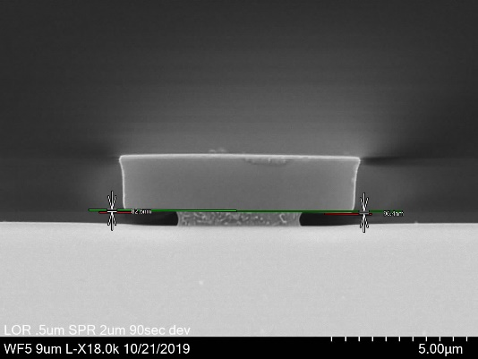

**Figure 2** - Post SiO2 stably constructed bi-layer 9 um L/S

The second key outcome assessed was the ability of a bi-layer structure to provide suitable lift-off results. Good lift off results is clean and uniform removal of the bi-layer post deposit processing and effective masking to dimension. In consideration of this evaluation factor the LOR height becomes a factor; in addition to the resist thickness and undercut width. In this study LOR heights of 0.3um and 0.5um were used. Cumulatively these variables impacted SiO2 throw into the undercut and lift-off performance.

To assess lift-off performance structures were subjected to visual optical and SEM inspection and energy dispersive X-ray spectroscopy (EDS) line scan analysis after processing. Visual inspections were for common lift-off imperfections such as fencing and rough edges (Figure 3). The EDS allowed for elemental detection of SiO2 near the LOR sidewall.

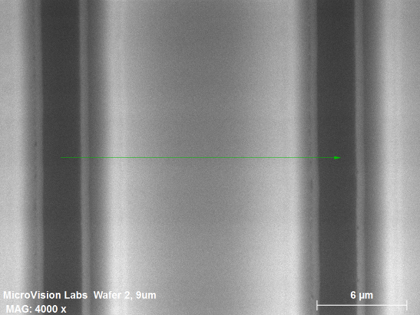

**Figure 3** – Example: SEM inspection of lift-off shows clean removal & good edge uniformity. Construction 0.5um LOR, 2.4um resist, 2.56um undercut and 9um L/S. 1500Å SiO2

The corresponding EDS for the image shown in Figure 3 is below in Figure 4. EDS confirmed a gap between the LOR sidewall and SiO2 deposit, in good agreement with the visual inspections performed.

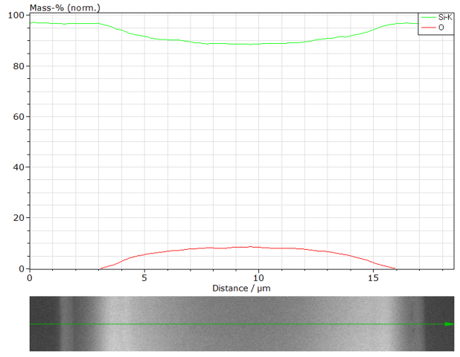

**Figure 4** - EDS linescan of Figure 3 bi-layer post lift-off

Co-optimization of a process window for a given SiO2 deposit was found to be describable by the ratio of resist thickness / deposit thickness (RD ratio) plotted versus undercut width as shown below in Figure 5. It was found this relationship described the interactivity of structural stability and oxide throw into the undercut relative to lift-off performance.

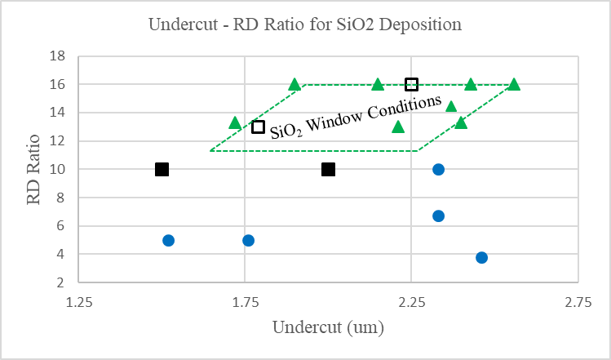

**Figure 5** – Bi-layer undercut width ploted against RD Ratio describes the interactivity of system performance

In Figure 5 the blue circle datapoints represent structurally unstable geometries. Solid black square structures were stable but not adequately uniform from side-to-side. Open black squares were struturally sound and almost adequate for undercut width to prevent SiO2 throw to the LOR wall. The green triangle structures showed good stability, uniformity, prevented SiO2 throw to the LOR wall and had clean lift-off performance. Data was for 9um L/S structures.

For the investigated bi-layers deposited with SiO2 resist thicknesses less than 2um were not stable. Resist layers in the range of 2um – 4um were stable with undercut widths in the range of 180um to 250um. Optimal lift-off was observed to occur with structures having resist thicknesses of 2.4um to 4um with undercut widths of 2.0um to 2.4um independent of LOR height. As expected a 0.3um LOR height helped to reduce SiO2 throw into the undercut compared to 0.5um but did not make the difference between a good and bad lift-off in the previoulsy reported ranges.

ALUMINUM OXIDE FILMS

The protocols previously described were used to assess Al2O3 deposits in the range of 1500Å to 2200Å. The results are shown below in Figure 6 comparitively to SiO2. The red

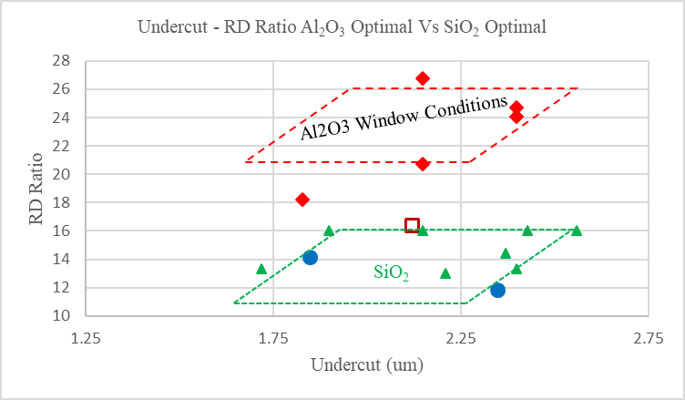

**Figure 6** – Comparison of SiO2 to Al2O3 by RD Ratio versus undercut width reveals an offset characteristic

diamonds represent successful Al2O3 results. The open black square is a stable structure but but had inadequate undercut. The blue circles represent failed structures. With Al2O3, lift-off success demanded a combination of thicker resist layer, greater undercut and lower LOR height. It is postulated that molecule atomic weight may influence its momentum and increase undercut penetration.

HIGH TEMPERATURE RESIST AND SiO2 FILMS

Becasue single layer lift-off resists are challenged to maintain geometric characteristics at elevated temperatures, Kayaku Advanced Materials developed a new high temperature negative tone resist that may be used for bi-layer structures and common oxide materials. Subsequently it was uncovered this capability could be extended to reactive films like TiN. The expanded range of applications for a high temperature bi-layer may offer a paradigm shift for masking.

The new resist has shown to be thermally stable for use to at least 170°C, able to fabricate uniform bi-layers structures with LOR/PMGI, and give adequate undercut as shown in Figure 7.

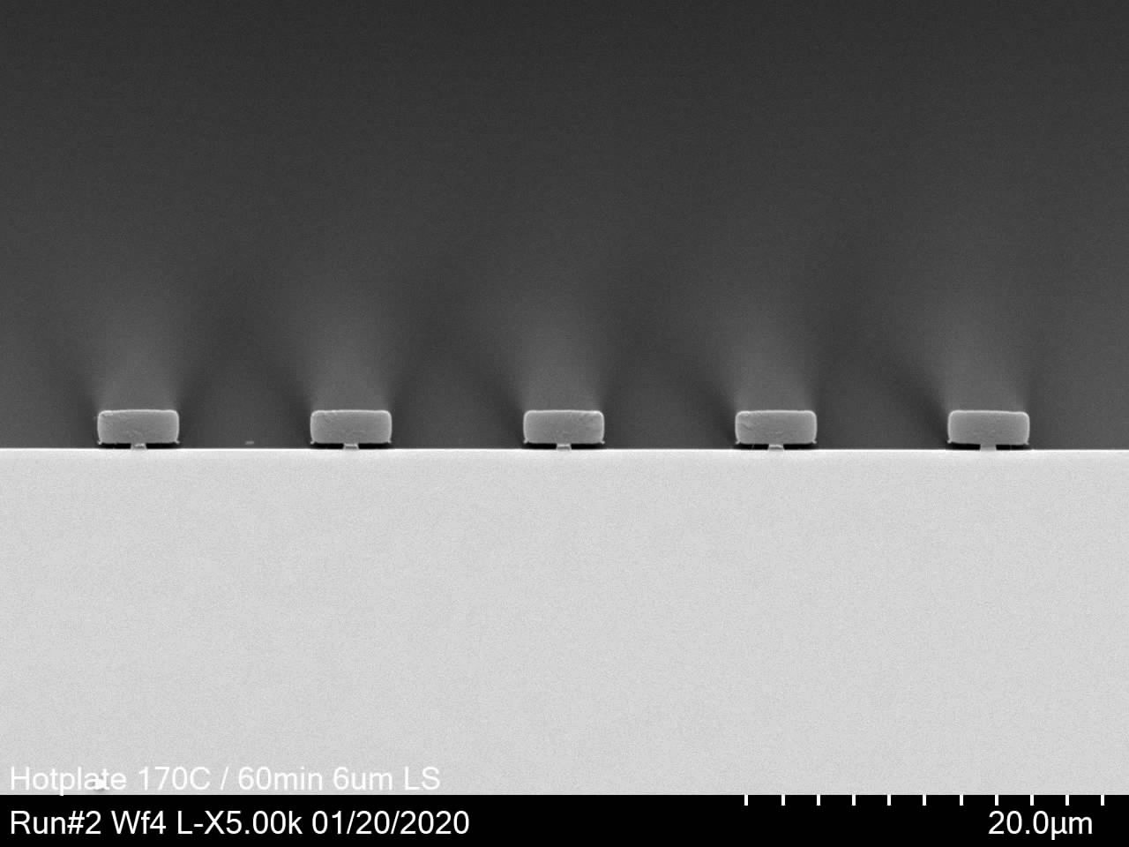

**Figure 7** – 6um L/S post 1 hour 170°C hot plate bake, 2.1um high temperature resist and 1.9um undercut width

Having demonstrated an increased thermal operating range, material was fabricated into bi-layers at a constant 0.3um LOR height and varrying resist thickness from 2.1um to 3.3um with undercuts from 1.8um to 2.1um to confirm fit to the original model developed using the SPR resist. A 2000Å SiO2 film was sputter deposited to stress the thinner resist layers. In Figure 8 the data collected for the bi-layers fabricated with the new resist are shown as open black triangles compared to closed green triangles for SPR based structures previously discussed. Figure 8 shows the new resist yields bi-layers with greater cantilever beam strength and consequently a somewhat greater strutural capability range versus undercut. Regardless of resist thickness and undercut the structures exhibited no signs of instability or deflection. As well, no SiO2 was detected at the LOR walls and correspondingly lift-off performance was excellent for all structures constructed (example, Figure 9).

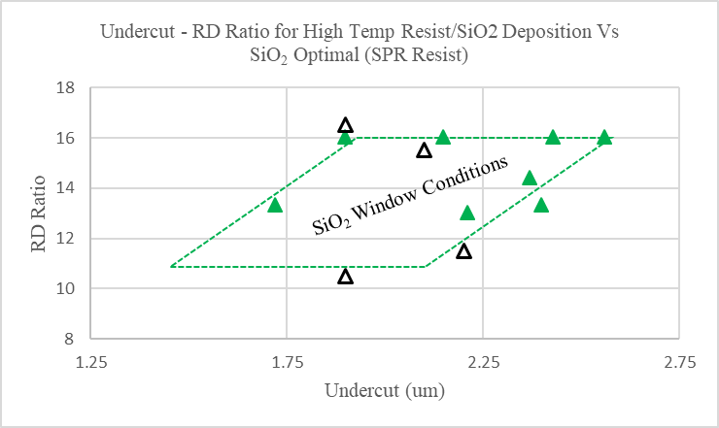

**Figure 8** - New high temperature resist compared to SPR

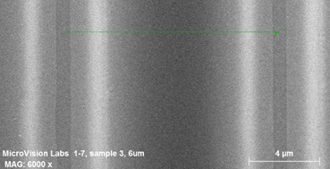

**Figure 9** – 6um L/S lift off, 2.3um high temperature resist, 2.2um undercut, 0.3um LOR 3A and 2000Å SiO2

SUMMARY AND CONCLUSIONS

Initial work with evaporated metallization films to define bi-layer construction requirements for good lift-off results were extended to insulator films. Through a series of experiments the viability of using a bi-layer structure with sputter deposited insulator films has been successfully demonstrated. The model undercut - RD Ratio was developed that could be used to characterize film deposition stress and structure stability relative to lift-off performance. Using this model, optimizing the bi-layer for sputter deposited insulators was found to be a multivariate exercise with strong dependency on cantilever strength, undercut and film type - thickness. Operating windows have been identified for both SiO2 and Al2O3 films commonly used in the industry.

To maximize the capability for the bi-layer in higher stress processes typical of sputtering, reactive films, or ICP-PECVD type application a new high temperature resist was developed and successfully utilized to fabricate bi-layers capable of operating under higher stress deposition processes with good lift-off results.

REFERENCES

[1]Guimaraes, T., Industry Clockspeed’s Impact on Business Innovation Success Factors, *Int. J. of Innovation Management*, 14(3) 2011 p. 322-344.

[2]Ludovic,M-L, Arnoult, A., Mazenq, L., et al Single lithography-step self-aligned fabrication process for VCSELs, *Materials Science in Semiconductor Processing, 61 (2017) 35-38*

[3]G.G. Stoney, Proc. R. Soc. London 82, 172 (1909).

[4]Zhang, Y. Zhao, Y. Applicability range of Stoney’s formula and modified formulas for a film/substrate bilayer, *J. Applied Physics* 99, 053513, 2006.

[5]Golden, J., Miller, H., Nawrocki, D., Ross, J. Optimization of Bi-layer Lift Off Resist Process, *CS Mantech Conference,* May 2009

[6]Tyler, P., Fijal, J., Nulman, K., et al, Development of Advanced Lift-Off Processes for 5G & VCSEL Applications, *CS Mantech Conference, May 2019*

[7]Kim, YH, Gook, HK, Nam SB, et al, Fabrication of multi-electrode array platforms for neuronal interfacing with bi-layer lift-off resist sputter deposition, *J. Micromech. & Microeng*. (23) 097001 2013

ACRONYMS

LOR: Lift Off Resist

VCSEL: Vertical Cavity Surface Emitting Laser

TMAH: Tetramethyl ammonium hydroxide

ICP-PECVD: Inductively Coupled Plasma Enhanced CVD