Improved Linearity GaAs pHEMT Technology and the Characterization of
Its Third-Order Intermodulation Distortion

Yong-Han Lin*, Shuan-Ming Li, Sheng-Hsien Liu, Fan-Hsiu Huang*, Cheng-Kuo Lin, Yu-Chi Wang

WIN Semiconductors Corp., Guishan District, Taoyuan City 33383, Taiwan
*E-mail: yonghanl@winfoundry.com and fhhuang@winfoundry.com

Keywords: linearity, pHEMT, OIP3, IMD3, trapping, memory effect

Abstract
In this work, we present an overview of WIN’s latest generation of 0.15-μm GaAs pHEMT technology specifically optimized for highly linear PAs for advanced mm-wave communication systems. When compared with the prior technology PP15-51 at either 5.8 or 29 GHz, the new technology PP15-61 outperforms the prior one in multiple respects, including enhanced P_{out}, an additional linear gain of > 1 dB, a 10 percentage point increase in peak PAE (from ≈ 44% to ≈ 54% at 29 GHz), and, most notably, an improvement of ≈ 3 dB in OIP3 when operated in the linear regions at 29 GHz. As part of routine characterization, the IMD3 asymmetry was further compared for both technologies. Its behavior can be descriptively interpreted in terms of a physical scenario considering effects due to charge trapping, thermal properties, and the bias networks used in the measurements.

Introduction

AlGaAs/InGaAs/GaAs pHEMTs have been widely used in various PA applications in today’s telecommunication systems. Linearity is one of the important characteristics of a PA device since undesirable effects may result from its nonlinear behaviors. These effects include gain compression and the generation of unwanted frequency components which can give rise to power losses, signal distortion, and possible detrimental interference with other sources. In order to serve the demand for higher data rates and to accommodate even more users in the next generation wireless network, the need for PA devices with higher linearity and excellent output performance are thus rapidly increased.
WIN Semiconductors, as the first pure-play 6-inch GaAs foundry in the world, has dedicated its efforts since its establishment to the manufacture of cost-effective, high speed, and high quality GaAs MMICs. Here, we present an overview of WIN’s latest generation of 0.15-μm GaAs pHEMT technology specifically optimized for highly linear PAs for advanced mm-wave communication systems. In comparison with the prior technology PP15-51 at either 5.8 or 29 GHz, the new technology PP15-61 exhibits not only improved power performance but also higher device linearity when operated in the linear regions. For the new technology PP15-61, the effect due to charge-trapping defects has also been considerably minimized. As part of routine characterization, the IMD3 asymmetry was further compared for both technologies. Such asymmetries (often referred to as memory effects) can be greatly affected by charge trapping, thermal effects, and the bandwidth of the bias networks used in the measurements [1]. To account for the observed asymmetries, we present a physical picture considering these factors in the second part of this work.

Technology Description

WIN’s 0.15-μm GaAs pHEMT technology platform, PP15, applies a classical AlGaAs/InGaAs/GaAs pHEMT structure with a double recess gate geometry. The epitaxial layers forming the active region are grown on top of a semi-insulating GaAs wafer. Ohmic contacts with low resistivities are achieved by employing an annealing process after the deposition of the contact metals patterned by photolithography. Isolation of individual active regions is made by ion implantation with varying dosages and ion energies. On top of the active region, electron-beam lithography and selective wet etching are utilized and followed by a metallization and lift-off process to create the Y-shaped gate with a gate length of 0.15 μm. Silicon nitride is used to passivate the exposed active regions and also functions as the dielectric layer in an MMIC capacitor. The interconnection of the PP15 platform consists of two metal layers designed with airbridges. Capacitors with C of 400 pF/mm², TaN thin film resistors with R_{sq} of 50 Ω/sq, and GaAs resistors with R_{sq} of 160 Ω/sq (PP15-61) are also devised for MMIC designs. An optional backside process is available to provide hot-via transitions connecting conducting lines or planes on opposite sides of the wafer.

Device Characteristics and Performance

For both the technologies PP15-51 and PP15-61, the manufactured D-mode pHEMT device is designed for an operating voltage of V_{D} up to 6 V. (PP15-61 has been qualified up to 7 V.) The power performance was measured with a standard load-pull system at f₀ = 5.8 and 29 GHz, respectively. The power sweep was conducted up to the 5-dB compression point. The value of OIP3 was taken by
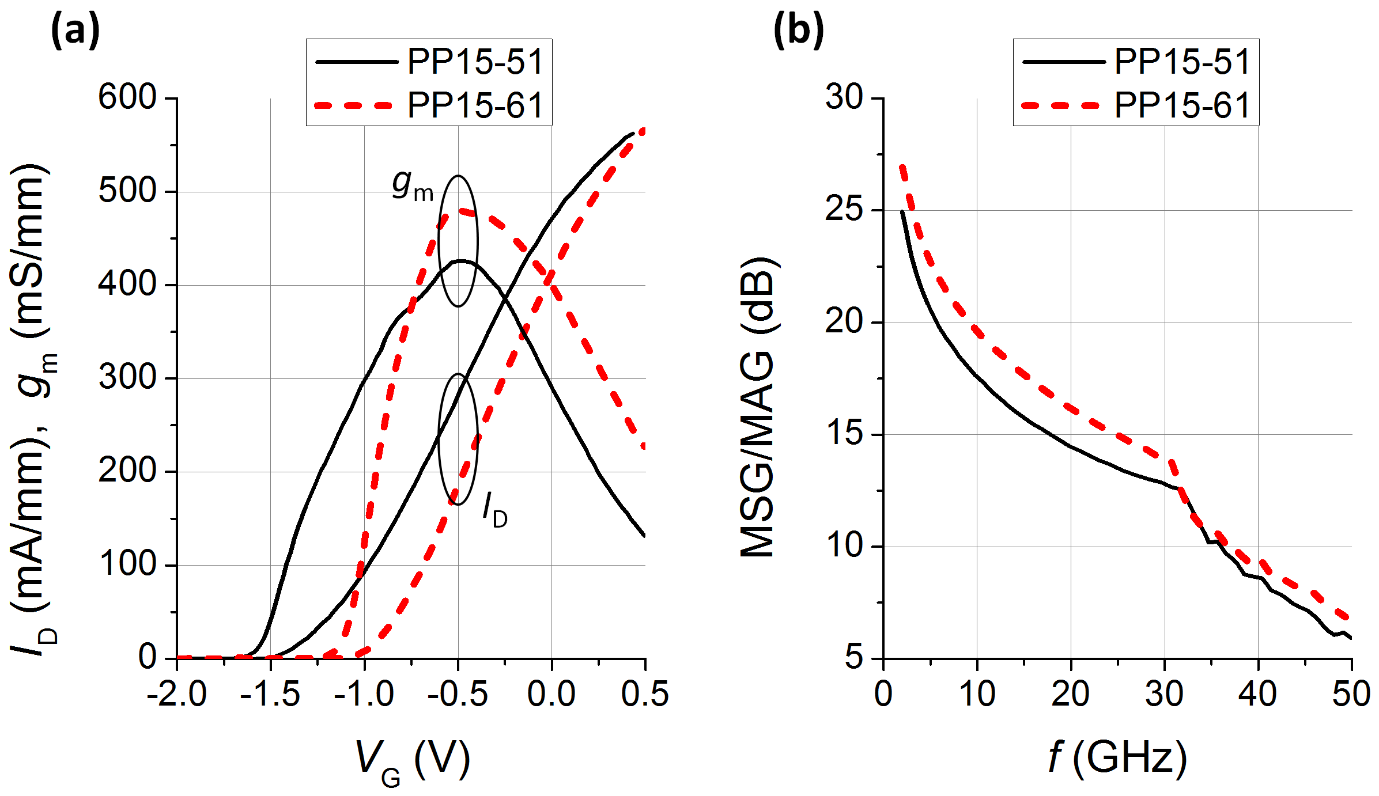
Fig. 1. (a) I_{D}-V_{G} and the corresponding g_{m}-V_{G} curves at V_{D} = 6 V, and (b) MSG/MAG as a function of f for PP15-51 and PP15-61, as indicated.

TABLE I
Key Parameters for PP15-51 and PP15-61.
Parameter | Unit | Technology
 |  | PP15-51 | PP15-61
V_{th} ^{(a)} | V | −1.30 | −0.95
g_{m, max} ^{(b)} | mS/mm | 460 | 585
I_{D, max} ^{(b, c)} | mA/mm | 620 | 630
I_{DSS} ^{(b)} | mA/mm | 465 | 400
BV_{DG} ^{(d)} | V | 16 | 13
f_{T} ^{(b)} | GHz | 90 | 100
f_{max} ^{(b)} | GHz | 185 | 220
^{(a)}I_{D} = 1 mA/mm, ^{(b)}V_{D} = 1.5 V, ^{(c)}V_{G} = 0.5 V, ^{(d)}I_{G} = 1 mA/mm.

injecting a 2-tone stimulus centered at f₀ with a tone spacing Δf = 10 MHz. To obtain the variation of ΔIMD3 with Δf, Δf was further varied between 1–11 MHz. (Here, ΔIMD3 ≡ IMD3_{Up} − IMD3_{Low}). In the following, all the data were measured with the device being presented to the optimized source and load impedances for extracting maximum P_{out}.
Figure 1(a) shows the I_{D}-V_{G} curves and the corresponding g_{m} dependence on V_{G} at V_{D} = 6 V for PP15-51 and PP15-61, respectively. Figure 1(b) displays their variations of MSG/MAG with frequency. The key parameters for both technologies are listed in Table I. (Parameter definitions can be found in Ref. 2.) The new technology PP15-61, as compared with the prior one PP15-51, reveals a much larger peak g_{m} value and larger MSG/MAG at measured frequencies up to 50 GHz. Specifically, at V_{D} = 6 V, the peak g_{m} difference is ≈ 55 mS/mm, while at V_{D} = 1.5 V, a much larger difference of ≈ 125 mS/mm is achieved. A large g_{m} value is in effect a desirable feature for a high-linearity PA device [3,4].
Figures 2 and 3 plot the power and OIP3 performance for PP15-51 and PP15-61 at 29 and 5.8 GHz, respectively. Both the devices were biased at the same I_{D} value of = 100 mA/mm (using different V_{G}’s) and V_{D} = 6 V. At either frequency, the new technology PP15-61 apparently
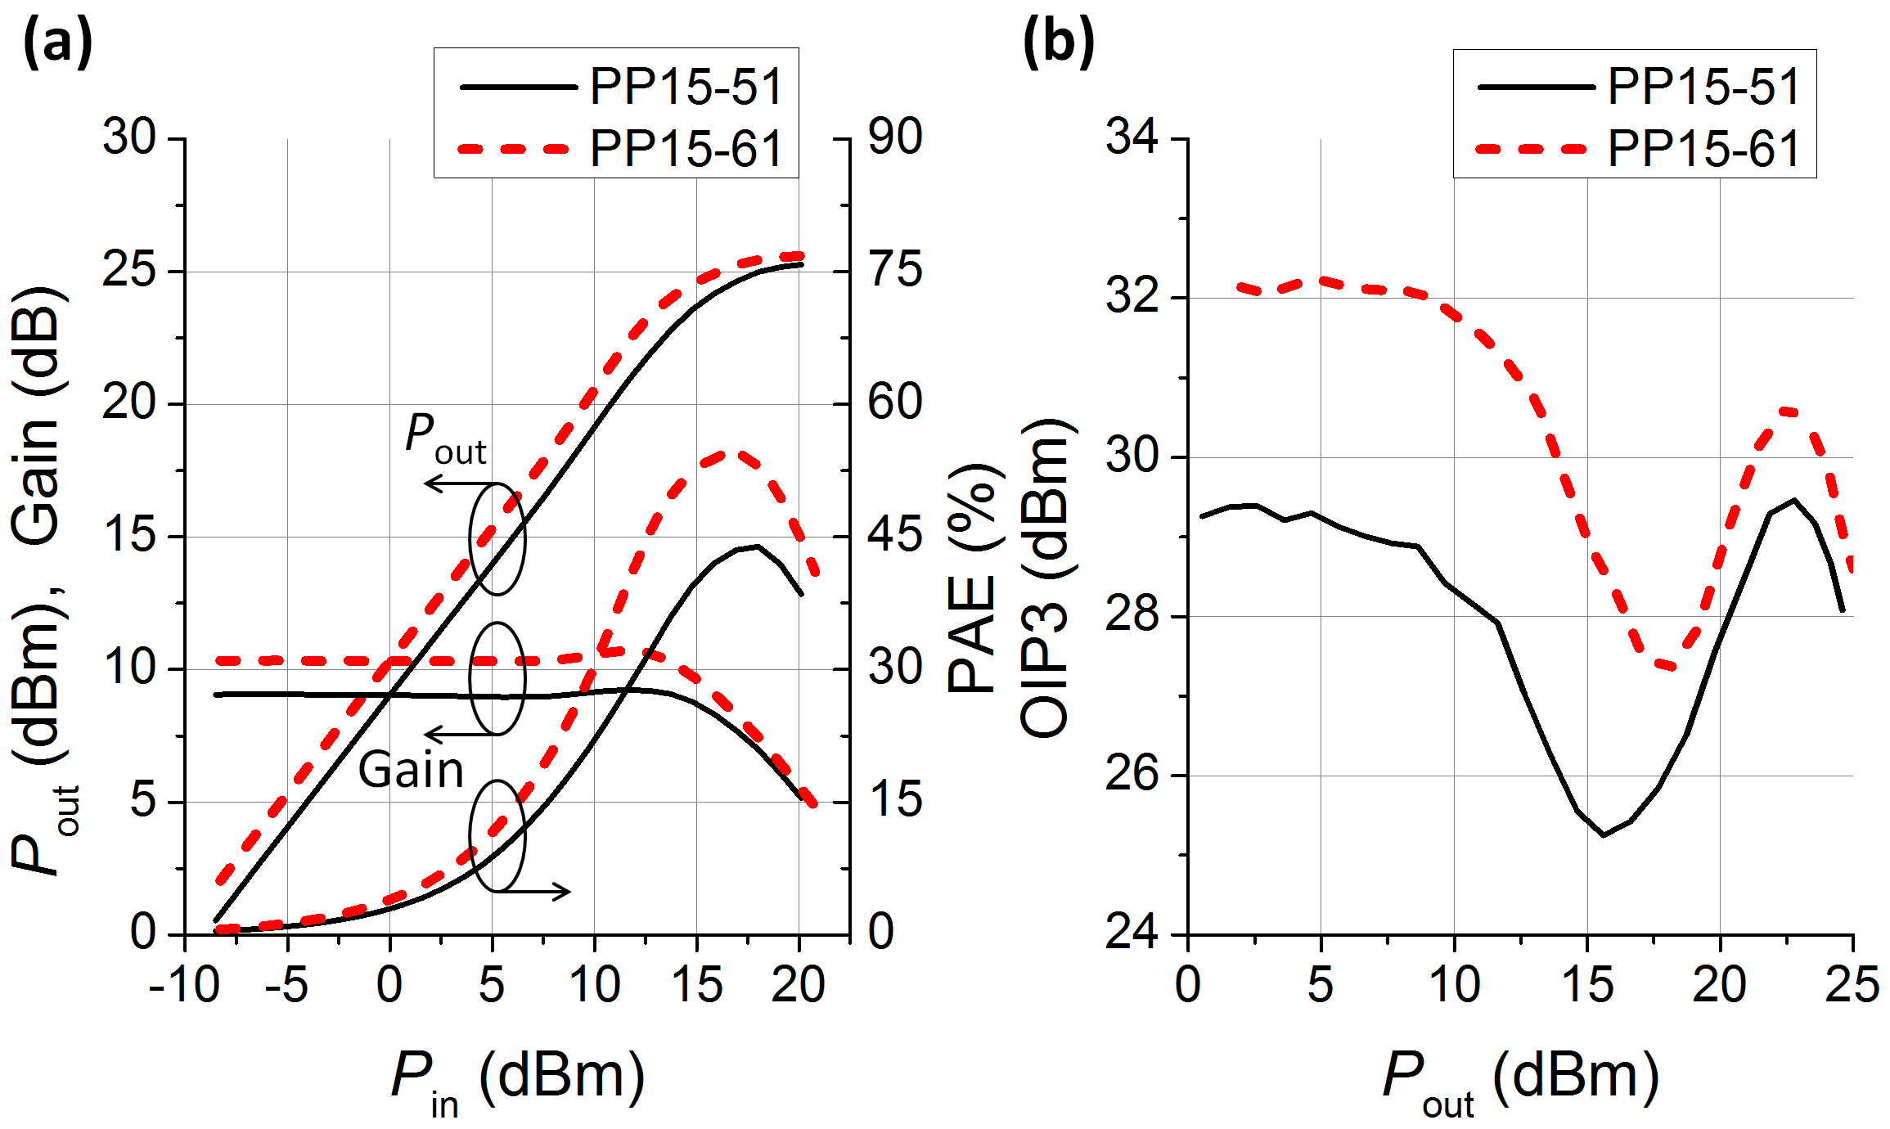
Fig. 2. Power performance at 29 GHz for PP15-51 and PP15-61. (a) P_{out}, gain, and PAE as functions of P_{in}. (b) Corresponding OIP3 as functions of P_{out}.

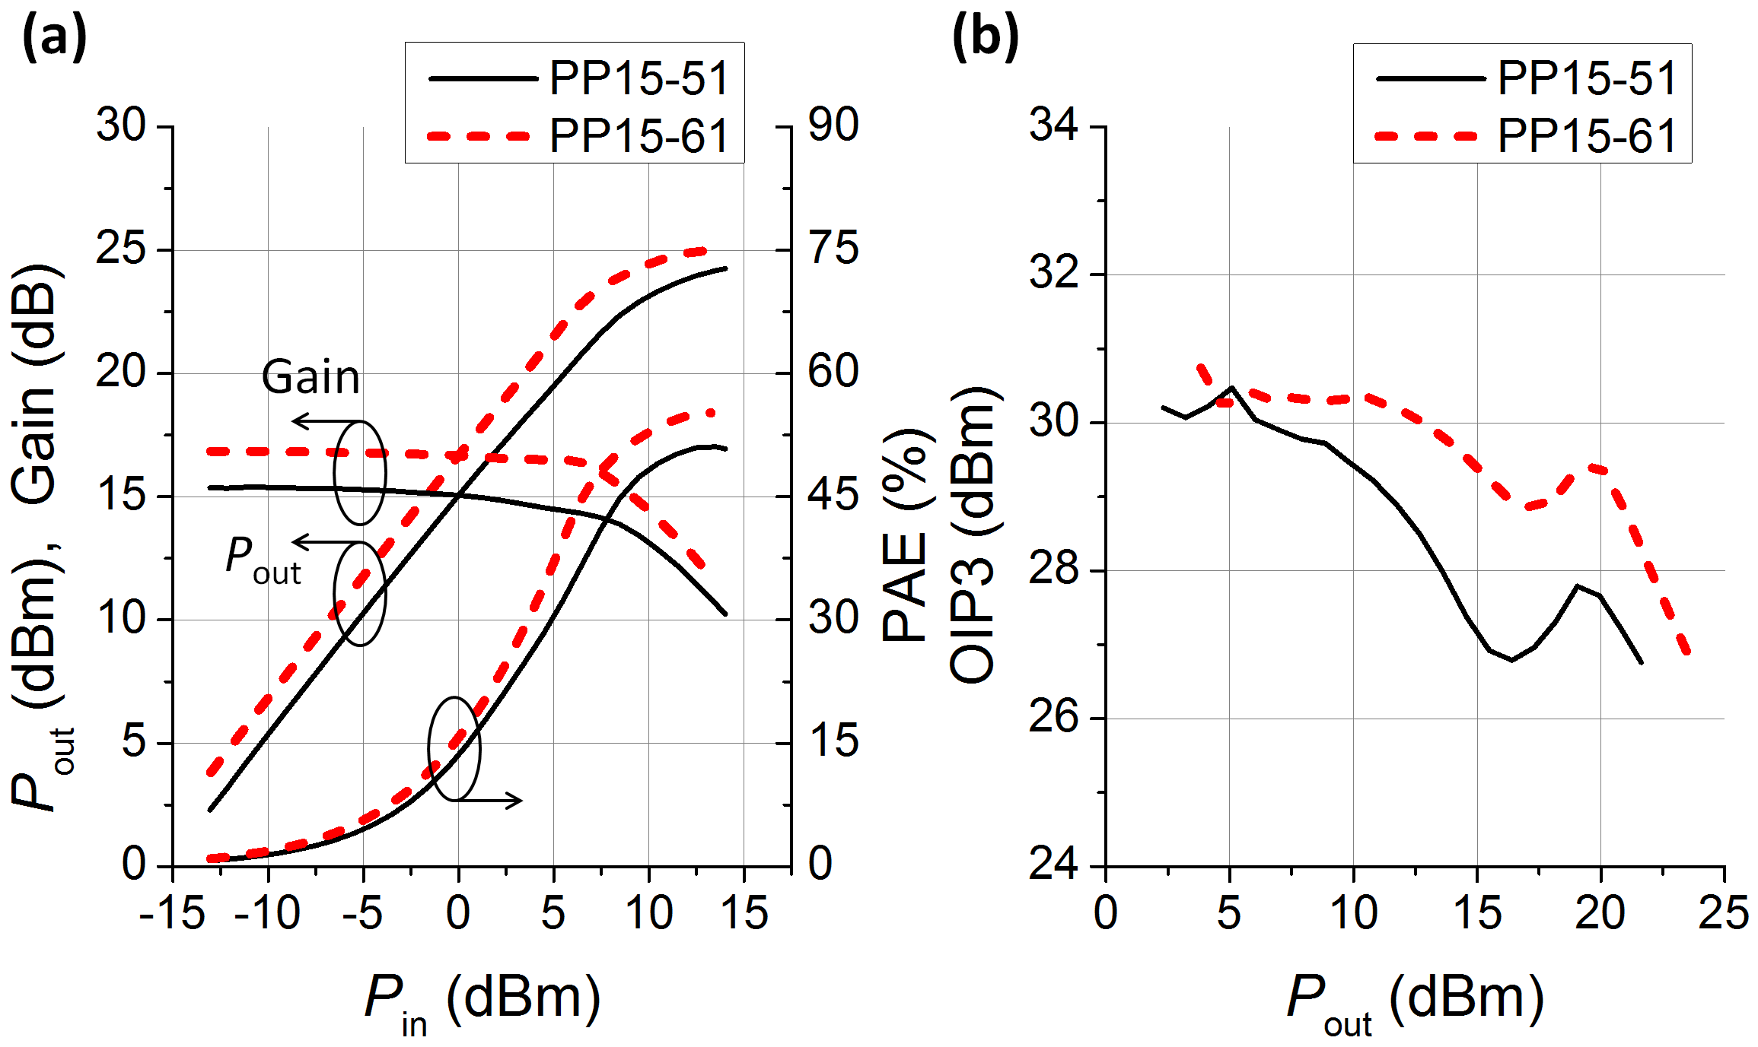
Fig. 3. Power performance at 5.8 GHz for PP15-51 and PP15-61. (a) P_{out}, gain, and PAE as functions of P_{in}. (b) Corresponding OIP3 as functions of P_{out}.

outperforms the prior one PP15-51 in multiple respects, including enhanced P_{out} (> 800 mW/mm at P_{1dB} at 29 GHz), an additional linear gain of > 1 dB, a 10 percentage point increase in peak PAE (from ≈ 44% to ≈ 54% at 29 GHz), and, most notably, an improvement of ≈ 3 dB in OIP3 when operated in the linear regions at 29 GHz.
Previously, an analysis based on classical theory has derived the expression [3,4]: OIP3 ∝ (g_{m})³/g_{m}″, where g_{m}″ is the second derivative of g_{m}. (For simplicity, we keep only the dependences associated with g_{m}.) Thus, for devices operated in class A, a larger OIP3 value is expected for the one with larger g_{m} and flatter g_{m} distribution. This expression can help as a rule of thumb in some cases. For example, at the Q-point used in Figs. 2 and 3, the g_{m} value for PP15-61 is ≈ 1.3 times larger than that for PP15-51, while their g_{m}″ values are approximately within the same magnitude. Using the expression, we estimate that OIP3 for PP15-61 would be ≈ 2.2 times larger than that for PP15-51. This value (corresponding to ≈ 3.4 dB) roughly coincides with the amount of OIP3 improvement (≈ 3 dB) measured at 29 GHz [Fig. 2(b)]. However, at 5.8 GHz [Fig. 3(b)], the estimation fails, meaning that in this case its dependences on other parameters should be considered as well.
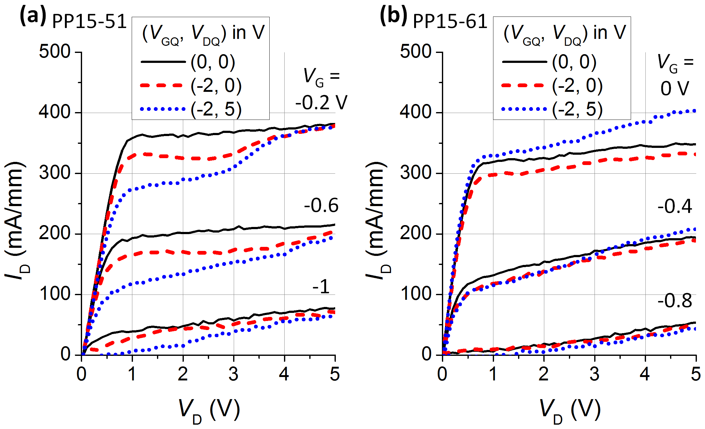
Fig. 4. I_{D}-V_{D} characteristics obtained by double-pulsed I-V measurements for PP15-51 (a) and PP15-61 (b), respectively.

Another feature that renders the new technology PP15-61 superior to the prior one PP15-51 arises from the fact that the overall effect due to charge-trapping defects within the device has been largely minimized. Figure 4 shows the I_{D}-V_{D} characteristics for PP15-51 and PP15-61 obtained by employing double-pulsed I-V measurements. The pulse width is 4 μs with a period of 2000 μs. Three Q-points were compared. It can be seen that PP15-61 has a relatively diminished effect due to different trap populations established by the different Q-points.
It should be mentioned that the new technology PP15-61 has also been qualified by a series of reliability tests, including high-temperature operating life, high-temperature reverse bias, high-temperature stress, highly accelerated stress, and thermal cycling. These tests ensure that the durability and the functionality of our devices are capable of meeting the requirements in various MMIC applications.

Asymmetry of Third-Order Intermodulation Distortion

Asymmetry in the amplitudes of lower and upper IMD3 components is often observed when a PA device is subject to a 2-tone stimulus. A proper knowledge of its behavior is crucial in designing a highly linearized PA circuit. However, several factors play a role simultaneously in determining the magnitude and the variation of measured ΔIMD3 [1,5]. These factors range from the charge-trapping defects within the device, to the thermal properties incorporating the environment with which the device interacts, and to the bandwidth of the bias networks used in the measurements. Separation of the individual contributions is not an easy task.
Figure 5 shows our measured ΔIMD3 variations as functions of Δf and P_{out} for PP15-51 and PP15-61 at 5.8 and 29 GHz, as respectively indicated. Note that at 5.8 GHz two separate measurements with two different sets of bias tees (accordingly labeled as A and B) were performed. All the bias tees used were commercially purchased.
Several observations can be drawn from an inspection of Fig. 5: (i) for PP15-51, ΔIMD3 behaves similarly regardless
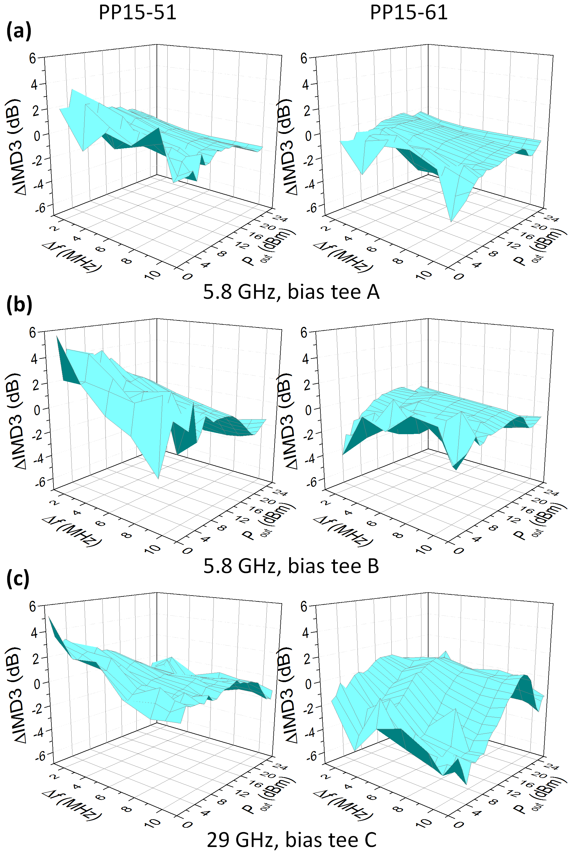
Fig. 5. ΔIMD3 variations as functions of Δf and P_{out} for the two technologies at 5.8 and 29 GHz, as respectively indicated. Note that, at 5.8 GHz, two separate measurements with two different sets of bias tees were performed.

of what bias tees we used or at what frequency we measured, (ii) for PP15-61 at 5.8 GHz, ΔIMD3 is also similar regardless of the bias tees used, (iii) the variation of ΔIMD3 for PP15-51 is different from that for PP15-61 either at 5.8 or 29 GHz, and (iv) for PP15-61, the variation of ΔIMD3 at 29 GHz is evidently not akin to those at 5.8 GHz, most particularly in the region of large Δf and small P_{out}.
These features can actually be explained, as follows, in terms of a physical scenario which takes into account at the same time the aforementioned factors, i.e., charge trapping, thermal properties, and effects of bias tees. [Notice that we give in the following only a descriptive explanation rather than a mathematical form of ΔIMD3(Δf, P_{out}) as the latter is far beyond the scope of this paper.]
We first focus on the situation at 5.8 GHz. Apparently, features (i) and (ii) exhibit that the impact of using different bias tees on measured ΔIMD3 for the same device is practically comparable. It is no surprise that commercial bias tees could be very much alike since they are designed based on the same considerations aiming for the same applications. However, at a different frequency (29 GHz), the situation continues only for PP15-51. (This point is discussed below).
Since the trapping effects in these two technologies are different as manifested in Fig. 4., feature (iii) in which the variation of ΔIMD3 for PP15-51 is different from that for PP15-61 is then expected. In fact, a close examination of Fig. 4 provides additional information about the distinct natures of the charge-trapping defects contained in these two devices. This is one of the keys to the explanation of feature (iv).
In theory, traps can be acceptor-like (neutral when empty, − charge when full) or donor-like (neutral when full, + when empty). Because I_{D} in the channel is changed by the trap-modified potential or Fermi level, the competition between (or the annihilation of) negatively and positively charged traps with different amounts thus can give rise to a variety of dynamic I_{D}-V_{D} behaviors. Conceptually, negative traps cause a decrease in I_{D} and positive traps cause an increase in I_{D}. Further complication occurs if traps with diverse lifetimes are distributed to varying extents all over the three-dimensional device. The possible locations and mechanisms can be numerous even for a single phenomenon such as the kink found in PP15-51 [Fig. 4(a)] [2]. Nevertheless, from Fig. 4, we can say in an approximate way that, in PP15-51, only negative traps dominate, whereas in PP15-61, negative traps compete with positive ones as the voltage difference between gate and drain changes.
We now turn to the issues concerning 5.8 and 29 GHz, i.e., features (i) and (iv). As described, it is reasonable to conjecture that the difference (resemblance) of ΔIMD3 between 5.8 and 29 GHz for PP15-61 (PP15-51) originates from the existence of two types (only one type) of traps. However, the question is, for PP15-61, what induces the competition between negative and positive traps to evolve when the frequency changes?
To answer this, we invoke the dielectric properties of the GaAs substrate. As shown in Ref. [6], below a frequency of ≈ 10 GHz, the imaginary part of the dielectric constant of GaAs barely changes. On the other hand, above a frequency of ≈ 10 GHz, it starts to increase and becomes at least several times larger when reaching ≈ 30 GHz. Such a property hence indicates that the loss of microwave energy of 29 GHz in the GaAs substrate can be rather strong as compared with that of 5.8 GHz. As a result, the environment (i.e., substrate) that the device interacts with when at 29 GHz could be at a temperature higher than when at 5.8 GHz. Since, in addition to potential, temperature is the other factor that can alter a trap population (if not high enough to activate some irreversible processes), the slightly elevated device temperature accordingly induces the evolution of the competition between negative and positive traps in PP15-61.
We mention in passing that our explanation can be supported by another feature revealed in Fig. 5. In the region of very large P_{out}, ΔIMD3 in all the six plots in Fig. 5 can be seen to approach a comparatively identical behavior, in which ΔIMD3 ≈ 0 dB for either small or large Δf. This is because that, at very large P_{out}, the imparted microwave power is large enough to take over in heating up the device. In such cases, the microwave power absorbed by the substrate becomes immaterial. This is also why feature (iv) appears most particularly in the region of large Δf and small P_{out}. (A small Δf can lead to a baseband IMD2 which is close to or at the system thermal response frequency and thus can additionally contribute to the thermal energy.)

Conclusions

An overview of WIN’s latest generation of 0.15-μm GaAs pHEMT technology specifically optimized for highly linear PAs for advanced mm-wave communication systems is introduced. When compared with the prior technology PP15-51 at either 5.8 or 29 GHz, the new technology PP15-61 outperforms the prior one in multiple respects, including P_{out}, linear gain, peak PAE, and, most notably, an improvement of ≈ 3 dB in OIP3 at 29 GHz. The IMD3 asymmetry is also compared for both technologies. A physical scenario considering effects due to charge trapping, thermal properties, and the bias networks used in the measurements is illustrated and explains the observed behaviors satisfactorily.

Acknowledgements

We would like to thank David Danzilio for his valuable discussions and those colleagues involved in the PP15-61 project for their experimental help.

References

[1] P. H. Aaen et al., Modeling and Characterization of RF and Microwave Power FETs (Cambridge, 2007).
[2] R. Davis, in Handbook of RF and Microwave Power Amplifiers, edited by J. Walker (Cambridge, 2012).
[3] K. Y. Hur et al., Electron. Lett. 32, 1516 (1996).
[4] Y. C. Lin et al., IEEE Trans. Electron Devices 54, 1617 (2007).
[5] N. B. Carvalho and D. Schreurs, Microwave and Wireless Measurement Techniques (Cambridge, 2013).
[6] Y. Poplavko and Y. Yakymenko, Functional Dielectrics for Electronics (Elsevier, 2020) Chap. 2.

Acronyms

IMD3: Third-Order Intermodulation Distortion
MAG: Maximum Available Gain
MMIC: Monolithic Microwave Integrated Circuit
MSG: Maximum Stable Gain
OIP3: Third-Order Intercept Point at Output
PA: Power Amplifier
PAE: Power Added Efficiency
pHEMT: Pseudomorphic High Electron Mobility Transistor

