**850 nm GaAs P-i-N Photodiodes for 50 Gb/s Optical Links**

**with Dark Current below 1 pA**

Dufei Wu, Yu-Ting Peng and Milton Feng

Department of Electrical and Computer Engineering, University of Illinois at Urbana-Champaign, Holonyak Micro & Nanotechnology Lab, 208 North Wright Street, Urbana, IL 61801

Email: [dufeiwu2@illinois.edu](mailto:dufeiwu2@illinois.edu)

**Keywords: P-i-N Photodiode, Bandwidth, Optical Fiber Links**

Abstract

Fabrication techniques and experimental data are presented for 850 nm GaAs P-i-N photodiodes designed for 50 Gb/s optical links. Optimizations in the device structure and the selective dry etching process reduce dark current below 1pA. Responsivity is shown to be comparable to commercial devices with similar dimensions. And microwave measurement shows a highest bandwidth of above 30 GHz, indicating potential for 60 Gb/s operation. Data rate testing is performed with a VCSEL up to 50 Gb/s, showing clear eye diagrams.

# Introduction

Optical links based on 850 nm transceivers are widely deployed in the optical communication system. Despite having relatively lower cost, their applications are limited due to the chromatic dispersion in optical fibers. However, recent development has shown that 850 nm VCSELs can operate at 22 Gb/s over 1 km OM4 fibers at 85 °C [1]. The maximum data rate has also been pushed to 57 Gb/s at room temperature and 50 Gb/s at 85 °C [2][3]. All results indicate that the application of 850 nm optical link could extend beyond short-haul transmission. P-i-N photodiodes (PD) are used as optical receivers in optical links for their high bandwidth and low noise level. A 50 Gb/s 850 nm high-speed and low noise photodiode which can serve as the counterpart for the VCSEL transmitters are demonstrated in previous works [4][5]. In this work, we present the fabrication and characterization of 850 nm GaAs P-i-N photodiodes designed for 50Gb/s optical link with improved bandwidth and reduced dark current.

The P-i-N photodiodes are designed with a circular mesa aperture to couple light efficiently from a multi-mode fiber. With small signal modeling, the diameter of the top mesa is chosen to range from 15 $μm$ to 30 $μm$ for 50 Gb/s operation [4]. Fig. 1 shows a summary of the photodiode responsivity and bandwidth with different aperture dimensions. It is found that the 15 $μm$ photodiode shows 0.30 A/W responsivity and bandwidth up to 33.5 GHz, being capable of operating at a maximum data rate of 60 Gb/s. High RF performance and low DC dark current are achieved for the photodiodes in this work. And the related design considerations, fabrication techniques and characterization results will be discussed.



Fig. 1. Summary of photodiode bandwidth and responsivity with respect to the aperture diameter.

# Fabrication

The epitaxial material of the photodiodes is grown by MOCVD on semi-insulating GaAs substrates. The growth begins from n-doped layers followed by a 0.75 $μm$ thick GaAs intrinsic region for photon absorption. On top of the intrinsic region are 0.5 $μm$ p-doped Al0.2Ga0.8As window and 0.03 $μm$ p-doped GaAs contact layer. The fabrication process starts with p-contact metal deposition and top mesa dry etching, followed by the n-contact metal deposition and an isolation dry etching down to the semi-insulating substrate. The device is then planarized with benzocyclobutene (BCB) which serves as a good insulator for DC signals and a low-loss dielectric for RF signals. The following etch-back and via opening steps with Freon RIE dry etching expose the mesa aperture as well as the p- and n- contact metal. The final step is top metal contact deposition which connects to the n and p metal and forms the signal/ground waveguide structure. The top view and the cross section of a fabricated device is shown in Fig. 2 and Fig. 3.

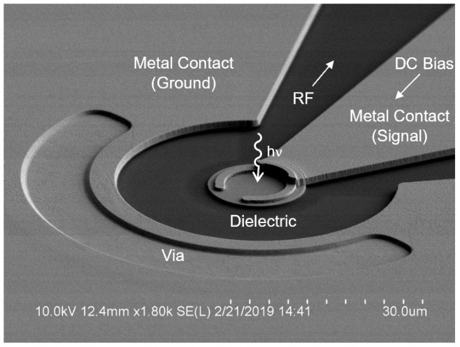

Fig. 2. Top view of a photodiode with an aperture diameter of 15 um under a scanning electron microscope (SEM).

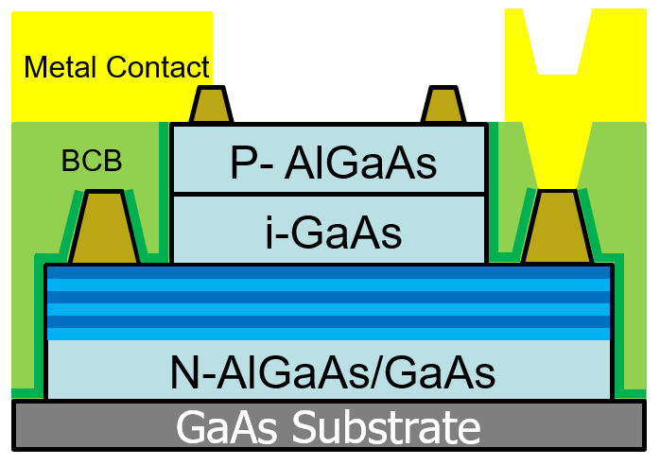

Fig. 3. Cross section of a photodiode.

# Dark Current

The dark current of a photodiode mainly arises from the DC current leakage paths in the device structure and the recombination of thermally generated electron-hole pairs. The former issue can be addressed with optimized device structure since the leakage current mostly flows through the dielectric between the metal contacts. The BCB used in the planarization step can serve a good insulator for DC signal with a volume resistivity of around 1019 Ω-cm. And leakage current can be minimized by avoiding vertical overlap and ensuring a minimum lateral distance of 5 $μm$ between the signal and ground metal contact.

The recombination current is heavily influenced by the condition of mesa sidewall. This is because dry etching steps used to create the mesa structure will always cause damage which serves as traps for surface recombination. As the device size is scaled down, more of the current will be distributed on the mesa periphery and surface recombination current becomes the major source of dark current. To mitigate this issue, a BCl3 ICP/RIE selective dry etching process with SiNx hard mask is calibrated to create a 90° top mesa and a smooth sidewall surface for p-doped GaAs as shown in Fig. 4(a). In this way, both the sidewall area and the trap density can be minimized. The tradeoff appears as a 102° etch footing extending over 1 $μm$ which could potentially connect p-doped layers to the n-contact metal and cause a short circuit. However, such risks can be avoided by over-etching 0.2 $μm$ into the n-doped material or increasing the lateral distance between the top mesa and n-contact metal, both at the cost of increased diode series resistance. Besides the dry etching itself, this process also requires a well-defined SiNx hard mask since the mesa structure is directly translated from it. Because of the high selectivity of the dry etching process, a slightly sloped hard mask will not cause significant differences to the mesa slope. However, it does lead to minor damage to the sidewall surface because the thinner SiNx on the pattern edge will be completely etched away first, exposing the mesa periphery. A comparison is shown in Fig. 4(b) and 4(c).

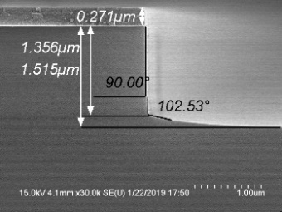



Fig. 4. The surface profile of the top mesa of a photodiode with low dark current, showing a straight sidewall with over 1 $μm$ etch foot (a), a smooth surface profile (b) and a slightly damaged surface translated from the imperfect SiNx hard mask (c).

**(b)**

**(c)**

**(a)**

The current of a fabricated device is measured with voltage bias from -4 V to 2 V using Keysight E5270b IV analyzer inside a black box to reduce the background illumination. The measurement presents an ultra-low dark current of below 1 pA at -3 V under room temperature as shown in Fig. 5 Additionally, the high temperature operation is tested under room light, demonstrating around 100 pA dark current at 100 °C. Fig. 6 plots the measured IV curves at four different temperatures. The increased reverse current at higher temperature is a result of increased amount of thermally generated carriers. And the change of slope with respect to temperature in the forward bias region is reflected in the ideal diode equation as $q/{2kT}$.

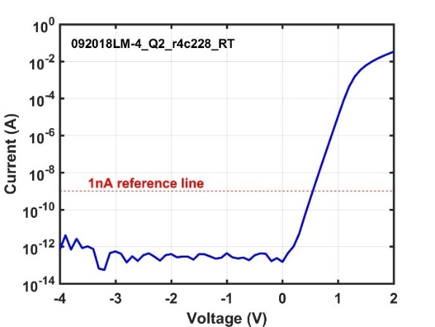

Fig. 5. Log-scale IV characteristics of a 15 $μm$ photodiode showing less than 1 pA dark current up to -3 V measured inside a black box.

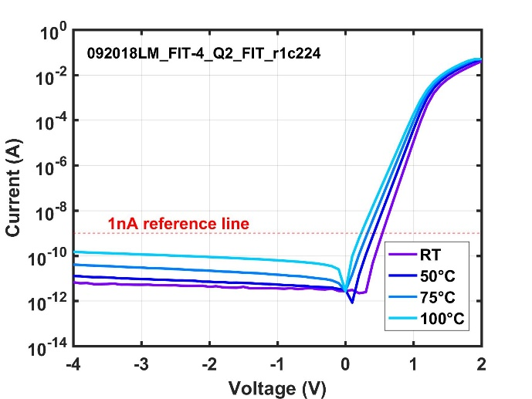

Fig. 6. Log scale IV characteristics of a 15 $μm$ photodiode measured at room temperature, 50 °C, 75 °C and 100 °C under room light illumination.

# Frequency Response & Data Rate Testing

For RF performance characterization, a multi-mode VCSEL with 29 GHz bandwidth is used as the laser source. The small-signal frequency response measurements start with characterization of VCSEL response up to 50 GHz with DXM30BF 30 GHz detector from Thorlabs. The optical output from the VCSEL is then collected and coupled into the photodiode with two optical probes and an OM4 fiber. The frequency response of the VCSEL-PD optical link can then be characterized with Keysight E5247A 67 GHz network analyzer. Fig. 7(a) shows the measured and fitting S21 of the VCSEL and VCSEL-PD link respectively. The optical response of the photodiode can be acquired by de-embedding the VCSEL response from the optical link response. The extracted optical frequency response of a 15 $μm$ photodiode is plotted in Fig. 7(b). This device shows a 3dB bandwidth of 33.5 GHz, capable of operating at 60 Gb/s.



Fig. 7. (a) Measured and fitted frequency response S21 of a 29 GHz VCSEL and a VCSEL-PD link. (b) Extracted frequency response of a 15 $μm$ PD. The measurement is carried out with direct modulation.

The large signal modulation is carried out with the setup in Fig. 8 which was previously introduced [6]. The DC bias is applied to the VCSEL and photodiode with two SG microwave probes. The NRZ signal is generated by a 60 Gb/s bit pattern generator (BPG) and feed into the VCSEL-PD link in back-to-back configuration. The received electrical signal from the photodiode side is then analyzed by a digital oscilloscope. Fig. 9 shows the eye diagrams measured from 20 $μm$ and 25 $μm$ photodiodes. The eye amplitudes at 50 Gb/s for 20 $μm$ and 25 $μm$ photodiodes are 215 mV and 308 mV respectively. Extracted rise/fall time are 11.9/15.1 ps for 20 $μm$ device and 12.4/15.5 ps for 25 $μm$ device. On-wafer probing and fiber coupling are the major limitations of this measurement. The bias tee used to mix the DC and RF signal has a low frequency cut-off which is not ideal for data rate testing. And the fiber coupling induces extra oscillation. A packaged photodiode with a transimpedance amplifier (TIA) is expected to present much better signal-to-noise ratio.

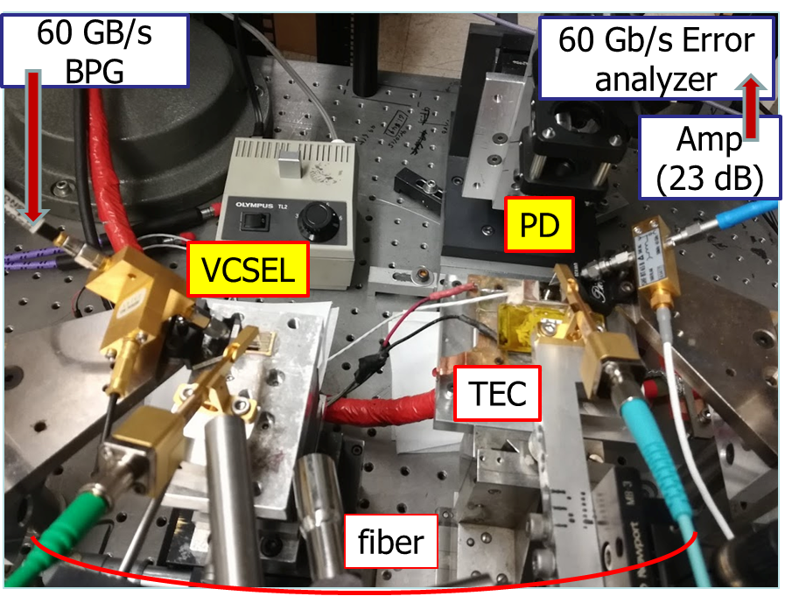

Fig. 8. Measurement setup for NRZ data rate testing for a BTB VCSEL-PD optical link [6].

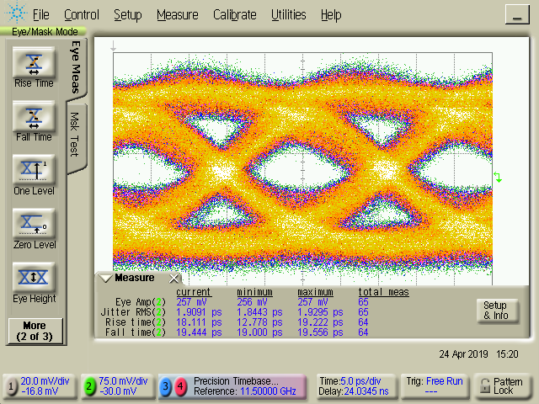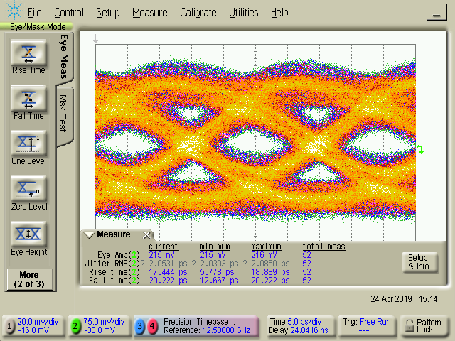

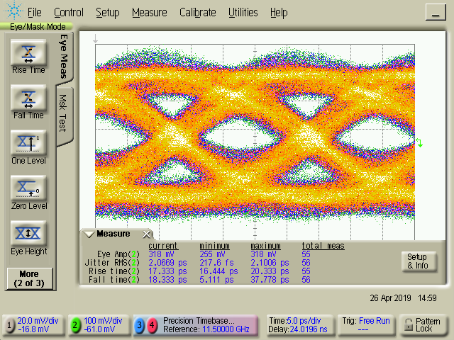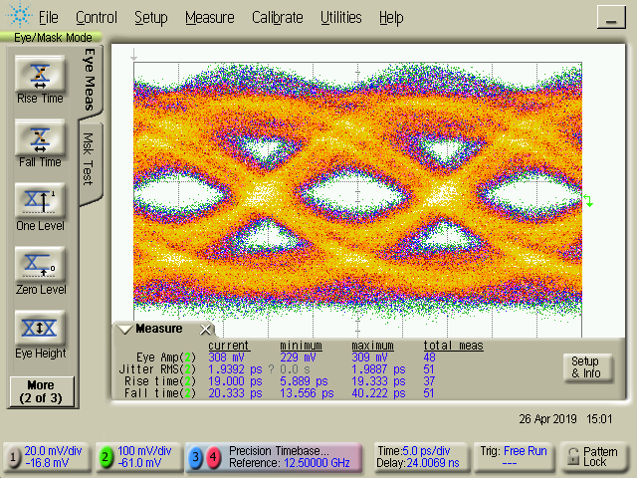

Fig. 9. Measured 46 Gb/s and 50 Gb/s eye diagram of VCSEL-PD optical links with 20 $μm$ and 25 $μm$ photodiodes.

**46 Gb/s, 20 um PD**

**50 Gb/s, 20 um PD**

**46 Gb/s, 25 um PD**

**50 Gb/s, 25 um PD**

# Conclusion

The GaAs P-i-N photodiodes designed for 50Gb/s optical links have been fabricated. The design and process considerations to achieve low dark current are discussed and measurement demonstrates less than 1pA dark current at room temperature. The 15 $μm$ device shows 0.3 A/W responsivity and 33.5 GHz optical bandwidth. Eye diagrams from data rate tests show device operation at 50 Gb/s.

# Acknowledgements

We sincerely acknowledge the generous sponsorship of this research project by Foxconn Interconnect Technology. The authors like to thank the support from Dr. Dennis Deppe, CEO sdPhotonics (Texas) and Dr. William Harrod, IARPA Super Cable Program under ARO W911NF-18-S-0009.

# Reference

[1] J. Qiu, X. Yu and M. Feng, "85°C operation of single-mode 850 nm VCSELs for high speed error-free transmission up to 1 km in OM4 fiber," *2019 Optical Fiber Communications Conference and Exhibition (OFC)*, San Diego, CA, USA, 2019, pp. 1-3.

[2] M. Liu, C. Y. Wang, M. Feng, and N. Holonyak, Jr. “Advanced development of 850 nm oxide-confined VCSELs with 57 Gb/s error-free data transmission,” in *Proc. GOMACTech*, Mar. 2016.

[3] M. Liu, C. Y. Wang, M. Feng and N. Holonyak, "850 nm oxide-confined VCSELs with 50 Gb/s error-free transmission operating up to 85 °C," in Conference on Lasers and Electro-Optics (CLEO), 2016*.*

[4] A. Winoto, Y.-T. Peng, M. Feng. “Design and fabrication of high-speed PIN photodiode for 50 Gb/s optical fiber links”, in *Compound Semiconductor Manufacturing Technology*, 2017

[5] Y.-T. Peng, A. Winoto, D. Wu, and M. Feng. “Process optimization and characterization of 25 GHz bandwidth 850 nm P-i-N photodetector for 50 Gb/s optical links,” in *Compound Semiconductor Manufacturing Technology*, 2018.

[6] Y.-T. Peng, J. Qiu, M. Feng. “Reconfigurable 43 Gb/s optical link test based upon on-wafer probes of GaAs photodetectors and VCSELs up to 85°C”, in *Compound Semiconductor Manufacturing Technology*, 2019

Acronyms

PD: Photodiode

SEM: Scanning Electron Microscope

VCSEL: Vertical-Cavity Surface Emitting Laser