Effective Polishing of Al-face of AlN Substrates using Advanced Polishing Process and Consumables

A. Titov, A. Walters
Engis Corporation, 105 W Hintz Road, Wheeling, IL 60090, USA

atitov@engis.com, 847-484-7326; awalters@engis.com, 847-484-7237

Keywords: Aluminum Nitride, Lapping, Polishing, Diamond Slurry

Abstract
This paper presents a novel surface finishing process and consumables for achieving an epi-ready finish on the Al-face of Aluminum Nitride (AlN) single crystal substrates and wafers. The designed combination of process parameters and newly developed slurries produces superior surface finish on the Al-face of AlN substrates and high removal rates yielding in significant reduction of wafer surface finishing process times for stock removal and chemical-mechanical polishing (CMP) steps.

Introduction

Aluminum Nitride (AlN) is a promising candidate for ultraviolet – light emitting diode (UV-LED), radio frequency (RF), and high-power devices because of the following advantages: the widest bandgap of 6.2 eV in direct transition semiconductors, a high thermal conductivity of 3.3 W/cmK, and excellent electrical insulation properties [1]. As a result, AlN single crystal is a desirable semiconductor substrate for fabricating optoelectronic and power electronic devices [2]. Device fabrication on AlN substrates generally involves the epitaxial growth of a device layer on the Al-face of the AlN substrate. The quality of this device layer depends on the quality of the surface of the Al-face of the AlN substrate [3]. As the AlN substrate is for electronics, the requirement for surface quality is very strict.
AlN single crystal is an extremely hard ceramic material to polish; a few polishing steps with extremely long processing times are normally required to achieve an epi-ready finish on the Al-face of the AlN substrate [4]. To produce the epi-ready surface, AlN substrates are generally mechanically lapped with slurries containing conventional abrasives, where the abrasive size is progressively reduced until the surface roughness (Sa) of a few nanometers is achieved [5]. The conventional lapping process takes usually more than 4 hours depending on amount of material to be removed and the post-grinding surface finish. Then chemical-mechanical polishing (CMP) is carried out using a colloidal silica slurry on a polishing pad to remove defects created during the mechanical removal step and to further smooth the surface and generate the epi-ready finish on the Al-face of AlN substrates. The CMP process is the most expensive step due to extremely long cycle times of about 20 hours (Fig 1). Reducing lapping and CMP cycle times is highly desirable both commercially and technically in order to minimize the cost of AlN substrate fabrication and to increase production throughput. Figure 1 illustrates typical surface finishing steps for the Al-face of AlN substrate polishing in comparison with a newly developed polishing process that we introduce in this paper.

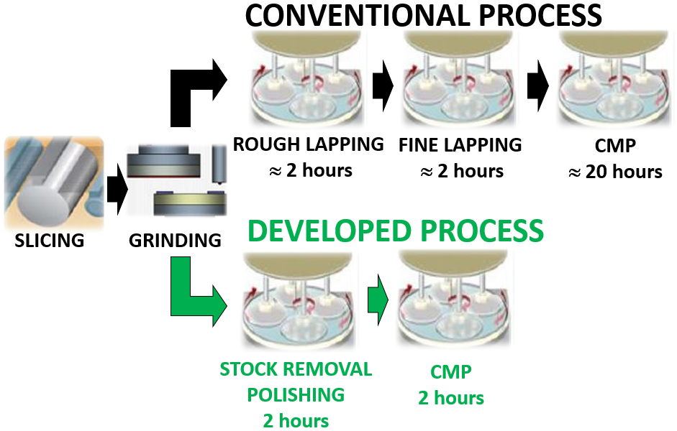

FIGURE 1. Comparison of developed Al-face of AlN substrate polishing process against conventional process.

Experimental

Four single crystal AlN wafers (C-plane) of 25 mm (1 in) in diameter and 635 μm thickness were used for polishing tests. The initial surface of both faces (Al- and N-) of the AlN wafers was ground and had surface roughness (Sa) of ≈355 nm. Polishing tests were performed only on the Al-face of the AlN wafers. A waxless polishing template mounted to a ceramic carrier disc 138 mm in diameter was utilized to hold the wafers in place during polishing. The wafers were evenly distibuted in the waxless polishing template which was inserted into a workstation of a polishing machine.
A 15-in Engis FastLap™ polishing machine was employed to conduct polishing trials. The close-up view of a polishing setup is displayed in Figure 2.

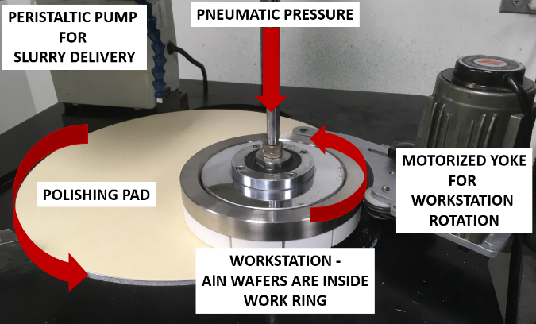
FIGURE 2. Polishing setup used for stock removal polishing and CMP tests – Engis FastLap™ polisher

Table 1 shows optimal process parameters which were identified for stock removal and CMP steps.

TABLE I
Process parameters for developed stock removal polishing and CMP processes
Process  Parameter | Stock Removal | CMP
Polishing pad | Engis HS4/SU | Engis M1000
Platen rotation | 90 rpm | 90 rpm
Station rotation | 70 rpm | 70 rpm
Pressure | 6 psi | 6 psi
Slurry | Developed  hybrid slurry | Developed CMP slurry
Flow rate | 10 mL/min | 10 mL/min
Process time | 2 hours | 2 hours

Material removal rate (MRR) was measured at 5 points of each AlN wafer as the difference in thickness of the wafer using a Mitutoyo Spherical Phase 395-Series micrometer with accuracy ± 2μm. In addition, material removal rate was confirmed with weight loss measurement on a Mettler AE260 Delta Range analytical balance with readability of 1 mg. Each wafer was weighed before and after each polishing process.
Surface roughness of the wafers was examined using a Zygo NewView™ 6300 3D Optical Profilometer. The average of surface roughness (Sa parameter) was calculated based on 3 measurements per each wafer (x4 wafers), resulting in 12 measurements total.

Results and Discussion

In the polishing process, the material is removed by the mechanical and chemical actions between abrasives, substrate and slurry chemistry. The material removal rate (MRR) and the surface finish mainly depend on the consumables being used (slurry and polishing pad) and the process parameters such as pressure, rotational speed of the polishing pad, and process time. Generally, the higher pressure and the rotation of the polishing pad, the larger abrasive grit size in the slurry, the faster material removal rate and the rougher surface. The properties of a polishing pad and slurries are the essential factors to ensure the high removal rate and the low surface roughness [5]. All these important principals were used for the development of the advanced surface finishing process and consumables for the Al-face of AlN substrate polishing. This leads us to the introduction of the developed surface finishing process which includes two polishing steps.
The first step is a stock removal polishing which is needed to remove surface damage from the AlN grinding step and at the same time to produce a smooth, flat, optically clear surface on the Al-face of AlN substrates. For this step, we engineered a hybrid slurry where conventional abrasives were mixed with superabrasives in a solution containing special chemical additives. All this helps enhance material removal and to improve the surface finish. The unique combination of abrasives results in a synergistic effect, combining the aggressiveness and hardness of diamond with a softer abrasive to compliment the removal and smooth the surface simultaneously. Figure 3 displays the performance of this developed hybrid slurry in comparison to slurries which do not contain the developed combination of superabrasives and chemical additives. These comparison tests were carried out on a rigid nonwoven polishing pad (Engis HS4/SU pad).

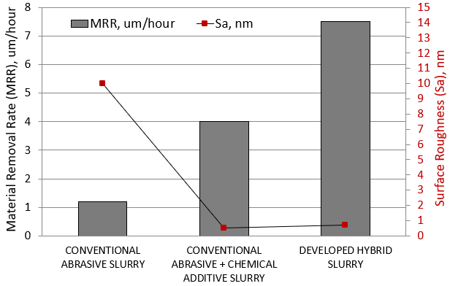
FIGURE 3. Comparison of developed hybrid slurry against conventional slurries for AlN stock removal polishing process.

The combination of the developed hybrid slurry and the non-woven polishing pad produces high stock removal rate of about 7.5μm/hour and an optically clear surface with surface roughness (Sa) of ≤ 0.74nm on the Al-face of AlN substrates (Figure 4).
The second step is a chemical-mechanical polishing which combines the action of chemical polishing with the mechanical removal properties of slurry abrasives on a polishing pad. This step is necessary for achieving the epi-ready finish on the Al-face of AlN substrates when defined key process parameters are applied.
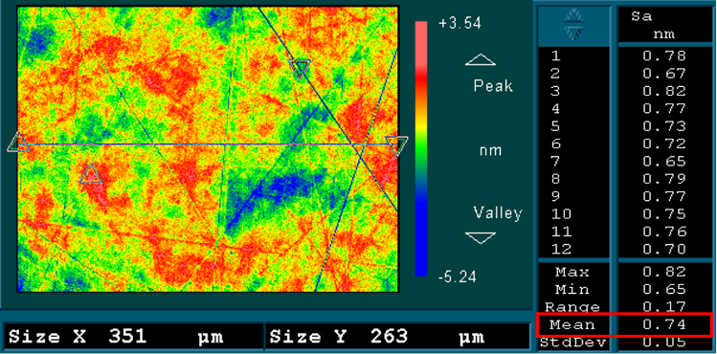
FIGURE 4. Surface roughness (Sa) results after stock removal polishing of Al-face of AlN wafers.

For this process, a new CMP slurry was developed and evaluated on a couple of polishing pads with different material properties: the rigid nonwoven pad - Engis HS4/SU pad that was utilized for the stock removal polishing process previously and a polyurethane polishing pad - Engis M1000 pad (Figure 5).
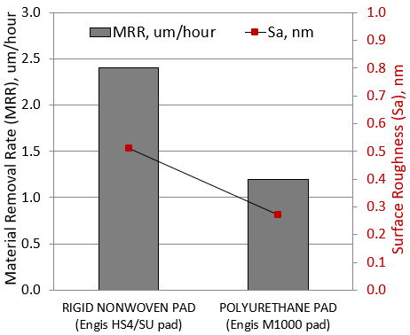
FIGURE 5. Effect of polishing pad on CMP slurry performance - CMP of Al-face of AlN wafers.

It is well known that polishing pads play a dominant role in the overall performance of the CMP process [6]. It was found that the rigid nonwoven pad (Engis HS4/SU) is more aggressive; therefore, it produces higher MRR and surface roughness which coincides with the important polishing principal of the faster material removal rate the rougher surface. On the contrary, the other pad which is the polyurethane pad (Engis M1000) generates satisfactory material removal rate of about 1.2μm/hour and an epi-ready finish of ≤ 0.3nm Sa (Figure 6). Consequently, this pad is suitable for the final polishing step (CMP process).
Figure 7 and Table II summarize polishing results of the developed surface finishing process for the Al-face of AlN single crystal substrate polishing.

Conclusions

Consumables, process parameters, and equipment become a very critical combination when an extermly hard ceramic compound semiconductor material such as AlN single crystal
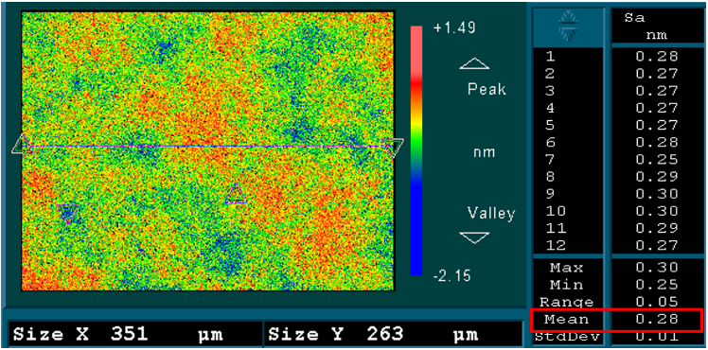
FIGURE 6. Surface roughness (Sa) results after CMP of Al-face of AlN wafers.

needs to be polished in the most efficient and economical way. We successfully refined this combination and developed the advance surface finishing process for polishing of the Al-face of AlN substrates. This novel process includes two steps: stock removal polishing for bulk material removal at the same time generating a smooth, flat, optically clear surface; followed by chemical-mechanical polishing for achieving the epi-ready finish on the Al-face of AlN substrates. Altogether, the developed advanced polishing process produces defect-free, superior smooth surface which is obtained at high removal rates and very short polishing times relative to conventional polishing processes.

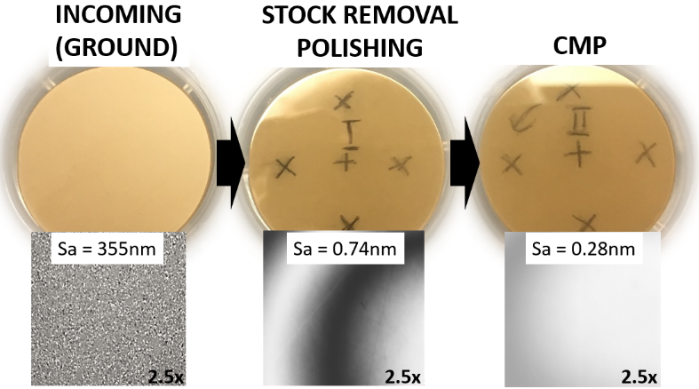
FIGURE 7. Surface finish of Al-face of 1” AlN wafers after each polishing process step

TABLE II
Summary of Al-face of AlN substrate developed surface finishing process
Parameter | Incoming | Stock Removal Polishing | CMP
Surface finish | Ground | Optical | Epi-ready
Surface roughness (Sa) | 355nm | 0.74nm | 0.28nm
Material removal rate | n/a | 7.5μm/hr | 1.2μm/hr
Process time | n/a | 2 hours | 2 hours

References

[1] I. Satoh, et al., Development of Aluminum Nitride Single-Crystal Substrates, SEI Technical Review, Number 71, October 2010.

[2] Information on: https://www.skysonginnovations.com/aluminum-nitride-aln-power-devices/

[3] L.J. Schowalter, et al., Method for Polishing a Substrate Surface, U.S. Patent No. 2007/0289946, December 20, 2007.

[4] H. Morkoc, Handbook of Nitride Semiconductors and Devices, Materials Properties, Physics and Growth, pp. 66, Wiley-VCH, 2008.

[5] Z. Zhong Zhou, et al., Study on the Finishing Process for the Aluminum Nitride Substrates, Advanced Materials Research, Vols. 69-70, pp. 282-286, 2009.

[6] A. J. Khanna, et al., Impact of Pad Material Properties on CMP Performance for Sub-10nm Technologies, ECS Journal of Solid State Science and Technology, 8 (5) P3063-P3068, 2019.

Acronyms

CMP: Chemical-mechanical polishing
UV-LED: Ultraviolet – light emitting diode
RF: Radio frequency
MRR: Material removal rate

