Market opportunities for Wide-Band gap semiconductors in EV/HEV applications
E. Dogmus, A.B.Slimane, C.Troadec

Yole Développement, 75 cours Emile Zola, 69100 Villeurbanne France, e-mail: ezgi.dogmus@yole.fr– Phone : +33.4.72.83.01.86.

Keywords: EV/HEV, Wide bandgap semiconductor, Gan, SiC, main inverter, DC/DC

Abstract
The high growth of the EV/HEV market impacted significantly the wide bandgap semiconductor industry, creating new opportunities and a competition between SiC and GaN in many applications such as on-board chargers, DC-DC converters and main inverters. This paper provides an overview of SiC and GaN device technology, including Yole Développement’s understanding of the market’s current dynamics and future evolution of wide band gap materials compared to mainstream Silicon power electronics market.

Introduction

The EV/HEV race has begun. More than $300B of EV/HEV investments have been announced by different OEMs, clearly confirming the automotive industry’s commitment to governmental CO2 reduction targets.
Indeed, the market figures are promising. In 2018, 1.32M battery electric vehicles (BEV) were purchased, along with 0.75M plug-in hybrid electric vehicles (PHEV) - compared to 0.78M units and 0.41M units in 2017, respectively. This equates to year-over-year growth of 68% and 84%, respectively. Moreover, sales of other hybrid cars have also increased.
New players from different technology areas (material and equipment suppliers, power electronic device manufacturer, system integrators, car makers…) are entering EV/HEV business. New divisions or joint ventures, fully dedicated to EV/HEVs are being established by many companies. The strong technology requirements and at the same time tough product qualification challenges call for development of new power electronic technologies. The high volume demand for EV/HEV attracts many players to be first to develop and implement such new solutions. In addition to already big EV/HEV market, the newly developed solutions can be also implemented in other applications areas, so further increasing business opportunities. But on the other side, there are some technology requirements specific for non-EV/HEV applications (higher device voltage, long lifetime, etc.). Some players might still find nice business opportunities in such application, instead of competing with growing number of players involved in EV/HEV business. In any case, for both EV/HEV and non-EV/HEV players it is worth to follow the EV/HEV trends in order to identify potential opportunities/threats.

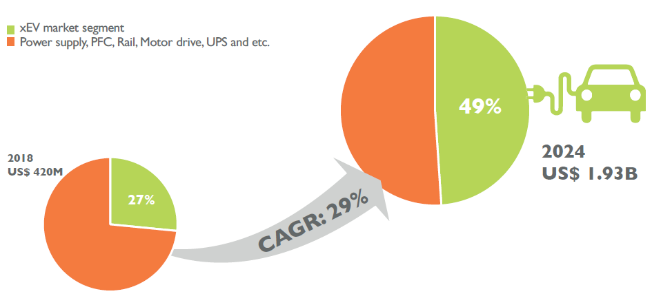
Fig. 1. SiC market evolution Special focus: automotive market segment

EV/HEV charging, energy storage and other markets related to the EV/HEV follow the trends in the EV/HEV industry: increasing EV battery pack voltage (400V/800V) leading to demand for 1,200 V rated power electronic devices, increasing battery cell energy and power densities, increasing battery pack energy capacity resulting in higher charging power needs, implementation of fast-switching silicon carbide (SiC) devices, etc. The companies involved in related applications have to continuously adapt their products while often benefiting of the technology development done for EV/HEVs.
Regarding the compound semiconductor industry, the electrification brings new market opportunities for wide band gap materials such as GaN and SiC. In most of the applications from on-board chargers, DC-DC converters and main inverters SiC and GaN are in a tough competition.

Market opportunities for SiC

The 2018 - 2019 SiC power device market is notable for Tesla’s adoption of SiC in its main inverter. The discussion concerning whether other automotive players will also adopt (or not) is THE topic of the year. Recently, the automotive industry has committed more than $300B investment towards xEV development, causing the xEV market to explode. This is in stark contrast to the traditional combustion engine car market, which is suffering through a slowdown. The xEV market is the primary market driver for Si power devices, and it is the source of excitement for SiC - which is not surprising at all.
Ranging from conservative to optimistic, industrial players offer very different forecasts in terms of market value for SiC in the xEV market. These forecasts range from several hundred million dollars to $3B in 2025, the latter estimated by STMicroelectronics. Everyone agrees that EV is the market of highest potential, but perceptions differ regarding how it will grow and how SiC will penetrate into the automotive market. These perceptions are based on the data that each player has collected and the arguments that derive from their interpretation of the data.

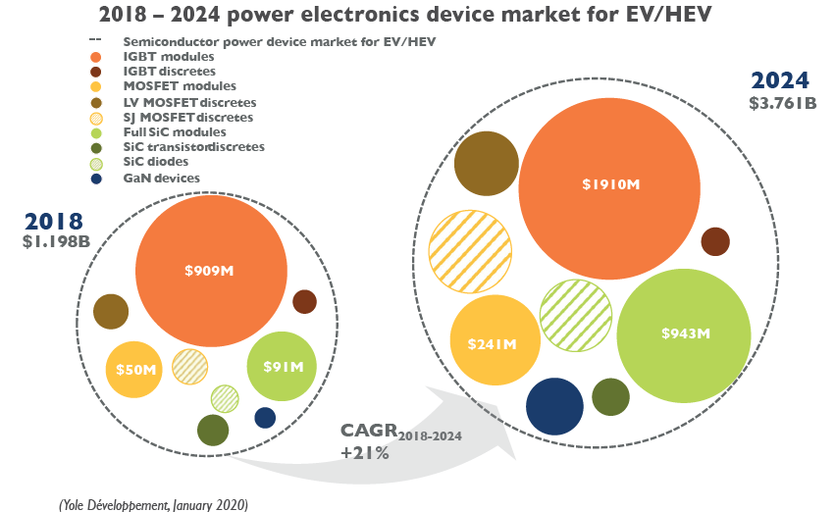
Fig. 2. Market forecast for power electronics device market for EV/HEV for the 2018-2024 period
Based on our discussions with different players, Yole sees a prospering SiC power device market. In fact, we expect the SiC power semiconductor market’s value to approach $2B by 2024, with a compound annual growth rate (CAGR) of 29% for 2018 - 2024.
The automotive market is undoubtedly the foremost driver, and as such will hold around 50% of total device market share in 2024.
At substrate level, in the last two or three years, the transition from 4” to 6” wafers, coupled with increasing wafer demand, led to a wafer short-supply. This was one of the most frequently discussed topics in the SiC power industry, and was a substantial bottleneck in 2018. This creates many significant changes at the ecosystem level.

GaN adoption in electric vehicles

Concerning GaN, even though its penetration in EV/HEV much slower than expected, there is an increasing interest for DC/DC converters in 48V mild hybrid electric vehicles, which are expected to reach high volume market in next 5 years. In addition, GaN enables an interesting cost and performance for the On-board chargers and DC/DC converters in the electrified vehicles. The GaN devices have started achieving the automotive qualification and the OEMs keep an eye on GaN and develop internally. Players like EPC and Transphorm have already obtained AEC qualification, and GaN Systems, which benefits from its BMW i Ventures investment, expects qualification by next year. These device manufacturers are working closely with packaging companies like ASE, AT&S, and Schweizer to enter the OEM supply chain and enjoy increasing volumes starting in 2023 – 2024 according to Yole Développement. Now the question is when and who adopts GaN in the next generation vehicles.

Conclusions

It is clear that wide band gap materials SiC and GaN have a strong growth potential in EV/HEV market. Both compound semiconductors have significant added values and challenges for market adoption.

[1] Yole Report: Power GaN Market: Applications, Players, Technology, and Substrates 2019-2024
[2] Yole Report: Power SiC Market: Applications, Players, Technology, and Substrates 2019-2024
[3] Yole Report: Power Electronics for Electric & Hybrid Electric Vehicles 2019-2024

Acronyms

EV/HEV: electric vehicles/ hybrid electric vehicles
BEV: battery electric vehicles
PHEV: plug-in hybrid electric vehicles
CAGR: Compound Annual Growth Rate
IGBT: insulated-gate bipolar transistor
OEM: original equipment manufacturer

