Exploring the capability of Hyperspectral Electroluminescence for process monitoring in vertical GaN devices

Mona A. Ebrish¹, Travis J. Anderson², James C. Gallagher², Joseph Spencer⁴, Andrew D. Kohler², Geoffrey Foster³, Karl D. Hobart²
¹NRC Postdoctoral Fellow Residing at NRL, Washington, DC 22310, USA mona.ebrish.ctr.ly@nrl.navy.mil 202-404-6788
²U.S. Naval Research Laboratory, Washington DC 20375, USA, ³ASEE Postdoctoral Fellow Residing at NRL, Washington, DC 22310, ⁴Virginia Tech, Blacksburg, VA

Keywords: GaN, Hyperspectral Electroluminescence, Vertical Diode, Failure analysis, Characterization

Abstract

GaN is a promising material for more efficient high frequency and high voltage power switching. However, GaN still is not the common material for power electronics due to immature substrate, homoepitaxial growth, and processing technology. Electroluminescence is a promising method to predict failure points due to high field stress, which can assist in the separation of inherent defects stemming from substrate quality, and from process-induced defects as well as identify problems related to proper edge termination design. In this work, we compare the Electroluminescence signatures of devices on inhomogeneous substrates to DC I-V behavior to demonstrate the utility of the technique for process monitoring.

INTRODUCTION

Despite the superb advantages of vertical GaN diodes in high power applications, the manufacturability of these devices is encountering reliability issues under high voltage stress, along with other epitaxial growth limitations that hinder scaling to >5kV [1]. Defects can either originate during the epitaxial layer growth process in the form of dislocations or impurity traps or during the fabrication process. The edge termination process specifically has a direct impact on the voltage blocking capability and reliability of the device. Here we present a characterization technique to evaluate failure mechanism and distinguish between the failure causes that derive from the killer defects in the substrate from those that originate during the fabrication process.

Hyperspectral electroluminescence (EL) testing can be used to study those defects under high voltage conditions. Furthermore, hyperspectral imager can be used to identify high field points that will cause reliability issues under reverse bias and also to spatially resolve defect band luminescence under forward bias. This technique gives a direct image of reverse bias device performance, and can be implemented during the fabrication sequence for process monitoring. Furthermore, it could be combined with other stress tests like the high temperature reverse bias (HTRB), and high temperature operating life (HTOL) on completely fabricated and packaged devices. If theses weak points can be identified early in the fabrication process, then it can optimize the edge termination design [2].

EXPERIMENT

Vertical GaN PiN diodes were tested and imaged in a custom vacuum probe station rated up to 20kV. The use of vacuum ambient presents an advantage over fluorinert testing as it preserves optical access to the device for imaging under high voltage stress conditions. At NRL our vacuum probe station with Hyperspectral Imaging has 250-1000nm imaging range, 2nm resolution, and broadband and monochromatic imaging modes as shown in Figure 1.

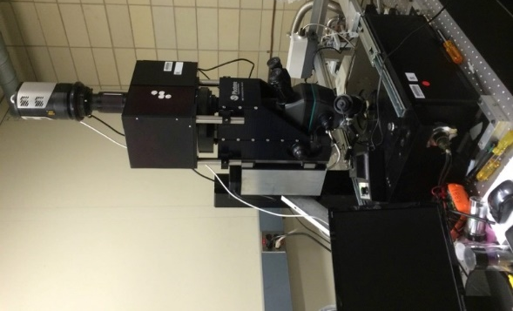
Figure 1 NRL Vacuum Probe Station with Hyperspectral Imaging.

Generally, GaN substrates can be classified into two categories based on homogeneous characteristics in impurities and defects (uniform) and those with inhomogeneous characteristics of impurities and defects (non-uniform) [3]. A cross-section schematic of the devices is shown in Figure 2, and the manufacturing process and typical device behavior is previously described [4]. Two devices from two different non-uniform substrates were utilized for this study, device A is from Substrate-1 and device B from Substrate-2 were measured under DC I-V sweep using Keithley 4200, shown in Figure 3. The I-V plot illustrated a typical PiN diode behavior, both devices have identical performance.

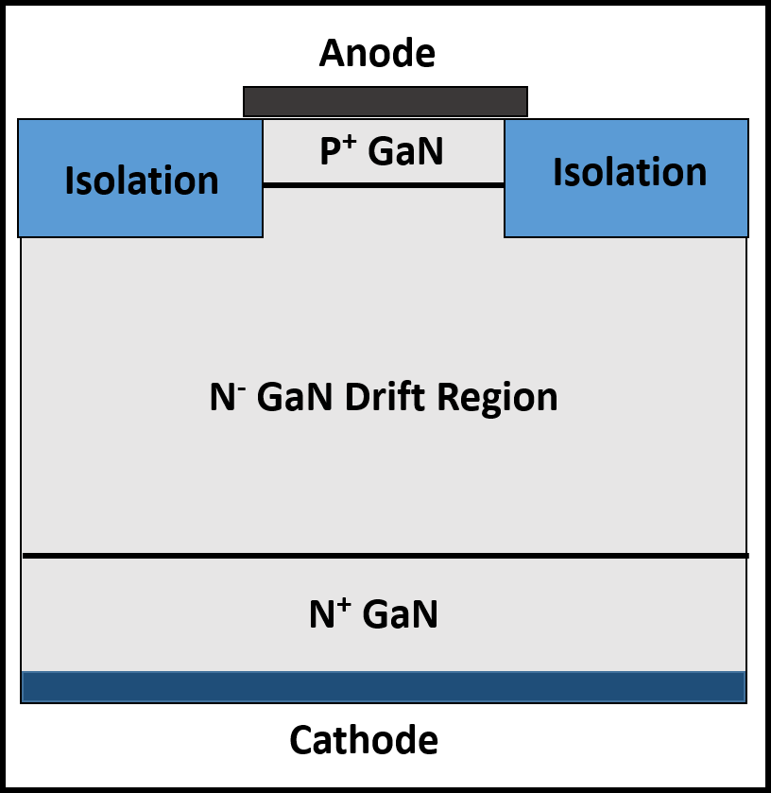
Figure 2: Schematic of a vertical PiN GaN.

A standard spectrometer was used to collect and analyze the luminescence during a forward bias condition of 0.9A with a 10sec acquisition time. The bias current needs to be relatively high because the fiber entrance is fixed a probe manipulator without an objective to guide the light thus a high current is needed to compensate for the loss in photons. This short loop test can be easily implemented into a production line to predict the reliability results. The spectra from both devices A&B are plotted in Figure 3. The spectra in Figure 3 show a distinct difference between the two devices that was not clear from the DC I-V sweep plotted at the top of the same figure. The DC I-V sweep characteristics for devices A and B are plotted to an absolute scale the spectra plot was normalized. The normalization was needed due to the difference in the absolute number of counts between the two devices. A more sophisticated apparatus can be implemented to collect the photons with minimum loss in the future.

To spatially resolve the reverse current and determine the failure points, Hyperspectral mapping can be utilized to locate the luminescence points on the device by imposing the emission location in pixel on the optical image taken by the same tool. The electroluminescence mapping of the device emission starts at the forward bias to identify certain wavelengths of interest.

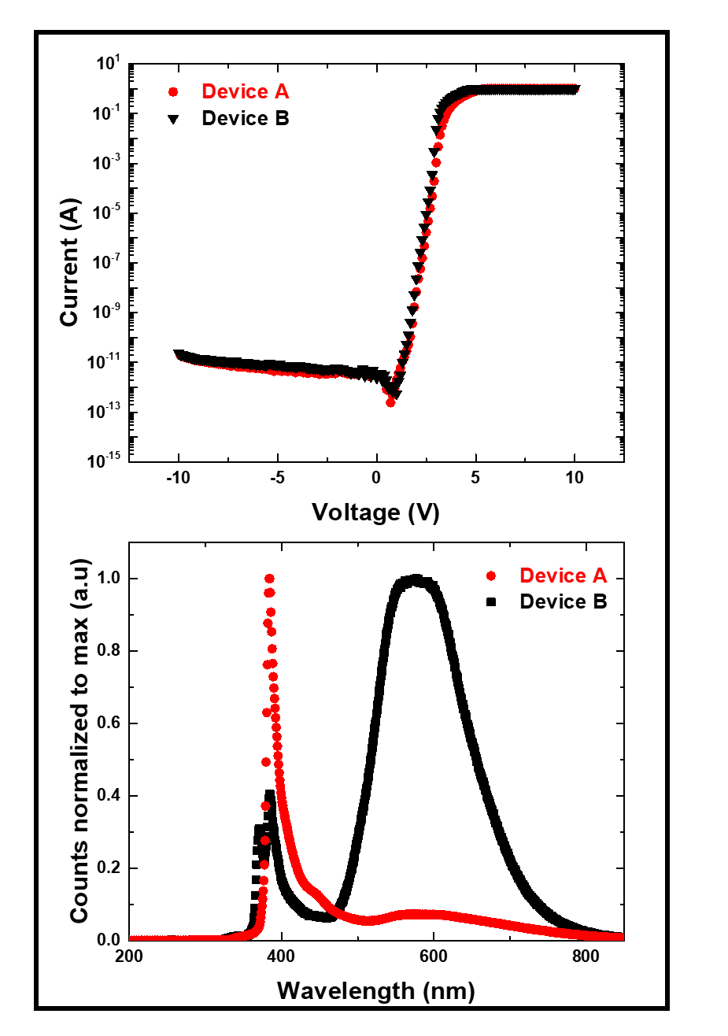
Figure 3: DC I-V sweep for both devices from different non-uniform substrates. The standard spectrometer spectra for the same devices under 0.9A forward current hold.

A series of monochromatic images with 10nm step size were taken to enable pixel-by-pixel spectrum extraction at the forward bias of 0.1A and same acquisition time for both devices. The forward current was reduced to 0.1A to avoid saturating the cooled CCD detector. Figures 4 and 5 illustrate the broadband EL image, capturing all wavelengths, along with the extracted pixel intensity vs wavelength from the data cube, chosen at 5 points within the device structure. Once the forward imaging is completed and certain peaks have been identified, reverse bias test can be applied to evaluate high field points. Because the acquisition time under reverse bias is substantially longer, full range hyperspectral mapping is not practical, thus a series of monochromatic images was taken to focus in the previously identified defect bands. Reverse I-V measurements to 1kV were taken with a Keithley 237 SMU, indicating different levels of leakage current at high reverse bias. Figure 6.a shows the reverse I-V reverse sweep for both devices A & B from zero to 1kV. Device A experiences three order of magnitude less leakage than device B. Therefore, device A cannot be studied under these reverse conditions to 1kV as the leakage current is too low to generate monochromatic images. Generally, running a reverse bias requires either vacuum setting or fluorinert therefore, it is not feasible to implement such a test along the production line, thus this technique is more practical for failure analysis.

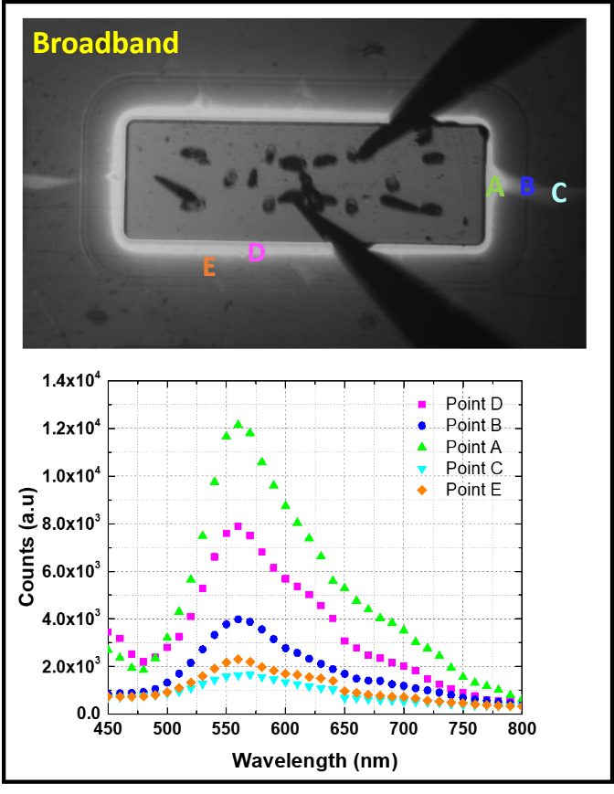
Figure 4: Broadband image of Device B during forward bias hold at 0.1A. Device B The hyperspectral plot of surface points from anode edge outward.

It is important to monitor the reverse current during the acquisition to make sure it does not drift higher which is an indicative of filament formation, or lower due to current loss to heat. The consistency in current in Figure 6.b assures that the bright points on device surface is a direct manifestation of the failure point dislocation leakage path. The monochromatic images are shown in Figure 6.c, along with the broadband image that captures all the wavelengths.

DISCUSSION

The standard spectra reveal a significant difference between that devices that are otherwise similar. Despite the fact that the emission collection was taken under the same condition there is a noticeable difference in the number of counts which is believed to reflect the difference in the brightness. The emission around 379 nm is the expected wavelength from GaN which strongly relates to its bandgap emissions. The signal is stronger in device A at that wavelength than it is in device B. Furthermore, device A does not exhibit other strong peaks while device B has conspicuous peaks ranges from 450-700nm. Those wavelengths represent energy levels near the band edge and deeper. The DC I-V initial sweep in Figure 3 does not hint to the disparity in the device performance at high reverse bias.

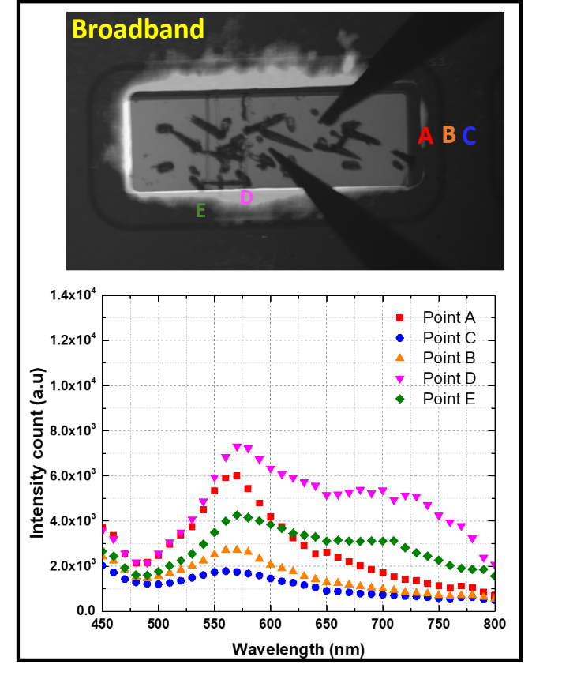
Figure 5: Broadband image of Device A during forward bias hold at 0.1A. Device A The hyperspectral plot of surface points from anode edge outward.

The hyperspectral imager electroluminescence results in Figures 4 shows that the emission spectrum has a distinct spatial distribution, with the UV emission strongly focused at the anode edge, then defect bands visible in the edge termination regions and outside of the device active area. In general, it indicates a broad peak in the yellow spectral region centered around 500-600 nm, and a presence of a weaker peak in the red spectral region from 700-800 nm. The forward luminescence was useful however to identify wavelengths to focus on during the reverse bias acquisition. Since devices were tested under the same conditions therefore, number of counts can be compared. Device A exhibits significantly less counts except at 450 nm. That is near band-edge peak and is expected from most non-uniform bulk GaN substrates. However, the peaks that represent deeper bands are less prominent in device A. It is well known that threading dislocations that can extend through thick layers of MOCVD GaN and make some undesirable path ways to reverse currents [5]. Therefore, it is not a surprise that device A experiences much lower leakage current than device B at the very high reverse voltages. The monochromatic imaging technique described above is a powerful tool to help resolve where the leakage path falls, both spatially within the device as well as within the spectrum of traps known in the GaN system. 700 nm is arguably the brightest which related to deep traps at 1.7eV followed by 510 and 450 nm respectively. It is interesting to note that there is only one clear bright spot on the device surface and it is located near the termination edge. This is clearly a failure point that could be further investigated by surface morphology evaluation, defect highlighting wet etches, or Cathodoluminescence to clarify whether it is more related to the termination fabrication process or threading dislocations inherent in the device structure [6]. Further testing to avalanche breakdown is necessary to identify the evolution of this spot under high field stress, as well as search for luminescence signatures in Device A.

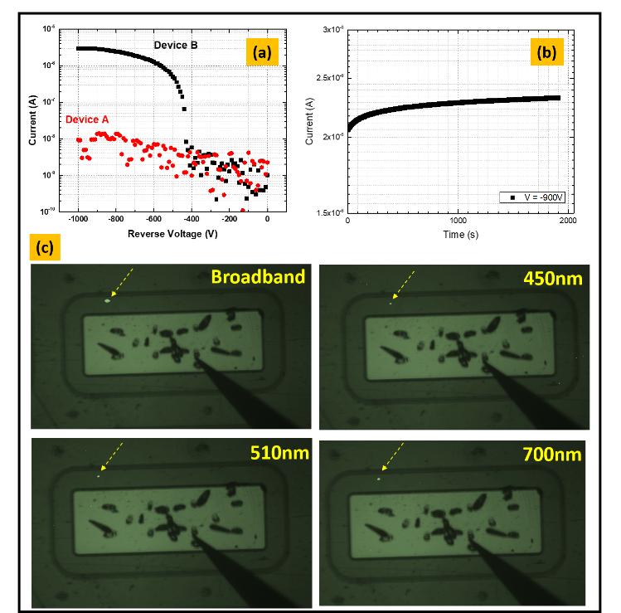
Figure 6: (a) Reverse sweep for devices A & B. (b) DC reverse bias hold during the EL acquisition. (c) EL images from device B at certain wavelengths while applying -900V.

CONCLUSION

Despite the fact that both devices were fabricated on non-uniform substrates, there is still disparity in their performance. This variation in the reverse leakage between the two substrates is more likely related to the fabrication process statistical variation or improper termination design for the given properties of the drift layer. This disparity can also stem from the fact that non-uniform substrates have various quality levels. We demonstrated that the standard DV I-V sweep does not predict deficiencies that lead to high leakage current at high reverse biases. Standard spectrometer was utilized to identify potential performance issues. Further investigation with the hyperspectral imager identified the wavelengths to monochromatically scan during the high reverse bias to spatially define the leakage spot and hence the failure point. Hyperspectral EL is a powerful characterization technique that can be utilized to identify failure mechanisms, and link them to fabrication processes down faults that impact the device performance. This technology can be automated which will allow researcher to statistically tie electrical stressing to process statistical vitiation.

REFRENCES

[1] A. J. Fischer et al., “High voltage and high current density vertical GaN power diodes,” Electron. Lett., vol. 52, no. 13, pp. 1170–1171, 2016.
[2] T. J. Anderson et al., “Hyperspectral Electroluminescence Characterization of OFF-State Device Characteristics in Proton Irradiated High Voltage AlGaN/GaN HEMTs,” ECS J. Solid State Sci. Technol., vol. 5, no. 12, pp. Q289–Q293, 2016.
[3] J. C. Gallagher et al., “Long range, non-destructive characterization of GaN substrates for power devices,” J. Cryst. Growth, vol. 506, no. October 2018, pp. 178–184, 2019.
[4] I. C. Kizilyalli, A. P. Edwards, H. Nie, D. Disney, and D. Bour, “High voltage vertical GaN p-n diodes with avalanche capability,” IEEE Trans. Electron Devices, vol. 60, no. 10, pp. 3067–3070, 2013.
[5] J. W. P. Hsu, M. J. Manfra, R. J. Molnar, B. Heying, and J. S. Speck, “Direct imaging of reverse-bias leakage through pure screw dislocations in GaN films grown by molecular beam epitaxy on GaN templates,” Appl. Phys. Lett., vol. 81, no. 1, pp. 79–81, 2002.
[6] S. Usami et al., “Correlation between dislocations and leakage current of p-n diodes on a free-standing GaN substrate,” Appl. Phys. Lett., vol. 112, no. 18, 2018.

