5G impact on Wireless Infrastructure and Compound Semiconductor Industry
E. Dogmus, A.B Slimane, C. Malaquin, A. Bonnabel, C. Troadec

Yole Développement, 75 cours Emile Zola, 69100 Villeurbanne France, e-mail: ezgi.dogmus@yole.fr – Phone : +33.4.72.83.01.86.

Keywords: wireless infrastructure, compound semiconductors, 5G, GaN, GaAs, InP

Abstract
The paper presents the market overview of different compound semiconductor such as GaN, GaAs, and InP impacted by the deployment of 5G in wireless infrastructure. The value chain from wafer and epitaxy to device level is covered, as well as technology and market trends and Yole’s forecast for the coming years.

Introduction

The wireless infrastructure industry is a mature steady market where a constant investment from telecom operators is shared between system makers down to component manufacturers. This constant envelope has seen a very low evolution in the past decades, and this should remain so. Nevertheless the current technology trend at antenna system level shuffles the cards, opens opportunities and closes some at component level for historical players and new entrants.
Today, most of the antenna systems used in base stations are based on a remote radio head (RRH) linked to a passive antenna. A RRH is a chain of high power RF components dedicated to signal filtering and amplification before transmission. They include two to four streams of RF signal at power levels reaching 120W at antenna level. For these systems, the technology is now mature and the technology split for the 4G has been well established. Nevertheless with the arrival of 5G, new communication bands at higher frequencies, namely the sub-6 GHz new radios, have offered a new opportunity for compound semiconductors in this field. Indeed, for all bands over 3 GHz, typically the 3.5 GHz band currently being mastered by Nokia and Ericsson systems, laterally diffused metal oxide semiconductor (LDMOS) technology cannot offer the proper performance and GaN substrate for power amplification is required. This is the main growth relay for GaN in the infrastructure field as more and more RRH at high frequency are expected in the future.
In parallel to these higher frequency RRH systems, a new kind of structure has appeared, they are the active antenna systems (AAS). These – more complex – systems are composed of up to 64 RF chains, each linked to a specific antenna element. By dissociating the antenna elements and creating independent RF chains, the systems has the ability to actively phase and change amplitude of the signal streams, therefore allowing through a savant RF wave combination the creation of constructive and destructive interferences that manage to shape and steer the signal into a orientable beam. This has a huge impact on the capability of the base station to reach a specific user, and to improve spectral efficiency. These AAS therefore use a multitude of low power RF chains (down to 2.5W at antenna level) instead of the few high power chains featured by RRH systems. These RF chains require new components, especially gain blocks which are multipurpose RF power amplifiers, LNAs, drivers, and also phase shifters and variable attenuators. All these components were either inexistent or featured in low volumes in standard RRH. This creates a growing market for low power active devices that are today mostly addressed by GaAs. We therefore expect a growth of the GaAs market in the infrastructure thanks to its implementation in active antenna systems.
Compound semiconductor therefore sees two noticeable potential markets, one in high power high frequency sub-6 GHz RRH for GaN and one in the low power RF chains of 5G active antenna systems for GaAs.
On the millimeter waves (mmWave) side, very high frequencies are used for backhauling, and will be used in high density small cells in dense areas like city centers, malls or stadiums. These devices rely mostly on SiGe and this will carry on in the future. Nevertheless, with the use of always higher frequencies (144 GHz frequency is considered at long term for backhauling), InP based technologies may compete with SiGe in this field, thus offering a potential market through penetration in high frequency systems. It is important to underline though that these developments are considered as “Beyond 5G” technologies, thus a long term opportunity.

5G’S IMPACT ON TELECOM INFRASTRUCTURE

The telecom infrastructure market has not moved much in the past decade in terms of the value of operators’ investments. Customer pricing also keeps decreasing, and building new infrastructure keeps showing smaller and smaller returns on investments for telecom operators. In this context, an attempt to create new markets and enlarge operators’ reach to customers beyond mobile phones created 5G. By modifying the network to allow for ultra-fast, ultra-reliable and ultra-flexible communications, 5G’s aim is to expand to new opportunities, such as enterprise owned networks, industrial automation or road safety. Nevertheless this is a bet on the future, and actual infrastructure market growth is not expected in the foreseeable future at site level.

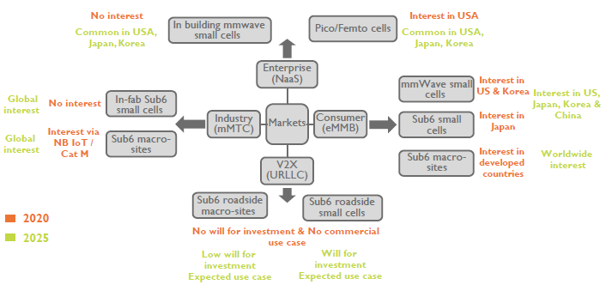
Fig. 1. 5G commercial uses cases 2020-2025
Yole Développement (Yole) expects the global market to remain steady and oscillate between 1.7 and 2 million macro site antenna systems shipped a year between 2018 and 2025. On the other hand, a new type of smaller infrastructure should still see notable growth. That infrastructure is referred to as ‘small cells’, and should reach shipment levels in the eight hundred thousands of units by 2025.

GaN based wireless infrastructure market

Over recent years, GaN has been significantly adopted by the Radio-Frequency (RF) industry owing to its higher power output at high frequencies, and its smaller footprint. The overall GaN RF market is expected to reach $2B by 2024, driven by two main applications: telecom infrastructure and defense.
Worldwide investment in telecom infrastructure has remained stable in the past decade, with a recent increase coming from Chinese government efforts. But in this steady market, the trend toward higher frequencies offers a sweet spot for RF GaN in power amplifiers (PA) in fifth-generation (5G) network at frequencies below 6 GHz, in remote radio heads (RRH). This application is expected to drive GaN market growth in the next five years. Even though the next generation active antenna technology could offer an advantage to silicon LDMOS technology, due to technical limitations such as thermal management and the localized need for such antennas in mostly high density areas, RRHs will not be replaced and will stay for the long term, using GaN PAs. Future large scale deployments of small cells and backhaul connections are also expected to represent a significant opportunity for RF GaN, starting from 2021.
In fact, since the apparition of first commercial products 20 years ago, GaN has become a serious rival to LDMOS and GaAs in RF Power applications, with a continuous improvement of performance and reliability at lower cost. The first GaN-on-Silicon Carbide (SiC) and GaN-on-Si devices appeared at almost at the same time, but GaN-on-SiC has become more technologically mature. Currently dominating the GaN RF market, GaN-on-SiC penetrated the fourth generation (4G) Long-Term Evolution (LTE) Wireless infrastructure market and is expected to be deployed in RRH architectures in 5G’s sub-6 GHz implementations. Nevertheless, in parallel, there has also been remarkable progress in cost-efficient LDMOS technology, which is likely to challenge GaN solutions in 5G sub-6 GHz active antennae and massive Multiple Input, Multiple Output (MIMO) deployments. In this context, GaN-on-Si stands as a potential challenger with possible expansion to production on 8-inch wafers, and promises cost efficient solutions for commercial markets. Even though, as of 2019, GaN-on-Si remains in small volume manufacturing, it is expected to challenge the existing LDMOS solutions in the Base Transceiver Station (BTS) and RF energy market. Another target of GaN-on-Si companies is the high-volume consumer 5G handset PA market, which can open up new market opportunities in coming years if successful. With eventual ramp-up of GaN-on-Si products, a coexistence of both GaN-on-SiC and GaN-on-Si in the market would be possible.

Conclusions

It is clear that compound semiconductors such as GaN, GaAs and InP, will play a significant role in the Wireless Infrastructure following the arrival of 5G. The technology choice and challenges are important to watch wafer, epiwafer and device level.

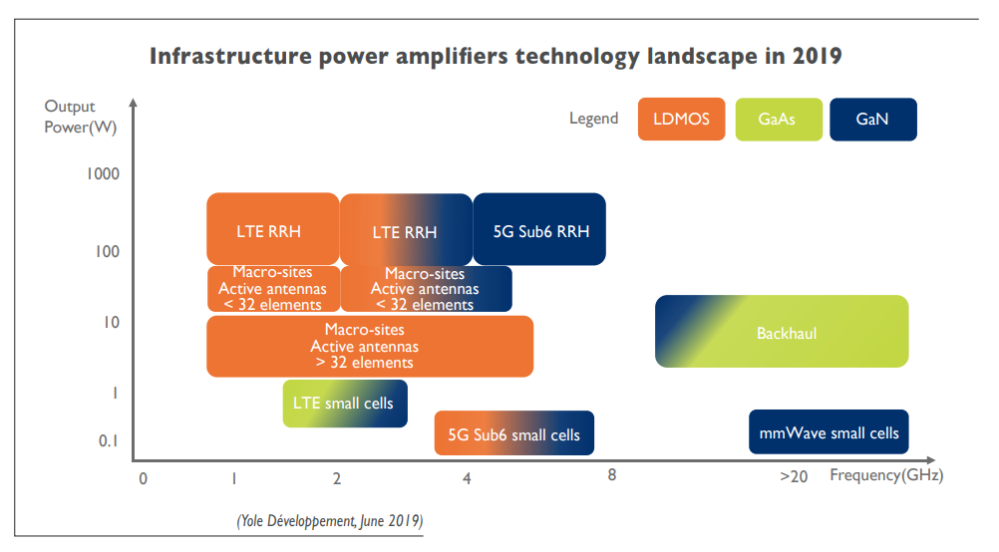
Fig. 2. Overview of different semiconductor platforms in 4G and 5G Wireless infrastructure

References

[1] Yole Report: RF GaN Market: Applications, Players, Technology, and Substrates 2019-2024
[2] Yole Report: Active and Passive Antenna Systems for Telecom Infrastructure report, Yole Développement, 2019
[3] Yole Report: 5G Impact on Telecom Infrastructure 2019

Acronyms

RRH: remote radio head
PA: power amplifiers
LDMOS: Laterally Diffused Metal Oxide Semiconductor
BTS: Base Transceiver Station
LTE: Long-Term Evolution
CAGR: Compound Annual Growth Rate
RF: Radio-Frequency
MIMO: Multiple Input, Multiple Output
AAS: active antenna systems

