Application of 280nm In-Situ Metrology to study the Influence of AlN Templates

**on Surface Roughness and Strain Effects in UVA/UVB LEDs**

# K. Prince1* A. Knauer2, A. Mogilatenko2, M. Weyers2, and K. Haberland1

1 LayTec AG, Berlin, Germany ([kamau.prince@laytec.de](mailto:kamau.prince@laytec.de)).

2 Ferdinand-Braun-Institut, Leibniz-Institut für Höchstfrequenztechnik, Berlin, Germany.

## **Keywords: UV LED, in-situ metrology, MOVPE, EpiCurveTT**

## **Abstract**

**Traditional in-situ reflectometry sensing at blue (405 nm), red (630 nm) and NIR (950 nm) wavelengths cannot resolve variations in InAlGaN surface roughness or layer thickness with the precision necessary for effective in situ process control. LayTec has developed in situ reflectance metrology at 280 nm to address this need.**

**We report successful application of in situ UV reflect-ometry and curvature, distinguishing between various phases of strain relaxation and surface relaxation during non-pseudomorphic growth of Al0.5Ga0.5N on AlN/sapphire. Results were validated by XRD, TEM and AFM. Results illuminate the influence of reduced TDD on relaxation effects during growth of UVA and UVB LED structures.**

## Introduction

Growing interest in the development and application of UV photonics has recently driven the development and adoption of energy-efficient LED sources operating in the UVA (320-400 nm) and UVB (280-320 nm) bands, mainly in medical (imaging, air/water purification, light therapy), and industrial applications as sensing, instrumentation, label tracking, ink/polymer curing [1-3]. The performance of these UV LED devices is directly related to strain and defect phenomena introduced during epi growth caused by lattice and thermal mismatch between AlGaN epi layers and the sapphire substrate.

UVA/B LED structures are based on AlGaN layers with relatively low Al mole fraction, which grow nonpseudomorphic on AlN and thus require relaxation of the involved compressive stress. The main relaxation process is the generation of dislocations and their inclination. Since threading dislocation (TD) lead to non-radiative recombination, TD densities below 109 cm-2 in the active region of LEDs are needed for efficient LEDs [4,5].

To avoid defect formation in the active region by strain relaxation the underlying AlGaN n-contact layer should form a fully relaxed pseudo-substrate of high crystalline quality. Process optimization demands in situ monitoring of strain relaxation phenomena (cracking and surface roughening).

## Experiment Details

DUV LED structures were simultaneously grown on 2 different two-inch (0001) oriented AlN/sapphire templates in a close coupled showerhead (CCS) metalorganic vapor phase epitaxy (MOVPE) reactor, using standard precursors. These LED structures consist of the following layers: 125 nm homoepitaxial AlN, 200 nm thick AlN/GaN short-period superlattice (average composition Al0.95Ga0.05N), 600 nm un-doped Al0.75Ga0.25N, 1600 nm AlxGa1-xN (x graded from 0.75 to 0.5), 750 nm thick n--Al0.5Ga0.5N:Si buffer, and 1150 nm n-Al0.5Ga0.5N:Si contact layer. The active region on the n-side comprised 3 InAlGaN/InAlGaN multi-quantum wells (MQW) for 310 nm emission, a Mg-doped AlGaN electron-blocking layer [9], 100 nm thick p-Al0.4Ga0.6N:Mg and a 30 nm thick p+-GaN:Mg contact layer, annealed for 15 minutes at 890°C in N2 ambient for p-doping activation. For in situ growth monitoring a LayTec EpiCurveTT® measuring reflectivities at 950 nm, 633 nm, 405 nm, and curvature (K) monitoring; was fitted with an additional 280 nm reflectance (R280) unit for improved surface sensitivity. Layer thicknesses were determined by Fabry-Perot oscillations of the R405 signal. Ex-situ verification was done by scanning electron microscopy of cross-sections of the LED structures. Strain, degree of relaxation, and layer composition were determined from high-resolution XRD using ω–ω/2θ reciprocal space maps (RSM) of the (00.4) and (11.4) reflections in a PANanalytical X’Pert3 system including a four-fold 220 Ge monochromator. For rocking-curve measurements in (00.2) and (10.2) reflection, the source aperture was 0.5 mm × 5 mm and the acceptance angle in front of the detector was 1°. An array detector was used for RSM measurements.

## Results

Nominally identical UVB LED heterostructures grown simultaneously on two AlN/sapphire template layers, with

different TDD and different surface roughness, were compared to understand relaxation mechanisms and their dependence on the properties of the template layers. Two templates with 1500 nm AlN grown at elevated temperature [10, 11] in a multi-wafer reactor on a 0.2 dgr and a 0.5 dgr off-oriented to m-plane sapphire substrate were employed to realize different TDD [12]. The AlN base layers show typical full width at half maximum of X-ray rocking curves (XC-FWHM) of ~ 60 arcsec for the (00.2) reflection for bothoff-cut angles. The FWHM of the (10.2) reflection is 600 arcsec for the 0.2 dgr off-cut and 550 arcsec for the 0.5 dgr off-cut sample. The corresponding estimated TDD [13-16] is ~ 4 x 109 and ~ 3 x109 cm-2. The estimated TDDs correlate well with TDDs determined by defect etching with a KOH solution and dark-spot densities determined by cathodoluminescence spectroscopy. Figure 1 a, b shows the surface morphology obtained on the different AlN/sapphire templates. The template with smaller off-cut (Fig. 1a) shows bilayer steps, while the 0.5° off-oriented template (Fig. 1b) has a step-bunched surface with ~6 nm high macrosteps [12, 16].

Fig. 2 presents the in situ transients of growth temperature, R280, R630 and K. During initial heating of the samples, increased (positive) curvature is observed since sapphire has a higher thermal expansion coefficient than AlN, producing concave bow and tensile strain in the AlN layer. For a constant Al mole fraction of the growing AlGaN layer, the curvature slope should be constant when it grows pseudomorphic. At lower Al mole fractions, lattice mismatch between AlGaN layer and AlN template increases, along with the compressive strain and the curvature slope.

The cyan/blue lines in Fig. 2a represent observations on the template with small off-cut with the highest TDD and a smooth surface of Fig. 1a. During growth of the AlN/GaN superlattice, curvature increases atypically (blue graph, upper Fig. 2a), i.e. tensile stress is induced during the growth of this layer, although the GaN layers of the SL introduce compressive strain into the structure and should therefore lead to a decrease in curvature. The relaxation degree of the SL determined ex-situ from RSM was 18 %, which should lead to a smaller curvature slope, but not introduce tensile strain. This unusual observation shows that the effective lattice constant of the AlN/sapphire pseudosubstrates [17] is larger than constant of the SL with an average Al-content x of 0.95. The “normal” case is slightly compressive growth of the SL as observed for the other samples (red, Fig. 2b). The AlN/GaN SL is followed by an Al0.75Ga0.25N layer, where the curvature decreases linearly for the sample with a smaller off-cut as expected for the pseudomorphic growth of AlGaN with a constant Al mole fraction. For the sample with 0.5° off-cut (red graph, Fig. 2 b) the negative slope of the curvature gets smaller, an indication of starting relaxation. In the following thick AlxGa1-xN the Al-content is linearly graded from x = 0.75 to 0.5 by reducing the growth temperature (orange). This reduces the loss of Ga due to desorption and thus the Al mole fraction. The curvature decreases further nearly linearly, i.e. the slope stays nearly constant. The compositional grading of the Al-content in the AlGaN layer should produce constant negative increase of the slope; reduction of the growth temperature should act similarly. The observed constant slope for the sample with the smaller off-cut shows that during growth of the graded AlGaN, a nearly linear strain relaxation occurs, which compensates the increasing compressive strain due to the compositional grading and the reduced growth temperature. Cross-sectional ADF STEM images of the first layers of the UVB LED structure (Fig. 3) obtained in both [11-20] and [1-100] AlN viewing directions showing all dislocation types formed in the sample reveal, that at the homoepitaxial AlN/AlN interface and in the AlN/GaN superlattice a remarkable part of the vertical threading dislocation lines coming from the AlN template show a kink and appear slightly inclined. When the local TDD is high, this inclination becomes enough to achieve dislocation annihilation as visible in Fig. 3a (see the arrows). The dislocation inclination in the Al0.75Ga0.25N buffer layer is strong enough to explain the measured relaxation of the compressive strain during AlGaN growth [18]. During the growth of the active region and the p-side, the curvature decreases further with a small negative slope because of the slow growth rates and the lower Al mole fractions in comparison to the (partially) relaxed Al0.5Ga0.5N underlayer. R280 of the sample (cyan, Fig. 2a) does not show any significant roughening during the growth of the AlGaN buffer or of the non-pseudomorphic n-contact layer and the p-side. In contrast, the slope of the curvature of the sample on the AlN template with the 0.5° off-cut (red graph, Fig. 2 b) goes nearly to zero at the beginning of the compositional grading and only after that continues with its constant



Fig. 1. AFM images (5 µm x 5 µm) of c-plane oriented AlN/sapphire templates with TDD of: a) 4 x 109 cm-2 on sapphire with 0.2° off-cut to m-plane; b) 3 x 109 cm-2 on sapphire with 0.5° off to m.

negative value as before. In this case a much stronger strain relaxation occurs at the beginning of the grading in comparison to the other template. The relaxation degree of the graded layer increases from 18 % to 53 %, as determined from RSM. In the corresponding ADF STEM image (Fig. 3b) elongated, horizontal dislocation loops can be seen at the beginning of the Al0.75Ga0.25N buffer growth explaining the reduction of curvature slope at this point by strain relaxation via newly generated dislocations.

   
  
  
  
Fig. 2 In situ data of MOVPE-growth of an UVB LED structure on AlN with: a, left) TDD ~ 4 x 109 cm-2, off-cut: 0.2° to m; b) TDD ~ 3 x 109 cm-2, 0.5° off-cut. Left side: curvature; Right side: R633 and R280 and growth temperature (orange).

At the end of the growth process during cooling down the curvature decreases drastically because of the larger thermal expansion coefficient of the sapphire in comparison to that of the AlGaN layers, i.e. the wafer becomes strongly convexly bowed and the whole structure is compressively strained.

Interestingly, during the strain relaxation by the new dislocations during the Al0.75Ga0.25N buffer growth R280 of the sample (red, Fig. 2b) does not show significant roughening, but during the growth of the following, more compressively strained Al0.48Ga0.52N R280 decreases strongly. This cannot be seen in the reflectivities at longer wavelengths due to lacking surface sensitivity. Obviously, the strain relaxation by dislocation inclination is not sufficient to relax the additional compressive strain under the used growth conditions (low growth temperature) and relatively low dislocation density (~ 1 x 109 cm-2). Thus surface roughening as an additional relaxation mechanism sets in.

## Conclusion

This work has demonstrated the applicability of in situ curvature measurements combined with reflectance measurement in the UV for monitoring and optimization of non-pseudomorphic AlGaN growth. The usefulness of more surface-sensitive reflectance measurements at shorter wavelengths than traditionally applied (405 nm, 630 nm, and 950 nm) with a reflectometer working at 280 nm was demonstrated.

The in situ data and TEM investigations show that for the growth of strongly compressively strained AlGaN layers for UVB LED structures on AlN templates the strain relaxation mechanisms will be strongly influenced by the absolute values of TDD and of the lattice constant of the AlN/sapphire pseudosubstrates.

Already small differences in TDD can lead to very different behavior during the growth of (Al,Ga)N layer structures for UVB LEDs.

## Acknowledgements

The authors would like to thank C. Neumann for technical assistance with the MOVPE tool, H. Lawrenz for cathodoluminescence and J. Enslin for AFM measurements. This study was partially supported by German Federal Ministry of Education and Research (BMBF) through consortia project "Advanced UV for Life" under contracts 03ZZ0130A, 03ZZ0134C, 03ZZ0130B, 03ZZ0134B; and Deutsche Forschungsgemeinschaft (DFG) within the Collaborative Research Center "Semiconductor Nanophotonics" (SFB 787).

## References

**200 nm**

 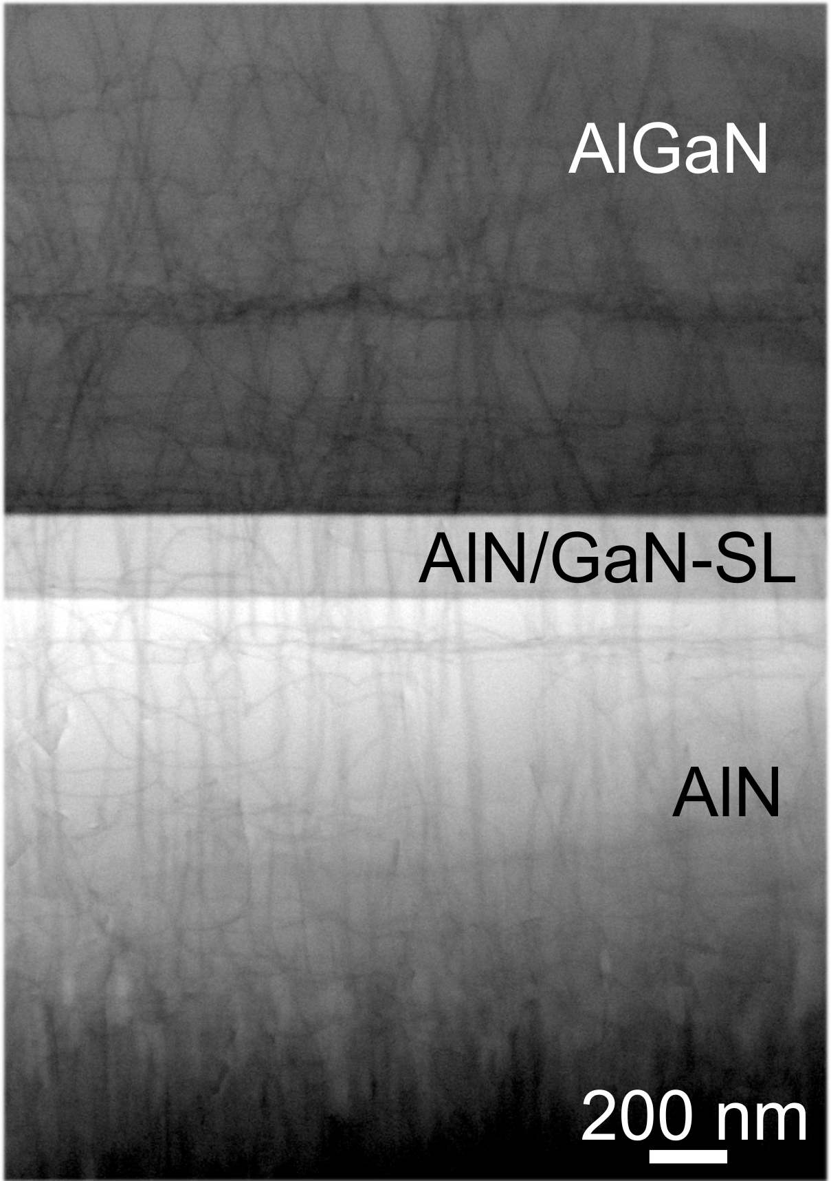

Fig. 3 ADF STEM cross-sectional images of UVB-LED structure on AlN template with TDD ~ 4 x109 cm-2, 0.2° off-cut to m; a) TD inclination and formation of horizontal dislocation lines in AlN/GaN superlattice (viewed in [11-20] AlN projection). The position of the homoepitaxial AlN/AlN interface is shown by dashed white lines. TD inclination as well as TD annihilation at this interface is marked by white and black arrows, correspondingly. Fig. 3b) TD behavior in the LED-structure grown on AlN template with TDD ~ 3 x109 cm-2, 0.5° off-cut to m.

[1] M. Kneissl, et al., Nature Photonics **13**, 233 (2019)

[2] K. Davitt, et al., Opt. Express **13**, 9548 (2005).

[3] M. Kneissl, J. Rass, *III-Nitride UV emitters*. Springer Series in Materials Sci.: Basel, Switzerland, 2016.

[4] M. Kneissl, et al., Semicond. Sci. Technol. 26, 014036 (2011).

[5] K. Ban, et al., Appl. Phys. Express **4**, 052101 (2011).

[6] H. Miyake, et al., Appl. Phys. Express **9**, 025501 (2016).

[7] H. Miyake, et al., J. Crystal Growth **456**, 155 (2016).

[8] K. Uesugi, at al., Appl. Phys. Express **12**, 065501 (2019).

[9] T. Kolbe, et al., Materials **10**, 1396 (2017).

[10] O. Reentilä, et al., J. Crystal Growth **310**, 4932 (2008).

[11] S. Hagedorn, et al., J. Crystal Growth **479**, 16 (2017).

[12] T. Kolbe, et al., J. Crystal Growth **526**, 125241 (2019).

[13] P. Gay, at al., Acta Metall. **1**, 315 (1953).

[14] T. Metzger et al., Philos. Mag. A **77**, 1013 (1998).

[15] S. R. Lee, et al., Appl. Phys. Lett. **86**, 241904 (2005).

[16] S. Walde, et al., J. J. Appl. Phys. **58**, SC1002 (2019).

[17] F. Brunner, et al., J. Crystal Growth **376**, 54 (2013).

[18] D.M. Follstaedt, et al., J. Appl. Phys. **105** (2009) 083507.

Acronyms

AFM: Atomic Force Microscopy

HTA: Hight Temperature Annealing

NIR: Near infrared (750-1400 nm)

R280: 280 nm reflectance signal

R405: 405 nm reflectance signal

R633: 633 nm reflectance signal

TDD: Threading Dislocation Density

TEM: Transmission Electron Microscopy

XRD: X-Ray Diffraction