Cost Reduction Opportunities in CS Maintenance & Inventory Management

Dimitry Gurevich, ILIA Kaplan

The MAX Group | 180 Old Tappan Road, Bldg. 4, Old Tappan, NJ 07675
dimitry_gurevich@maxieg.com ILIA_kaplan@maxieg.com | +1 (201) 750-7888

Keywords: supply chain management, part crib inventory optimization, maintenance spare parts, cost of ownership, cost reduction, compound, semiconductor

Major cost gaps were identified from a benchmark (BM) study for a Semiconductor fab. The study triggered deep-dive assessments of both maintenance practices and supply chain business processes. Those assessments uncovered significant improvement opportunities. In this paper, we discuss the approach used to identify and quantify those opportunities, and share important results and observations with the Compound Semiconductor (CS) manufacturing community.

BACKGROUND
Compound Semiconductor (CS) fabs do not have to comply with Moore’s Law. Automotive chip suppliers, for example, have steady demand and long product lifespans owing to customer requirements. While on the surface that may give a sense of relative business security, there are major conflicting priorities between the “Cost of Quality” and the overall “Cost of Product.” The first is driven by strict customer demands, while the second by a Pareto of factors. This Pareto is traditionally dominated by the substrate costs and the cost of die manufacturing. However, recent technological advancement in manufacturing II-VI substrates, growing marketing demand for the CS products and the introduction of new players in device fabrication, make the Cost of Manufacturing a hot topic.
The issue gets more complex when we factor process tools into the cost equation. Legacy 100-150-mm wafer-size equipment is virtually unsupported by the OEMs, thus there is a limited number of available solutions for the supply of parts and consumables. Outcomes of such issues are typically the increased frequency of part stock-outs and longer wait for parts that drive variable repair times, which in turn impacts product cycle time and output.
In that broad context, Compound Semiconductor fabs aspiring to be the leaders of this very competitive pack, must adopt operational strategies from their Silicon-based counterparts to be able to move fast from the known steady output to the more aggressive ramp without compromising product quality, and in parallel continuously optimize the aspects of operational cost. Precision equipment maintenance and spare parts management become crucial enablers for this kind of operational flexibility, and will eventually become the main characteristics, thus distinguishing the leaders from the followers.
The discussed study was performed in a small/mid-volume 150-mm & 200-mm wafer fab, similar to what the average CS fab has to cope: legacy equipment, variable part supply, outdated Information Systems (IS) and lacking maintenance management and engineering practices. Because of this close resemblance, we project that several study aspects will resonate closely within the CS community; additionally, the study flow and methods can be instrumental for the teams on their path to become Best-in-Class (BiC) manufacturing.

PURPOSE
This paper summarizes a case study on the impact of Supply Chain practices and Maintenance Cost management on the overall Cost per Mask Layer (CPML). The paper then discusses the results and the possible applications for CS manufacturers.

OBJECTIVES
- To define and explain assignable causes for the systematic high spending on Spare Parts and Consumables as discovered in the study
- To use study results to reflect upon the gaps in the generic supply chain practices
- To highlight opportunities for the CS manufacturing community

METHODOLOGY
Data sets include financial reporting, crib transactions and inventory, standard SEMI E10 metrics and equipment maintenance history.

Methods and techniques:
- Spending trends to identify baselines, patterns and points of change for further investigation,
- Statistical correlations (linear regressions) between the Fab moves and Spending,
- Interviews with key stakeholders,
- Direct observations of daily standard work.

Problem Statements:
- Engineering and maintenance practices drive higher than typical spending of spares parts used during equipment repairs and consumables used during standard Preventative Maintenance (PM),
- Generic supply chain business processes are not designed to minimize cost, thus contributing to the higher spending.
Selected Important Findings:

- Maintenance and engineering practices
  - Cost reduction activities were mainly focused on savings from stopping the continuous improvement projects (FIGURE 1)
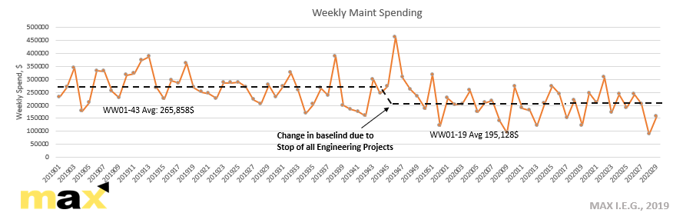
FIGURE 1: Change in Weekly Spending as a Result of Halted Engineering Continuous Improvement

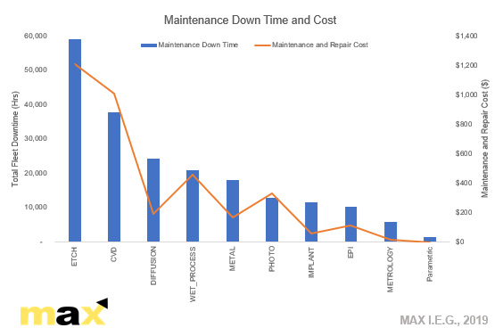
  - Strong correlation between tool downtime and equipment availability with higher spending in certain tool fleets (FIGURES 2 and 3)
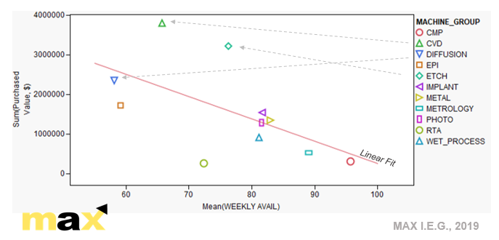
FIGURE 2: Equipment Downtime and Spending
c
FIGURE 3: Spending as a Function of Equipment Availability

  - Low Preventive Maintenance (PM) survivability within the interval between PMs for the high-spending tool fleets – signal of an ineffective standard planned maintenance (FIGURE 4)

  - The team used unoptimized historical spending averages to define cost targets. Also, there was no attempt to calculate the “entitlement” cost stemming from the planned preventative (FIGURE 5)
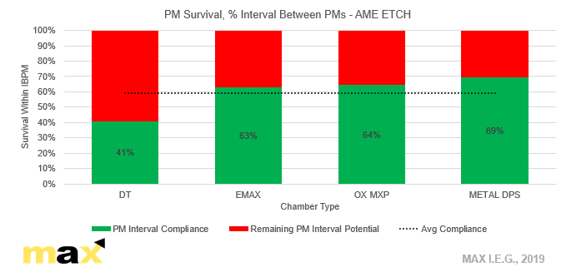

FIGURE 4: AME PMs Survival of Planned Interval between PMs
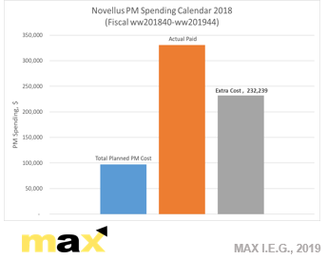
FIGURE 5: Planned PM and Total Maintenance Cost
Planned PM Cost Calculation Method:
[Moves by tool]/[Intrvl btw PMs]x[PM BOM Cost]

B. Supply Chain Management Practices

a. Strategic Management

It was determined that the use of multiple databases caused a lack of comprehensive reporting and a mis-alignment among several stakeholders, such as supply chain, finance and engineering/maintenance.

Additionally, there was inadequate spending account allocation for maintenance and engineering, which further complicated analysis and control.

Moreover, there was an issue associated with the IS integration with the crib management and equipment maintenance systems, which was partially solved by creating another set of manual reports (an inefficient work around).
b. Crib Inventory turns was significantly lower than
the industry benchmark (BM), which was evident
from the excess inventory purchased and a lack
of precision inventory control policy (FIGURE 6)

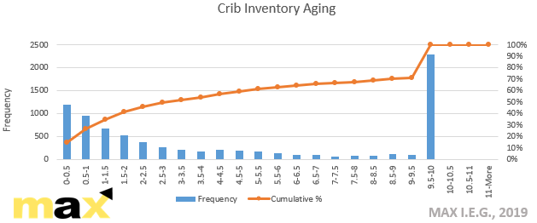
FIGURE 6: Distribution of Inventory Age
c
c
c
c
c

- Reorder Point (ROP) System was not fully defined

Not carrying enough inventory resulted in constraint tools waiting for parts. At the same time, there was an excess of inventory of parts that were not needed due to the higher than required safety stock.

- Supply Chain Management (SCM) software

- Only partial utilization of system capabilities with undeveloped strategic topics (FIGURE 7)
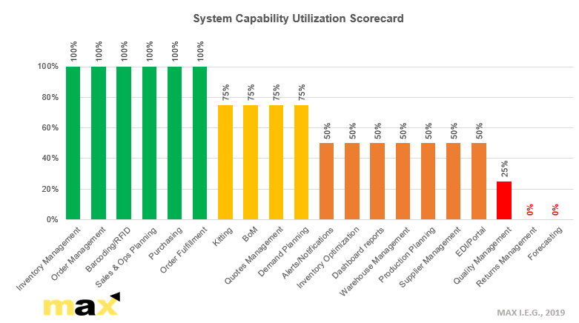
FIGURE 7: Utilization of System Capabilities

- Lack of both integration capability and future compliance with key modules and algorithms

- Constant difficulty with low-usage part supply and the lack of economic leverage with part suppliers and refurbishment vendors - consignment and part-sharing programs were not entertained (FIGURE 8)

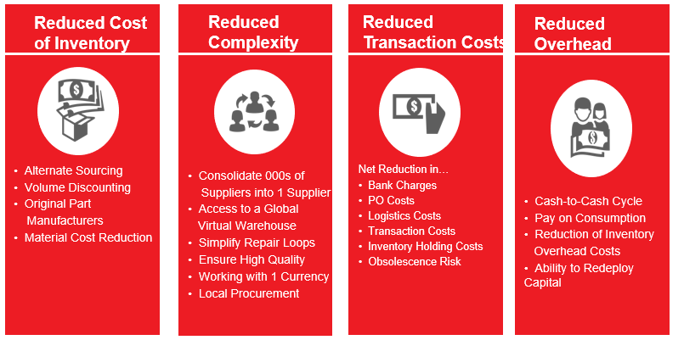
FIGURE 8: Part-sharing Program Outline

RESULTS

Not accounting for the by-product operational improvements, man-hour gains and product quality benefits, the team identified $2M of savings resulting from:
- On-hand inventory reduction and optimized purchase
- Liquidation of dead inventory
- Precision Maintenance in high-spending tool fleets
- Additional potential of $1M savings from one time sell-off of aging parts/spares

IMPORTANT RECOMMENDATIONS

- Supply Chain Management *SCM)

- Complete alignment on measurements and controls between the stakeholders
- Use of efficient analysis with minimal manual adjustment
- Leverage modern data science capabilities for cost optimization

Suggested strategies and methodologies:

- Unified reporting, utilizing single database for all stakeholders (manufacturing, supply chain, engineering and finance)
- Optimized account allocation by area and tool groups
- Crib part ROP and safety stock optimization
- Enhanced single source part management
- Parts clean vendor management – delivery and quality
- Consignment and inventory sharing
- System integration on all levels

- Engineering/Maintenance

- Accurate prediction of PM Cost
- Establish spending targets based on projected usage
- Increase PM spend vs repair through the PM optimization
- Revival of the engineering projects
- Proactive PM management rather with optimized spending prediction

Suggested Strategies and Methodologies:

- Minimize variability: PM/CM procedures, PM execution measurement and standardization
- Focused equipment engineering support – pumps/scrubbers/abatements
- Develop capabilities for failure prediction (Smart Maintenance)

CONCLUSIONS AND IMPLICATIONS FOR COMPOUND SEMICONDUCTOR FABS

Operational environment of the legacy Silicon-based fabs bear close resemblance to a lot of CS fabs. Despite of the differences between the operational cost profiles of Si and CS manufacturing, the concepts like cost optimization, Supply Chain Management (SCM) and Precision Equipment Maintenance are universally applicable to both. New marketing reality gradually forces CS fabs to shift their operations into the ramp mode - a less familiar ground for many of the community members, though a natural place of their Silicon counterparts.

This is an opportunity to share the experience and proactively address the emerging issues with the solutions already developed and tested by the neighboring industry.

ACKNOWLEDGEMENTS

The author would like to thank the fab for its support during the project and for its receptiveness in receiving our recommendations. In addition, the authors would like to thank the MAX I.E.G. colleagues, who worked together on the project to achieve the desired results.

ACRONYMS

- BM: Benchmark
- ROP: Re-Order Point
- PM: Preventative Maintenance
- CS: Compound Semiconductor

