InAlN HEMT Epi and RF Devices on 8” Si
M. Pan, S. Lee, E. Tucker, R. Bubber, B. Kim, A. Paranjpe, D. Hanser
Veeco Instruments, MOCVD Operations, 394 Elizabeth Avenue, Somerset, NJ 08873
Email: mpan@veeco.com, Phone: 732-560-5300

K. Nomoto, L. Li, J. Hwang, D. Jena, H. Xing,
School of ECE, Cornell University, Ithaca, NY 14853
Key Words: InAlN, High electron mobility transistor (HEMT), Silicon, Metal organic chemical vapor deposition (MOCVD), Radio frequency (RF)

Abstract
In this paper, we report our work on epitaxial growth of InAlN HEMTs for RF device applications. InAlN HEMTs were grown on 8” high resistivity silicon substrates. Various characterization techniques were used to analyze the quality of the epi wafers. An average sheet resistance (R_{sh}) of 206Ω/□, with a uniformity of 1.5% (1σ/average), indicated a high quality and uniform 2DEG. Hall measurement showed a high sheet charge density of 2.27×10¹³cm⁻² and a mobility of 1430cm²/(Vs). A pit free epi surface was obtained with optimized growth process of the active layers. T-gate RF devices fabricated on the InAlN epi wafers demonstrated an f_{T} of 250GHz and an f_{MAX} of 204 GHz, which are the record high values for GaN-based HEMTs on silicon.

INTRODUCTION
GaN high electron mobility transistors (HEMTs) have been used commercially for radio frequency (RF) applications for over one decade, mainly on SiC substrate. [1-3] In recent years, GaN HEMTs on large size Si wafers (from 6” to 12”) are becoming more and more attractive for high power and high frequency devices, due to the availability of high resistivity silicon substrates, much lower costs and significantly improved performance. [4-5] Using the newly developed TurboDisc® Propel® MOCVD system, we have achieved high uniformity epitaxial growth of RF AlGaN and InAlN HEMTs on 8” Si wafers. [6] Compared with traditional AlGaN HEMT, InAlN HEMTs possess some unique advantages, such as a lattice matched barrier to the GaN channel, which enables zero strain, and a much higher sheet charge with relatively thin barrier thicknesses because of the strong spontaneous polarization of InAlN. These features of InAlN make it possible to further improve HEMT power performance and to scale down the device size. However, it is a big challenge to grow high quality InAlN HEMTs. Pits are often observed on InAlN HEMTs, which affect device performance. [7]
In this paper, we investigated the MOCVD growth process, especially for the AlN spacer, and achieved high quality InAlN HEMTs with improved surface morphology. RF devices made from the InAlN HEMT epi wafer demonstrated record high f_{T}/f_{MAX} values.

EXPERIMENTAL
InAlN HEMTs were grown on 8” 725µm high-resistivity (≥3000Ωcm) silicon substrates with a Veeco Propel® HVM MOCVD system. A schematic of the epi stack is shown in Figure 1, which consists of an 11nm InAlN barrier, an 1nm AlN spacer and an 1μm unintentionally doped GaN channel layer above AlGaN/AlN transition layers.
A typical growth process for the InAlN barrier layer was with pure N₂ flow in growth chamber at (770-800)ºC. To investigate AlN spacer layer influence on final epi wafer surface quality, the epi growth process for the bottom AlN/AlGaN/uGaN layers and InAlN barrier were kept the same, but the AlN spacer growth conditions were varied, including temperature and gas. The growth temperature of AlN spacer layer was changed from T1, T2(T1+25ºC), T3(T1+50ºC) to T4(T1+65ºC) in a pure H₂ growth ambient. The AlN spacer was also grown in a pure N₂ flow ambient to compare with growth in pure H₂.

11nm InAlN barrier
1nm AlN spacer
1µm GaN
AlGaN
AlN
8” 725µm High Resistivity Si

Fig. 1 Schematic epi structure of RF InAlN HEMT on an 8” 725µm high resistivity Si substrate.

Various techniques were employed to characterize the InAlN HEMT epi wafers. Atomic Force Microscopy (AFM) was used to analyze epi surface morphology. To evaluate the 2-dimensional electron gas quality (2DEG), sheet resistance of epi wafers was measured by Lehighton, a contactless Eddy current measurement, and Hall effect was measured by the Van der Pauw method. Secondary Ion Mass Spectrometry (SIMS) analysis was used to confirm the In composition in InAlN barrier, which was compared to the value obtained from XRD measurement on a sample with a thicker InAlN layer grown under the same conditions as the much thinner layer. Transmission Electron Microscopy (TEM) was used to analyze cross sections of the epitaxial film to measure the thicknesses of the epi layers and to evaluate the defect level within the epi layers.
RF devices using a T-gate design were fabricated from the InAlN HEMT epi wafers. MBE regrowth was conducted to form an 80nm thick Si-doped n⁺⁺ GaN as ohmic contacts in the devices. Source-drain spacings were defined by electron-beam lithography (EBL). Ti/Au and Ni/Au were used for source/drain and for T-gate, respectively. A schematic drawing and an SEM image of the RF device are illustrated in Figure 2.
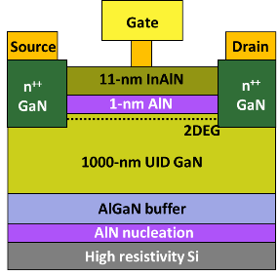  (a) | 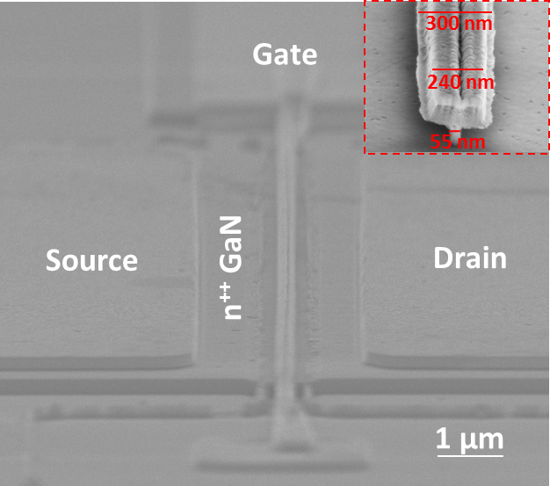  (b)
Fig. 2 (a) Schematic diagram of a RF InAlN/GaN HEMT on Si and (b) SEM picture of device

RESULTS AND DISCUSSION
A major challenge in growing InAlN/Si HEMT epi wafers is to avoid pits on the surface which commonly form during the AlN spacer and InAlN barrier growth. The growth temperature of the AlN spacer layer has a significant impact on the AlN/InAlN interface and InAlN barrier quality. We explored different growth conditions for the AlN layer and developed a growth process to significantly improve the surface morphology, while maintaining a low sheet resistance for the 2DEG. Table 1 lists four samples with growth temperatures from T1, T2(T1+25ºC), T3(T1+50ºC) to T4(T1+65ºC) under H₂ for the AlN layer growth and test results accordingly. AFM images of these four wafers are shown in Figure 3. The estimated pit density of all wafers ranges from 1 - 2E9/cm², except wafer A which does not show any clear pits. It can be seen clearly that increasing growth temperature from T2 to T4 makes the surface rougher (RMS increases from 0.43nm to 0.88nm), while the pit density and pit size become larger. At the same time, sheet resistance also increases from 210 to 251Ω/□ with increased growth temperatures.
Table 1 InAlN HEMT wafers with H₂ AlN spacer layer grown at different temperatures
Wafer  ID | GT  (ºC) | R_{sh}  (Ω/□) | Pits density (cm⁻²) | 5µmx5µm AFM Rq (nm)
A | T1 | 206 | N/A | 0.49
B | T1+25 | 210 | 1.0E+09 | 0.43
C | T1+50 | 219 | 1.3E+09 | 0.58
D | T1+65 | 251 | 2.0E+09 | 0.88

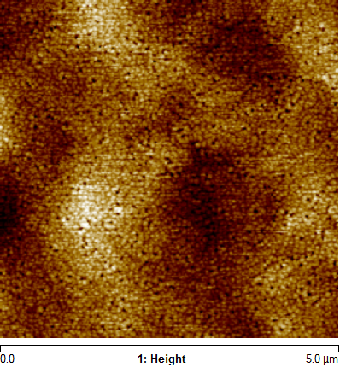  (A) | 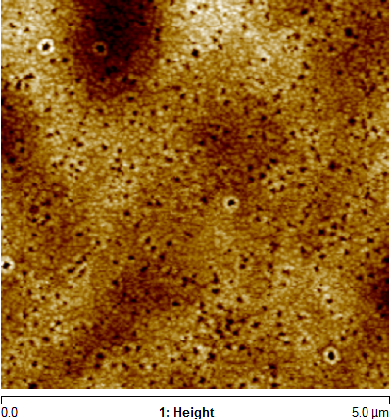  (B)
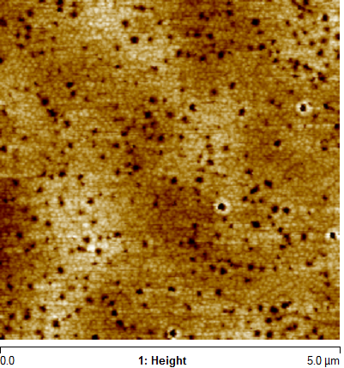  (C) | 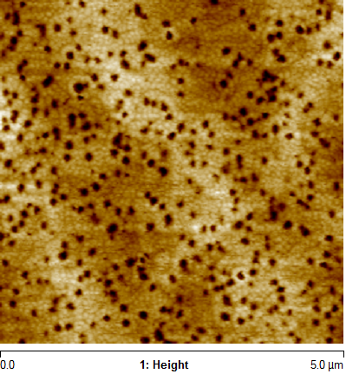  (D)
Fig. 3 AFM images of InAlN barrier surface: wafer B, C and D with AlN spacer grown at T2, T3 and T4 under a H₂ environment has a pit density of 1 to 2E9/cm²; only wafer A with the AlN spacer grown at T1 did not show any clear pits on surface.

A comparison of test results for epi wafers with the AlN spacer grown in N₂ and H₂ environments are listed in Table 2. AFM images of the InAlN HEMT surface with the AlN spacer grown in N₂ are shown in Figure 4.
Table 2 Test results of InAlN HEMT wafers with N₂ AlN spacer and H₂ AlN spacer
Wafer  ID | Gas | GT  (ºC) | R_{sh}  (Ω/□) | Pits density (cm⁻²) | AFM Rq  (nm)
A | H₂ | T1 | 206 | N/A | 0.49
E | N₂ | T1 | 216 | N/A | 0.54
C | H₂ | T1+50 | 219 | 1.3E+09 | 0.58
F | N₂ | T1+50 | 232 | N/A | 0.47

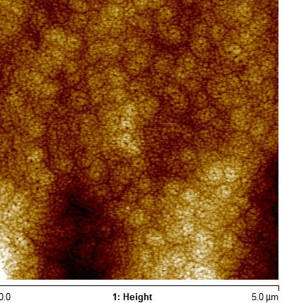  (E) | 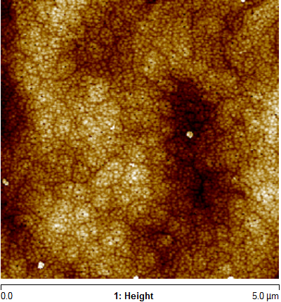  (F)
Fig. 4 AFM images of InAlN barrier surface with N₂ AlN spacer showed no clear pits: wafer E – at T1 and wafer F – at T3.

For AlN spacer growth in pure N₂, the surface morphology at T1 was like growth in pure H_{2.} However, at a higher growth temperature of T3, the pure N₂ process for the growth of the AlN spacer resulted in a much better surface compared to growth in pure H₂ (Fig. 3(c)). As mentioned before, the InAlN barrier was grown at a much lower temperature (770-800ºC) than AlN spacer. Back etching of the AlN spacer during ramping down of the temperature to the InAlN growth temperature would be expected to cause a rougher interface and poorer crystal quality of InAlN layer. A higher temperature and H₂ atmosphere would enhance such an etch back on AlN spacer layer compared with a lower temperature or with N₂ environment.
Figure 5 shows a Lehighton sheet resistance wafer map for Wafer A which has a very low average R_{sh} value, 206Ω/□, and a uniformity of 1.5% (1σ/average), indicating a high quality and uniform 2DEG was formed. Hall measurement provided a high sheet charge density of 2.27×10¹³cm⁻² and a mobility of 1430 cm²/V·s.
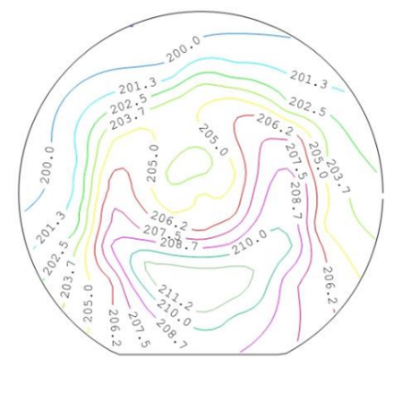
Fig. 5 Sheet resistance map measured by Lehighton: an average R_{sh} value of 55 points on this 8” wafer was 206Ω/□, with a uniformity (1σ/average) of 1.5%.

InAlN barrier composition was analyzed by SIMS. Al and In profiles are shown in Figure 6. SIMS analysis confirmed that the In% and Al% of InAlN barrier was 16% and 84%, respectively. A sample with a bulk InAlN layer which was grown under the same condition as the above mentioned InAlN barrier was characterized by XRD. The In and Al composition from the XRD measurement was consistent with the SIMS results.
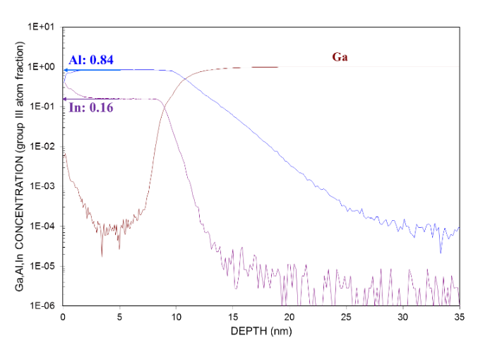
Fig. 6 SIMS analysis on the composition of InAlN layer: 16% In and 84% Al.

TEM was used to analyze the epi layers to obtain accurate thickness values and identify defects in the layer structure. As shown in Figure 7 (a), total thickness of AlN spacer plus InAlN barrier in the stack was ~12nm, with a smooth interface between the GaN and AlN layers. A higher magnification image of InAlN/AlN layers is shown in Figure 7(b). There are no defects observed in the InAlN/AlN layers and GaN channel near the active layers.
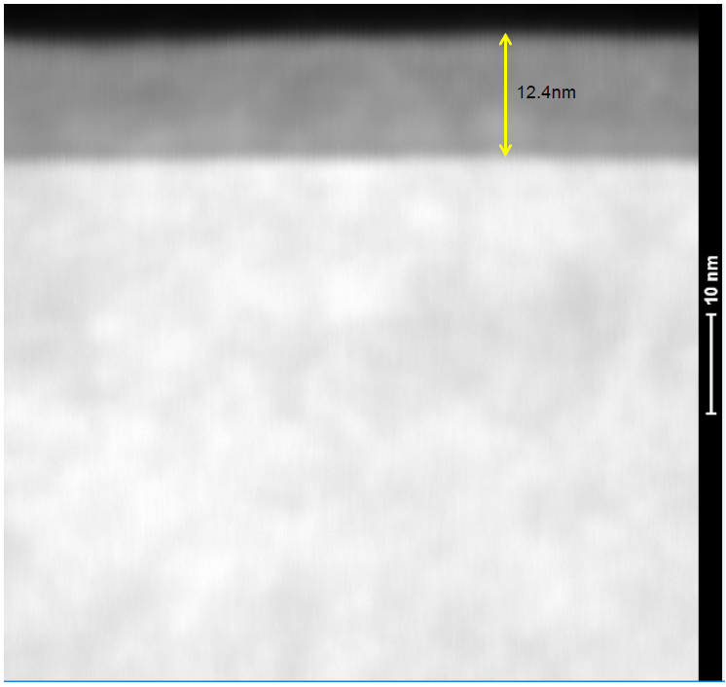  (a) | 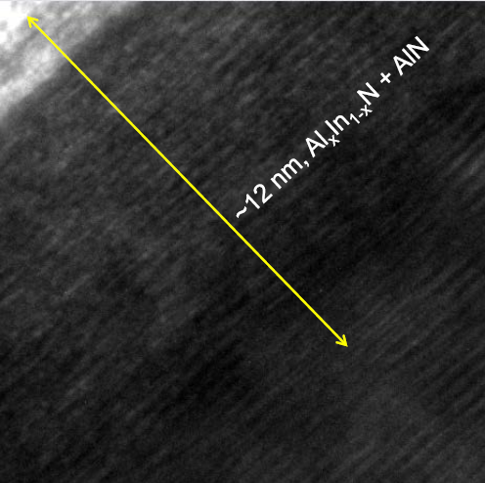  (b)
Fig. 7 Cross section TEM images of the active layers: (a) a total thickness of AlN+InAlN 12.4nm; (b) a zoom-in view on the InAlN/AlN layers.

RF devices with a T-gate design were fabricated from the InAlN/Si epi wafers. By using MBE regrown n⁺⁺GaN as ohmic contacts, a low on resistance R_{ON}=0.6Ωmm was obtained for the RF device. Figure 8 shows current gain |h₂₁|² and unilateral gain U measurements of the device with a gate length of 55nm and source-drain spacing of 175nm. A current gain cut-off frequency f_{T}=250GHz and a maximum frequency of oscillation f_{MAX} =204GHz was achieved, which are record high values for GaN-based HEMTs on Si.
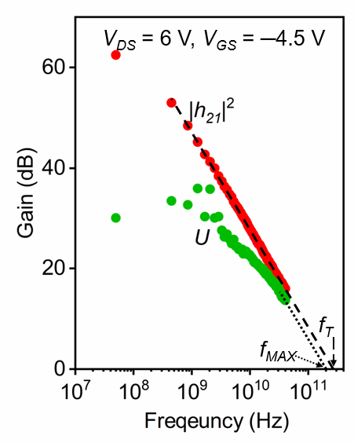
Fig. 8 Current gain and unilateral gain of RF device with L_{G}=55nm and L_{SD}=175nm, showing f_{T} / f_{MAX} = 250/204GHz

CONCLUSIONS
High quality RF InAlN/GaN HEMT epi wafers were grown successfully on 8” 725µm high resistivity silicon substrates. The AlN spacer layer growth conditions had a significant impact on the crystal quality of InAlN barrier. Epi performance was significantly improved by tuning growth processes of the AlN spacer layer. RF devices fabricated from the 8” wafers achieved record high f_{T}/f_{MAX} of 250GHz/204GHz, demonstrating a very promising future of low cost InAlN/Si HEMTs for high power and high frequency device applications.
AKNOWLEDGEMENT
The authors would like to thank Dr. Balakrishnan Krishnan at BRIDG for helping with TEM analysis on RF InAlN/Si HEMT samples.
REFERENCE
[1] R. Pengelly, et al. IEEE Transactions on Microwave Theory and Techniques (TMTT), Vol 60. No. 6 (2012)
[2] M. Pan et al. CS MANTECH 2012, Boston (2012)
[3] B. Green, et al. IEEE BCTM, Bordeaux, France (2013)
[4] F. Zeng, et al. Electronics 2018, 7(12), 377
[5] W. Xing, et al. IEEE Electron Device Letters, Vol. 39, No. 1 (2018)
[6] M. Pan et al. CS MANTECH 2018, Austin (2018)
[7] M. Hiroki, et al. IEICE Transactions on Electronics, Vol. E93-C, No. 5 (2010)

