Development of a World Class Silicon Carbide
Substrate Manufacturing Capability

J. D. Blevins
Air Force Research Laboratory (AFRL)
Materials and Manufacturing Directorate
Wright Patterson Air Force Base, OH

Keywords: Sublimation growth, semi-insulating, 6H, 4H, SiC, GaN HEMT, MOSFET

Abstract

Silicon carbide (SiC) semiconductor substrates are the foundation for revolutionary improvements in the cost, size, weight and performance of a broad range of military and commercial radio frequency (RF) and power switching devices. Due to the lack of a viable, native gallium nitride (GaN) substrate, semi-insulating (SI) SiC substrates are presently the substrate of choice for high power AlGaN/GaN High Electron Mobility Transistors (HEMTs) due to their near lattice-match to GaN, superior thermal conductivity and commercial availability. GaN has emerged as the technology of choice for RF power because of its superior output power capability compared to gallium arsenide. Similarly, semi-conducting (N⁺) SiC substrates are required for fabrication of high voltage Schottky diodes and metal oxide semiconductor field effect transistor (MOSFET) power switching devices. Critical to this realization is the availability of affordable, high quality, large diameter SI and N⁺ SiC substrates for production of GaN and SiC power semiconductors. SiC is unique in that bulk single crystals cannot be grown via traditional melt-based manufacturing processes such as Czochralski. Rather, a high temperature sublimation process is required. In the late 1980s, pioneering physical vapor transport research taking place at North Carolina State University ultimately led to the formation of Cree Research and subsequently the wide bandgap semiconductor industry. U.S. Department of Defense investment in wide bandgap semiconductors, since the early 1990s, has easily exceeded $1B spawning an entirely new industry. The early days of SiC physical vapor transport growth research were fraught with perceived insurmountable technical challenges associated with micropipes, doping, polytype conversion, diameter expansion and crystalline defects. Despite this monumental crystal growth, technology hurdles, SiC substrates are presently manufactured at a cost and quality never thought possible. This paper highlights more than 20 years of AFRL sponsored development with II-VI aimed at positioning itself as a world-class manufacturer of SiC substrates.

INTRODUCTION

SiC is a wide bandgap semiconductor with unique electronic, physical and thermal properties ideally suited for a broad range of electronic and optical applications. Wide bandgap (WBG) semiconductors have the capability to operate at higher voltages, frequencies, temperatures, and efficiencies than competing technologies. Conducting SiC substrates are used for homoepitaxial device structures such as Schottky diodes or MOSFETS. Similarly, semi-insulating SiC substrates are preferred for heteroepitaxial growth of GaN HEMT structures for RF power devices.

SiC has been the subject of research since its discovery in 1893 when Dr. Ferdinand Moissan identified beautiful sparkling crystals in rock samples from the Canyon Diablo meteorite in Arizona. Moissan determined the sparkling crystals to be SiC and were later named Carborundum or Moissanite in his honor [1]. Acheson patented the electric batch furnace technique in the late 19th century used to first manufacture silicon carbide powder for abrasives. Interest in SiC as a semiconductor material began at the dawn of early transistor development. Despite its superior intrinsic electrical properties, there was no viable path to production of SiC single crystals suitable for large-scale manufacturing of semiconductor electronics. As such, silicon and germanium were pursued due to their scalability and reproducibility of melt-based growth of large single crystals. In 1955, Lely [1] synthesized single crystal, hexagonal SiC platelets. These platelets were typically only 1cm² enabling only basic research into SiC electronics. It wasn’t until 1978 when Tairov and Tsvetkov established the basic principles of seeded sublimation growth of 6H-SiC [3, 4]. This modified Lely process provided a growth technology path for growth of large single crystals that could be cut and polished into substrates suitable for device fabrication. Continued development of the sublimation growth process at North Carolina State University led to formation of Cree-Research in 1987. A few years later, Cree-Research became the first company to commercialize a SiC substrate [2].

EARLY YEARS OF SIC DEVELOPMENT

In addition to Cree-Research, both Westinghouse Science and Technology Center and Advanced Technology Materials, Inc. (ATMI) were actively engaged with SiC research and development in the early 1990s. The early years of SiC sublimation growth research were fraught with perceived insurmountable technical challenges associated with micropipes, doping, polytype control, diameter expansion and crystalline defects. It cannot be overstated the difficulties associated with high temperature sublimation growth. Unlike silicon, SiC does not possess a liquid phase. As a result, traditional melt-based techniques such as Czochralski cannot be used for growth of SiC single crystals. SiC sublimes instead of melting at reasonably attainable pressures. SiC growth process is based on heating a polycrystalline SiC source material between 2000°C and 2300°C under controlled atmospheric conditions where it sublimes into a supersaturated vapor species and subsequently condenses onto a cooler SiC substrate seed [5]. SiC can exist as several hundred different crystal structures called polytypes. Each polytype possesses its own set of semiconductor properties, even though they are chemically 50% carbon atoms bonded to 50% silicon atoms. Early growth research focused on development of both 4H-SiC and 6H-SiC polytypes. Ability to control the polytype required precise control of crystal growth conditions. There is a preference for use of 4H-SiC due to its higher bandgap, thermal conductivity and mobility. However, 6H-SiC remains in widespread use today for GaN HEMT devices. The electrical properties of SiC can be controlled over a wide range. It can be doped both n-type and p-type using nitrogen and aluminum, respectively. Semi-insulating properties can be achieved either by incorporating specific impurities such as vanadium [6] or intrinsic defects [7] into the material to introduce deep energy levels within the bandgap. In both approaches, deep levels compensate for residual shallow donors (N) and acceptors (B) to pin the Fermi level near the middle of the bandgap.

Defects were commonplace with early SiC substrates. Micropipes were the most widely recognized and deleterious structural defect. They penetrate the SiC crystal along the c-direction and in most cases represent super-screw dislocations with a very large Burgers vector [8]. The density of micropipes tended to be the key quality discriminator with early commercially available SiC substrates. Pioneering work with the seeded sublimation technique at Cree-Research led to the first commercial offering of 25mm 6H SiC substrates in 1991 and 50mm 4H in 1998. Despite the availability from multiple vendors, the substrates were expensive and possessed micropipe densities (MPD) exceeding 100cm⁻². Even though a significant amount of technological achievement was demonstrated through the years leading up to 2000, inferior quality bulk crystals prohibited development of commercially viable SiC-based devices.

AFRL SPONSORED SIC DEVELOPMENT

Since the early 1990s, AFRL has been a strong funding agent for SiC research and development impacting nearly all companies pursuing SiC including Cree-Research, Westinghouse, ATMI, Sterling, Litton-Airtron, DOW and Intrinsic. AFRL has also served as subject matter experts for program execution as well as assessment of SiC substrate electrical and physical properties.

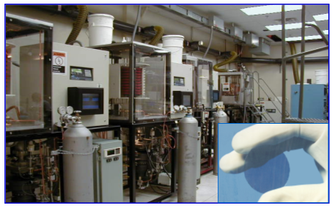
Fig. 1 Litton-Airtron SiC crystal growth facility circa 1999 [9].

In 1999, the Title III Program, managed under AFRL, provided a much-needed kick-start to the SiC industry by awarding cost share contracts to Cree-Research, Sterling (ATMI) and Litton-Airtron to expand substrate diameter to 75mm and improve crystalline quality. This program was Litton-Airtron’s first Government contract since the licensing of key SiC technology IP from Northrop-Grumman (Westinghouse). Prior to Litton-Airtron being acquired by Northrop-Grumman and subsequently II-VI, they were a leading producer of GaAs substrates [Fig 1].
Timing of Title III Program support was instrumental in positioning the industry to respond to ever demanding diameter and quality requirements of DARPA’s Phase I Wide Bandgap Semiconductor initiative, which began in 2002. Both Cree and Sterling were awarded DARPA contracts to improve N-type and semi-insulating SiC substrate diameter to 100mm and reduce micropipe density to <1/cm2. Sterling’s parent company Uniroyal Corp filed for bankruptcy only weeks following the DARPA awards leading to exodus of key technical personnel. DOW immediately acquired Sterling assets and was able to complete the DARPA contracts but failed to achieve program objectives. Figure 2 shows cross-polar images for Cree, Dow and II-VI 4HN substrates. A low cross-polarizer contrast was a measure of good crystalline quality. Cree clearly distinguished itself with respect to quality and diameter. DARPA’s support of SiC substrate development essentially ended in 2005 with only Cree showing strong signs of accelerating the technological readiness of SiC substrate capabilities. DARPA’s investment going forward focused on SiC power switching and GaN RF devices of which Cree’s substrate business benefited. Title III continued to play a pivotal role with maturation of GaN manufacturing capabilities through targeted investments exceeding $75M with Cree (Wolfspeed), Raytheon, Northrop-Grumman and Triquint (Qorvo). These efforts continued to stimulate demand for improved quality and access to SiC substrates.

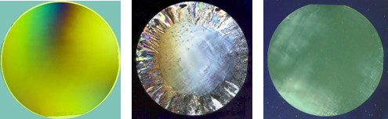
Fig 2. AFRL assessment (left to right) of Cree-75mm, DOW-75mm and II-VI-50mm cross-polarized images circa 2002 [10].

During the early 2000s, Cree continued to lead in all aspects of SiC substrate technology development and production. Given their vertical integration, they were able to drive material quality improvements through their internal usage requirements. This meant their key competitors were also customers for their substrates and epitaxy. Emergence of a pure-play SiC substrate capability was deemed critical to the long-term development and commercialization of SiC and GaN device technologies. Dependence on single source supply chain would likely stall development and limit access.

Improving the technology and manufacturing readiness and access to SiC was a priority for AFRL’s substrate initiative, which kicked off in 2003. The first contract was awarded to II-VI to improve the quality and producibility of 75mm 4HN substrates using their patented Advanced Physical Vapor Transport (APVT) SiC crystal growth process. The following year, AFRL collaborated with Missile Defense Agency (MDA) to support development of 100mm semi-insulating SiC substrates. This joint initiative kicked off in late 2004 with another award to II-VI. Use of MDA’s SBIR program led to the emergence of Intrinsic Semiconductor in 2004. Key personnel from Sterling Semiconductor formed Intrinsic. Ironically, Intrinsic acquired the old Sterling facility to establish their capability. Intrinsic experienced rapid success announcing the availability of zero micropipe SiC substrates. Cree subsequently acquired them in July 2006. During performance of these two contracts, II-VI expanded crystal diameter from 50 to 100mm to enable commercial release of 100mm 4HN and semi-insulating substrates. 100mm semi-insulating substrates crystal lattice curvature was reduced from ~2.5° to 0.01-0.04° and Full Width Half Max (FWHM) rocking curves from ~200arcsec to a best result of 14-27arcsec. MPD was reduced from 100-200cm⁻² to a best result of 0.06cm⁻². Use of vanadium compensation [6] enabled average resistivity >1E11Ωcm and resistivity-based yield of nearly 100%. Similar improvements were made with 100mm 4HN substrates. While II-VI was playing catch up, Cree continued to accelerate widespread adoption of SiC by introducing 100mm semi-insulating substrates in 2007 and 150mm 4HN substrates in 2010. Micropipes became a “pipe dream” shortly after Cree’s acquisition of Intrinsic.

In late 2010, AFRL awarded its largest contract to date with II-VI; a 50-50 cost share contract than ran for 6½ years and exceeded $20M in government funding. This effort focused on development and commercialization of both 4HN and semi-insulating 150mm substrates. II-VI invested heavily in facilities and equipment including expansion of their NJ facility but also the establishment of a new polishing facility in Starkville MS. II-VI relied on a combination of patented APVT [11] and Axial Gradient Transport (AGT) [12] crystal growth technologies to address the objective of growing large, high quality SiC crystals. New crystal growth stations were designed with expanded hot zones and automated control electronics to ensure reproducibility and increase throughput. II-VI demonstrated Absolute ZeroTM (micropipe-free) 100mm 6H semi-insulating and 150mm 4HN substrates in 2013 and 2014 respectively [Fig 3]. Continued focus on diameter expansion led to the industry’s first demonstration of 200mm 4HN substrates in July 2015 and 200mm 6H semi-insulating substrates in October 2019 [Fig 4]. Figure 5 summarizes 4HN substrate manufacturing trends for micropipe and dislocation densities for a period of over ten years. The ability to scale production processes while concurrently maintaining high substrate quality is evident.

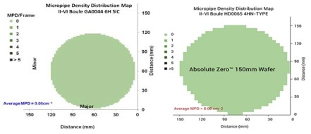
Fig. 3 Micropipe density of 100mm 6H semi-insulating substrate and 150mm 4HN substrate.

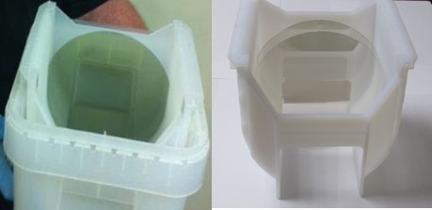
Fig. 4 First demonstration of (a) 200mm 4HN substrate and (b) 200mm 6HSI substrate.

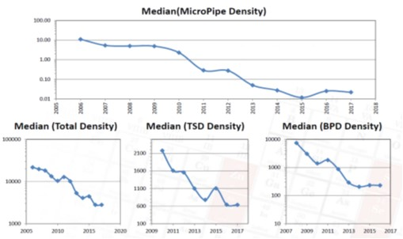
Fig. 5 Manufacturing trends for micropipe and dislocation densities for 4HN substrates.

The final AFRL contract was awarded to II-VI in March 2017. This was a 50-50 cost share contract for five years and >$12M of government funding. Increased focus on improving manufacturing efficiencies and throughput of crystal growth, fabrication and polishing processes. II-VI has developed and implemented strategies aimed at enhancing producibility without impacting quality. The rapid transition to 150mm substrates is ongoing with 200mm substrates on the horizon, particularly for power electronics.

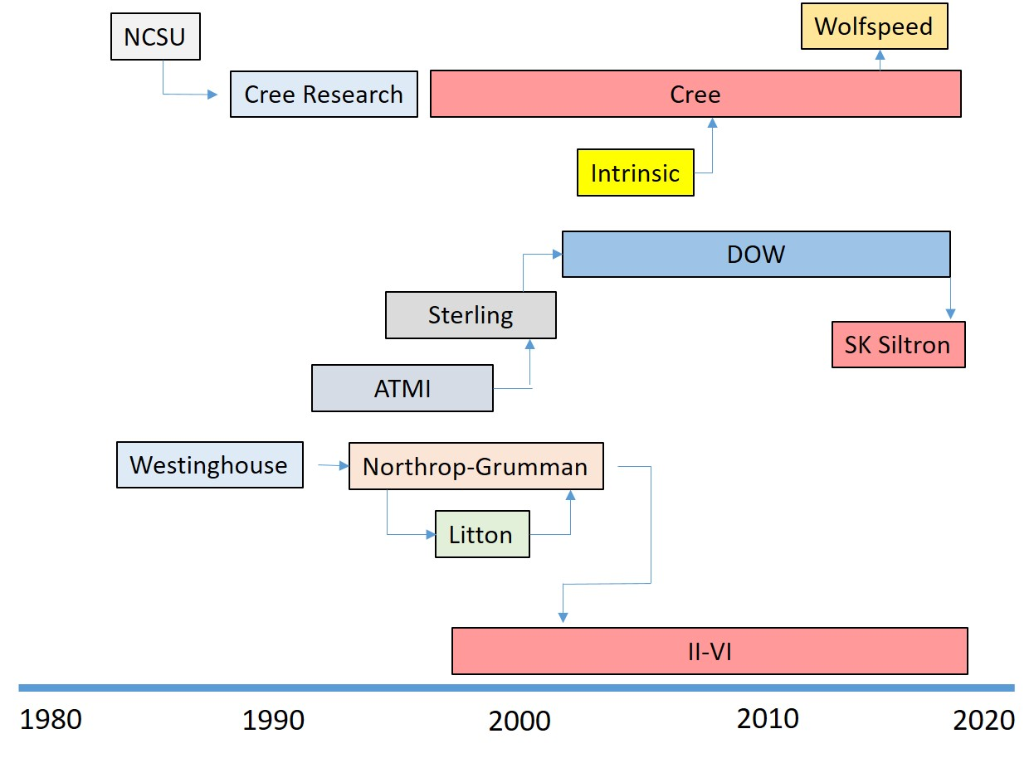
Fig. 6 Evolution of US SiC substrate industry.

CONCLUSIONS

During the past 30 years, companies such as Cree Research, Westinghouse, Northrop-Grumman, ATMI,
Sterling, Litton-Airtron, Dow and Intrinsic have emerged and faded. Fortunately, the remnants of each still exist today with Wolfspeed, II-VI and SK Siltron [Fig 6]. Commercial and military demand for SiC substrates is growing rapidly. Wolfspeed has committed to investing $1B to expand their SiC and GaN capabilities. Summarily, II-VI is expanding their SiC substrate capabilities in NJ, PA and MS. II-VI’s long-term financial commitment combined with Government R&D funding has led to the creation of a world-class, merchant, SiC substrate-manufacturing capability. While Wolfspeed SiC production capability remains the largest, II-VI has made great strides improving their quality to be on par with Wolfspeed. The manufacturing readiness level (MRL) of their 100mm and 150mm processes exceed MRL 8. SiC substrates are presently being manufactured at a scale and cost never thought possible.

REFERENCES
[1] J. Casady, et al., Technical and Reliability Maturity of SiC Power Diodes, MOSFETs and Modules in 2016, CS IC Symposium, (2016).
[2] P. Neudeck, SiC Technology 1998, ntrs.nasa.gov.
[3] Tairov, Y. M. and Tsvetkov, V. F., Investigation of Growth Processes of Ingots of Silicon Carbide Single Crystals, Journal of Crystal Growth, 43, 209, 1978.
[4] Tairov, Y. M. and Tsvetkov, V. F., General Principals of Growing Large-Size Single Crystals of Various Silicon Carbide Polytypes, Journal of Crystal Growth, 52, 146, 1981.
[5] A.Gupta, et al., Materials Science Forum, Vols. 600-603, pp 35-38, (2009).
[6] V. Balakrishna et al., US Patent 6,056,820 (2000). II-VI holds an exclusive license.
[7] C.H. Carter, M. Brady and V.F. Tsvetkov. Semi-insulating silicon carbide without vanadium domination. US Patent 6,218,680; 6,396,080; 6,403982 and 6,639,247
[8] J.Heindl, H.P. Strunk, V.D. Heydemann, G. Pensl, Micropipes: Hollow Tubes in Silicon Carbide, Phys. Stat. Sol. (a), 162, 251, (1997).
[9] R. Hopkins, et al., Defense applications for SiC, Defense Manufacturing Conference, (1999).
[10] J. Blevins, Historical look at SiC development in the US, AFRL SiC Materials & Devices Workshop, (2018).
[11] D.L. Barrett et al., US Patent No. 5,611,955 (1997).
[12] D. Snyder and W. Everson, US Patent 6,800,136 (2004).

