Opto-plasmonic Devices for High Performing Photodetectors

P. Dianat^{1,2}, B. Nabet^{1,2}

¹Nanograss Photonics, 3401 Bethlehem Pike, Suite 303, Flourtown, PA 19031
²Drexel University, Electrical and Computer Engineering Department, 3141 Chestnut St, Philadelphia, PA 19104

Keywords: 2DEG, 2DHG, Photodetector, Optical Communications, Plasmonics

Abstract
We have developed a family of opto-plasmonic devices (OPDs) for next generation Tera-bits-per-second (Tbps) tele/data communication infrastructure. Particularly, a top illuminated optical detector is produced as an essential part of the value chain in PIC. This solves a bottleneck in high-speed PIC that currently use Germanium-based photodetectors. Specifically, a photodetector is demonstrated that operates at a 6x higher bandwidth and at 10-20x lower optical power conditions, compared to a commonly used 40-GHz pin device. These provide value for optics engineers to design: i) an optical receiver module with a %75 enhancement in reliability, and ii) an optical link with 10x extension in length.

Introduction

In the past two decades, optical systems have taken a dominant role in facilitating a wide range of applications from navigation using LiDAR systems in autonomous vehicles, to transmission of data over fiber optics in data centers using optical transceivers. Particularly, the increasing need for on-demand creation of and access to large volumes of data have driven tele/data communication and sensing and imaging markets to grow into $5 Billion markets. It is expected that with the advent of 5G, the volume of data increases by 1000 times by 2025. Consequently, optical system integrators and engineers serving these two markets actively seek economically viable solutions with reliability and capacity to keep-up with the data boom.
While the demand exists for a >1Tbps data rate per transceiver, the offering by system integrators remains in 100-400 Gbps with a high price point of $100-500 per unit. The major physical limitation stems from “the curse of kinetic energy” on the component/physical level where the power consumption due electric drive of the optical components (laser, modulator, photodetector) and DSP units inside a transceiver limits the bandwidth and data rate of the system. Use of InP-based photonics in a transceiver addresses the data-rate limitation, however, it comes with a significant increase of cost per unit of up to 10 times, and therefore not economically viable for hyper-scale data centers.
We have developed a family of opto-plasmonic devices (OPDs) that leverages the physics of a collective of electronic charges, aka plasmonic waves, for detection and manipulation of optical signal arriving from an optical communication link e.g. fiber, to an electronic signal ready for processing. While competing methods of optical detection rely on transport of electrons, and therefore are fundamentally limited by the dynamics of individual charge transport, our method exploits the super-fast dynamics of collectives of electrons in the form of a propagating charge density, plasmonic, wave. In response to 40-femto-second pulses of (830nm) coherent light, our photodetectors have exhibited response times as small as 2 ps, while the fastest competing technologies cannot go below 20 ps due to the limits imposed by charge transport. Circumventing this limitation by exploiting the collective behavior of electrons allows this 10x improvement in speed of response that is fundamentally different from other methods of light detection. In the past two decades there has been a tremendous amount of basic research on plasmonics, however and despite its great potential, not so many viable commercial products are achieved, mainly due to difficulty in manufacturing. Distinctly, our OPD technology has overcome this obstacle by embedding the plasmonic medium in the device.

Device Characteristics and Discussion

The wave motion in an electron gas medium has time constants of the order of the dielectric relaxation time of the medium which is proportional to the product of the medium’s permittivity ε_{s} and resistivity ρ which for high charge densities is in tens of femtosecond range. On the other hand, time constants based on charged particle motion are much slower than these dielectric relaxation times [1]; this is to be expected since the former can be an energy relaxation process, while the latter is due to real charge motion due to acceleration by the force of the electric field and deceleration due to scattering. By analogy, if electron transport current is similar to water flow in a river, the dielectric response is the wave in a pond. In our opto-plasmonic photodetector, we construct two-dimensional electron, and hole, gases in semiconductors to create reservoirs of charge which respond to (optical) excitation with speed and sensitivity that is not possible to obtain with a current flow model. Instead, this is analogous to detecting a drop of water in a pond by the wave it generates; a feat that is not possible to perform by detecting the change in current flow. As a result, a 400-fs perturbation by about 11,000 photons in an 8.5-μm device produces a less than 2.5-ps response which would take over 100 ps if it were based on charge transport.
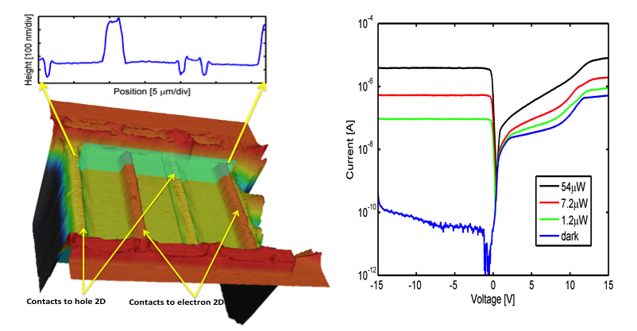 Figure 1 Left) Image of the fabricated device. Rectifying contacts are made separately to two-dimensional electron and hole reservoirs. Contact separations are over 8 μm as the cross-sectional cut above shows. Right) Current-voltage relation in ambient light and under 1.2, 7.2, and 54 μW of optical power, respectively, shows small amount of current that flows in dark despite high concentration of charge carriers.

Micro Plasma Photodetector Device -- The reservoirs of charge produced here are those with sheets of electrons and holes whose motion is confined to two dimensions rather than 3D motion that occurs in bulk semiconductors. Layer structure contains confined two dimensional electron gas (2DEG) and 2-dimensional hole gas (2DHG) attained by using typical techniques in the fabrication of High Electron Mobility Transistors (HEMT). The wafer was grown by Molecular Beam Epitaxy (MBE) on semi-insulating GaAs. After growth of a buffer layer, Al_{0.3}Ga_{0.7}As is lattice-match grown and p-type delta-doping is used to produce the 2DEHG with holes that can only move in the direction perpendicular to growth direction. A thin layer of GaAs which is a fraction of the wavelength of incident photons is grown to absorb light. Although the fundamental edge of absorption in GaAs is around 830 nm, it absorbs light in the solar spectrum; it can, however be substituted by other material with absorption capability at required wavelengths. On top of this thin ~100nm absorption region another heterointerface with a wide gap material is grown so as to produce to produce a 2D electron gas. Electron and hole distributions are calculated by self consistent solution of Poisson and Schrodinger equations, indicating the existence of relatively dense concentrations, ~6.5x10¹¹cm-² electrons and ~2.2x10¹¹cm⁻² holes, Additionally, geometrically identical devices were fabricated for comparison purposes with the same layer structure but without the doping, hence without the two-dimensional reservoirs of charge.
It should be mentioned that the study of the collective properties of electron gases such as at dielectric interfaces, or the surface of liquid helium have been the subject of intense interest [2], being motivated by the study of the role of surface states in metal-insulator-semiconductor devices and in the silicon metal oxide semiconductor field effect transistor (MOSFET) device [3]. Collective modes of excitations, plasmons, in a two-dimensional electron gas (2DEG) were first observed for electrons in the system of electrons trapped by the image potential on the liquid-helium in 1976 [4] and then in the inversion layer of MOSFET. Direct interaction of radiation with the electrons in the MOSFET inversion channel were studied as early as 1976 [5]. Serious interest in the room-temperature properties of 2DEG was, however, based on the seminal work at Bell Laboratories on the ‘inversion channel’ of AlGaAs/GaAs heterojunctions [6] and on InP [7]. Though initiated for the study of the collective behavior of the electron plasma, reduced electron scattering and higher mobility of the 2DEG compared to bulk, it resulted in its successful incorporation as the charge transport channel of high electron mobility (HEMT) transistors [8,9]. Presently such transistors hold speed of operation record at well over 650GHz [10] that is primarily limited by the transport time of electrons in the <40-nm distance between the source and the drain electrodes.
DC Optical Properties-- A confocal microscope image of the fabricated device is shown in Fig. 1, with a cross-sectional cut demonstrating that the 2DEG and 2DHG are separately contacted by evaporation of metals forming blocking contacts. The current-voltage (I-V) relation in ambient room light (dark) and under continuous wave (CW) illumination by an 830-nm Ti:Sapphire laser at three different optical intensity levels are also shown in Fig. 1. The dark I-V is shows currents below 100 pA when the contact to 2DHG is the cathode. The very low dark current observed here verifies that the blocking contacts maintain the confined reservoirs of charge under quasi equilibrium, with small amount of current flowing by thermionic emission. Had these contacts been Ohmic, as is the case for the source and the drain of a transistor, up to eight (8) orders of magnitude more current, in milliamps, would flow.
The device is illuminated with a laser light with an 830-nm wavelength that is absorbed in the ~100nm thick GaAs absorption layer which is sandwiched between two-dimensional sheets of electron and hole gas reservoirs. Without the 2DEG and 2DHG reservoirs the photogenerated carriers would be swept by the lateral electric field that is produced by the Schottky contacts in this structure, and collected at the contacts. Here there is a vertical electric field of ~8V/μm which moves the optically generated electrons to the (top) 2DEG and the holes to the (bottom) 2DHG. Figure 1 shows that the device is a very efficient optical detector with five (5) orders of magnitude current change caused by a 54μW optical excitation. It is also very sensitive, with 1.2 μW of light causing a current change by a factor of over 4000, as compared to the device in dark. In other experiments as low as 250 nW was detectable, limited by the electronic equipment.
Time Response-- The dynamics of the response of these 2DEG and 2DHG micro plasma are probed by perturbing them with short, 400 femtosecond, pulses of light generated by the Ti:Sapphire laser with a center wavelength tunable from 750-1080nm. Absorption of these pulses of light generates electron and hole pairs in the (~100 nm thick) GaAs region. Subject to the large vertical electric field, electrons and holes separate and drift, respectively, towards the 2DEG and 2DHG reservoirs which laterally extend the long (>8μm) distance between the contacts. High speed testing is performed with an electro-optic sampling (EOS) system.
The measured time response to ~400 fs pulses with average 54 μW optical power and applied biases of 0, 1, and 2 V is shown in Fig. 2A. Data normalized to peak value in the inset of the figure shows pulsewidth, given as the Full-Width at Half-Maximum (FWHM), values of 2.9, 2.9, and 2.4 ps, respectively. The 1.4-ps rise time of the response is longer than the EOS system response and is potentially due to transmission line dispersion occurring from the electrical pulse's 250-μm propagation distance. This would suggest an even faster intrinsic device response by up to 0.4 ps . This short response cannot be due to transit of electrons which, in the best case of saturation drift velocity of 10⁷ cm/s would be around 80ps, with holes taking nearly ten times longer, depending on the electric field intensity.
To accentuate this point, a device with 8 μm separation of contacts, and similar layer structure, but without 2DEG and 2DHG was fabricated and tested. The temporal pulsewidth for 11-μW incident power, as shown in Fig. 2B, is 50, 55, and 75 ps (FWHM) for respectively, 7, 9, and 15V bias--the larger bias was chosen to assure carrier sweep out and a fair comparison. The response tail –the fall time-- which depends on the transport and collection of slow moving carriers, is seen to be as high as 200-250 ps in this device. This may be contrasted with the response shown in the inset of Fig. 2B for a device with 2DEG and 2DHG reservoirs under 7 μW of power and more than 8.2 μm cathode-anode distance. The latter has a pulsewidth of less than 3 ps FWHM, and fall time of less than 2 ps. This orders-of-magnitude increase in speed is due to the collective response of the charge reservoirs that circumvents the drift velocity limitations.
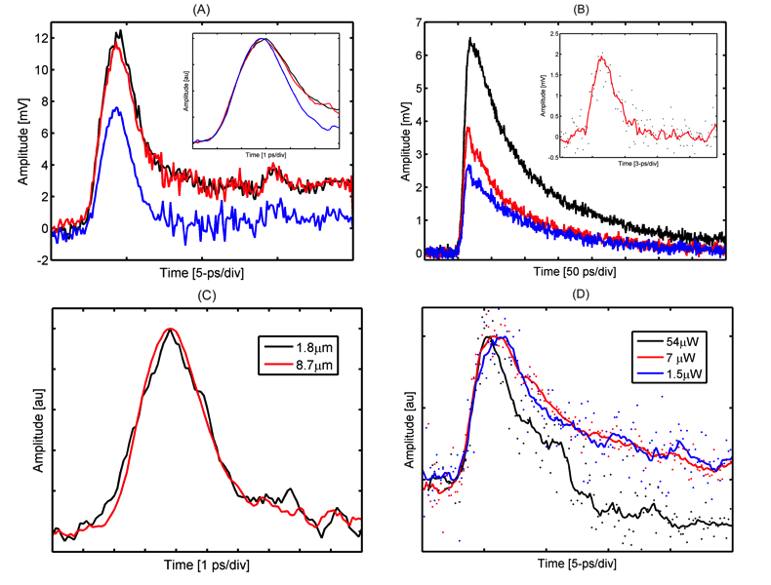
Figure 2 (A) Time response to ~400 fs light pulses with 54 μW optical power, at 0, 1, and 2 V bias. Inset is normalized to peak showing 2.9 ps, 2.9 ps, and 2.5 ps full-width half-max (FWHM) pulse width, respectively, for the device with >8.5 μm distance between cathode and anode. (B) Time response of a device with 8.5 μm gap distance, but without 2D electron and 2D hole reservoirs, under 7 (blue), 9 (red), and 15 (black) V bias shows FWHM of 50, 55, and 75 ps, respectively, limited by electron transit time, with a 200-250 ps, tail that is due to the slow moving holes. Inset is time response of device with similar geometry under the same optical power; it is much faster with < 2.9 FWHM and ~ 2ps fall time, due to the collective 2DEG, and 2DHG, response. (C) Time responses for devices with 1.8 μm and 8.7 μm transit distances are nearly identical, and are independent of charge transport distance. (D) Measured time response at various optical powers under 2 V bias shows high sensitivity: at lowest power, nearly 10,500 photons that are absorbed in the GaAs region, produce the electric pulse consisting of ~1500 electrons. All data is at room temperature.

Further proof that the response is not due to the transport of charge carriers is provided by comparing the response of two devices with gap distances of 1.8 μm and 8.7 μm, respectively, in Fig. 2C. The response of the device with nearly five (5) times the gap distance is practically identical to the shorter one, not only in rise time and pulsewidth, but also in fall time. This also shows that the 2D hole reservoir reacts in the same manner as the 2D electron reservoir with time constants that are of the order of dielectric relaxation time, implying that the hole effective mass (used to determine the drift velocity in response to the electric field's force) is rather immaterial.
This important characteristic is to be expected since the effective mass is derived from force-velocity relationship of the E-K relation, while here transfer of energy is the collective response of the medium. By analogy, this experiment is similar to kicking a ball at one end of a long row of balls in contact with each other, and observing the last ball move. Obviously the first ball has not travelled the distance hence its velocity or mass does not enter calculations, rather it is the transfer of energy through the line of balls that has transported the information and caused motion of the last ball.
Device Sensitivity-- Extreme sensitivity is expected from the picture of a reservoir being perturbed by small excitation, similar to observing the ripples caused by a drop of water on a serene lake. Response to ~400fs pulses with 1.5, 7, and 54 μW of average optical power under 2V bias, shown in Fig. 2D, verify this expectation. The 1.5-μW light pulse of 400 fs duration, repeated at 76 MHz and chopped at 50% duty cycle, corresponds to roughly 4x10⁻¹⁴ Joules of energy, or equivalently, 167,000 photons at wavelength of 830 nm. The 30% reflectivity from AlGaAs surface and the 10% reflected by the metal electrodes, results in detection of an incident flux of 105,000 photons. Moreover, nearly 90% of these photons penetrate through the ~110nm thick GaAs absorption layer. This means that 10,500 photons are absorbed, to produce a 6.5-ps wide and 1.5-mV tall pulse, with an identical pulse propagating in each half of the 80-ohm transmission line, resulting in N = I * dt / q = 1500 electrons per pulse. Thus, nearly one electron leaves the device for every 7 absorbed photons.
The data presented in Fig. 2 proves the great promise of micro plasma devices offering unprecedented sensitivity and speed. Single reservoir of 2DEG was used to facilitate current transport between cathode and anode [11-13] of a heterojunction MSM. The key to the successful design and operation of the present devices was in the realization that holes should also be confined so as no to obscure the device behavior. Furthermore, keeping the device in quasi equilibrium was necessary. As Fig. 2A shows, even without an applied bias, as low as 1.2 mW of optical power is detected with a FWHM of ~2.5 ps, while in other experiments, fast response was measured with 250 nanoWatts of optical power.

Conclusions

In the past two decades there has been a great amount of basic research on plasmonics, however and despite its great potential, not many viable commercial products have resulted, mainly due to difficulty in manufacturing. Distinctly, our OPD technology has overcome this obstacle by embedding the plasmonic medium in the device, using the mature technology developed for high electron mobility transistors (HEMTs). While at the device/physical level our photodetector provides an unprecedented 300-GHz bandwidth, challenges still exist to integrate it with legacy
electronic circuits. We intend to extend our methodology and develop an integrated optoplasmonic receiver that incorporates our photodetector with electronics that allow us to produce single channel 100-200Gbps lines that replace present 4x25-50Gbps ones.

References

[1] H. Haug, S. W. Koch, Quantum Theory of the Optical and Electronic Properties of Semiconductors (5 ed.) World Scientific, Singapore: (2009).
[2] T. Ando, A. B. Fowler, F. Stern, Electronic properties of two-dimensional systems. Reviews of Modern Physics 54 (2), 437-672 (1982).
[3] S. J. Allen, D. C. Tsui, , R. A. Logan. Observation of the two-dimensional plasmon in silicon inversion layers. Phys. Rev. Lett., 38, 980-983 (1977).
[4] C. C. Grimes, G. Adams, Observation of two dimensional plasmons and electron-ripplon scattering in a sheet of electrons on liquid helium. Phys. Rev. Lett. 36 145-148 (1976).
[5] S. J. Allen, D. C. Tsui, B. Vinter. On the absorption of infrared radiation by electrons in semiconductor inversion layers. Solid State Commun. 20, 425 -428 (1976).
[6] R. Dingle, H. L. Stormer, A. Gossard, W. Wiegmann, Electron mobilities in modulation-doped semiconductor heterojunction superlattices, Appl. Phys. Lett. 33, 665-667 (1978).
[7] K. Von Klitzing, T. Englert, D. Fritzsche, Transport measurements on InP inversion metal-oxide semiconductor transistors. J. Appl. Phys. 51, 5893-5897 (1980).
[8] T. Mimura, S. Hiyamizu, T. Fujii, K. Nanbu, A new field-effect transistor with selectively doped GaAs/AlxGa1-x As heterojunctions. Jpn. J. Appl. Phys. 19 (5), L225–L227 (1980).
[9] D. Delagebeaudeuf, P. Delescluse, P. Etienne, M. Laviron, J. Chaplart, N. T. Linh, Two-dimensional electron gas MESFET structure. Electron Lett., 16 (17), 667–668 (1980).
[10] D.-H. Kim, B. Brar, J. A. Alamo, fT=688 GHz and fmax=800 GHz in Lg=40 nm In0.7Ga0.3As MHEMTs with gm,max >2.7 mS/um. Proceedings IEEE International Electron Devices Meeting Washington DC, 13.6.1-13.6.4 (2011).
[11] B. Nabet, F. Castro, A. Anwar, and A. Cola, “Heterodimensional Contacts and Optical Detection,” (invited) Int. J. of High-speed Electronics and Systems, Vol. 10, No. 1, pp. 375-386, Aug. 2000.
[12] B. Nabet, M. Currie, P. Dianat, F. Quaranta, and A. Cola, “High-speed high-sensitivity optoelectronic device with bilayer electron and hole charge plasma,” ACS Photonics, Aug. 2014, pp. 560-569
[13] Z Wang, M Currie, P Dianat, G Konica, P Prete, N Lovergine, and B Nabet, “On dimensional dependence of interaction of light and nano structures,” Oct. 2013, Frontiers in Optics, FTh3C. 1

