GaN-on-diamond: the correlation between interfacial toughness and thermal resistance

Daniel E. Field^{1,2*}, Chao Yuan¹, Roland B. Simon³, Daniel Twitchen⁴, Daniel Francis^{4,5}, Firooz Faili⁴, Dong Liu¹, Martin Kuball¹

¹Centre for Device Thermography and Reliability, H. H. Wills Physics Laboratory, University of Bristol, UK, ²Centre for Diamond Science and Technology, UK, ³ThermMap Solutions, Bristol, UK, ⁴Element Six, 3901 Burton Drive, Santa Clara, California, ⁵Akash Systems, Inc., 600 California Street, 11th Floor, San Francisco, CA 94108
*df13461@bristol.ac.uk, Tel: +44 (0) 117 928 8734

Keywords: Diamond, thermal barrier resistance, interfacial toughness, residual stresses

Abstract
A nanoindentation induced blistering method has been used to extract the GaN/diamond interfacial toughness (adhesion energy) from four types of GaN-on-diamond samples with varying SiN_{x} interlayer thicknesses. The mode I energy release rate (G_{IC}) was quantified and is presented. Additionally, transient thermoreflectance has been used to measure the thermal boundary resistance (TBR) between the GaN and the diamond substrate. It was found that a thin SiN_{x} interlayer resulted in a lower TBR (15 m² K GW⁻¹) whilst maintaining a reasonable interfacial toughness (1.4±0.5 J m⁻²). For interlayers of a similar thickness, samples with a high interfacial toughness and high residual stresses in the GaN had a smaller TBR. This indicates that the intrinsic interfacial characteristics that enhanced the interfacial toughness could be beneficial in improving the TBR.

Introduction

Improved thermal management of GaN high electron mobility transistors (HEMT) is key for increasing power density and long-term device reliability [1]. Diamond is a highly advantageous material for heat extraction due to its exceptionally high thermal conductivity; polycrystalline diamond can have a thermal conductivity above 2000 W m⁻¹ K⁻¹ [2]. Hence, integrating GaN HEMTs with diamond is desirable. To date, there has been success in the growth of polycrystalline diamond on GaN using a seeding layer such as SiN_{x} [3], [4]. Two key factors must be considered during this process. First, the thermal boundary resistance (TBR) between the GaN and the diamond must be minimised to fully exploit the diamond’s thermal properties. Second, as the temperature of the GaN/diamond interface ramps between 25 and 200°C during typical device operation, and over an even larger ranges for satellite applications, there could be significant local stress due to thermal expansion mismatch [5]. To survive these conditions for a prolonged time, the interface between these two materials needs to be mechanically strong. The thermal expansion mismatch can also result in significant tensile stresses in the GaN during diamond growth which is carried out at around 800°C. Upon cooling, the GaN film will attempt to contract but the newly formed diamond layer will stay essentially the same volume. If the bond between the GaN and the diamond is strong, the diamond will hold the GaN in its expanded state resulting in tensile stresses.
The aim of this study was to characterize the interfacial fracture toughness, the TBR and the GaN residual stresses for different samples. More specifically, transient thermoreflectance (TTR) [3] was used to probe the TBR between the GaN and diamond whilst nanoindentation induced blisters were used to assess the mode I interfacial toughness($G_{IC}$) [5]. Residual stresses in the GaN films were assessed by Raman spectroscopy.

experimental methods

Three different samples were investigated, each with different SiN_{x} interlayer thicknesses but identical diamond growth conditions; all samples had a 50 nm SiNx protective layer on top of the GaN (Table 1). Diamond growth was carried out by Element 6. Commercial GaN-on-Si wafers were temporarily bonded to Si handle wafers. The Si substrate and strain relief layers were then removed and the SiN_{x} interlayer was deposited onto the GaN. The SiN_{x} layer was then seeded using diamond nano particles (diameter 5-10 nm) and diamond growth was carried out by microwave chemical vapour deposition using the same growth conditions for all samples. Nanoindentation was carried using a Berkovich tip at a range of depths (10 indents at each depth). The indents were 100 μm apart to prevent stress field interactions. A selection of blisters was analysed using atomic force microscopy (AFM, Fig 1a) and the blister radii, a, and the maximum buckle height, δ, were extracted from line profiles along the principal directions of the indent (Fig. 1b).
The mean of the radii and buckle heights for each blister were used to calculate $G_{IC}$ using the Hutchinson-Suo method [6]. The blister is modelled as a clamped plate undergoing Eulerian buckling. Hutchinson and Suo showed that it is possible to calculate the mode I interfacial toughness for circular blisters with brittle interfaces using equation 1
 | $$G_{IC}=\frac{G_{iC}\left(ψ\right)}{\left[1+\tan^{2}\left(\left(1-λ\right)ψ\right)\right]}.$$ | (1)
Here, $G_{iC}\left(ψ\right)$ is the mixed mode interfacial toughness and can be calculated if the biaxial buckling stress and the driving stress are known. These can be derived from a, δ, the film thickness, h, and the Young’s modulus and Poisson’s ratio of the film. In this case, $E$ was taken as 295 GPa, $v$as 0.25 [5], and $λ$, which is the shear contribution to the fracture toughness, as 0.3. The value of ψ was calculated using the asymptotic solution for the phase angle of a circular blister [6].
For TTR measurements, a 355 nm pulsed laser was used to heat the GaN surface while a 488 nm continuous wave probe laser was used to monitor the reflectance change as a function of time, which has a linear relation to the temperature change of the sample surface. To extract the TBR between the GaN and diamond, the normalised traces were fitted by solving the heat diffusion equations through a multilayer stack [7].
TABLE 1
DETAIL OF THE SAMPLE STRUCTURE.
GaN Supplier | Sample | GaN / nm | SiN_{x} Interlayer / nm
1 | 1 | 375 | 17
2 | 2 | 742 | 33
2 | 3 | 752 | 35
2 | 4 | 756 | 35

The residual stress in the GaN film was measured for samples 2-4 using Raman spectroscopy. A Renishaw InVia spectrometer was used with a 488 nm excitation laser to collect the depth averaged spectra through the whole GaN film at 10 different locations on each sample. The GaN E₂ (high) peak shift relative to 567.6 cm⁻¹ was used to calculate the residual stress as shown in ref [8].

Results and discussion

Examples of a fitted TTR and a micrograph of a blister trace are shown in Fig. 1 and Fig. 2 respectively. A summary of the TBR and $G_{IC}$ measured for each sample is shown in Fig. 3. Sample 1 was found to have the lowest TBR (Fig. 3). This is a result of its thin SiN_{x} interlayer (Table 1) as SiNx has a low thermal conductivity and reducing its thickness reduces TBR. An adhesion energy of 1.5±0.3 J m⁻² was determined which compares favourably to values previously measured for GaN-on-diamond of 0.5-1 J m⁻² [5]. However, it is still much lower than for GaN-on-Si ($G_{IC}$>2.96 J m⁻²) [5].
For all samples, the TBR is above the expected minimum TBR for SiN_{x} thermal conductivity of approximately 1.9 W m⁻¹ K⁻¹ [7](Fig 3). There appears to be no correlation with interfacial toughness. For instance, sample 4 has the lowest interfacial toughness but has a comparable TBR to sample 2 which has interfacial toughness nearly twice that of sample 4.

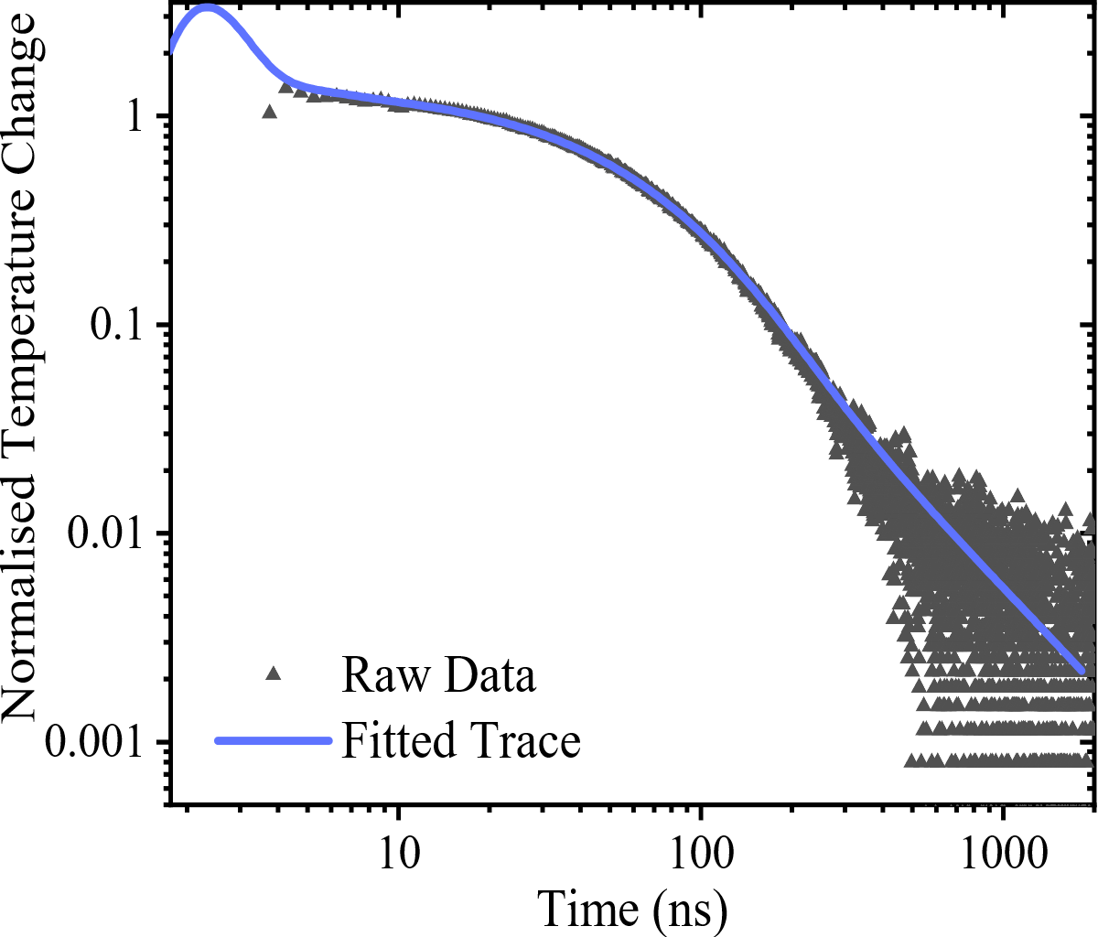
Fig 1: TTR trace for sample 2 with a fitted TBR of 20 m² K GW⁻¹. Temperature rise is normalised from 20 ns.
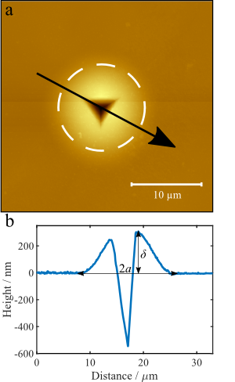
Fig 2. (a) Atomic force micrograph of an 850 nm indent on sample 4. (b) is an example of a line profile where δ is buckle height, and a is the blister radius taken along the arrow in (a).
However, it is important to note that G_{IC} is not just determined by the strength of the interfacial bonding; tensile residual stresses in the film will result in a lower G_{IC} but will not affect the thermal transport across the interface. Fig 5 shows the residual stresses measured in samples 2-4, i.e. samples with similar SiN interlayer thickness and used same Si substrate (sample 1 used a different Si substrate during processing), against the measured interfacial toughness. Samples 2 and 4 had much higher residual stress than sample 3 whilst maintaining a similar or greater G_{IC}. Both these samples also had a lower TBR than sample 3, approaching the limit expected from the thermal resistance of the SiN_{x} interlayer (Fig 4). The implication here is that the interfacial bond is much stronger in samples 2 and 4 than for sample 3 and that the same properties which give a strong interface also give a lower TBR.
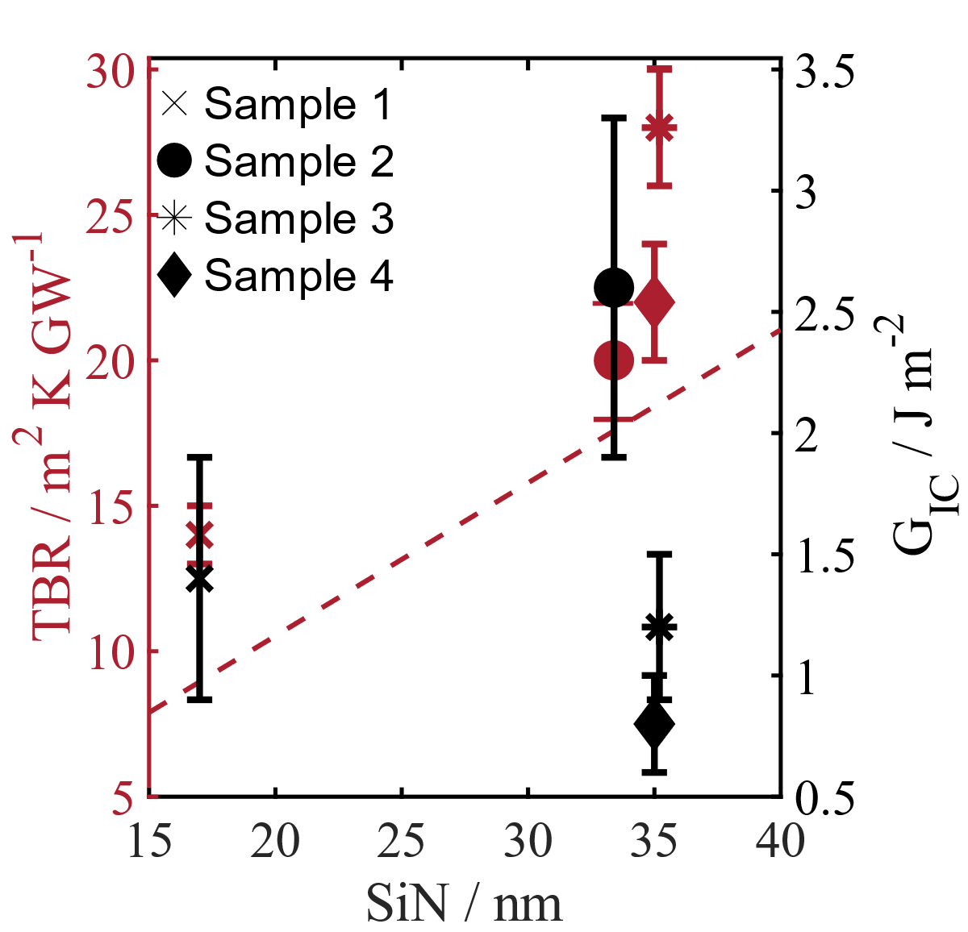
Fig 3: The measured TBR (left) and interfacial toughness (right) of all samples against their SiN_{x} interlayer thickness. The dashed line indicates the expected TBR from the SiN_{x} interlayer using the thermal conductivity in the literature of 1.9 W m⁻¹ K⁻¹ [7].
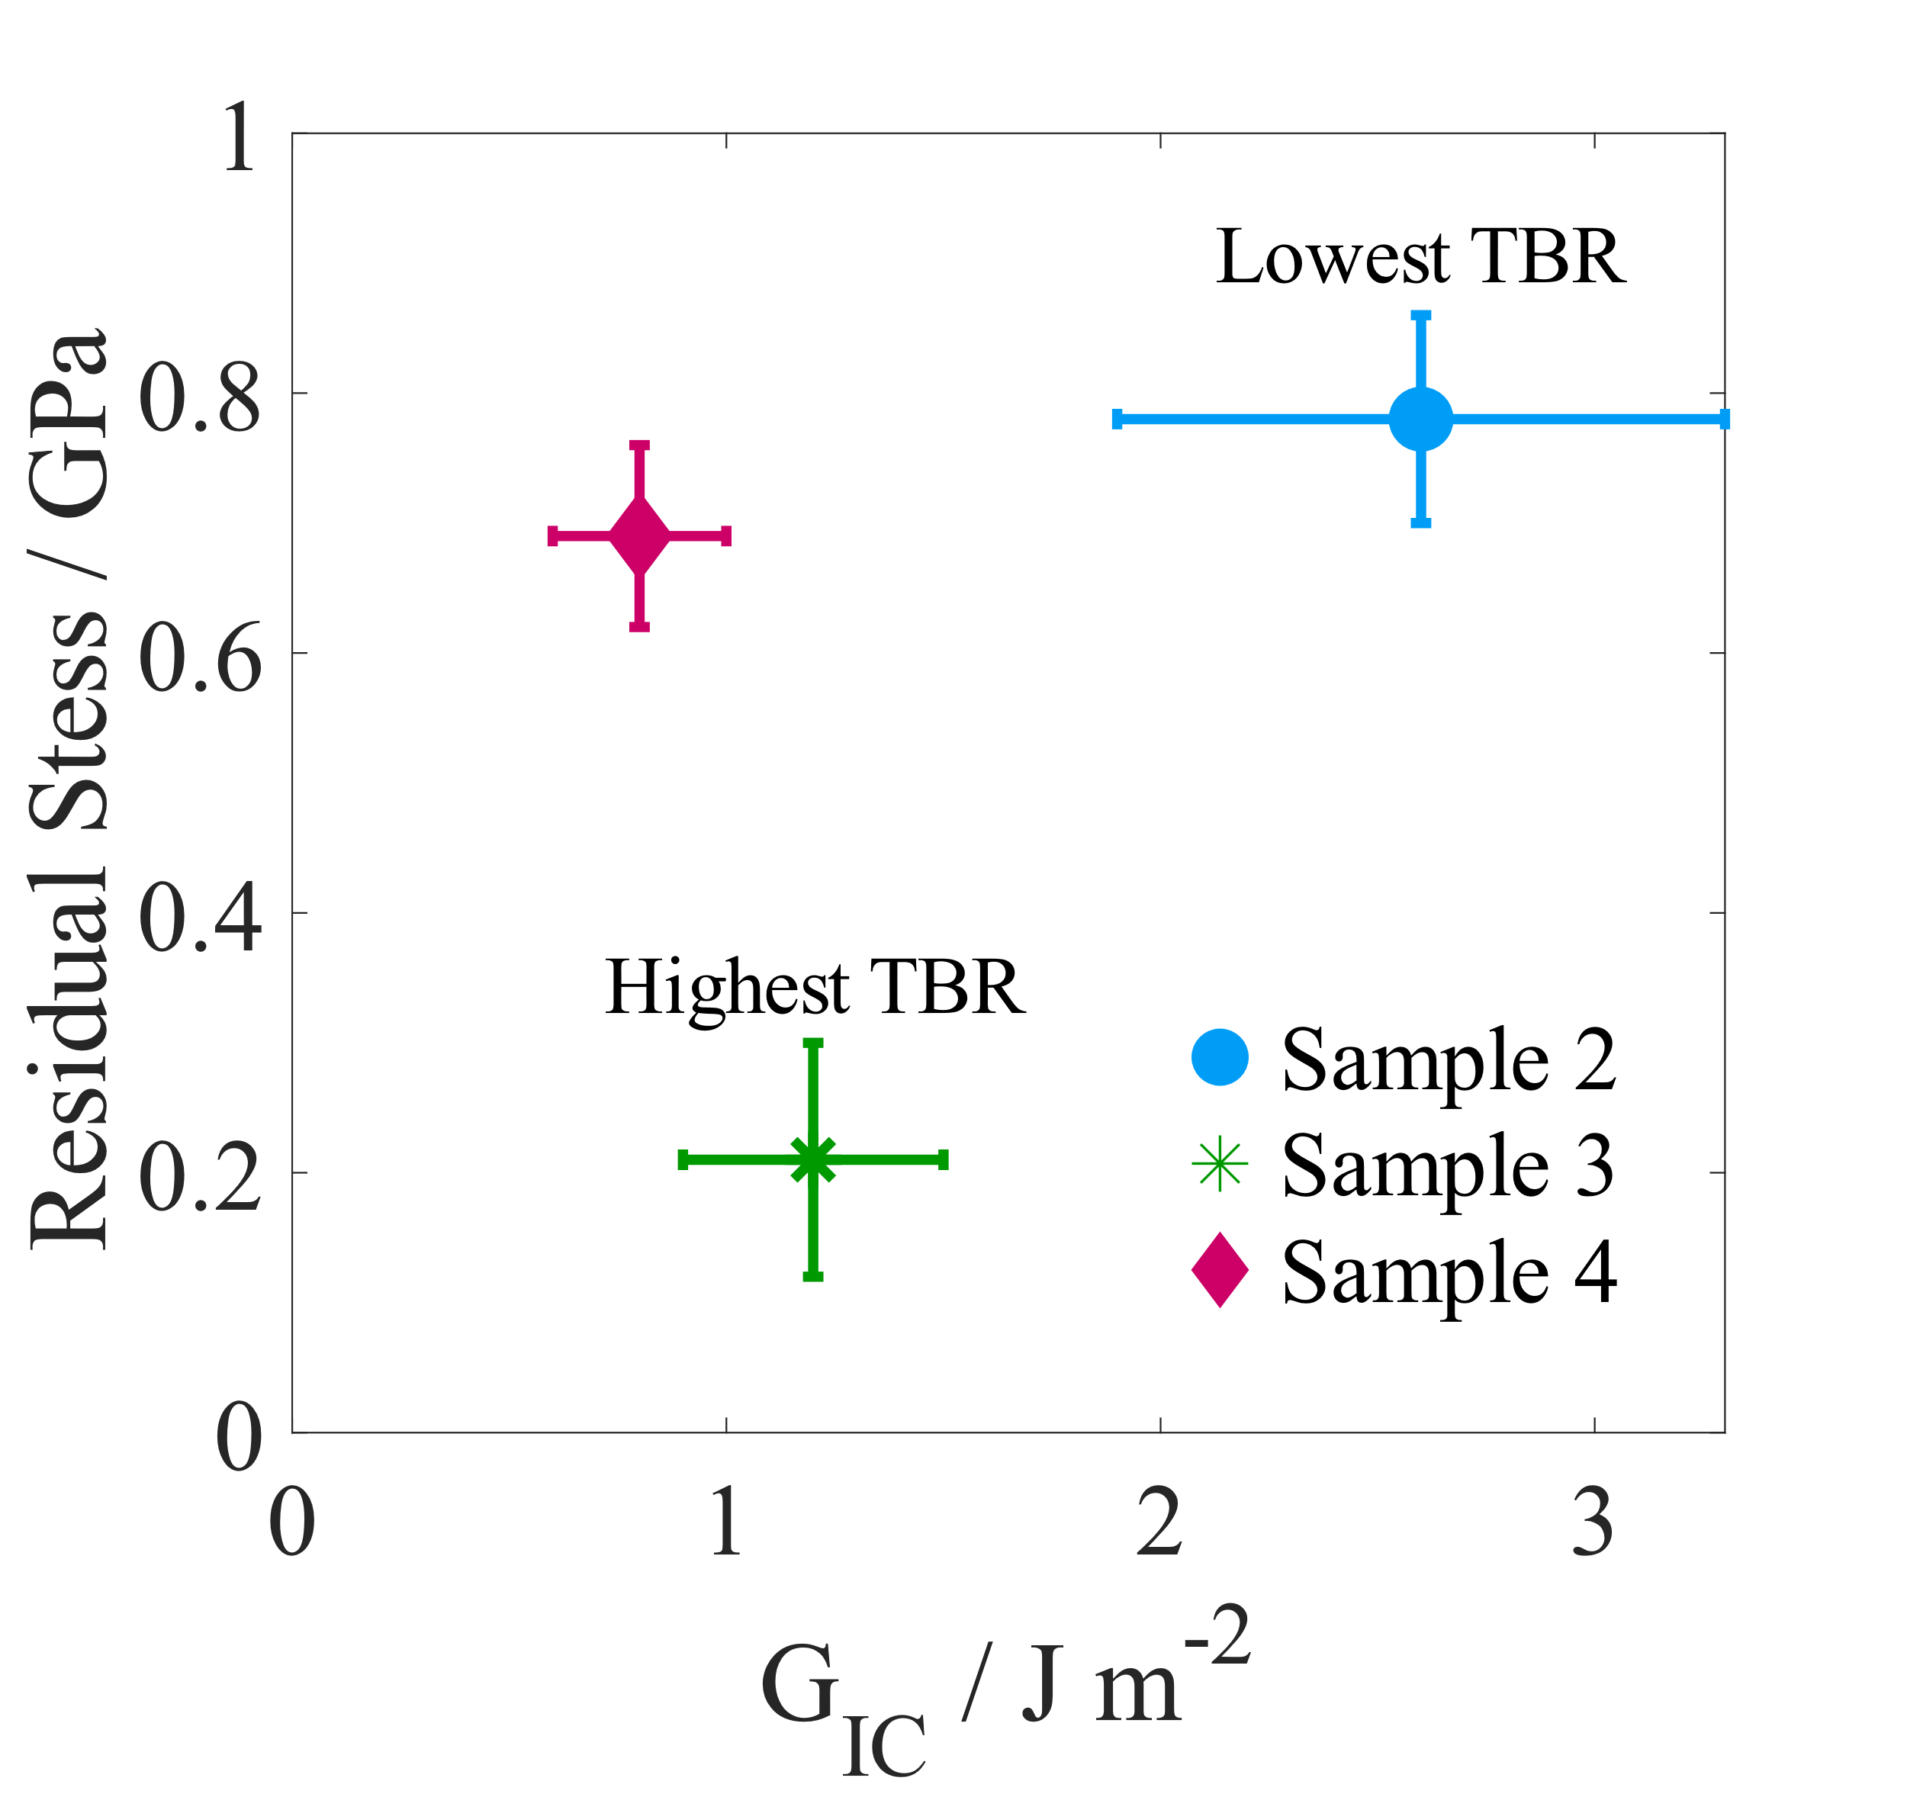
Fig 4: The residual stresses measured in samples 2-4 using Raman spectroscopy against the calculated G_{IC}.
Currently, the thickness of the SiN_{x} interlayer is the dominant factor in determining TBR. In this work, it has been shown that reducing the SiN_{x} thickness is a viable option for maximizing the benefits of diamond heat sinking of GaN HEMTs as the interface strength is maintained. Moving forward, the use of interlayers with a higher thermal conductivity than amorphous SiN_{x}, such as single crystalline AlN [8], will reduce the impact of its thickness on the TBR. Hence, the strength of the interfacial bonding would become a more important parameter to evaluate in GaN-diamond with decreased TBR, for its validation as a viable manufacturable technology for RF applications.

CONCLUSIONS

For the 4 samples studied, the biggest factor in reducing TBR of GaN-on-diamond is found to be the thickness of the SiN_{x}. It has been shown that it is possible to produce GaN-on-diamond with a SiN_{x} interlayer with a very low TBR and a good interfacial toughness. There was no obvious correlation between interfacial toughness and TBR. However, for similar samples there is correlation between the residual stress in the GaN layer and the TBR. Tentatively, this could indicate that these samples have a stronger interfacial bond which helps increase thermal transport across the interface.

Acknowledgements

The authors would like to acknowledge financial support of the Engineering and Physical Sciences Research Council under the program Grant GaN-DaME (EP/P00945X/1). Thanks also go to the Engineering and Physical Sciences Research council, the centre for doctoral training in diamond science and technology, and Element 6 for funding.

References

[1] S. Lee et al., IEEE Int. Reliab. Phys. Symp. Proc., pp. 446–449, 2008.
[2] C. J. H. Wort et al., Diam. Relat. Mater., vol. 3, no. 9, pp. 1158–1167, Aug. 1994.
[3] J. W. Pomeroy et al., IEEE Electron Device Lett., vol. 35, no. 10, pp. 1007–1009, 2014.
[4] D. Francis et al., Diam. Relat. Mater., vol. 19, no. 2–3, pp. 229–233, 2010.
[5] D. Liu et al., ACS Appl. Electron. Mater., vol. 1, pp. 354–369, 2019.
[6] J. W. Hutchinson and Z. Suo, Adv. Appl. Mech., vol. 29, pp. 63–191, 1991.
[7] Y. Zhou et al., ACS Appl. Mater. Interfaces, vol. 9, no. 39, pp. 34416–34422, 2017.
[8] J. M. Wagner and F. Bechstedt, Phys. Status Solidi, vol. 234, no. 3, pp. 965–969, 2002.

Acronyms
HEMT: High Electron Mobility Transistors
TBR: Thermal Boundary Resistance
TTR: Transient Thermorefelctance
AFM: Atomic Force Microscopy

