Impact of Water Content in NMP on Ohmic Contacts in GaN HEMT Technologies

Alexander Hugger¹*, Aleksandra Dlugolecka¹, Hermann Stieglauer¹, Raphael Ehrbrecht¹, and Michael Hosch¹

¹United Monolithic Semiconductors GmbH, Wilhelm-Runge-Straße 11, 89081 Ulm, Germany
*e-mail: alexander.hugger@ums-ulm.de, phone: +49 (0) 731 505-3093

Keywords: GaN HEMT, Manufacturing, Front End, wet chemical lift off, ohmic contact

Abstract
Wet chemical lift off in N-Methyl-2-pyrrolidone (NMP) is widely used in GaN HEMT Front End manufacturing. In case of a Ti-Al-Ni-Au based metal stack for ohmic contacts, the quality of the lift-off process is much depending on the water content in the solvent NMP. In this paper, it will be shown that the metal stack can be attacked during lift off in NMP with too high water content. Additionally, environmental impacts on the hygroscopy of NMP are investigated in order to keep moisture below a certain level and avoid optical defects on ohmic contacts after lift off.

Introduction

In GaN HEMT technologies, Ti-Al-Ni-Au based ohmic contacts are commonly used. At UMS, the single layer thicknesses were optimized to achieve both low contact resistance and high optical quality. A defined morphology and low defect density of the metal surface after wet chemical lift off are essential for subsequent process steps.
On the qualified UMS 0.25µm GaN HEMT technology GH25-10 [1], over a long period some wafers showed ohmic contacts with damaged edges after lift off which we called “peeling effect”. Detailed statistic and physical analysis revealed that the peeling effect is correlated to the water content of the NMP bath in which the wet chemical lift off is done.

Process details

On GH25-10 technology, the integration of the ohmic contacts is done by an image reversal lithography, an evaporated Ti-Al-Ni-Au based metal stack followed by a wet chemical lift off. The lift off consists of several steps. It starts in a non-hermetic NMP bath which is heated to 60°C (1st bath). The lift off in this bath takes about 2 hours. The NMP in this bath is renewed after processing of in total 50 wafers. In between the processing of different lots, the bath heating is usually switched off.
As a second step in the lift off sequence, the wafers are treated for one minute in another non-hermetic NMP bath (2nd bath) at room temperature which is renewed after at most 25 wafers. Then, the wafers are rinsed with water and dried.

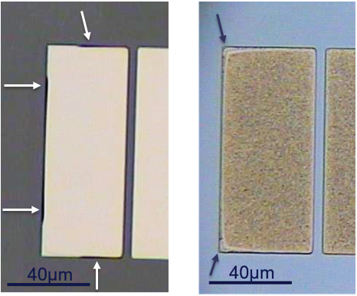

Fig. 1. Left: peeling effect on ohmic contact after lift off; right: peeling effect after high-temperature anneal. Arrows point towards the optical deviations.

Finally, the wafers are treated in a high pressure spray tool to remove particles and lift off residues.
After lift off, the wafers are treated in a high-temperature rapid thermal anneal at more than 800°C.

Optical defects after lift off

The peeling effect of ohmic contacts after lift off was detected on several GH25-10 production wafers. Fig. 1 shows an affected structure directly after wet chemical lift off and after anneal.
The peeling effect was found to be dependent on the layout. Small structures with low metal coverage in the surrounding chip area are strongly affected, whereas big structures with high metal coverage in the surrounding chip area on the same wafer are not affected at all.
TEM cross section and EDX analysis showed that on the affected structures the nickel layer within the ohmic contact metal stack is partly missing and seems to be etched from the edge of the contact towards the inside, see Fig.2.

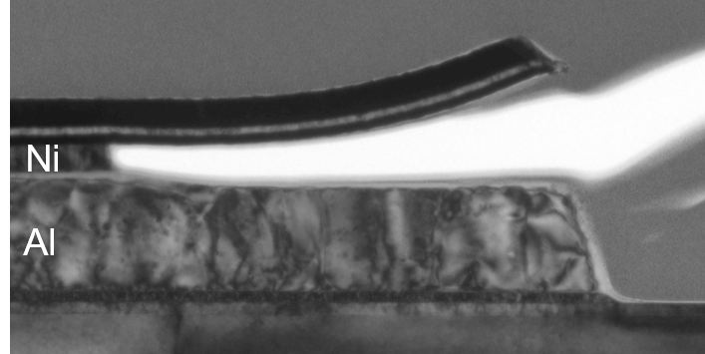

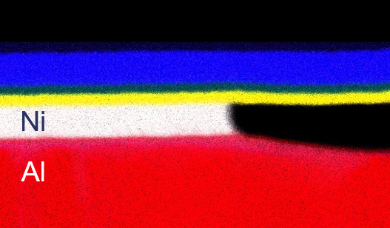

Fig. 2. Top: TEM cross section of an ohmic contact metal pad with peeling effect after lift off.
Bottom: EDX analysis on the cross section.

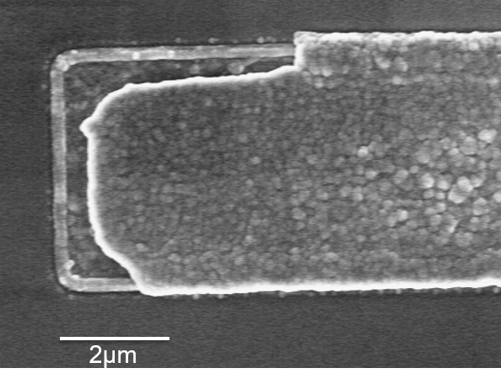

Fig. 3. SEM top view of an ohmic contact metal pad with peeling effect after anneal at more than 800°C.

During high-temperature anneal, the metal layers above the etched Ni are removed, shown in the SEM top view in Fig. 3. Statistics showed that the defects only occurred on wafers that were lifted when the 1st bath was renewed more than eight days ago. Interestingly, the number of wafers that have been processed in the bath did not have an impact on the peeling effect.

Hygroscopy of NMP – Etching of Nickel

N-Methyl-2-pyrrolidone is a basic, hygroscopic and polar compound with high stability. It is also a water-miscible organic solvent, not corrosive and only slowly oxidized by air [2]. Because of its hygroscopy, the water content of NMP is continuously increasing in humidity.
NMP, viewed from a different perspective, is a product of ring closure from γ-N-methyl aminobutyric acid. Although lactam-ring of NMP is chemically stable, under neutral conditions, it can be opened under acidic or alkaline condition to form acid and other products and both alkali and temperature have effect on the hydrolysis of NMP [3].
Based on the statistics of affected wafers we argue that with increasing water content, NMP is becoming more aggressive towards Ni and is able to etch it.
Generally, nickel reacts slowly with air under standard conditions because an oxide layer forms on the surface and prevents further corrosion (passivation). For this reason, nickel-etching mixtures require a medium, which is able to dissolve the initially present as well as the constantly forming oxide, as well as an oxidizer [4].
It is still unclear to us why the mixture of NMP and water is so aggressive towards Ni because there is a large number of factors like pH, temperature, composition of metal layers, size of the structure or layout, which can influence on the reactivity.
We hypothesize that either the composition of different metal layers within the ohmic contact metal stack or/and the product of hydrolysis of NMP can support electrochemical reaction and lead to etching (oxidation and dissolution) of nickel.
The general hypothesis that a mixture of NMP and water etches Ni could be confirmed by an experiment where we intentionally put defined amounts of water in fresh NMP and used these solutions for lift off in beakers. We reproduced a strong peeling effect in the solution with 10% water in NMP, a slight peeling effect with 5% water and no defects were observed with 3% water in NMP. We also varied the rinsing on these engineering wafers. However, including an additional rinse in isopropyl alcohol (IPA) after lift off in NMP did not impact the affection regarding metal peeling compared to the standard procedure where the wafers go directly from NMP to water rinse.

Measurement setup – Karl Fischer titration

In order to show the evolution of water content in NMP in humidity, we performed measurements with coulometric Karl Fischer titration.
Karl Fischer titration is one of the most popular chemical analysis, which uses titration to determine trace amounts of water in a sample. There are two types of Karl Fischer titrators: volumetric and coulometric titrators. The main difference between the two is that by volumetric method, the

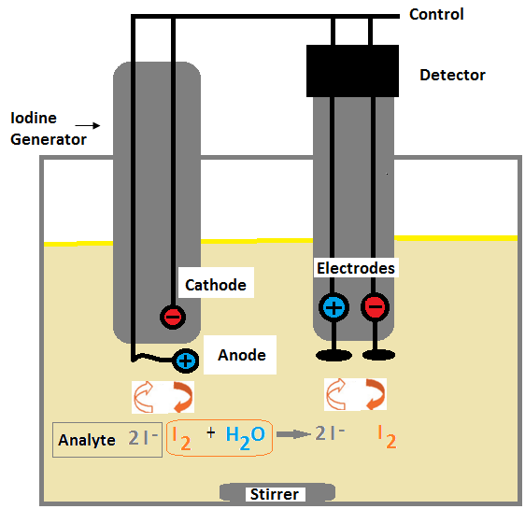

Fig. 4 Karl Fischer coulometric titration principle.
titrant is added directly to the sample by a burette and by coulometric method, the titrant is generated electrochemically in the titration cell. The advantages of the coulometric KF titration is that the measureable water levels are much lower than with the volumetric method.
In coulometric Karl Fischer titration, iodine (I₂ ) is generated electrochemically from the analyte which contents iodide
(I–). When iodine (I₂) comes in contact with the water in the sample, water is titrated according to the following reaction scheme:

- ROH + SO₂ + RN (RNH)SO₃R
- (RNH)SO₃R · 2RN + I₂ + H₂O (RNH)SO₄R + 2(RNH)I
Once all of the water available has reacted, the reaction is complete. The amount of water in the sample is calculated by measuring the current needed for the electrochemical generation of iodine (I₂) from iodide (I–) according to the following reaction:

- 2I- I₂ + 2e-
A schematic of the Karl Fischer coulometric titration is shown in Fig. 4.

experimental results

Measurement results obtained with 200ml NMP in different beaker glasses at cleanroom conditions (T=20°C, humidity 40%) are shown in Fig. 5.

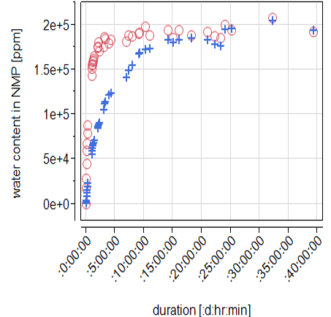

Fig. 5. Evolution of water content in 200ml NMP in cleanroom environment (T=20°C, humidity 40%) measured with coulometric Karl Fischer titration.
Blue crosses: beaker with a diameter of 8cm
Red circles: beaker with a diameter of 18cm

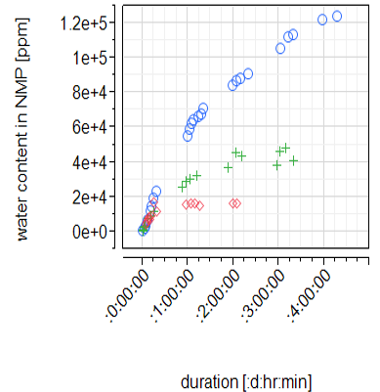

Fig. 6. Evolution of water content in 200ml NMP in beakers with 8cm diameter at different temperatures.
blue circles: T=20°C
green crosses: T=40°C
red rhombs: T=60°C

The water content at room temperature is increasing up to a saturation level of about 20% (2×10⁵ppm). The speed of the evolution of moisture depends on the contact area of NMP to
air which is given by the size and shape of the beaker glass. A higher contact area leads to a faster increase of moisture.

Additional measurements showed that the evolution of water content in NMP is strongly dependent on its temperature. At room temperature (T=20°C), the water content is increasing faster and reaches a higher level than at T=60°C. The moisture evolution in NMP at different temperatures is shown in Fig. 6.

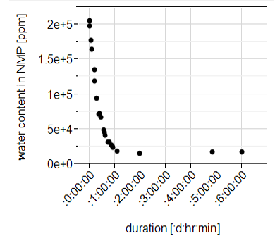

Fig. 7. Evolution of water content of a mixture of 200ml NMP with 20% water at T=60°C.
At T=60°C, the water content in NMP saturates at about 1.6% due to the lower boiling point of water compared to NMP. In another experiment, we mixed fresh NMP with 20% water at room temperature, heated this mixture up to T=60°C and measured the evolution of water content, see Fig. 7. The water content of this mixture rapidly decreases at T=60°C and finally reaches a saturation level of about 1.6% which is in line with the measurement shown in Fig. 6.

Modifications of lift off process

In order to avoid the peeling effect and the resulting optical defects, we changed the lift off sequence based on the experimental results shown before.
So far, the heating of the 1st bath was usually turned out between the processing of different lots. During this time, the NMP cools down to room temperature and its water content increases. As soon as a new lot for lift off arrives, the bath heating is activated and the wafers are processed when the final temperature (T=60°C) is reached. However, the water content in NMP can then still be higher than the critical 5% which results in the known optical defects.
Now, we changed the procedure for the lift off process so that the heating of the 1st bath has to be kept permanently on. With this change, the water content in NMP does not exceed 2% (see Fig. 6) and the peeling effect and optical defects can be prevented.
Consequently, we also analyzed the impact of the lift off step in the 2nd bath (room temperature). Indeed, measurements in this bath showed that the water content is rapidly increasing after filling, like it was shown in the experiment in Fig. 5. However, the risk of getting optical defects due to a too high water content in the 2nd bath is much lower than in the 1st bath because of the shorter processing time (1 min vs. 2 hours). Anyway, since test wafers that were processed without the 2nd bath showed good lift off results and low particle density, we decided to skip this part of the lift off step.

Conclusions

Optical defects on ohmic contacts in GaN HEMT technologies were analyzed. The so called peeling effect is caused by too high water content in NMP which leads to an etching of the nickel layer inside the ohmic contact metal stack during wet chemical lift off. The moisture in NMP is increasing in air due to its hygroscopy, which is mainly depending on its temperature. By modifying the lift off procedure, the peeling effect can be prevented.

Acknowledgements

The authors would like to thank the wet chemistry engineers and technicians at UMS for performing the Karl Fischer measurements and realizing the experiments.

References

[1] D. Floriot, H. Blanck et al., GH25-10: New qualified power GaN HEMT process From Technology to Product Overview, 9th European Microwave Integrated Circuit Conference, 2014.
[2] World Health Organization Geneva, 2001. Concise International Chemical Assessment Document 35 N-Methyl-2-pyrrolidone (No. 35, 2001) https://www.who.int/ipcs/publications/cicad/en/cicad35.pdf (accessed 7 Feb 2020)
[3] Yu Jing Ou, The effects of alkali and temperature on the hydrolysis rate of N-methylpyrrolidone, IOP Conf. Ser.: Earth Environ. Sci. 100 (2017) 0123036
[4] MicroChemicals, Wet Etching of Al, Au, Cu, Cr, Ni, Ti and Ag; https://www.microchemicals.com/downloads/application_notes.html (accessed 4 Feb 2020)
[5] Machinery Lubrication, Karl Fischer Coulometric
Titration Explained and Illustrated
https://www.machinerylubrication.com/Read/594/karl-fischer-coulometric-titration (accessed 10 Feb 2020)

Acronyms

NMP: N-Methyl-2-pyrrolidone
TEM: transmission electron microscopy
EDX: energy dispersive X-ray spectroscopy
IPA: isopropyl alcohol

