Defect Detection and Mitigation in Low Pressure PECVD Systems: Special Case of Nodule Formation in Densified SiN_{x} Films.

Jeremiah Sires

Skyworks Solutions, Inc., 2427 W. Hillcrest Drive, Newbury Park, CA 91320
jeremiah.sires@skyworksinc.com

Keywords: SiN_{x}, nanoclusters, densified dielectrics, PECVD, N-H bonds, K centers

Abstract

Extensive literature exists on characterization of SiN_{x} (silicon nitride) films based on C-V (Capacitance – Voltage) performance and hydrogenation of films, as well as the photoluminescent properties studied through various spectroscopy methodologies (Raman, SIMS and XPS). However, few physical defect studies, particularly in low frequency PECVD (Plasma-Enhanced Chemical Vapor Deposition), can be found. This study will discuss in detail the formation of nodules in densified N-rich (N/Si > 1.33) SiN_{x} films deposited via LF PECVD on CZ polished Si substrates via the formation of K centers and resulting Si nanoclusters and surrounding nitrogen depletion zones within the film. Additionally, three distinct defect mechanisms are isolated and procedures implemented to mitigate product exposure through detection methodology and determination of appropriate preventative hardware maintenance.

Introduction

As we move toward achieving true 5G capability, each new technology release requires tighter electrical performance specifications for all handset applications. Customers demand the highest quality parts as functionality increases and frequency ceilings continue to rise. Suppliers must implement robust and proactive detection methodologies to prevent yield impact before WIP (work in progress) is committed to processing. The procedures discussed in this submission will address sample failure modes and methodologies implemented to eliminate occurrences, further reducing the RPN (risk priority number) in failure mode analysis.
The dielectric films discussed herein are specific to the III-V industry, further constraining the process window in creating robust interlevel dielectrics. Densification and hydrogen content are controlled via the inclusion of LF reactors, while not exceeding the limited thermal budget for most GaAs technologies [1]. Unfortunately, there is an additional component degradation of the showerheads during these depositions, and most notably the post-processing plasma cleans, resulting in possible sources of contamination on and within the films being grown. Another common source of particulates originates within the pumping systems responsible for maintaining vacuum for the chambers and transfer load locks.
Perhaps the most interesting finding, in parallel to addressing well-known defect mechanisms, has been formation of Si-rich nodules, unique to c-Si substrate monitors subjected to the processes optimized for epitaxial GaAs technologies [2]. After discussing some of the typical particle generation mechanisms, this work will discuss the dissociation and recombination reactions of the constituent gasses resulting in an increase in K centers, which are shown to be insufficient to effectively passivate the defects at the Si/SiN_{x} interface.

Experimental

New p-type 150 mm polished (100) Silicon substrates were processed in a Novellus Concept One (C1) multi-station sequential deposition system for all experimentation. Si wafers were primarily used as particle monitors, as such these monitors did not receive any pretreatment and were pre-scanned prior to deposition. Bare gallium arsenide wafers were run in parallel for bulk film characterization. Densified SiN_{x} films of 60 nm to 100 nm were grown via RF combination of low and high frequency power using SiH₄ and NH₃ reactant gasses, with N₂ as a diluent, while the substrates were resistively heated at 300 °C.
Film thickness and refractive index were measured on a Rudolph dual wave-length ellipsometer. Particle scans were performed on a KLA Tencor Surfacescan 5400 tool. Focus-ion beam (FIB) and tilted-SEM (scanning electron microscopy) images were collected on a fei 8200 dual beam system. All metrology, excluding the Transmission Electron Microscopy (TEM), was performed on-site.

Common Particulate Sources and Mitigation

As dielectric films are grown under vacuum, the mechanical pumps utilized, even when maintained, are susceptible to failure and facility impacts. Dusting from the exhaust lines back into the process tool is typical in these instances. The C1 system utilizes separate pumps for the load lock (LL) and the process chamber, with a controller unit to maintain a stable pressure differential between the two. A pump issue, including throttle valve malfunction, or a clogged exhaust line for either unit could result in the generation of particles. Dusting signatures from exhaust issues are generally randomly distributed on the substrates; although, depending upon the location of exhaust ports some additional root cause isolation may be possible.
Partition tests are the most common and reliable means to identify the actual sources of contamination and discover the mechanism by subdividing the process steps and wafer locations within the system. The sample defect map of a random particle signature shown in Figure 1a was due to unstable LL pressure from a faulty differential pressure controller resulting in perturbation of normally static byproduct. Whereas, the edge signature depicted in Figure 1b was representative of specific showerhead degradation caused by plasma damage to that component.

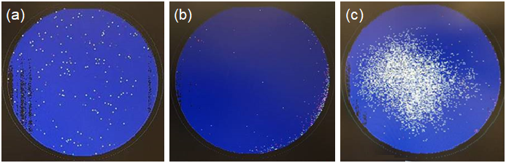
Figure 1. (a) Random distribution from load lock; (b) edge particles from degraded showerheads; (c) burst signature with nodule formations.

Installation of an upgraded controller unit with enhanced battery backup, and a scheduled replacement of showerhead hardware mitigated the aforementioned defects, respectively (see Figure 2 for typical particle type). The third defect (Figure 1c) will be discussed in detail within the next section.

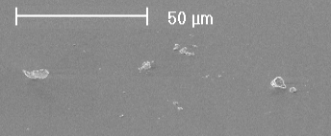
Figure 2. Typical crystalline SiN_{x} byproduct defects sitting on top of film.

Special Case of Silicon Nodule Formation

Densified SiN_{x} films rich in nitrogen (those with N/Si ratios greater than 1.33) have been favored for metal-insulator-metal (MIM) capacitance devices in GaAs-based technologies due to the high breakdown voltage and low leakage current. Consequently, these films with low refractive index are shown to have more N-H bonds above stoichiometric silicon nitride [3]. Incidentally, more detailed inspection of the burst signatures identified previously show depletion zones of 10 µm to 20 µm in diameter, with raised nodules at the epicenter, exacerbating the actual defect density in the particle scans (Figure 3). FIB images of the

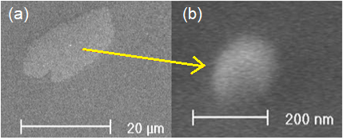
Figure 3. (a) Formation of nitrogen rich “halo” ranging from 10-20 µm; (b) with formation of Si nanocluster in center.

nodules indicate the defects are not merely resting on the film, but are actually a constituent part of the SiN_{x}, as seen in Figure 4.

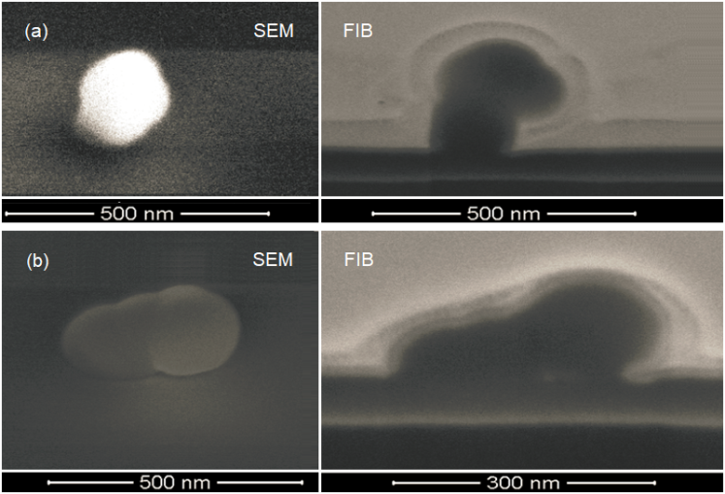
Figure 4. Two different examples of nodules, with SEM and FIB images demonstrating growth out of film.

Previous studies have suggested that N-H bonds act as precursors to charge states known as K centers, resulting in field-effect passivation at the SiN_{x}/Si interface, and these fixed charges can be influenced further in the presence of SiO_{x} [4]. In this case the SiO_{x} is native to the polished substrates without any pretreatment. Furthermore, it can be surmised that the increase in the number of charge states cannot compensate for high defect densities at the interface. Since the baseline process window being explored has NH₃ flowing continuously (including while RF power is off), the ammonia may continue to provide additional radicals for N-H bonds to form at low temperature, even in the presence of diluent nitrogen that is utilized only during the RF power cycles [5]. The increase in K centers results in a distortion layer within the film due to the insertion of N and H [6]. HRTEM (Figure 5) indicates sharp contrast of interface states between the bulk film and the SiN_{x} within the depletion zones, the interface states at the top and bottom of the film. The Si clusters seen in the mid-gap are larger in sample b as well. Also apparent in the high magnification sample is the difference in substrate aberrations, with the defect types under the depletion area significantly deeper and denser than those under the non-affected film. The overall film thickness has not deviated, but the component bond variability between the two samples, from different areas of the same wafer, are obvious.

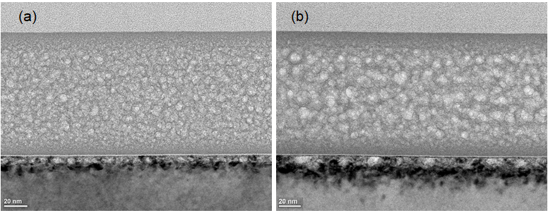
Figure 5. (a) HRTEM of normal SiN_{x} film on Si substrate; (b) HRTEM of depletion zone surrounding Si nanocluster. Lighter clusters correspond to higher Si composition.

High resolution imaging of the nodule itself confirms the anomalous formation is grown from the SiN_{x} film (Figure 6 - the four bands on top of the sample were sputtered materials for the preparation and can be ignored). Interestingly, two distinct nanocrystal formations are visible among the smaller mid-gap ordering, and the interface state at the top of the film remains consistent over the clustering.

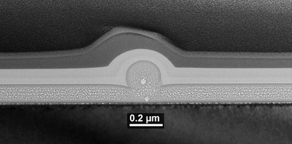
Figure 6. HRTEM depicting dual nanocluster formation with N-rich band gap at the SiN_{x}/Si interface.

Some atomic hydrogen diffusion into the substrate can occur through trapping mechanisms, even in densified films, with poor quality substrates amplifying the effect due to additional defect states and dangling bonds accepting radicals. Precedent for ion damage of bulk silicon substrates from LF processing also exists. Moreover, a lack of high annealing temperatures, which would act to redistribute H for more efficient bulk passivation, would further the probability for high densities of fixed charges and the repulsion of minority carriers from the recombination regions [7]. The result is non-uniform compositional densities that are insufficient to compensate for the higher volume of interface states.
At higher magnification the white line bisecting the substrate and nitride film, seen in Figure 7, depicts the thin SiO_{x}N_{y} (silicon oxynitride) layer formed from native oxides present on the wafers prior to PECVD processing. As mentioned previously, and even more apparent below, the inconsistencies of the Si substrate regions under the nanoclusters are sufficiently deep and varied to create incongruities within the N-rich SiN_{x}, catalyzing additional defect states within the film.

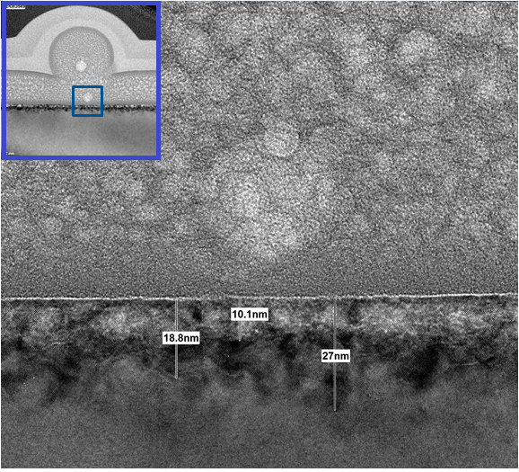
Figure 7. TEM depicting depth of c-Si wafer defect regions directly under the depletion zone of Si-rich nodule.

Conclusions

Containment is no longer an option; prevention must be the organizational focus to eliminate risk to product and deliver to increasingly stringent customer demands. To wit, thorough process characterization should include monitoring materials and practices. Creating a signature library and implementing corrective actions for observations permit the quick root cause isolation and resolution for future incongruities. In the study above, particle scan recipe optimization reduced the defect density to accurately assess nanocluster signature. In addition to upgrading the faulty pressure differential controller, replacement schedules of the showerhead components were documented to mitigate risk from degradation.
The false-fail silicon nodule anomaly is easily precluded in the selection of more suitable substrates and incorporating chemical pretreatment congruent with production flow methodology. Although not ideal for III-V dielectrics, Si-rich films would be less prone to Si nanocluster formation, due to wider and shallower quantum wells [8]. A limited thermal budget to a greater extent prohibits the high temperature annealing required to reduce the density of charge states.

Acknowledgements

The author would like to thank the Skyworks Solutions team, including Lam Luu for isolating the showerhead induced particle generation and Sasha Kurkcuoglu for additional data collection. Special thanks to Daniel Weaver for facilitating the TEM analysis.

References

[1] J. Yota, Interlevel Dielectric Processes Using PECVD Silicon Nitride, Polymide, and Polybenzoxazole for GaAs HBT Technology, Journal of The Electrochemical Society, 156 (11), G173-G179 (2009).

[2] Y. Wan, et. al., Characterisation and Optimization of PECVD SiN_{x} as an Antireflection Coating and Passivation Layer for Silicon Solar Cells, AIP Advances 3, 032113 (2013).

[3] T. Dominguez Bucio, et. al., Material and Optical Properties of Low-temperature NH₃-free PECVD SiN_{x} layers for photonic applications, J. Phys. D: Appl. Phys. 50 (2017).

[4] H. Mackel, R. Ludemann, Detailed Study of the Composition of Hydrogenated SiN_{x} Layers for High-Quality Silicon Surface Passivation, Journal of Applied Physics, 92 (5), 2602-2609.

[5] J. Yota, Effects of Deposition Method of PECVD Silicon Nitride as MIM Capacitor Dielectric for GaAs HBT Technology, 2011 ECS, May 2011.

[6] M. Lamers, et. al., The Interface of a-SiN_{x}:H and Si: Linking the nano-scale structure to passivation quality, Solar Energy Materials and Solar Cells, 120 (Part A), 311-319 (2014).

[7] J. Lelievre, et. al., Study of the Composition of Hydrogenated Silicon Nitride SiN_{x}:H for Efficient Surface and Bulk Passivation of Silicon, Solar Energy Materials and Solar Cells, 93 (8), 1281-1289 (2009).

[8] V. Gritsenko, et. al., Silicon Dots/Clusters in Silicon Nitride: Photoluminescence and Electron Spin Resonance, Thin Solid Films, 353, 20-24 (1999).

Acronyms

FIB: Focus-Ion Beam
GaAs: Gallium Arsenide
HRTEM: High Resolution Transmission Electron
Microscopy
PECVD: Plasma-Enhanced Chemical Vapor Deposition
N-rich: Nitrogen-rich
NH₃: Ammonia
SEM: Scanning Electron Microscopy
SiH₄: Silane
SiN_{x}: Silicon Nitride
WIP: Work in Progress

