eDataLyzer Application on Solving DS Yield Issue with Starburst Pattern

Yiping Wang¹, Robert Waco¹, Matthew Johnson¹, Pat Hamilton¹, Jinhong Yang¹, Dana Schwartz¹, Corey Nevers¹, Edward Elkan¹, Kaushik Vaidyanathan¹, and KimKok Gan²

¹Qorvo, Inc. 2300 NE Brookwood Parkway, Hillsboro, OR 97124
Yiping.Wang@Qorvo.com (503) 615-9264
² Bistel America, Inc., 3151 Jay St., Santa Clara, CA 95054
kkgan@bistel.com (415)425-4748

Keywords: eDL, FDC, DS, BOB, WOW, FA, FIB, TA, YMS, MA, IM, PSN

Abstract

A die sort (DS) yield loss forming a ‘starburst’ pattern in a wafermap was observed in a pHEMT technology manufactured by Qorvo. Typical data analysis performed by yield engineers was unable to correlate the failure root cause to a specific process step. To help drive to root cause, Bistel was consulted on the use of eDataLyzer (eDL) software.

This paper will describe the ‘starburst’ DS yield loss pattern in details, followed by the application of Bistel’s eDL software combined with process tool Fault Detection and Correlation (FDC), and end with the validation of the failure mode.

Introduction

During the manufacturing launch of a next generation PhEMT technology, a DS yield loss trend with a specific pattern, termed as ‘starburst’ is shown in Fig. 1. The yield loss was observed systematically across every wafer within a fab lot. However, not every lot was impacted.

Failure analysis and focused ion beam (FIB) cross sectioning found that underetched nitride in a non-obvious interaction between the nitride film and etch process. Thus, the data analysis focused on the steps forming the gate layer. Best-of-best (BOB) and worst-of-worst (WOW) lots were selected, and a tool commonality analysis was performed. The analysis did not point to the root cause as there were critical processing steps on single-point tools in the flow. This forced commonality confounded the final resolution. To dig deeper, Bistel was consulted to explore the application of eDL ^{[1]}. Bistel is a supplier to Qorvo and eDL has been deployed internal in Qorvo fabs.

This paper will detail how eDL was applied to help break the forced commonality due to the tools and to gather additional information into the nitride deposition and subsequent etch.

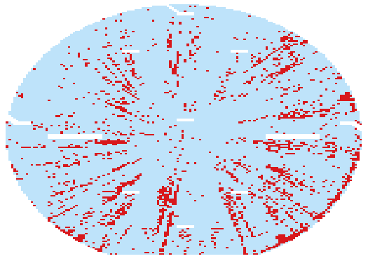
FIGURE 1: DS Yield Loss Issue with ‘Starburst’ Pattern

eDataLyzer OVERVIEW

eDataLyzer is an analytic product platform developed by Bistel. It can combine process tool FDC data with wafer yield data (i.e. with YMS data, typically comprise of Yield, Etest, Defect and Metrology) into one platform to perform FDC Full (every process recipe step) Trace Analytic and search for correlations. This automated method is more efficient on resolving a yield excursion than traditional analysis approach typical in yield engineering roles. Table 1 illustrates a sample analysis difference between classical yield analysis and eDL application ^{[2]}.

TABLE 1. Comparison between classical yield analysis and eDL
Customer (200 &300mm fab) | Time to Root Cause Identification  (TTRCI) for Traditional Method | TTRCI using  BISTel MA + IM+TA
A | 7 days | < 4 hours
B | 3 weeks | < 4 hours
C | >4 weeks | < 3 hours

eDL Application on solving ‘starburst’ issue

- Cause and Effect Analysis

Similar to the traditional yield analysis, three BOB and three WOW lots were selected based on DS yield trends. For the ‘starburst’ issue, leakage current trends were targeted. eDL platform has the ability to select ‘Cause Variables’ (i.e. FDC trace data from critical steps which could potentially cause to yield loss), and ‘Effect Variables’ (i.e. yield and grouping). Since wafer-level traceability was not available in the fab processing, lot-level FDC trace analysis was employed.

Once ‘Cause’ and ‘Effect’ was determined, ‘Effect to Cause’ analysis was performed with the results available instantaneously. Like most automated analysis, the smaller scope of the Cause variables, the shorter the analysis time will be. Prior to eDL TA, eDL Intellimine (advanced data mining) helps to narrow down the Cause variables to a few (e.g. few potential problematic process tools) from thousands of Cause variable. Then drilldown to TA on the scoped tools FDC trace variables.

- TA Results Observation

eDL TA will display the effect results sorted by ranking upon ‘Effect to Cause’ analysis. The ranking of the potential candidates is sorted by the most significant to least significant deviated Trace feature score: 0 to 1 (Figure 2).

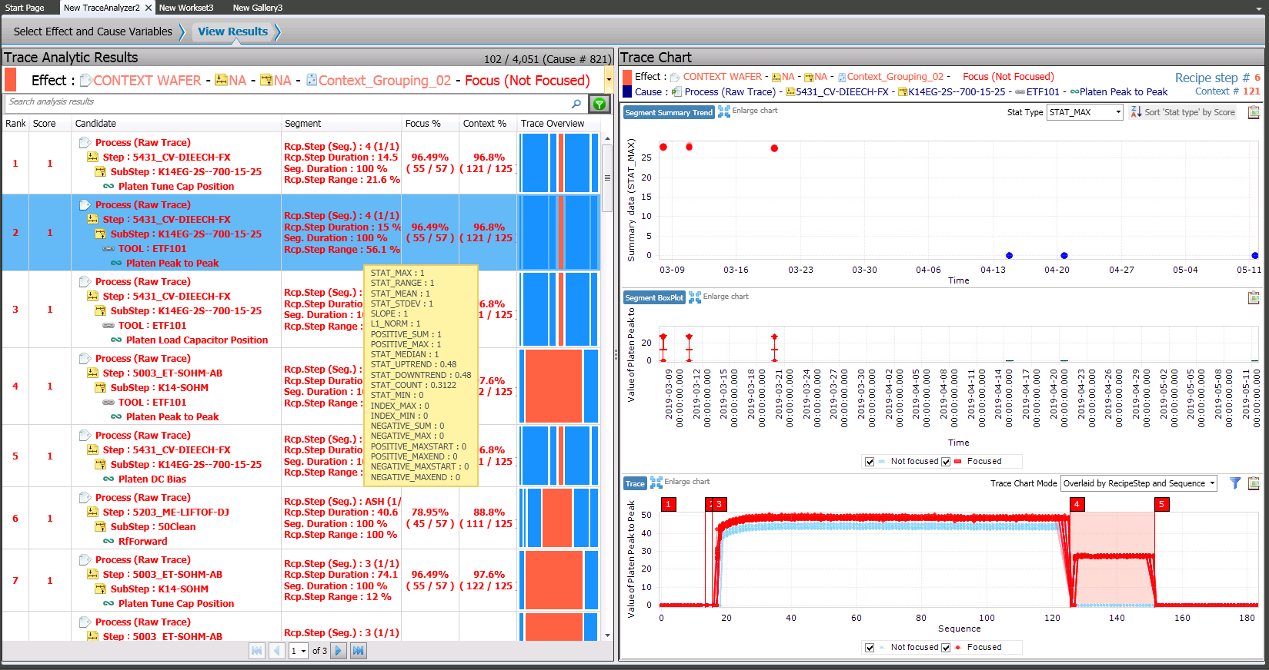
FIGURE 2. Example of Starburst TA Result Display with Rank and Trace Feature Scores

For the ‘starburst’ issue, etch platen parameters, (e.g. platen DC bias, peak-to-peak voltage etc.), from the single-point etch tool, ranked the highest among the other parameters showing significant difference between the BOB and WOW groups (Figure 3).

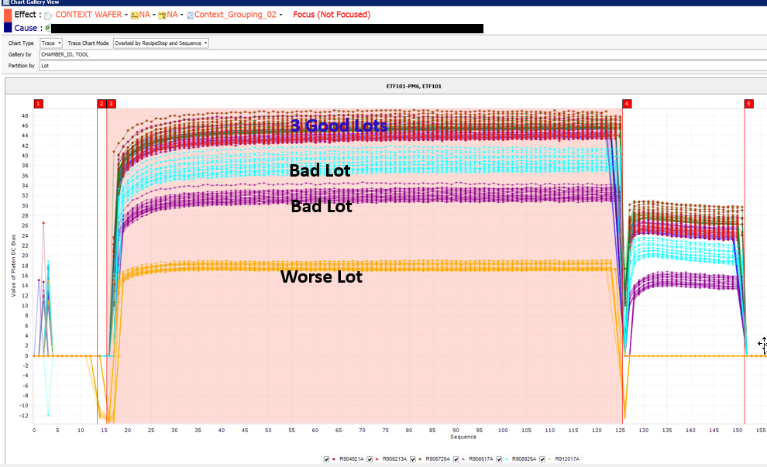
FIGURE 3. Comparison between BOB and WOW on Platen DC Bias Signal

- Validation on eDL Analysis Results

Based on the analysis results from eDL, longer term FDC data was extracted from the specific etch tool. The analysis team discovered that the ‘starburst’ yield loss time periods aligned with abnormal peak-to-peak voltage steps. Further drill down confirmed that the etch tool had an abnormal chuck and peak-to-peak voltage traces recovered after the chuck was replaced (Figure 4)

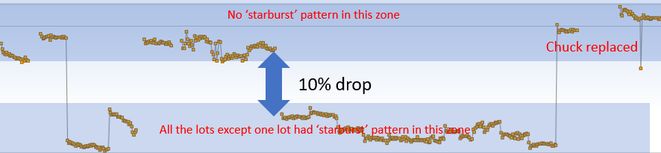
FIGURE 4. Platen Peak to Peak Voltage Trend

To further understand the issue and have a robust process, a DOE (Design of Experiment) was developed to improve process margin. It was confirmed that both thicker PSN (Silicon Nitride) or underetch would cause the issue. A full validation result will be presented in the conference.

Conclusions

eDL is a very efficient platform to do yield analysis and narrow down the potential contributors quickly. It will save yield engineers significant time compared to analyzing yield data using traditional methods. Additionally, eDL has been shown in this paper to provide the ability to further drive yield enhancement and do it more efficiently. To fully realize the benefits from eDL, it is critical to have FDC configured for all the tools in the fab and set up strategies properly.

References

[1] https://www.bistel.com/solutions/analyze/edatalyzer/
[2] Internal communication between Qorvo and Bistel

ACKNOWLEDGEMENTS

The authors would like to acknowledge the support from yield director Dr. Shailesh Mulgaonker and etch manager Dr. Mark Tesauro on investigating and solving the issue.

Acronyms

eDL: eDataLyzer
FDC: Fault Detection and Classification
DS: Die Sort
BOB: Best of Best
WOW: Worst of Worst
FA: Failure Analysis
FIB: Focused Ion Beam
TA: Trace Analysis
DOE: Design of Experiment
YMS : Yield Management System
MA: Map Analytic
IM: Intellinmine
PSN: Silicon Nitride

