Development and Testing of Sub 0.5-micron Features for Advanced Lift-Off Processes
Phillip Tyler¹, Jonathan Fijal¹, Anil Vijayendran¹
Jennifer Rieker², David Rennie², Guanyang Lin², John Sagan², Tomotsugu Yano³, Masahiko Kubo³
Phil Greene⁴, Gregg Wallace⁴, Shihu Deng⁴, Laura Mauer⁴
¹Veeco Instruments – Precision Surface Processing, Horsham, PA, ptyler@veeco.com
²EMD Performance Materials, Branchburg, NJ, jennifer.rieker@emdgroup.com
³Merck Performance Materials, Japan, tomotsugu.yano@merckgroup.com
⁴Ferrotec Corporation, Livermore, CA, pgreene@ferrotec.com

Keywords: photolithography, KrF negative tone resist, KrF lift-off photoresist, metallization, metal lift-off

Abstract
Previous studies have shown the importance of selecting the correct photoresist, metallization method, resist remover, and tool to achieve a successful lift-off^{[1]}. Improper selection of just one of the four can result in insufficient lift-off due to conformal metal coating of the photoresist, greater number of defects, lower throughput and a higher cost of ownership. Feature sizes of 50 µm down to 0.5 µm were previously demonstrated and this paper will focus on feature sizes under 0.5 µm. These size features are gaining more traction in metal lift-off processes for RF and power applications that require smaller features for improved performance.

Introduction
The purpose of this paper is to demonstrate procedures to deliver practical sub 0.5 µm features using a metal lift-off process. The exposure dose and development time of the newly developed KrF negative-tone photoresist had been previously optimized to obtain the ideal retrograde profile for successful metal lift-off. The optimized process conditions will be investigated for their effect on sub 0.5 µm feature sizes. Metal will be deposited onto the photoresist and cross sections of the stack will be inspected to ensure there is not conformal coverage of the metal. The wafers will then be subjected to lift-off with an industry standard metal lift-off tool. The wafers will be inspected before metal deposition and after lift-off with a critical dimension scanning electron microscope (CD-SEM) to compare desired trace width to actual trace width, which provides guidelines for proper electrical design. Percent metal fill as a function of photoresist thickness will also be investigated to determine if there is an ideal ratio for a successful lift-off at smaller line and space dimensions.

Photolithography
Feature size is heavily dependent on selecting the right photoresist. Previous studies demonstrated that AZ® nLOF 2070 successfully lifted features ranging from 10 to 50 µm lines/spaces and AZ® nLOF 5510 photoresist successfully lifted 0.5 µm lines and spaces. Both photoresists were negative tone, which is required for a successful lift-off due to the retrograde profile produced. A new type of negative photoresist, AZ® nLOF K8030, will be used in this study. AZ® nLOF 5510 had a minimum resolution of 0.5 µm, whereas AZ® nLOF K8030 can resolve features as small as 0.15 µm.

To meet sub 0.5 µm lines and spaces of photoresist patterning, it is mandatory to select suitable exposure wavelength, film thickness and chemicals. The AZ® nLOF K8000 series is a chemically amplified type of negative-tone photoresist designed for 248 nm DUV lithography (KrF) sensitive at less than 0.6 µm film thickness. It has high contrast between open and patterned areas, and a slightly retrograde or straight sidewall profile without pattern collapse of photoresist at smaller feature sizes for higher resolution.

A rule of thumb in metal lift-off processes is that the photoresist thickness should be at least two times the deposited metal thickness. For example, if you want to deposit 1 micron of metal, the photoresist should be a minimum of 2 microns thick. However, in order to resolve smaller linewidths, the thickness of the photoresist must decrease which thereby limits the metal thickness. As a result, the 2:1 rule was expanded upon to determine how much metal can be deposited before affecting the metal lift-off process. Two features sizes (200 and 300 nm CD) were investigated in this study.

Experimental Setup
Wafer Preparation
Primed 200mm SiO₂/SiON-silicon wafers were coated with AZ® nLOF K8030 to a thickness of 338nm. The wafers were then baked at 110°C for 60 seconds to drive off the solvent. Wafers were exposed on a Canon FPA-3000EX5 system with illumination conditions of ½ Annular with NA of 0.63 and σ of 0.40/0.80 (inner/outer). A constant exposure dose and focus were applied. A post exposure bake of 100°C for 60 seconds was performed. Wafer was developed with AZ® 300MIF Developer for 60 seconds. The corresponding CD-SEM measurements and sidewall profiles can be found in the Results section.

The reticle design used in these experiments contained a line:space array with dimensions from 1:1 to 1:5. The dimensions of these lines and spaces varied from 200 nm up to 500 nm (Figure 1), however, only features with dimensions of 200nm and 300nm were investigated in this experiment.

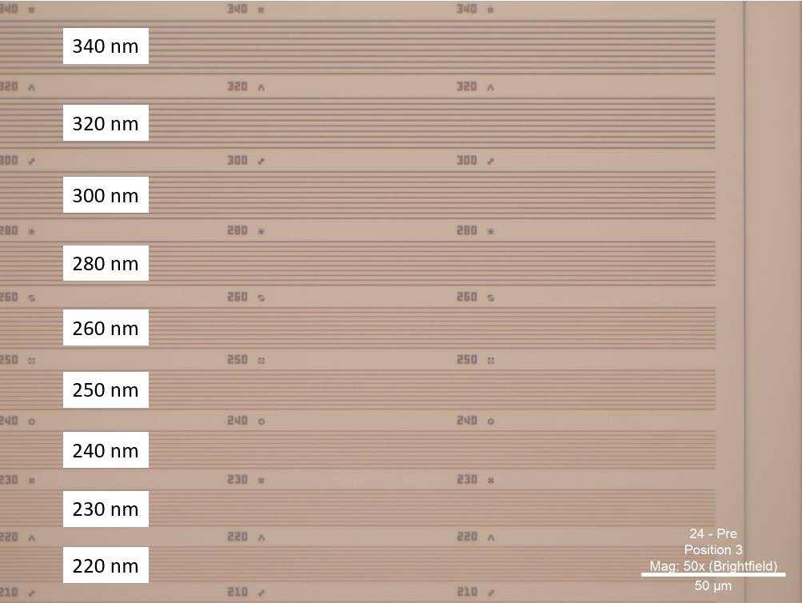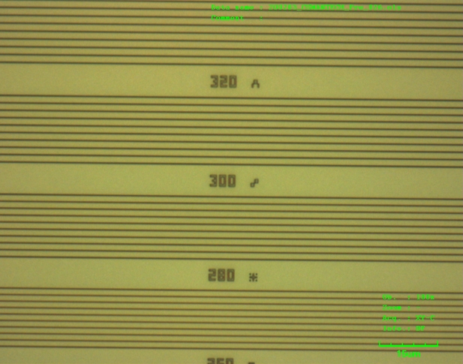
Figure 1: Area of interest micrograph (50X-left and 100X-right)

Metallization
E-beam evaporation was utilized in this study because such systems can be designed to efficiently provide deposition at the normal angle of incidence that is best suited for metal lift-off. Alternative deposition techniques, such as sputtering, either suffer greatly in efficiency to avoid producing conformal coatings or create coatings that are not as readily able to achieve clean metal lift-off. To keep variables consistent with the previous study, a UEFC6100 HULA (High Uniformity Lift-off Assembly) e-beam evaporator which provides highly uniform films (~1%), efficient material collection (>20%), and high wafer capacity (25-200mm wafers)^{[2]} was used in this study. A source to substrate distance of 46” was maintained throughout the experiments to preserve the material incident angle less than 5 degrees. The total thickness of the titanium and copper film stacks were varied (Table 1) in order to determine the effect of metal fill to resist thickness in the ability to achieve a good metal lift-off process.
Table 1: Experimental metal film thicknesses
Titanium Thickness (nm) | Copper Thickness (nm) | Total Metal Thickness (nm) | Photoresist Thickness (nm) | Percent Metal Fill
50 | 120 | 170 | 338 | 50%
50 | 210 | 260 | 338 | 77%
50 | 250 | 300 | 338 | 90%

Lift-off – Solvent Selection
Photoresist remover selection is one of the four critical variables in a successful metal lift-off process. Matching the correct remover with the photoresist being used is of utmost importance. The chosen remover should be capable of fully dissolving the resist within a suitable time frame in order to maintain optimum wafer throughput. For negative tone resist, the right remover is typically a formulated product which contains components such as a strong acid or base that helps break down the resist crosslinking network to enable the dissolution of resist polymer in the solvent system of the remover. In addition, the remover should also clean the resist without leaving a residue and etching the underlying materials. Traditional single solvent removers such as NMP may lift a negative tone resist but often do not achieve complete dissolution. This can lead to higher defectivity levels and shorter bath life. As a result, a resist remover that can fully dissolve the resist has many advantages and is the preferred option.

AZ® Remover 400T was developed to dissolve various resist types, both positive-tone and negative-tone, while also maintaining low etch rates on many common metals. Experiments were conducted with this remover product to determine its ability to perform the metal lift-off on the AZ® nLOF K8030 resist.

Lift-off – Tool Selection
The last variable in a successful lift-off is choosing the correct tool to perform the lift-off. Veeco’s WaferStorm® solvent-based platform with ImmJETTM technology was used in the previous study and kept constant in this study.^{[2]} The metal lift-off process used in this study is listed below in Table 2.
Table 2: Process flow for metal lift-off on silicon wafers
Step | Process | Chemical | Time | Speed (rpm)
1 | Wafer immersion | AZ® Remover 400T | 15 or 30 minutes | N/A
2 | HPC Fan Spray | AZ® Remover 400T | 1 minute | 200
3 | Rinse | IPA | 20 seconds | 200
4 | Dry | N/A | 45 seconds | 1500

A wafer immersion time of 15-30 minutes, high pressure chemical (HPC) fan spray of 1 minute, IPA rinse of 20 seconds, and spin dry of 45 seconds was kept constant in this study. The immersion time was sufficient to swell the photoresist and the HPC fan spray then removed the photoresist/metal mixture from the wafer surface. Automated handling and advanced software ensured each wafer was soaked and sprayed for the same amount of time. Advanced software enabled batch soak and single wafer spray, which provided a high throughput process.

Results
Complete metal lift-off was achieved on all wafers, regardless of percent metal fill. The below SEM images show features on the wafer surface before and after the lift-off process. The primary difference between the two percent fills and isolated/dense spacing was the shape of the deposited metal after lifting. Metal shape after lifting varied from rectangular for isolated and larger ratios and more trapezoidal for denser and smaller ratio features.

In Figures 2-5, the post metal deposition wafers (center images) show some pulling and distortion of the metal. This is typical when performing a manual cleave of the wafers.

Figure 2: SEM images of 200nm CD at 1:1 L/S before metal deposition (left), after metal deposition (center) and after lift-off (right). Metal fill in relation to photoresist thickness is 50% (top) and 90% (bottom).

Figure 3: SEM images of 300nm CD at 1:1 L/S before metal deposition (left), after metal deposition (center) and after lift-off (right). Metal fill in relation to photoresist thickness is 50% (top) and 90% (bottom).

Figure 4: SEM images of 200nm CD at 1:5 L/S before metal deposition (left), after metal deposition (center) and after lift-off (right). Metal fill in relation to photoresist thickness is 50% (top) and 90% (bottom).

Figure 5: SEM images of 300nm CD at 1:5 L/S before metal deposition (left), after metal deposition (center) and after lift-off (right). Metal fill in relation to photoresist thickness is 50% (top) and 90% (bottom).

To obtain statistically relevant data, a CD-SEM was used to quantify a minimum of 73 and average 279 locations across the wafer surface after photolithography (Table 3) and after lift-off (Table 4).

Table 3: AZ® nLOF K8030 CD-SEM measurements after photolithography
Target CD | Line Spacing | Average CD (nm) | Standard Deviation (nm)
200 | 1:1 | 190.07 | 5.15
200 | 1:2 | 157.36 | 16.41
200 | 1:5 | 162.31 | 10.07
300 | 1:1 | 278.83 | 4.51
300 | 1:2 | 271.71 | 8.68
300 | 1:5 | 330.63 | 10.29

Table 4: CD-SEM measurements after metal lift-off
Target CD | Spacing | Measurement | Average CD (nm)
 |  |  | 50% Fill | 77% Fill | 90% Fill
200nm | 1:1 L/S | Average | 175.8 | 176.5 | 177.4
 |  | Std. Dev. | 3.53 | 6.23 | 4.2
 | 1:2 L/S | Average | 169.0 | 170.3 | 165.6
 |  | Std. Dev. | 5.86 | 7.1 | 9.60
 | 1:5 L/S | Average | 190.3 | 196.0 | 196.9
 |  | Std. Dev. | 9.38 | 8.1 | 9.80
300nm | 1:1 L/S | Average | 294.7 | 302.2 | 299.5
 |  | Std. Dev. | 4.57 | 6.3 | 5.3
 | 1:2 L/S | Average | 284.8 | 287.5 | 284.7
 |  | Std. Dev. | 10.2 | 16.6 | 12.5
 | 1:5 L/S | Average | 318.7 | 320.1 | 318.9
 |  | Std. Dev. | 8.68 | 12.95 | 9.4

The sidewall profile of the resist pattern on the SiO₂/SiON/Si surface showed some standing wave effect caused by the interference effect of incident and reflected light from the substrate. However, when coated by AZ KrF-17B which is a BARC (Bottom Anti-Reflective Coating) designed for 248nm DUV lithography (KrF), the AZ® nLOF K8000 series has demonstrated down to 150 nm L/S patterning on Si substrate.

Development of a unique antireflective coating which is compatible with metal lift-off processes is on-going at EMD Performance Materials. However, to apply SiO₂/SiON/Si substrate without AZ® KrF-17B coating, minimum feature size for resist patterning was 200 nm. This is because smaller feature patterns are more sensitive to the reflectivity effect which causes significant resist pattern undercut that leads to the resist pattern being peeled off. Reflective control to cancel interference effect on a specific substrate is one of the challenges to realize the patterning of smaller feature sizes for advanced metal lift-off applications.

Conclusion
Below is a dimensional summary (Table 5) of the post lithography spaces and the corresponding post lift-off metal trace widths. The largest difference between the average CD measurements was 6.6 nm and 7.5 nm for the 200 nm and 300 nm target CD, respectively. While the average metal trace CD of each percent fill is statistically different from the other two percent fills for all spacing groups using a student’s t-test, the previous values correspond to only 3.4% and 2.5%, respectively, of the average CD. Theoretically speaking, CD-SEM measurements of the trace width should not be impacted by the percent fill. The CD-SEM measures the maximum value of the trace width, which was previously defined by the photolithography step. Percent fill, which corresponds to a change in height, does not influence trace widths. Therefore, the explanation for statistical differences between the percent fills of a given spacing is attributed to experimental error.
Table 5: CD-SEM measurements of metal lines after lift-off versus space measurements after photolithography
Target CD | Spacing | Post Litho Space CD (nm) | Average CD (nm)
 |  |  | 50% Fill | 77% Fill | 90% Fill
200nm | 1:1 L/S | 192.07 | 175.8 | 174.5 | 177.4
 | 1:2 L/S | 157.36 | 169.0 | 170.3 | 165.6
 | 1:5 L/S | 162.31 | 190.3 | 196.0 | 196.9
300nm | 1:1 L/S | 278.83 | 294.7 | 302.2 | 299.5
 | 1:2 L/S | 271.71 | 284.8 | 287.5 | 284.7
 | 1:5 L/S | 330.63 | 318.7 | 320.1 | 318.9

However, there are more significant differences when comparing the average post photolithography space CD to the average metal trace width CD measurements. One possible explanation for this difference is in the measurement of the post photolithography space. CD-SEM’s measure from top down. Given the retrograde profile of negative photoresists that enables a successful lift-off, the CD-SEM is measuring the top of the photoresist (blue arrow, Figure 6, left) and not the bottom of the photoresist (red arrow, Figure 6, left). The width difference between these two was measured up to 30 nm on one side, which could lead to significant differences in the expected versus actual post photolithography space measurements. In hindsight, the proper way to make these measurements would have been using cross-sections but that severely limits the quantity of measurements due to the high throughput of a CD-SEM.

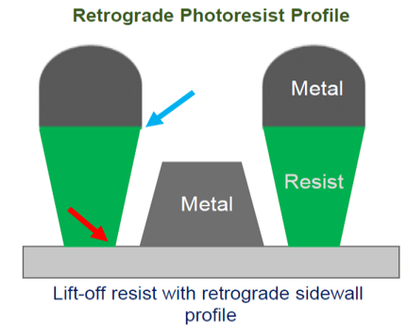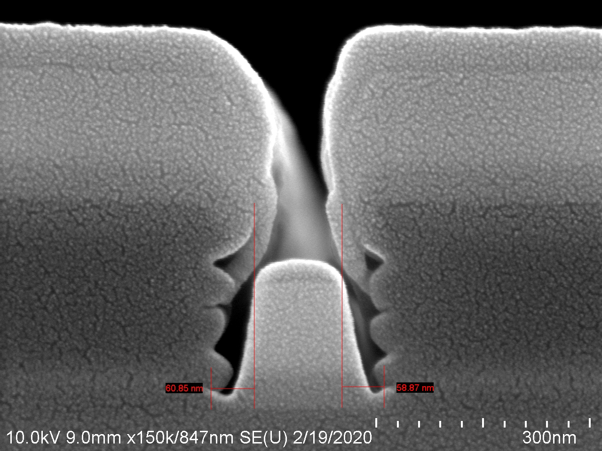
Figure 6: Illustration of ideal retrograde profile for lift-off (left) and SEM image of measurement differences (right)

Given the above, one would expect the average metal trace CD measurement to always be bigger than the post photolithography space measurement. However, this trend only held true for four of the six spacing experiments. The 1:1 L/S for 200 nm CD and 1:5 L/S for 300 nm CD both had post litho CD’s larger than the post lift-off CD’s. Further investigation would have to be made into why these two sets of experiments do not match with theory.

Ultimately, the original goal of this investigation was to determine if the general rule of using a 2:1 photoresist thickness to metal thickness ratio held up at sub 0.5-micron dimensions. All eighteen of the experiments with various percent fills and line/space densities successfully lifted off, indicating the 2:1 rule of thumb does not have to be strictly followed. More emphasis should be placed on ensuring the photoresist has the correct retrograde profile and the metal does not conformally coat the sidewall of the photoresist.

References
[1] “Development of Advanced Lift-Off Processes for 5G
and VCSEL Applications”, CS Mantech 2019.

- G. Wallace, “Electron-beam Lift-off: Collection efficiency & Paths to improvement”, Compound Semiconductor, V. 19, March 2013

Acronyms
- CD – Critical dimension
- SEM – Scanning electron microscope

