Correlation study between molten KOH etching and laboratory X-ray Diffraction Imaging (X-ray topography) in n+ 4H-SiC wafers

David Jacques^{1a}, Vishal Ajit Shah², Richard Bytheway¹, Tamzin Lafford¹, Benjamin Renz², Peter Gammon², Paul Ryan¹, Hrishikesh Das³

¹ Bruker UK Ltd, Bede House, Belmont Business Park, Durham, DH1 1TW, United Kingdom, ² School of Engineering, Power Electronics, University of Warwick, Coventry, CV47AL, United Kingdom, ³ ON Semiconductor, 333 Western Avenue, South Portland, Maine, 04106, USA, ª david.jacques@bruker.com, tel: +44(0)1913324700

Keywords: SiC, KOH, X-Ray Topography, DIC, X-ray Diffraction Imaging

In order to meet the forecast growing demand of n⁺ SiC material, wafer suppliers will need to implement new metrology techniques to allow the detection of crystalline defects and ensure the quality of their materials. Incumbent techniques such as KOH etching have been used for many years but remain very costly as the wafers cannot be processed further. Alternative techniques such as X-ray Diffraction Imaging (X-ray Topography) can be used to detect crystalline defects non-destructively but studies have been limited to synchrotron radiation which cannot be used as an in-line characterization. In this paper, Bruker have used novel equipment (Sensus-CS) to study the correlation between laboratory X-ray Diffraction Imaging and KOH etching performed at the University of Warwick.

Introduction

The demand for n-type SiC wafers for the power electronics sector is expected to grow at a 45% CAGR between 2018 and 2024 [1]. One of the major issues faced by the industry is to be able to ramp up production in order to meet this ever-growing demand for material. In order to solve this, SiC wafer suppliers need to improve their material quality and develop a means to drive down the cost of production.
SiC wafer growth and device manufacturing have improved significantly but as substrate sizes increase the process yields are still low due to the high density of crystalline defects which damage device performance and long-term reliability [2]. Implementing standardised wafer specifications and developing new metrology techniques that are capable of detecting these defects have become critical in order to understand defect creation mechanisms and how to reduce or eliminate them.
Several techniques are currently used in the SiC industry to detect these crystalline defects but they have numerous limitations. In particular, etching using molten KOH comes with the disadvantage of being destructive and time-consuming, preventing the analysed wafers going back into the production line, thus limiting the use of etching to a few wafers per boule.
X-Ray Diffraction Imaging (XRDI; also known as X-ray topography) enables the non-destructive detection of the detrimental micropipes (MP), threading screw dislocations (TSD), threading edge dislocations (TED), stacking faults (SF) and basal plane dislocations (BPD) on all types of SiC wafers thus making it a technique that could replace KOH etching in the long term as a defect metrology and reduce the cost of manufacturing SiC wafers.
Comparisons between molten KOH etch and XRDI have been widely published but are typically limited to synchrotron radiation topography [3,4,5]. In this study, we have measured several n+ 4H-SiC wafers from a wide range of suppliers using X-ray topography in transmission geometry on the Sensus-CS, a commercially available tool from Bruker, to image the crystalline defects present in these wafers. Wafers were then etched using molten KOH at a temperature above 500˚C for several minutes, and optical microscope images of the etch pits were taken using Differential Interference Contrast (DIC) microscopy.

Experimental procedures

Several SiC wafers were purchased from different suppliers. The Table I below provides the list of samples studied in this work.
TABLE I
SILICON CARBIDE SUBSTRATES TESTED IN THIS WORK
Vendor | Substrate type | Size
A | n⁺ Production Grade | 6”
B | n⁺ Test Grade | 6”
C | n⁺ Production Grade | 6”

All samples were measured by X-ray Diffraction Imaging at the Bruker site in Durham (United Kingdom) using the Sensus-CS, a novel equipment to perform transmission X-ray topography. The Sensus-CS enables the measurements of full wafers up to 8” in diameter using a CCD camera with 5.2µm pixel size. A full 6-inch wafer can be measured in about 30 minutes including Bragg condition alignment and correction.
Selective defect etching was performed using a molten KOH bath at the facilities of the University of Warwick (United Kingdom). The molten mixture comprised 99.99% pure KOH pellets, heated to 530˚C. The temperature of the crucible was calibrated without etchant. During the etching process, the temperature was controlled by a thermocouple next to the crucible in an enclosed volume, external to the etch. The etchant atmospheric condition was initially in air, but within its own enclosed volume. Images of the etch pits were obtained using Differential Interference Contrast (DIC) microscopy.

Results

Fig. 1 shows the ($\text{11}\overline{\text{2}}\text{0}$) X-ray topograph of a full 6-inch wafer from Vendor A. This production grade wafer exhibits a wide range of defects. The area highlighted with a red rectangle was the point of focus in the study of the correlation between the XRDI image and the microscopy images after KOH etching.

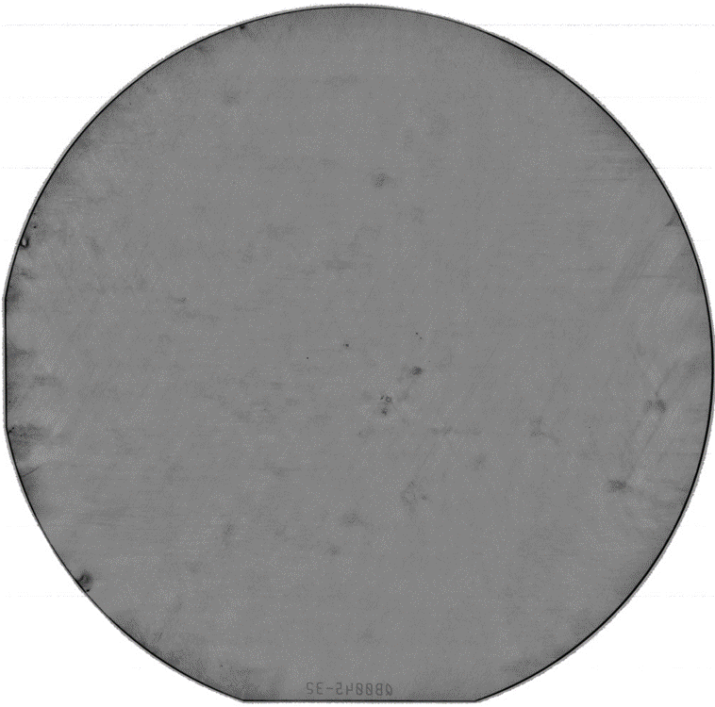
Fig. 1 : Example of a full 6” SiC wafer (Vendor A) as measured on the Sensus-CS XRDI tool from Bruker. ($\text{11}\overline{\text{2}}\text{0}$) X-ray topograph was taken in 30 minutes.

Fig. 2 shows a qualitative comparison between the $(\text{11}\overline{\text{2}}\text{0}\text{)}$ X-ray diffraction image (transmission geometry) and the DIC (Differential Interference Contrast) microscope image taken after KOH etching of the production grade 4H-SiC wafer with an epilayer from Vendor A. Multiple etch pits can be correlated with the strain fields imaged by the Sensus-CS instrument.

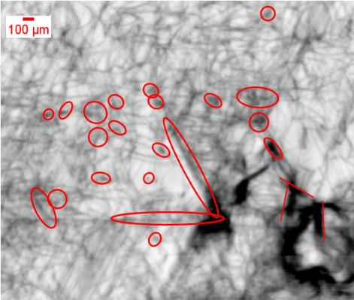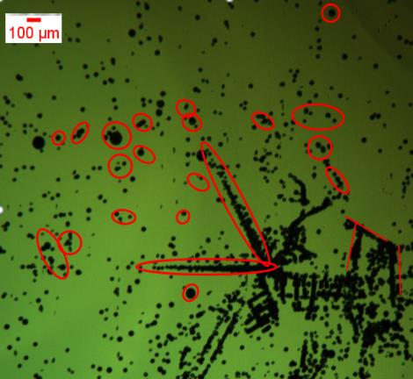
Fig. 2: Comparison of a ($\text{11}\overline{\text{2}}\text{0}$) X-ray diffraction image (top) and the DIC (Differential Interference Contrast) microscope image taken after KOH etch (bottom) showing clear correlation between etch pits and XRDI strain field image for the wafer from Vendor A. A selection of correlated features is indicated.

Fig. 3 and Fig. 4 below both show the qualitative comparison between the $(\text{11}\overline{\text{2}}\text{0)}$ X-ray topograph (transmission geometry) and the DIC (Differential Interference Contrast) microscope image taken after KOH etch of the n⁺ 4H-SiC wafers from Vendors B and C, respectively. As observed for the sample from Vendor A, it is clear that multiple etch pits observed in the microscope images can be associated with strain fields imaged by the X-ray topography Sensus-CS tool.
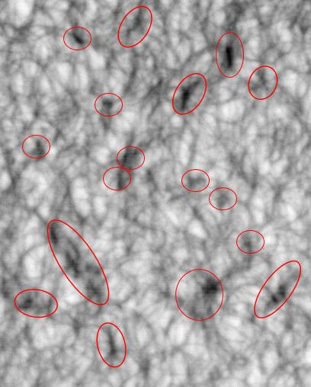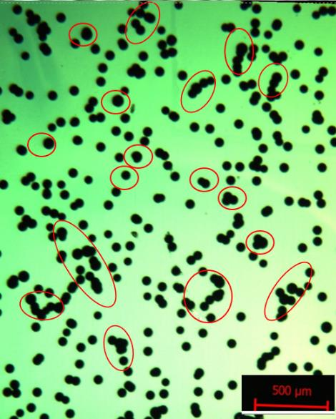
Fig. 3: Comparison of a ($\text{11}\overline{\text{2}}\text{0}$) X-ray topograph (top) and the DIC (Differential Interference Contrast) microscope image taken after KOH etch (bottom) showing clear correlation between etch pits and XRDI strain field image for the Vendor B wafer. A selection of correlated features is indicated.
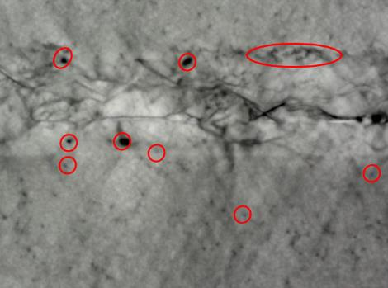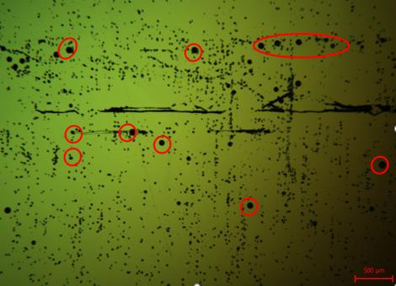
Fig. 4: Comparison of a ($\text{11}\overline{\text{2}}\text{0}$) X-ray topograph (top) and the DIC (Differential Interference Contrast) microscope image taken after KOH etch (bottom) showing clear correlation between etch pits and XRDI strain field image for the Vendor C wafer. A selection of correlated features is indicated.

The measurements of these three different wafers indicate the capability of laboratory X-ray diffraction imaging instruments to detect crystalline defects in Silicon Carbide wafers and that the resolution obtained by the Sensus-CS is sufficient to correlate the images of strain fields from defects with the KOH etch pits.
To enable SiC defectivity to be determined non-destructively in a production environment, image analysis and defect detection using an algorithm developed by Bruker were carried out in order to determine the correlation between types and densities of defects detected by etch pits and by XRDI.
Fig. 5 shows the results of defect detection in the case of the wafer from Vendor A. The analysis using dynamic threshold algorithm allows the detection of the main strain fields observed in the X-ray diffraction image. This analysis can be performed on a full wafer scale allowing the determination of the density of defects and enabling reporting of defect maps in KLARF formats, which is the standard file format for defect metrology in the silicon industry. This method of defect detection can be integrated into a production line in order to help the development of quality materials and improve standardized specifications of SiC wafers in the future.

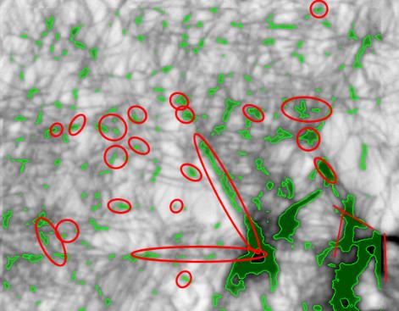
Fig. 5: Comparison of a ($\text{11}\overline{\text{2}}\text{0}$) X-ray topograph (top) and the defect detection algorithm (bottom) developed by Bruker for the Vendor A wafer.

Conclusions

This study shows that laboratory X-ray diffraction imaging instruments such as the Bruker Sensus-CS can be used to detect defects in n⁺ SiC that are detrimental to the performance of the devices grown on these substrates.
The ability to perform XRDI measurements without using synchrotron radiation enables the in-line monitoring of production SiC wafers within a fab environment, and opens the path to improved material quality, yield improvement, and cost reduction by replacing the costly KOH etching process.

Acknowledgements

The authors would like to thank the staff at the University of Warwick that helped perform the KOH etching and the DIC microscopy. Additionally, support and direction in the measurements from Dr. Das at ON Semiconductor is appreciated.

References

[1] Yole Développement, Power SiC report, 2019
[2] Kimoto, T. (2015). Material science and device physics in SiC technology for high-voltage power devices. Japanese Journal of Applied Physics, 54(4), 040103.
[3] Wang, H., Sun, S., Dudley, M., Byrappa, S., Wu, F., Raghothamachar, B., ... & Loboda, M. J. (2013). Quantitative comparison between dislocation densities in offcut 4H-SiC wafers measured using synchrotron X-ray topography and molten KOH etching. Journal of electronic materials, 42(5), 794-798.
[4] Yao, Y., Ishikawa, Y., Sugawara, Y., Sato, K., Danno, K., Suzuki, H., ... & Nishikawa, K. (2013). Correlation between etch pits formed by molten KOH+ Na2O2 etching and dislocation types in heavily doped n+-4H–SiC studied by X-ray topography. Journal of Crystal Growth, 364, 7-10.
[5] Kallinger, B., Polster, S., Berwian, P., Friedrich, J., Müller, G., Danilewsky, A. N., ... & Weber, A. D. (2011). Threading dislocations in n-and p-type 4H–SiC material analyzed by etching and synchrotron X-ray topography. Journal of Crystal Growth, 314(1), 21-29.

Acronyms

g: Diffraction Vector
DIC: Differential Interference Contrast
KLARF: KLA Results File
KOH Etching: Potassium Hydroxide Etching
MP: Micropipes
SiC: Silicon carbide
TSD: Threading Scree dislocations
TED: Threading Edge dislocations
BPD: Basal Plane dislocations
XRDI: X-ray Diffraction Imaging (also known as X-ray Topography)

