**The Characteristics of 6-inch GaN on Si RF HEMT with High Isolation Composited Buffer Layer Design**

Chong Rong Haung1, Chia-Hao Liu 1, Hsiang-Chun Wang1, Hsien-Chin Chiu1, Chih-Tien Chen2, Kuo-Jen Chang2

1 Department of Electronics Engineering, Chang Gung University, Taiwan, R.O.C.

2National Chung-Shan Institute of Science and Technology, Materials and Electro-Optics Research Division, Taoyuan, Taiwan

**TEL: +886-3-2118800 # 3645 Email:** [**hcchiu@mail.cgu.edu.tw**](mailto:hcchiu@mail.cgu.edu.tw)

**Keywords: back barrier (B.B.) layer, conduction band energy, current gain (*f*T) and power gain (*f*max)**

## **Abstract**

**In this study, a 50-nm Al0.05Ga0.95N back barrier (BB) layer was used in an AlGaN/GaN high-electron-mobility transistor between the two-dimensional electron gas channel and Fe-doped/C-doped buffer layers. This BB layer can reduce the channel layer. The BB layer is affected by doped carriers in the buffer layer and the conduction energy band between the channel and the buffer layers. The *I*on/*I*off ratio of the BB device was 3.43 × 105 and the ratio for the device without BB was 1.91 × 103. Lower leakage currents were obtained in the BB device because of the higher conduction energy band. The 0.25-μm gate length device with the BB exhibited a high current gain cutoff frequency of 26.9 GHz and power gain cutoff frequency of 54.7 GHz.**

## Introduction

AlGaN/GaN high-electron-mobility transistors **(**HEMTs) have potential applications in next-generation high-power and microwave devices. GaN exhibits high electron mobility, breakdown voltage, electron saturation speed, and thermal conductivity because of the wide band gap. Therefore, GaN is widely used in high-frequency and high-power devices. Currently, sapphire and Si are popularly used as substrate materials for GaN. However, the large lattice mismatch between GaN buffer and Si (~17 %) [1] substrate or the nitrogen vacancy and oxygen impurity may result in defects and a large number of dislocations in the buffer layer, forming an n-type buffer layer [2].

(a)

(b)

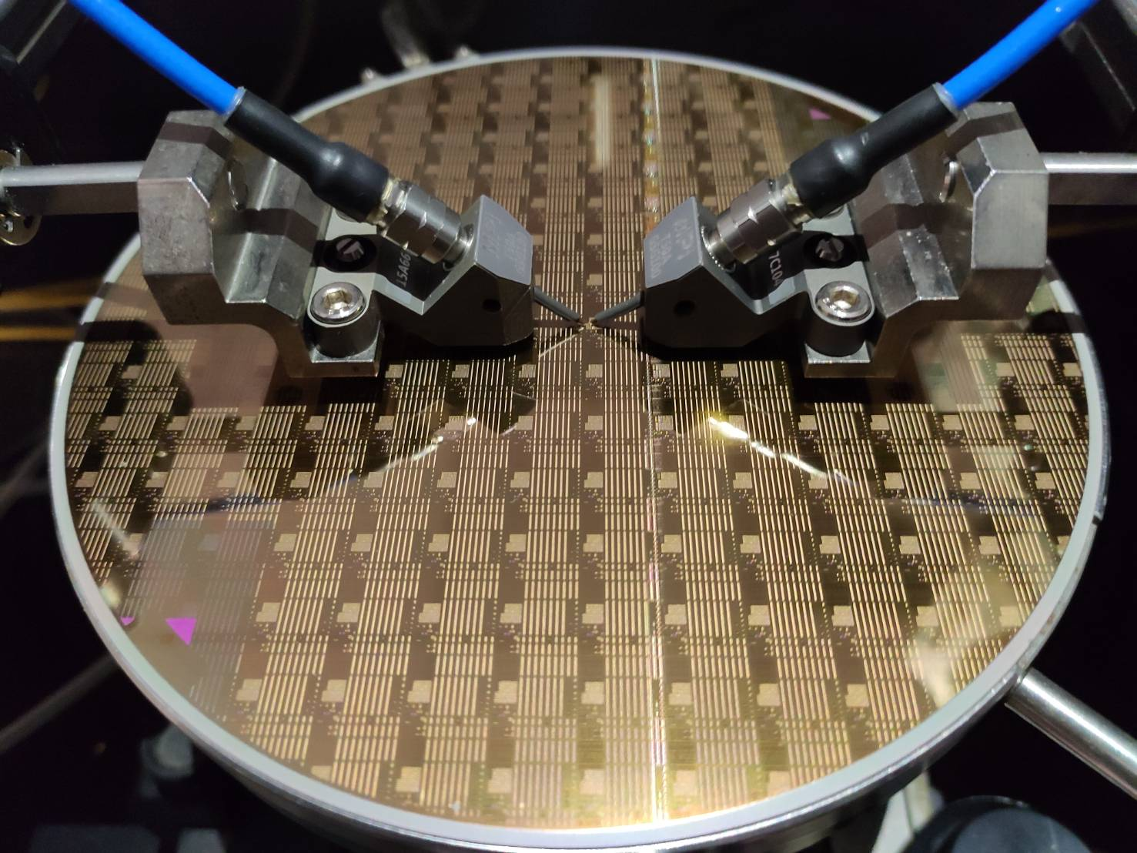

Several studies have presented doped iron (Fe) [3]–[5] or carbon (C) [2], [6]–[8] in the buffer layer to suppress buffer defects. If the doping position is too close to the channel layer or the doping concentration is too strong, it may affect the reliability and electrical properties of the device. Therefore, the doped buffer devices with impurities can result in current collapse (CC), resulting in the buffer traps inducing threshold voltage (*V*th) shifts [9].

When a high drain voltage was applied, some electrons from the two-dimensional electron gas (2DEG) were captured by dislocations or traps in the buffer layer, which caused reliability problems. Therefore, in this study, a back barrier (BB) layer was used to reduce the leakage from electron tunneling into the buffer layer and effectively confine electrons to the 2DEG.

## Experimental procedures

In this study, the AlGaN/GaN HEMT was grown on 6-inch Si substrates through metal organic chemical-vapor deposition (MOCVD) with/without (device A/B) the Fe-doped/C-doped GaN buffer layer. To avoid the diffusion of Fe ions to the channel layer, a 50-nm Al0.05Ga0.95N BB with (device A) and without (device B) was deposited. A 0.5-nm-thick AlN spacer layer was grown between the GaN channel layer and the 20-nm-thick Al0.24Ga0.86N barrier layer. Finally, a 2-nm GaN cap was deposited through MOCVD. The schematic of a heterostructure is presented in Fig. 1(a) and 1(b), which shows the 6-inch GaN on the Si HEMT wafer.

The device was fabricated through mesa isolation by using an inductively coupled plasma system with BCl3, Cl2, and a combination in the first step. Then, a Ti/Al/Ni/Au (25/130/25/80 nm) metal film was deposited through electron beam evaporation (E-gun) for the ohmic contacts (*L*DS = 4 µm). The device was annealed at 875 °C for 35 s in an N2 atmosphere by using a rapid thermal annealing system. The T-shaped gate (LG = 0.25 µm) was defined using electron beam lithography, and the electrode was formed using Ni/Au (50 nm/300 nm). A metal film Ti/Au (25/80 nm) was deposited as the pad for interconnection. Finally, the device was passivated with Si3N4 through plasma-enhanced chemical vapor deposition (PECVD).



Fig. 1. (a) Cross-sectional schematic of GaN on Si HEMT and the (b) 6-inch GaN on the Si HEMT wafer.

To study the effect of AlGaN BB on the performance of the device, we simulated the conduction band energy diagram by using the 1-dimensional Poisson distribution, as depictedin Fig. 2. From the energy band diagram, the peak formed by the BB can effectively suppress the penetration of electrons into the buffer layer.



Fig. 2.  The BB device Conduction band energy simulation through 1-D Poisson distribution.

In order to understand the diffusion and incorporation of Fe into the layer structure of device A, Secondary Ion Mass Spectrometer (SIMS) profiles of Fe, C, Al, Ga and N in the device A are shown in Fig. 3. Additionally, the slower turn-off of the Fe in the buffer layer between AlGaN back barrier and Fe-doped region may be due to memory effects of Fe diffusion associated with high growth temperatures. However, if the excess Fe atoms diffusion into the GaN channel layer behave similarly to defects and thus degrade the device performance. Thus, this study to reduce the Fe atoms diffusion by using an AlGaN back barrier.

In the Fig. 3, the Fe atoms were limited to the AlGaN back barrier because of the lattice constant of AlGaN is lower than that of GaN. Therefore, this structure can reduce the diffusion of Fe or C atoms into the channel layer, thereby improving the reliability of the device.

Fig. 3 SIMS measurement of AlGaN HEMT with BB/Fe-doped/C-doped.

## RESULTS AND DISCUSSION

We measured *I*DS–*V*GS, *I*DS–*V*DS, and *I*GS–*V*GS characteristics of the devices by using Agilent 4142B. Fig. 4 depicts the transfer characteristics (*I*DS–*V*GS) at *V*DS = 10 V with a *V*GS sweep from −6 to 2 V. The saturation current of devices A and B were 1036 and 998.2 mA/mm at *V*GS = 2V and *V*DS = 10 V, respectively. The peak extrinsic transconductance values of the two devices were 323 and 271 mS/mm. As depicted in Fig. 4, because of the high conduction energy band of the AlGaN back barrier layer, the BB can reduce the electron distribution in the 2DEG channel of device A, causing the gate to pinch off more easily. The transfer characteristics of device A showed a higher pinch-off performance than device B. Therefore, to turn off the device, a higher negative threshold voltage was required to be applied to device B (*V*TH = −3.8 V) than to device A (*V*TH = −2.6 V).

Fig. 4 Transfer characteristics (*I*DS–*V*GS) at *VDS* = 10 V with a *VGS* sweep from −6 to 2 V of device A and device B.

To investigate the effect of the BB layer on the off-state of the device, the saturation current data in Fig. 4 were converted into the log-scale. Fig. 5 displays the leakage current curve of gate (*I*GS−*V*GS) and off-state leakage current curve of the drain (log-scale *I*DS–*V*GS). The gate off-state leakage current of devices A and B at *V*GS = −6 V was 6.7 × 10−1 and 2.7 × 10−3, as depicted in Fig. 5. The drain off-state leakage current was 5.9 × 10−3 (with BB) and 5.9 × 10−1 (w/o BB) at *V*GS = −6 V.

This result showed that the addition of a BB layer can effectively reduce the gate leakage current. The BB layer also verifies the data in the simulation diagram of Fig. 2 and the data in Fig. 5. Therefore, satisfactory pinch-off characteristics of device A along with a moderate *I*on/*I*off ratio of 3.43 × 105 can be calculated from the subthreshold swing (SS) of 0.132 V/dec. For the *I*DS*-V*DS and *I*GS*-V*GS of device B, an order of magnitude difference is found, which indicates that there is a phenomenon that the components are not tightly closed when the components without BB are in the Off-State state, showing that BB can have better characteristics and solve the problem that the component is not tightly closed in the Off-State state.

Fig. 5 Off-state leakage current curve of the drain (log-scale *I*DS–*V*GS) and gate (*I*GS–*V*GS).

Fig. 6 depicts the *I*DS*–V*DS characteristics of devices A and B measured at *V*DS ranging from 0 to 10 V with a *V*GS sweep from −6 to 2 V and a step of 1 V. The on-resistances (*R*on) extracted from the devices’ drain to source current in the linear region in Fig. 5 is *R*on_with BB = 3.57 ohm-mm and *R*on_w/o BB = 2.96 ohm-mm.



Fig. 6 Characteristics of the 0.25-μm gate quaternary AlGaN/GaN HEMT *I*DS–*V*DS curve.

For further analysis of the high-frequency characteristics of the device, the S-parameter was measured using an Agilent network analyzer. Fig. 7 displays the measurement conditions of the device with the BB for current gain (*f*T) and power gain (*f*max) at *V*GS = −1.2 V and *V*DS = 10 V. The maximum *f*T and *f*max of the device were 26.9 and 54.7 GHz, respectively. The current gain (*f*T) and power gain (*f*max) at *V*GS= −3 V and *V*DS = 10 V were measured in the device without the BB. The maximum *f*T and *f*max of the device were 23.1 and 43.2 GHz, respectively. This measurement result indicated that the use of an Al0.05Ga0.95N BB improved the pinch-off characteristics of the device, thereby improving the high-frequency characteristics.



Fig. 7 Small-signal characteristics of 0.25-μm gate quaternary AlGaN/GaN HEMT.

When the device is operated in the cutoff region, the bias applied by the gate and drain causes defects in the device, resulting in the capture of electrons. This phenomenon prevents the device from achieving the expected operating current when turned on, thereby generating the CC effect. In 2014, Chen's team used a short-pulse measurement method to explore the CC phenomenon [10]. The pulse I–V was measured using an AMCAD AM241 pulsed system.

As depicted in Fig. 8, the dynamic *R*on ratio measurement conditions of devices A and B were a pulse width of 2 μs and period of 200 μs. In the measurement process, we set a static bias *V*GSQ (quiescent voltage) of the gate and a static bias *V*DSQ of the drain. First, (*V*GSQ = 0 V, *V*DSQ = 0 V) was measured to obtain a steady state current (static) without bias. Then, the static bias voltage of the drain terminal was increased from 0 to 30 V, step was set as 10 V, and the quiescent gate bias was −6 V. The electric field at the drain terminal renders electrons susceptible to defects existing on the surface of the device and below the drain terminal [11].

Therefore, the dynamic *R*on ratio of the devices with and without the AlGaN BB was calculated. The dynamic *R*on ratio improved from 1.86 to 1.52 times at *V*DSQ = 30 V, as indicated in Fig. 8. The AlGaN BB can effectively reduce electrons trapped by buffer layer defects.

Fig. 8 Dynamic *R*on ratio of the two devices.

To understand the uniformity of the 6-inch GaN on the Si HEMT, the histograms of the saturated current (*I*DS_max) are depicted in Fig. 9. TABLE I show the Large signal load-pull measurement was investigated the behavior of RF power performance of 0.25μm T-shaped gate of device A and B at operating frequency at 3.5 GHz. For class-AB operation, a saturated Pout and PAE of device A are 3.19 W/mm and 53.23% with 20V drain and -1.8V gate bias, respectively, about 2.67 W/mm and 45.61% with 20V drain and -3.1V gate bias higher than those in Sample B.



Fig. 9 Histogram of saturated current measured in 45 devices.

TABLE I

RF POWER OUTPUT PERFORMANCE OF TWO DEVICES IN LOAD-PULL MEASUREMENT AT 3.5 GHz.

|  |  |  |  |
| --- | --- | --- | --- |
|  | Gain(dB) | PAE(%) | Pout(W/mm) |
| with BB | 15.82 | 53.23 | 3.19 |
| w/o BB | 14.47 | 45.61 | 2.67 |

## Conclusions

The AlGaN/GaN HEMT with a 50-nm Al0.05Ga0.95N BB increased the conduction band energy in the buffer layer. By using this structure, the pinch-off characteristics of the devices can be improved and the electrons trapped by buffer layer defects can be reduced. Finally, the high-frequency characteristics of the device were analyzed. According to the results, the device with a Al0.05Ga0.95N B/B layer has high potential for use in high-power and high-frequency electronics applications.

## References

1. D. Zhao, and D. Zhao, “Analysis of the growth of GaN epitaxy on silicon,” Journal of Semiconductors, vol.39, No.3, March 2018.
2. J. H. Lee, “High Figure-of-Merit (V2BR/RON) AlGaN/GaN Power HEMT With Periodically C-Doped GaN Buffer and AlGaN Back Barrier,” Journal of the Electron Devices Society, Vol. 6, 2018, pp. 1179-1186.
3. H. Chiu, S. Chen, “AlGaN/GaN Schottky barrier diodes on silicon substrates with various Fe doping concentrations in the buffer layers,” Microelectronics Reliability, vol. 83, 2018, pp. 238-241.
4. Y. Jia, Y. Xu, Senior Member, IEEE, K. Lu, Z. Wen, A. D. Huang, and Y. X. Guo, Fellow, IEEE, “Characterization of Buffer-Related Current Collapse by Buffer Potential Simulation in AlGaN/GaN HEMTs, ”IEEE TRANSACTIONS ON ELECTRON DEVICES, VOL. 65, NO. 8, AUGUST 2018.
5. P. Murugapandiyan, S. Ravimaran, and J. William, “30 nm T-gate enhancement-mode InAlN/AlN/GaN HEMT on SiC substrates for future high power RF applications,” Journal of Semiconductors, Vol. 38, No. 8, August 2017.
6. V. Joshi, S. P. Tiwari, Senior Member, IEEE, and M. Shrivastava, Senior Member, IEEE, “Part I: Physical Insight Into Carbon-Doping-Induced Delayed Avalanche Action in GaN Buffer in AlGaN/GaN HEMTs,” IEEE TRANSACTIONS ON ELECTRON DEVICES, VOL. 66, NO. 1, JANUARY 2019.
7. S. Kumar, P. Gupta, I. Guiney, C. J. Humphreys, S. Raghavan, R. Muralidharan, and D. N. Nath, “Temperature and Bias Dependent Trap Capture Cross Section in AlGaN/GaN HEMT on 6-in Silicon With Carbon-Doped Buffer,” IEEE TRANSACTIONS ON ELECTRON DEVICES, VOL. 64, NO. 12, December 2017.
8. F. S. Choi, J. T. Griffiths, Chris Ren, K. B. Lee, Z. H. Zaidi, P. A. Houston, I. Guiney, C. J. Humphreys, R. A. Oliver, and D. J. Wallis, “Vertical leakage mechanism in GaN on Si high electron mobility transistor buffer layers,” JOURNAL OF APPLIED PHYSICS 124, 055702, March 2018.
9. J. M. Gong, Q. Wang, J. D. Yan, F. Q. Liu, C. Feng, X. L. Wang, Z. G. Wang, “Comparison of GaN/AlGaN/AlN/GaN HEMTs Grown on Sapphire with Fe-Modulation-Doped and Unintentionally Doped GaN Buffer: Material Growth and Device Fabrication,” CHIN. PHYS. LETT. Vol. 33, No. 11, 2016, 117303
10. Z. Tang, S. Huang, X. Tang, B. Li, and K. J. Chen, “Influence of AlN Passivation on Dynamic ON-Resistance and Electric Field Distribution in High-Voltage AlGaN/GaN-on-Si HEMTs,” IEEE Trans. Electron Devices, vol. 61, no. 8, Aug. 2014.
11. J. Joh and J. A. del Alamo, “A Current-Transient Methodology for Trap Analysis for GaN High Electron Mobility Transistors,” IEEE Electron Device Letters, vol. 58, no. 1, Jan. 2011.