RF Harmonic Distortion of Coplanar Waveguides on GaN-on-Si and GaN-on-SiC
Substrates

Lina Cao¹, Hansheng Ye¹, Jingshan Wang¹, Hugues Marchand², Wayne Johnson² and Patrick Fay¹

¹Department of Electrical Engineering, University of Notre Dame, Notre Dame, IN 46556, USA
²IQE, 200 John Hancock Rd., Taunton, MA 02780, USA
E-mail:pfay@nd.edu

Keywords: Coplanar waveguide, harmonic distortion, large-signal measurements, GaN-on-Si, GaN-on-SiC

Abstract
The RF harmonic distortion of coplanar waveguides (CPWs) fabricated on AlGaN/GaN HEMT heterostructures grown on both high-resistivity Si (GaN-on-Si) and semi-insulating SiC (GaN-on-SiC) substrates is reported for the first time. The loss performance and the nonlinear behavior of the CPW lines were experimentally characterized using both small- and large-signal measurements. From 100 MHz to 20 GHz, low loss (less than 0.3 dB/mm at 20 GHz) was achieved; the attenuation of CPW lines on the GaN-on-Si substrate is ~0.05 dB/mm higher than that of the GaN-on-SiC substrate. The harmonic distortion levels of the GaN-on-Si substrate and GaN-on-SiC were also evaluated experimentally; in contrast to the small-signal loss, more significant differences in second- and third-order nonlinearity, and thus intermodulation, are observed between Si and SiC substrates. Large-signal characterization of the GaN-on-Si substrate was carried out over temperature from 25 °C to 175 °C. Due to increases in substrate conductivity with temperature, the harmonic distortion levels are found to increase significantly at temperatures above 75 °C.

Introduction

Wide bandgap III-N devices are promising candidates for high power and high frequency circuit applications. Compared to the high cost and limited wafer diameter of SiC substrates, Si offers a potentially attractive alternative due to its low cost and availability in large wafer sizes. However, with the advent of 5G and other advanced communication protocols, linearity is becoming an increasingly important consideration. Significant improvements in GaN-based device linearity have been reported [1], but linearity can also be impacted by on-chip interconnects. For best system performance, high-performance RF and microwave MMICs require low-loss transmission lines with high linearity. In this work, we characterize the linear and nonlinear behavior of coplanar waveguides (CPWs) fabricated on AlGaN/GaN HEMT heterostructures grown on high-resistivity Si substrates (GaN-on-Si), and compare with reference lines on nominally identical heterostructures on semi-insulating SiC substrates (GaN-on-SiC). A comparison of the RF harmonic
distortion of CPWs on GaN-on-Si and GaN-on-SiC substrates is reported for the first time, and the large-signal performance of CPWs on the GaN-on-Si substrate over temperature from 25 °C to 175 °C are also investigated.
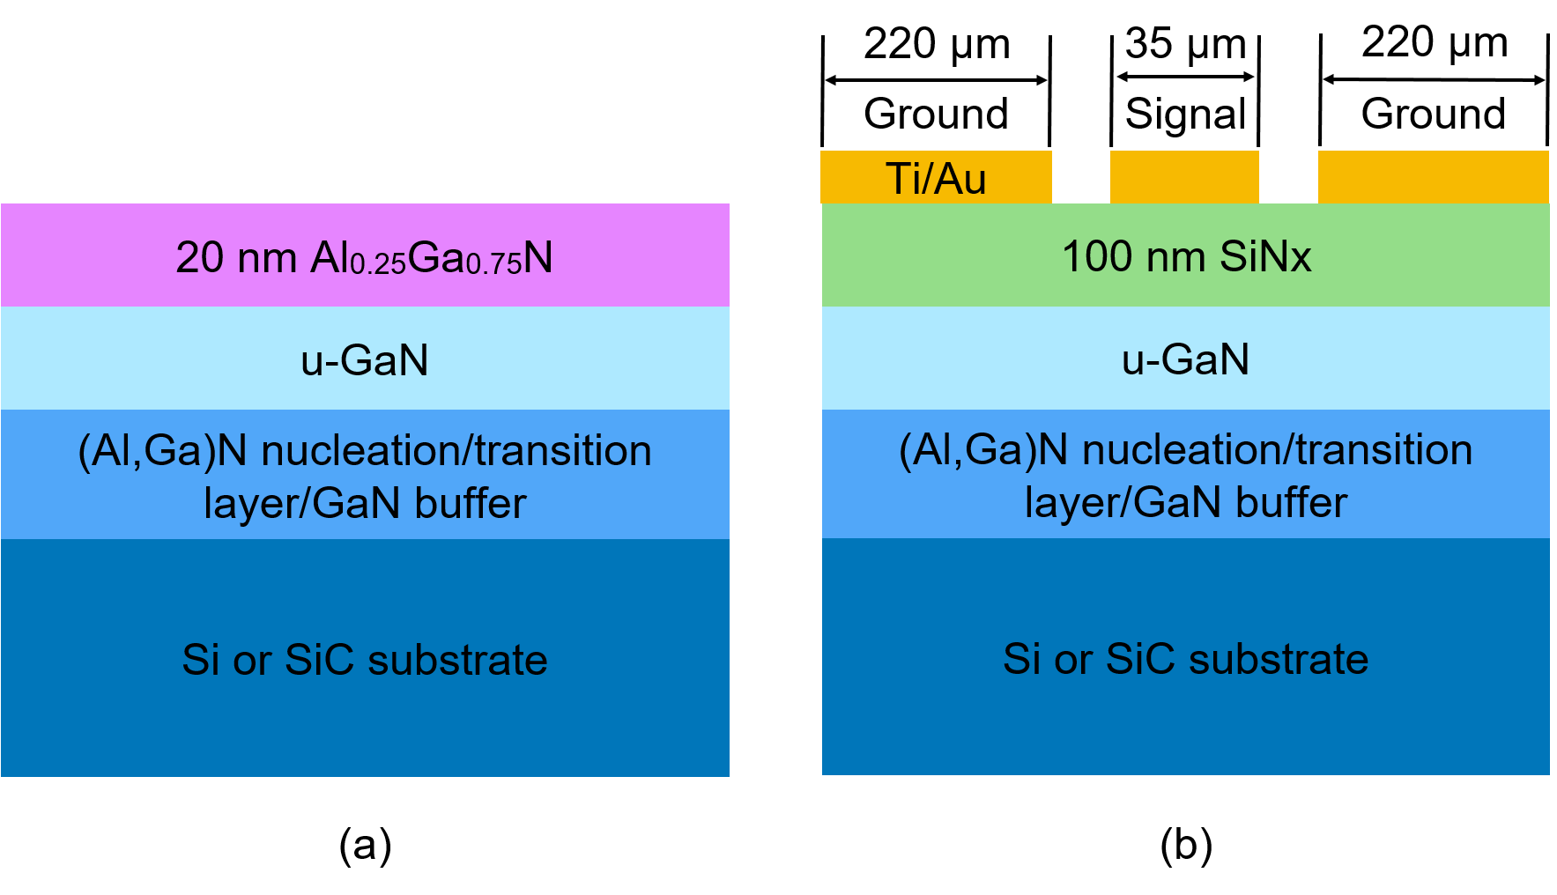
Fig. 1. Cross section of the GaN-on-Si and GaN-on-SiC wafers: (a) as received; (b) after CPW fabrication process. All dimensions are in µm.

Device structure and fabrication

The CPWs were fabricated on commercially available AlGaN/GaN HEMT wafers grown by IQE plc. The cross section of the GaN-on-Si and GaN-on-SiC wafers is shown in Fig. 1(a). For the GaN-on-Si wafers, the epitaxial layers were grown on 100 mm diameter float-zone refined (111) high resistivity silicon substrates with a bulk resistivity of 5000 Ω·cm and a thickness of 625 µm. The epitaxial structure (from top to bottom) consists of a 20 nm Al_{0.25}Ga_{0.75}N barrier layer, an 800 nm undoped GaN channel, followed by a carbon doped GaN buffer layer. An (Al,Ga)N nucleation/transition layer was used between the Si and III-N epitaxial layers. The GaN-on-SiC wafers were grown on 100 mm diameter semi-insulating SiC substrates (10⁵ Ω·cm) with a thickness of 500 µm. The active device epitaxial layer structures on both substrates were nominally identical; only the buffer and nucleation layers were changed to optimize material quality on each substrate [2], [3].

Fig. 1(b) shows the cross section of the CPWs. To mimic on-chip transmission lines in a mesa isolated process flow, the top 100 nm of the heterostructure was etched away and then a 100 nm thick SiN_{x} layer was deposited by PECVD. The CPW dimensions are designed for a characteristic impedance of 50 Ω. The center signal conductor width and ground plane conductor width are 35 µm and 220 µm for both GaN-on-Si and GaN-on-SiC substrates. The gap spacing between signal
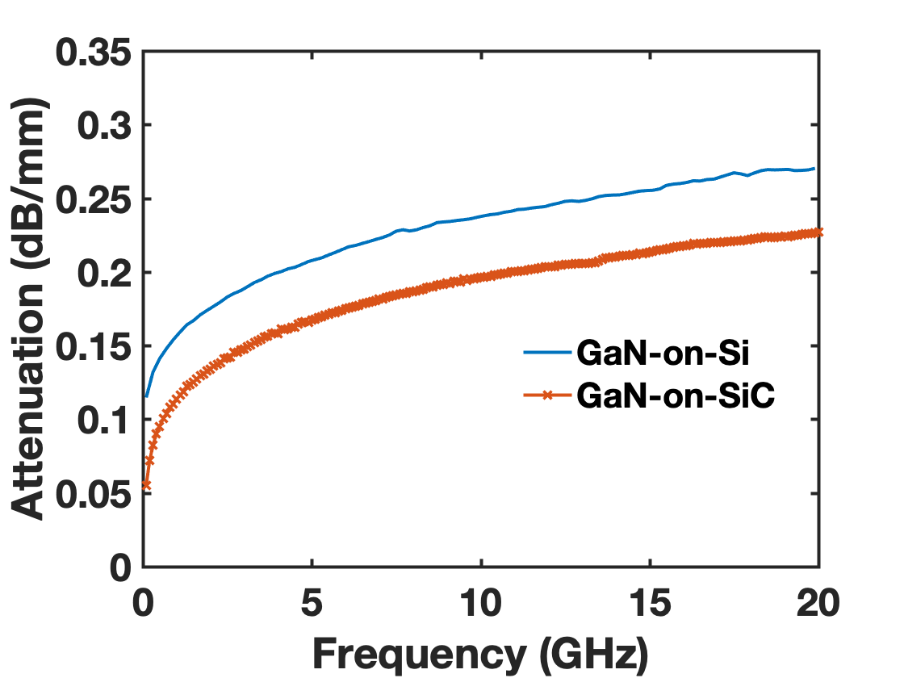
Fig. 2. CPW line loss comparison between GaN-on-Si and GaN-on-SiC substrates.
conductor and ground plane conductor is 20 µm for GaN-on-Si substrate and 15 µm for GaN-on-SiC substrate due to its lower permittivity. The CPW metalization consisted of a Ti (20 nm) / Au (750 nm) bilayer, and no metalization was used on the backside of the wafers. The length of the CPW transmission lines is 4 mm. The fabrication process used here
is similar to that reported in [3].

Rf losses and Harmonic Distortion

The CPWs’ small-signal and large-signal performance was assessed by taking on-wafer measurements. The attenuation constant of the CPW is extracted from the measured small-signal S-parameters using the method in [3]. Figure 2 compares the loss of CPW lines on GaN-on-Si and GaN-on-SiC substrates. For the frequency range from 0.1 to 20 GHz, both CPWs present extremely low loss (less than 0.3 dB/mm at 20 GHz). The attenuation of GaN-on-Si substrate is only ~ 0.05 dB/mm higher than that of GaN-on-SiC substrate, indicating potential for high performance GaN-on-Si MMICs.

For the large-signal measurements, a Keysight PNA-X provides the signal source and also acts as a spectrum analyzer [4], as shown in Fig. 3. A single tone (f_{in}) with a fundamental frequency of 900 MHz is injected into one end of the CPW lines, and the power of the harmonic frequencies is measured at the opposite end of the CPW. The fundamental power is measured at the network analyzer’s Port 2 and the second and third harmonic power levels are measured at Port 4. Through careful selection of the power amplifier and filters, a harmonic distortion setup has been implemented capable of detecting harmonic levels of a 900 MHz signal as low as -110 dBm for a maximum input power of 30 dBm. Figure 3(a) and (b) shows the measured second harmonic and third harmonic components at the output port of the CPW lines versus the fundamental output power on GaN-on-Si and GaN-on-SiC substrates. As shown in Fig. 3, the CPWs on SiC substrates exhibit lower second and third order distortion than the Si-based lines. From the data in Fig. 3, we estimate the OIP3 of the GaN-on-Si and GaN-on-SiC CPWs is 55 dBm and 72 dBm, respectively, as inferred from the harmonic levels.
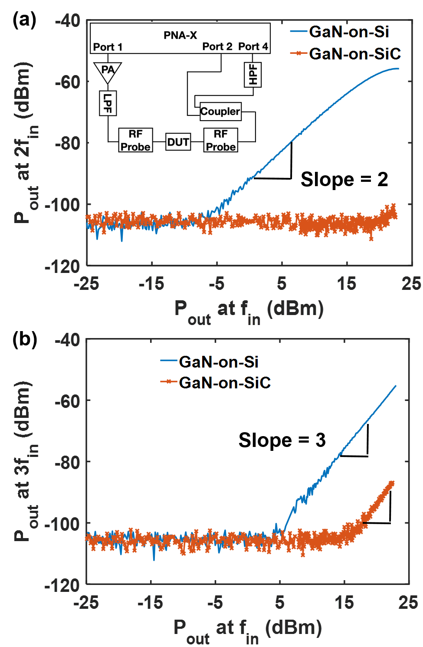
Fig. 3. Measured (a) second- and (b) third-order harmonic distortion components of 4-mm-long CPW lines on GaN-on-Si and GaN-on-SiC substrates. The fundamental frequency is 900 MHz, the second harmonic is at 1800 MHz and the third harmonic is at 2700 MHz. Inset: block diagram of on-wafer large-signal measurement setup.

Figure 4 shows the measured harmonic distortion levels of a 4-mm-long CPW line on GaN-on-Si substrate as a function of input power and temperature, for an input frequency of 900 MHz. As can be seen in Fig. 4(a) and (b), the GaN-on-Si substrate becomes less linear as the temperature is increased, with the most significant change occurring above 75 °C. The second harmonic component increases by approximately 15 dB as the temperature is raised from 25 °C to 175 °C for an input power of 20 dBm. This can be understood physically by noting that increased temperature also increases the thermal generation of free carriers in the Si substrate, leading to higher substrate conductivity. As a result of the increased substrate conductivity, there is more significant RF substrate current flowing through nonlinear substrate (and substrate/epitaxial interface), leading to higher signal distortion products. For the Si substrates used here, the effective doping concentration is approximately 3~6×10¹¹ cm⁻³ (n-type). When the temperature is increased to 75 °C, the thermal generation rate is sufficient for the Si substrate to become intrinsic. Further increases in the temperature result in significant additional decreases in substrate resistivity when the temperature is increased above 75 °C.
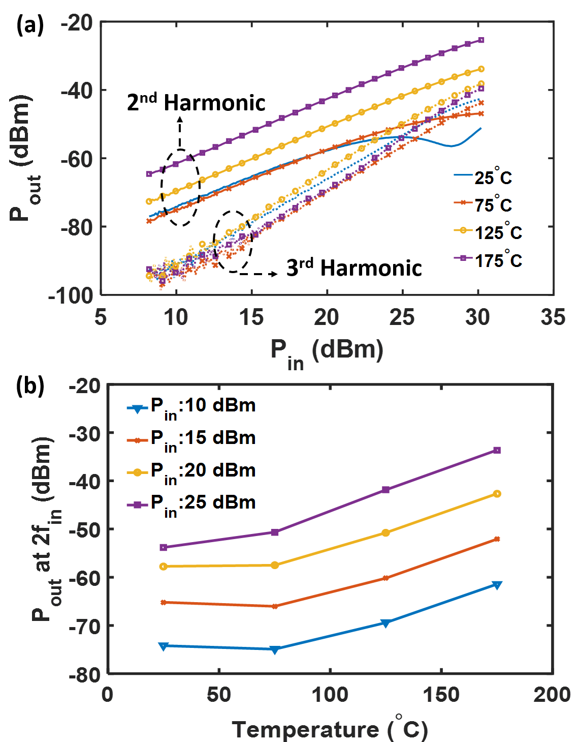
Fig. 4. Measured harmonic distortion levels of a 4-mm-long CPW line on GaN-on-Si substrate as a function of input power and temperature: (a) 2nd (solid line) and 3rd
(dash line) harmonic levels vs. input power at different temperatures; (b) 2nd harmonic levels vs. temperature with different input power.

The harmonic distortion levels of the GaN-on-Si substrate are much larger (~30 dB at power levels ≥ 15 dBm) than those of the GaN-on-SiC substrate despite the fact that the linear attenuation difference is within 0.05 dB/mm. This highlights the importance of considering both loss and harmonic distortion in interconnect evaluation. The difference between GaN-on-Si and GaN-on-SiC is likely due to the dynamic modulation of the conductive interfacial layer at the GaN/Si interface [5], [6].

Conclusions

The linear and nonlinear behavior of CPWs fabricated on GaN-on-Si and GaN-on-SiC substrates is experimentally characterized using small- and large-signal measurements. From 100 MHz to 20 GHz, both substrates achieve loss below 0.3 dB/mm at 20 GHz; the attenuation of the GaN-on-Si substrate is ~0.05 dB/mm higher than that of GaN-on-SiC substrate. However, the nonlinear characteristics of CPWs on the two substrate types are significantly different. From on-wafer measurements, the OIP3 of the GaN-on-Si and GaN-on-SiC substrate is 55 dBm and 72 dBm, respectively. In addition, the harmonic distortion levels of the GaN-on-Si substrate increases significantly over 75 °C, due to the decrease of the resistivity of the Si substrate.

Acknowledgements

This work was supported in part by the Office of Naval Research, grant N00014-1-16-2850, Paul Maki program manager, and the National Science Foundation, grant ECCS-1509188, Jenshan Lin program manager

References

[1] J. S. Moon et al., “Novel High-speed Linear GaN Technology with High Efficiency,” in 2019 IEEE IMS, Jun 2019, pp. 1130–1132.
[2] U. K. Mishra et al., “GaN-Based RF Power Devices and Amplifiers,” Proc. IEEE, vol. 96, no. 2, pp. 287–305, Feb. 2008.
[3] L. Cao et al., “Coplanar Waveguide Performance Comparison of GaN-on-Si and GaN-on-SiC Substrates,” in 2017 IEEE CSICS, Oct 2017, pp. 1–4.
[4] M. Rack et al., “Small- and Large-signal Performance up to 175 °C of Low-Cost Porous Silicon Substrate for RF Applications,” IEEE Trans. Electron Devices, vol. 65, no. 5, pp. 1887–1895, 2018.
[5] L. Cao et al., “Low-Loss Coplanar Waveguides on GaN-on-Si Substrates,” IEEE Microw. Wireless Compon. Lett., vol. 28, no. 10, pp. 861–863, Oct 2018.
[6] D. Marti et al., “110 GHz Characterization of Coplanar Waveguides on GaN-on-Si Substrates,” Appl. Phys. Express, vol. 3, no. 12, p. 124101, 2010.

Acronyms

CPW: Coplanar Waveguide
HEMT: High Electron Mobility Transistor
MMIC: Monolithic Microwave Integrated Circuit
OIP3: Output Third Order Intercept Point
PECVD: Plasma Enhanced Chemical Vapor Deposition

