Methods of Improving and Optimizing Isolation Implantation
for Stacked HBT on HEMT Epitaxial GaAs Semiconductor Devices

Sasha Kurkcuoglu and Shiban Tiku

Skyworks Solutions, Inc., 2427 W. Hillcrest Drive, Newbury Park, CA 91320
Email: sasha.kurkcuoglu@skyworksinc.com

Keywords: Isolation Implant, Polyenergetic Implant, GaAs, HBT, HEMT, Helium, Nitrogen, Epitaxial.

Abstract:

The issues of achieving good isolation and low leakage for complex integrated circuits such as stacked HBT on HEMT (BiHEMT) epitaxial GaAs semiconductor devices are described in this paper. The need for achieving a balance between short cycle time and optimum performance by use of appropriate ion implant species and schedules (energy/dose) are discussed in detail.

Introduction:

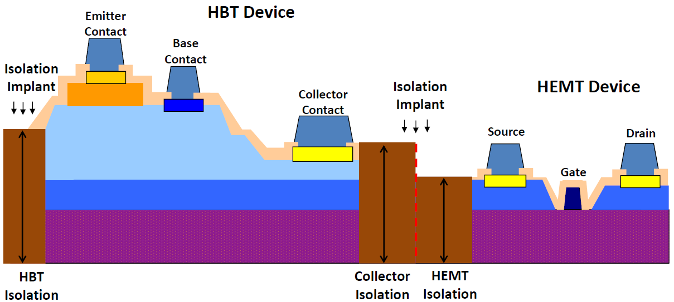
Isolation Ion Implantation (III) is the preferred method in III-V compound semiconductor processing to isolate active devices from adjacent devices and to restrict unwanted current flow, also referred to as leakage current, between those conducting regions by selectively creating a highly resistive layer throughout the epitaxial structure [1]. Isolation implant reduces the number of processing steps significantly by removing or reducing the need for isolation by mesa etching which in turn allows for better topology and heat dissipation [2]. Depending on the technique of III-V compound semiconductor processing, the depth of the required ion implantation can vary; if HEMT type devices are grown on top of a semi-insulating substrate, the implant depth required can be shallow. However, for HBT devices that are grown epitaxially, and have mesa structures, the implantation may need to target much greater depths depending on the extent of isolation achieved by etching [2]. The purpose of this paper is to explore methods of improving and optimizing isolation implantation for GaAs semiconductor devices. This paper will focus on epitaxially grown devices that require both shallow and deep depths of ion bombardment to effectively isolate devices.

Approach:

For device isolation, both light and heavy ions can be used to attain a needed isolation resistance; however, heavy ions require higher energy ion implanters (MeV) and elevated temperature annealing (above 300°C) for activation which becomes problematic for GaAs based device fabrication due to the temperature sensitivity and thermal budget of the substrate and the dangers of encountering diffusion or outgassing which can cause issues with device performance. Light ions, such as He+, are able to activate at room temperature removing the need for an annealing step post-implantation [3, 4]. When implanting with such ions for isolation, the implantation-induced defects of crystal structures corresponds to deep midgap levels and can serve as traps for free charge carriers. The Fermi level in the material becomes pinned in the middle of the bandgap which implies high resistivity and causes the implanted material to become semi-insulating [4]. For BiHEMT devices that have different devices at different epitaxial depths (Figure 1), a near-uniform defect distribution is required through the entire epitaxial depth to achieve the needed device isolation [5].
Fig. 1: Schematic cross-section of a stacked HBT on HEMT (BiHEMT) device on the same epitaxial substrate, showing the variation in implant depth required to effectively isolate all devices.

Due to the complex topology of BiHEMT devices, a single step implantation will not be sufficient to isolate all active regions from each other as there are devices in shallow regions and deep regions of the epitaxial layers. This brings the need for polyenergetic implantation, which refers to the selection of multiple energy set-points implanted sequentially for isolation creating a superposition of the energy specific defect distributions along the epitaxial layer [5]. This introduces more complexity and cycle time for device fabrication in the ion implantation module, but is needed to properly create an isolated region throughout the epitaxial depth. The key is to select the correct ion species
with optimized schedules (energy/dose) which will further be discussed in the next section.

Experimental:

Polyenergetic Isolation Implant

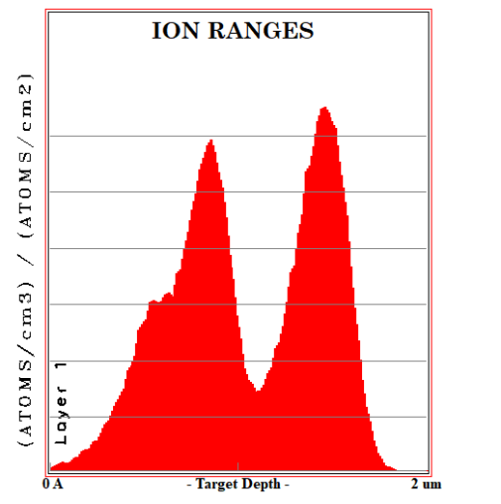
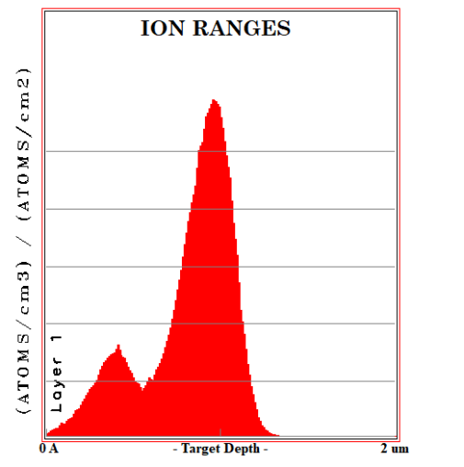
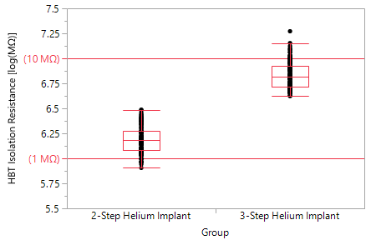
When developing a polyenergetic isolation implant sequence, the first step is to calculate the required energies for the selected species. Stopping and Range In Matter (SRIM) is used to simulate different energies and energy combinations to determine what multi-step implant sequence will result in the most uniform super-positioned ion distribution [6]. In this experiment, to be able to target extreme epitaxial depths, Helium was chosen due to the nature of the element. Helium being a light ion tends to leave tracks characterized by relatively small amounts of damage. The ion slows down initially mainly due to the electronic stopping processes with little displacement damage, until eventually nuclear stopping becomes dominant at the end of the range [4]. For experimental purposes, initially, a three-step Helium Ion Implantation flow was created to set a base-line for device isolation resistance at varied depths. By having three separate steps, there is an increase in cycle time which will increase cost of device fabrication; however, the quality of the isolation will be noticeably optimized which is a trade-off that must be considered.
Fig. 3: Ion Ranges of a three-step Helium Ion Implant sequence.

Fig. 2: Ion Ranges of a two-step Helium Ion Implant sequence.

Next, a two-step polyenergetic Helium Ion implantation flow was created targeting both the shallow HEMT region and the deeper HBT region, but not reaching as deep of a depth observed in the 3-step ion implantation flow (Figure 2, 3). For the shallow HEMT device, a very small decrease in isolation resistance was observed; however, for the HBT device a much larger decrease in isolation was observed, almost an order of magnitude difference due to the fact that the ions did not penetrate as deep of a depth (Figure 4, 5). Depending on the device requirements and specifications, this difference in isolation resistance may cause issues with leakage current. If the device layout rules demand larger spacing between devices, and the circuit can handle slightly lower isolation resistance at those depths, reducing the implantation sequence from a three to a two-step sequence will greatly reduce cycle time and thus reduce device cost with the tradeoff of a larger die.

Fig. 4: HBT Isolation Resistance of two vs. three-step Helium implant sequence.
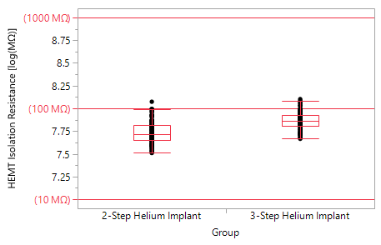

Fig. 5: HEMT Isolation Resistance of two vs. three-step Helium implant sequence.

Multi-Species Polyenergetic Isolation Implant

Implant isolation can also be accomplished by the utilization of Nitrogen ions which creates deep states in GaAs [7]; however, since N+ is a heavier ion compared to He+ the characteristics of the implant vary slightly. Heavier ions create damage clusters along their path. These ions undergo a relatively higher degree of nuclear stopping compared to lighter ions, displacing target atoms right from the surface inward [4]. At too low of a dose, the isolation implant does not sufficiently reduce the carrier concentration allowing for free carriers to conduct. As the dose is increased, the carrier concentration will begin to drop meaning an increase in isolation resistance; however, when the damage density due to isolation implant becomes higher than optimal, isolation resistance can start to decrease due to the effect of hopping conductance: a characteristic in which trapped carriers hop from one damage site to another i.e. intrastate transitions between neighboring defect sites [1, 5]. This infers that isolation resistance as a function of dose is not monotonic and depends on the initial carrier concentration [2]. When increasing dose, the isolation resistance will increase until reaching a plateau corresponding to the electrical carrier trapping saturation or a threshold at which an increase in dose will not increase isolation resistance [2]. Further increasing the dose will cause the resistivity to drop slowly until a certain dose from which hopping conduction becomes the prevalent mechanism. This is why dose selection is very critical when developing an isolation implant regime. Ion doses from all implantation steps superposition on one another, so the more steps there are in the process, the more critical the dose selection becomes as saturation can occur and may be marginally close to the point where hopping conduction takes over. Additionally, when combining different species for isolation, the doses may not sum in the same manner as if one of those species were being used, so characterizing multi-species implant can become very challenging and experimentation is required.

To improve HEMT isolation, which requires very shallow isolation, on a BiHEMT device, a two-step polyenergetic Helium implant sequence was compared with a multi-species polyenergetic Helium ion followed by Nitrogen ion isolation implant sequence. The Helium implant sequences were the same for all samples; select samples were implanted with an additional kiss of Nitrogen at different doses to determine if a very shallow Nitrogen ion implant can improve HEMT isolation. Figure 6 illustrates the additional Nitrogen implant step showing a small peak at the surface which can help create an additional resistive layer to reduce leakage current; however, dose selection is quite critical as the mechanism of the implant can change drastically if dose is not optimally chosen.

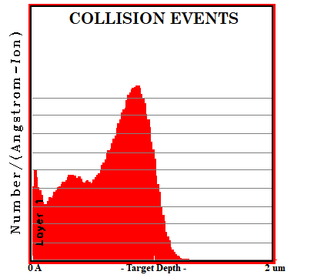
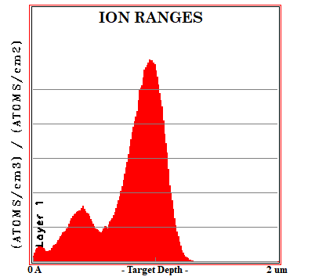
Fig. 6: Collision Events and Ion Ranges of Ultra-Low energy Nitrogen Implant followed by two-step polyenergetic Helium Ion Implant.

Dose Optimization – Effects of Hopping Conduction

Different doses of Nitrogen were selected to determine the point at which hopping conduction occurs which will decrease isolation resistance and increase leakage current. As expected, when implanted with too high of a dose, isolation resistance dropped, and leakage current skyrocketed (Figure 7). This is because the isolated region switched from a trap for carriers to a hopping conduction mechanism allowing for current to flow.

Interestingly, when the dose was dropped, the leakage current greatly improved compared to only implanting with a 2-step polyenergetic Helium implantation sequence (Figure 8). This proves that Nitrogen can be utilized to improve isolation for shallow HEMT devices while also allowing for HBT device isolation with the use of Helium.

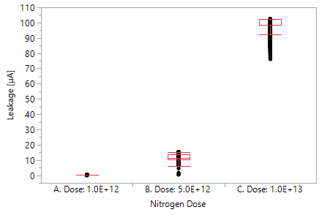
Fig. 7: Leakage current of a multi-species polyenergetic Helium ion implant followed by a Nitrogen ion implant step showing the effects of increasing Nitrogen dose while keeping the Helium Implant sequence constant.

Fig. 8: Leakage current of a two-step polyenergetic Helium implant sequence (labeled Helium Implant) compared with a multi-species polyenergetic Helium ion followed by Nitrogen ion implant sequence (labeled Nitrogen Implant).

Conclusion:

Dose optimization is very critical for achieving good isolation resistance in integrated circuits. A larger dose is not always better, as it can cause marginality due to the hopping conduction phenomena. It is very important during the development phase to perform simulations and experiment with many different doses and determine at which dose saturation occurs and at which dose hopping conduction starts to occur. It is best practice to implant at a dose below the value at which saturation occurs, or in other words, not marginally close to the point at which hopping conduction occurs in the case that there is a tool shift, fab to fab variation, or a tool mis-calibration which results in a dose shift. Light species, like Helium and Hydrogen, have limitations in isolating highly doped cap epitaxial layers, like the ones used for FET/HEMT type devices. In this case, the use of Nitrogen ion implant makes a significant improvement in leakage current; however, the effects of hopping conduction become even more dramatic. In conclusion, the combined use of Nitrogen and Helium ion implant at different energies and doses, a polyenergetic multi-species sequential implant technique, must be optimized very carefully for the full potential of device isolation and leakage minimization.

Acknowledgments:
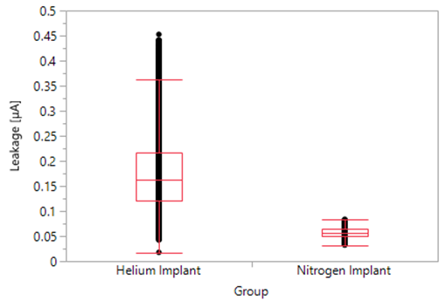
We would like to thank the Skyworks Solutions team including Lam Luu and Ravi Ramanathan for their support, discussions, expertise, and knowledge in regards to the isolation implant experiments performed. We would also like to acknowledge John Schuur and Doug Gonelli from INNOViON Corporation for their support with the Nitrogen Ion Implantation experiments.

References:

[1] S.J. Pearton. Ion implantation doping and isolation of III–V semiconductors, Nuclear Instruments and Methods in Physics Research Section B: Beam Interactions with Materials and Atoms, Volumes 59–60, Part 2, 1991, Pages 970-977.
[2] Maciej Artur Kozubal, Anna Szerling, Kamil Kosiel, Marcin Myśliwiec, Karolina Pągowska, Rafał Jakieła, Renata Kruszka, Marek Guziewicz, Adam Barcz, Electrical isolation of GaAs and AlGaAs/GaAs Quantum Cascade Lasers by deep hydrogen implantation, Materials Science in Semiconductor Processing, Volume 74, 2018, Pages 88-97.
[3] S. Tiku, D. Biswas. III-V Integrated Circuit Fabrication Technology. Pan Stanford Publishing, 2016, 306-311.
[4] S.J. Pearton, Ion implantation for isolation of III-V semiconductors, Materials Science Reports, Volume 4, Issue 6, 1990, Pages 313-363.
[5] F.F. Komarov, A.S. Kamyshan, A.M. Mironov, A.E. Lagutin, I.S. Martynov, Formation of device isolation in GaAs with polyenergetic ion implantation, Vacuum, Volume 63, Issue 4, 2001, Pages 577-579.
[6] SRIM, Stopping and Range of Ions in Materials, www.SRIM.org.
[7] Niketa Sharma, Sandeep Kumar Dhakad, C. Periasamy, Nidhi Chaturvedi, Refined isolation techniques for GaN-based high electron mobility transistors, Materials Science in Semiconductor Processing, Volume 87, 2018, Pages 195-201.

