Reducing Lens Heating Effects on High Mileage Projection Lenses Used in Optical Lithography
Steven D. Mayer
Skyworks Solutions, Inc., 2427 W. Hillcrest Drive, Newbury Park, CA 91320
Email: Steven.Mayer@skyworksinc.com

Keywords: Photolithography, Steppers, Optics, Lens Heating, CD Slimming

Abstract

The demand for low cost lithography solutions in modern manufacturing has led to extended lifetime of optical lithography equipment. Use of steppers with "high mileage" has shown that heating of the projection lens with high energy input severely degrades the aerial image. This paper discusses the lens heating effects [1] and discusses the common solutions to address this issue. This paper also demonstrates a practical solution used in high volume manufacturing environment.

This paper will discuss how absorption increases with the summation of energy through a projection lens and its effect on lens aberrations. Classical techniques to reduce lens heating effects will be presented. Low NA, low Sigma resist process, targeted for lift-off applications, is used to study its effect on lens heating. Solution for high transmittance, high dose application will be presented with theory, data and images.

INTRODUCTION

In photolithography, a stepper lens delivers radiation repeatedly to resist coated substrates and it is controlled by either a shutter or laser pulses. Lenses are designed to transmit most of that radiation through. The energy absorbed by the lens is converted to heat. The amount of energy absorbed by the lens depends on the absorption of the materials used, number of elements, thickness and diameter of the elements and optical design. The amount of heat retained by the lens during exposure is determined by illuminator intensity, dimensions of the reticle, % clear area of the reticle (i.e. reticle transmittance) and shutter open and closed durations. A relative measurement of lens heating by a masking layer can be derived as follows.

Lens Heating Potential = % reticle transmittance x dose

Some examples of lens heating potential are listed in table 1.

Table1: Lens-heating potential by layer
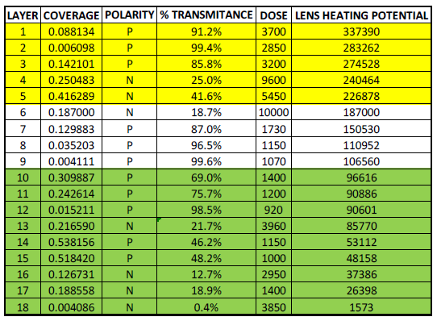

LENS HEATING

As a lens ages due to repeated transfer of energy, physical changes to glass and optical elements increase their absorption. The rate of absorption through any lens increases, as one would expect, with the number of exposures and with the amount of energy pumped through it. So what happens as the amount of absorbed energy heats the lens up sufficiently to change the propagation of radiation through it? In case of glass elements, they expand and, in doing so, change their curvature. The change in curvature changes the lens aberrations (most notably spherical aberration). The change in aberrations can lead to CD “slimming” in resist lines or spaces as the lens heats up (Figure 1). In this case of high potential lens heating layer, CD of a space feature gets smaller as the amount of heat pumped into the lens exceeds its ability to dissipate it.

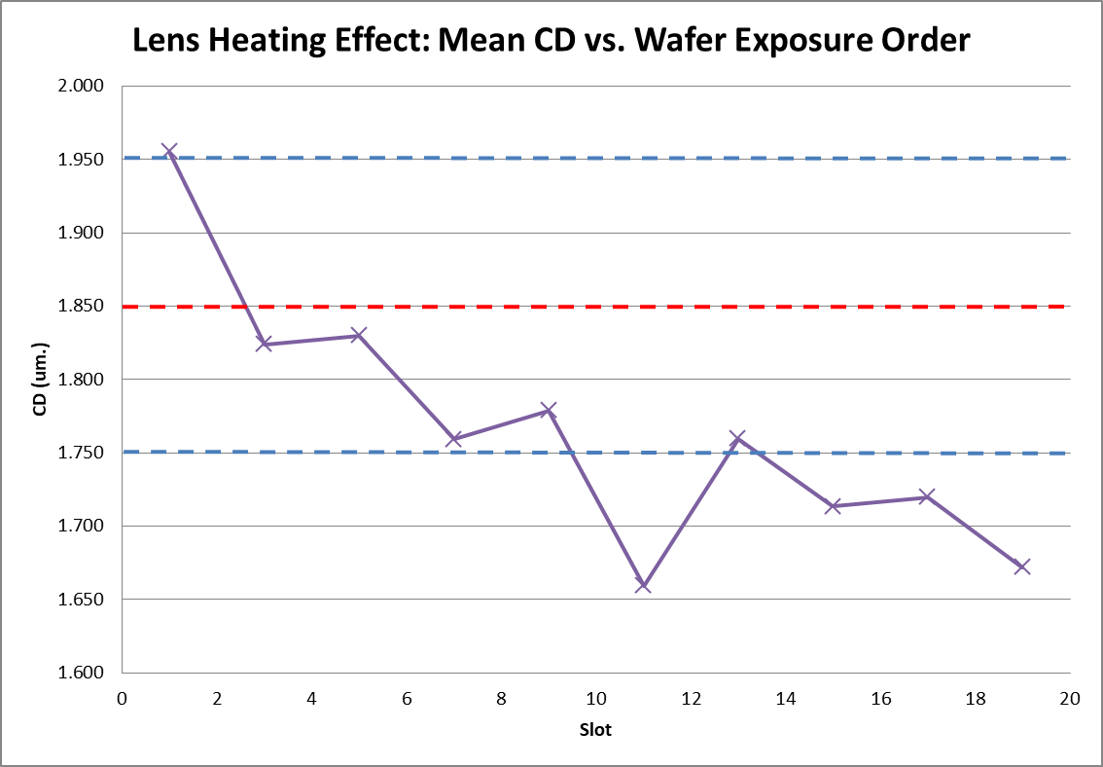
Figure1: Effect of Lens Heating on CDs

As light passing through the lens is turned off, thermal cooling occurs. Optics will return to their “cold” state and aberrations return to their initial condition.

PREVENTING LENS HEATING

From a practical standpoint, to prevent lens heating aberration, process engineers use the classical techniques to prevent lens heating. These are mask/resist polarity optimization, using “fast” resist and limiting the energy/unit time introduced to the lens.

Mask/Resist polarity optimization is designing the process to utilize dark field reticles. As indicated in the lens heating potential discussion, reducing the % reticle transmittance keeps the minimum energy passing through the projection lens. The resist polarity (positive or negative) is then selected based on the mask polarity.

Using a resist/developer combination with a fast photo speed reduces the dose, the second half of the formula. Limiting the light energy /unit time was a technique developed by lithography system manufacturers to prevent lens overheating [3]. The technique adds a delay time before opening the shutter between exposing fields. The net effect is to allow the lens to dissipate absorbed heat over a longer time. This technique works with the trade-off being throughput. Figure 2 shows an example of throughput reduction using exposure duty control (EDC(tact) [3].

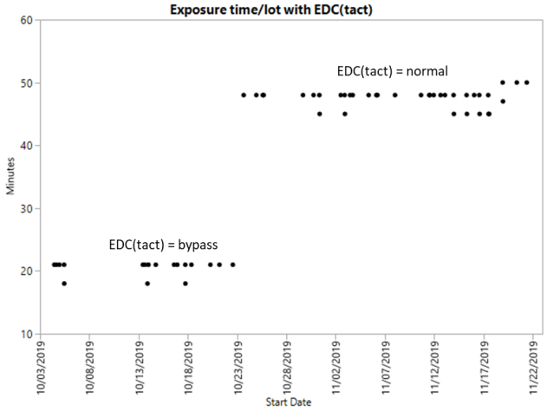
Figure 2: Throughput loss using EDC(tact)

PROCESS DETAILS:

Not all the light energy passing through the lens uses the full diameter of every optical element. Many processes have been developed with numerical aperture and sigma combinations optimized for common depth of focus. Reducing numerical aperture and sigma effectively reduce the transmitted light through a smaller diameter of the lens elements. In order to maintain throughput, lithography tool makers have designed the illuminators to collect the light and increase the intensity into those smaller diameters of the lens. Doing so creates localized non-uniform heating of the optical elements. This creates localized element deformation which in turn increases lens aberration.

Low NA / Low Sigma Process

A low numerical aperture / low sigma process was designed for metal lift-off to reduce the occurrence of metal tearing, metal stringers and straps during the optimization, Prolith simulations confirmed that the reverse wall angle of the developed resist was sharper at the top of the resist over a wider DOF with low numerical aperture / low sigma. Notice in Figure 3 the rounding of the retrograde resist profile towards the top of the resist with high sigma compared to low sigma.

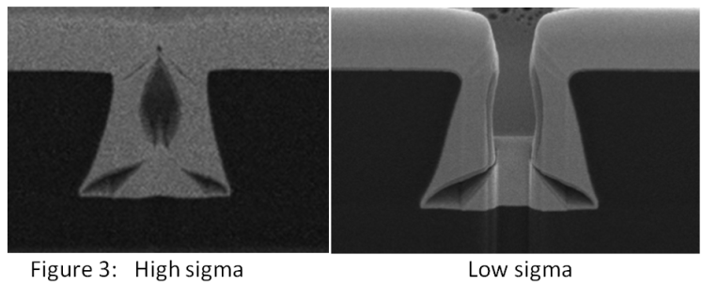

The numerical aperture /sigma selected for the process produced a clean separation of the metal deposited (Figure 4). Notice the clean separation of the metal deposited on top of the resist from the metal deposited at the bottom.

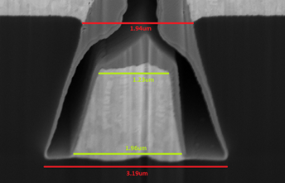
Figure 4: Resist cross-section with metal deposition

RESULTS & DISCUSSION

The implementation of this low numerical aperture / low sigma process to high volume manufacturing produced lens heating detected as the CD decrease in the window feature as more wafers were exposed (Figure 1).

As discussed earlier, concentrating the light through the small NA / small sigma, local thermal expansion was the root cause. As the metal lift-off process was sensitive to stringers and wings formed by the rounding of the resist retrograde wall angle as sigma was increased, increasing sigma was not an option. In this case, EDC(tact) was applied to reduce the energy. Figure 5 shows the results of using EDC(tact) to prevent the lens from heating up past the point where the aberrations cause a steady CD decrease.

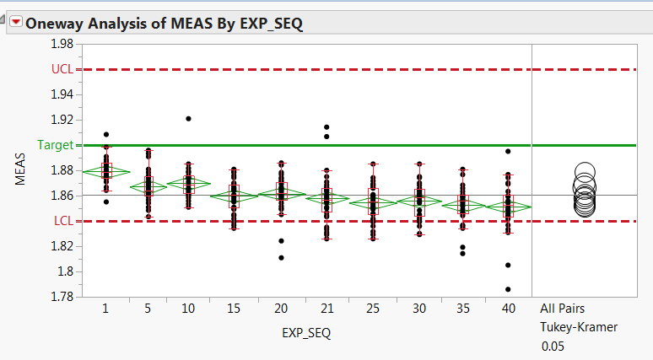
Figure 5 (A): Without EDC(tact)
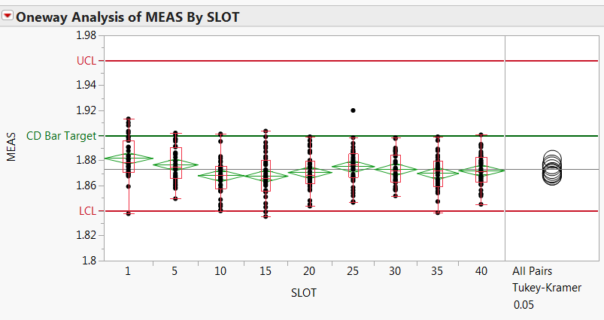
Figure 5 (B): With EDC(tact)

High Transmittance / High Dose Application

A new equipment purchase required that a high lens heating potential layer be transferred to an older “high mileage” lithography tool in the fleet. Initial testing showed CD decrease and resist wall angle degradation in a single lot exposure. Figure 6 shows the feature distortion and Figure 7 shows the wall angle change within a single lot.

(1st) (5th)
(10th) (15th)
(20th)
Figure 6: Feature distortion vs. Expose Order
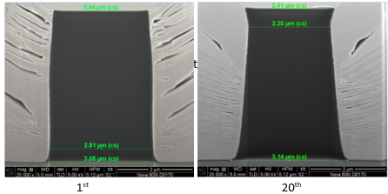
Figure 7: Resist Wall Angle Change vs. Expose Order

As this layer has a very high dose, using EDC(tact) with a 50% throughput decrease was not considered an option for high volume manufacturing. Based on the knowledge of lens heating with low NA, low Sigma process, increasing the NA and Sigma to the maximum was the hypothesis to reduce lens heating by spreading the heat across the maximum diameter of the lens elements. As the feature size for the layer was large, depth of focus was still adequate at maximum numerical aperture. This technique proved successful for this layer. Figure 8 shows the improvements in feature distortion and wall angle.

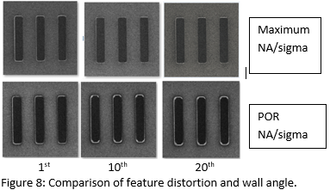

For comparison, the POR NA/sigma process with EDC could produce similar results at the expense of stepper throughput.

CONCLUSIONS

We have demonstrated that maximizing NA and sigma is an effective method to reduce lens heating in “high mileage” lenses. It is recommended that high mileage lens not be used for annular, quadrupole or any type of non-symmetric illumination schemes which will have a similar lens heating effect as reduced NA and sigma.

ACKNOWLWDGEMENTS

Thanks to Glen Hilario and Jarreth Seyssel for their help conducting the wafer testing and measurements. Thanks to Sarang Kulkarni for editing the manuscript.

REFERENCES

[1] Y. Mao, et. al. Modeling and optimization of lens heating effect for lithographic projector, Journal of Micro/Nanolithography, MEMS and MOEMS, Vol 17, Issue 2 (April 2018).

[2] M. Toukhy, et. al. High resolution negative i-line resist and process for metal lift-off applications, Proc. SPIE 4690 Advances in Resist Technology and Processing XIX (July 2002).

[3] EDC(tact) – Canon Inc.

